PROJECT DOCUMENTATION
AI-ASSISTED IT HELP DESK
MANAGEMENT SYSTEM
A ServiceNow-based incident management solution
with external Gemini AI integration
Prepared by: Chagal Samreen
Department: CSE( Data Science)

Document Control
Item | Details
Project title | AI-Assisted IT Help Desk Management System
Platform | ServiceNow Personal Developer Instance (PDI)
AI service | Google Gemini API (external AI integration)
Primary application | AI-Assisted IT Help Desk
Document purpose | Describe the implemented solution, configuration, validation and future scope
Version | 1.0
Prepared on | 5 November 2026

Important note about implementation details
This document is based on the configuration and test outcomes shared during the project build. Where exact internal implementation details (such as every script condition, field name, API model version, or SLA schedule) were not independently verified, the description is kept at a functional level. Before formal submission, add your own screenshots, student details, exact field names, and any institution-specific formatting.

Abstract
The AI-Assisted IT Help Desk Management System is a ServiceNow-based solution designed to streamline IT incident handling. It uses the Incident table as the central record for reported issues and applies automation to calculate priority and route incidents to appropriate support groups. A Gemini API integration generates an AI-written incident analysis containing a concise summary, a likely category and troubleshooting suggestions. The application also includes email notifications, a P1 response Service Level Agreement (SLA), reports and an operations dashboard. The implementation was tested in a ServiceNow Personal Developer Instance using sample incidents. The observed tests confirmed critical-priority calculation, network and Service Desk assignment paths, successful Gemini analysis and category prediction, active P1 SLA tracking, dashboard visualizations, breached-SLA reporting, and delivery of the custom incident email to an alternate recipient address.

1. Introduction
IT support teams receive incidents involving network connectivity, hardware, software, printers, accounts and other services. If incidents are handled manually, classification and routing may be inconsistent, response may be delayed, and support teams may have limited visibility into workload and SLA performance.
This project uses ServiceNow to centralize incident records and automate selected support activities. External Gemini AI is used as an assistant for analyzing incident text; the platform's own rules and workflows remain responsible for operational actions such as priority calculation, assignment and notification.

2. Problem Statement
A help desk needs a consistent way to record incidents, determine urgency, route work, communicate with users and monitor response commitments. Manual processing can lead to incorrect categorization, delayed assignment, missed notifications and difficulty tracking SLA performance. The project addresses these issues through a configurable ServiceNow application with AI-assisted analysis and automation.

3. Objectives
- Centralize IT incident creation and tracking using the ServiceNow Incident table.
- Calculate incident priority from impact and urgency.
- Route network-related incidents to the Network group and other tested support cases to Service Desk.
- Generate AI-assisted summaries, likely categories and troubleshooting suggestions using Gemini.
- Notify relevant recipients when incidents are created or assigned.
- Track critical-incident response using a P1 response SLA.
- Present incident and SLA information through reports and a dashboard.
- Validate the solution with repeatable test cases.

4. Scope

4.1 Included
- Incident form and list-based incident management.
- Priority and assignment automation.
- Gemini API integration through a ServiceNow server-side component and UI action.
- AI Analysis field and AI-assisted category output.
- Flow Designer automation and email notifications.
- P1 response SLA and breached-SLA reporting.
- Operations dashboard and functional testing.

4.2 Not included / future scope
- Production-grade identity, access and security review.
- Automated AI execution for every incoming incident (unless separately configured).
- Advanced model evaluation, confidence scoring and human-feedback loop.
- Multiple SLA policies, escalation tiers and a full service catalog.
- Production email-domain and deliverability administration.

5. Technology Stack
Technology / component | Purpose
ServiceNow PDI | Development and execution platform
Incident [incident] table | Stores reported IT incidents
Client Scripts / Business Rules | Client-side behavior and server-side record automation, where configured
Flow Designer | Workflow automation for incident assignment and related actions
ServiceNow SLA / Task SLA | Tracks response commitment and breach state
ServiceNow Notifications / Email | Generates incident and assignment email messages
Google Gemini API | External AI analysis of incident information
Script Include: AIHelpDeskGeminiService | Server-side integration logic for calling Gemini
Connection Alias: Gemini_AI_Help_Desk_Connection | Stores/references connection configuration
UI Action | Allows an authorized user to request AI analysis from an incident
Reports and Dashboards | Operational monitoring and visualization

6. High-Level Architecture
The Incident table is the central data source. ServiceNow automation evaluates incident details and performs routing and priority-related actions. When requested, the UI Action calls the Script Include, which uses the configured connection details to send incident information to the Gemini API. The returned analysis is saved to the incident's AI Analysis field and the AI-assisted category is reflected on the record. Notifications and SLA tracking operate alongside this process.
User / Help Desk Agent
↓
ServiceNow Incident [incident]
├── Priority & assignment automation
├── Flow Designer → support group routing
├── UI Action → Script Include → Gemini API
│ ↓
│ AI Analysis / Category
├── Notifications → Email recipients
└── P1 SLA → Task SLA → Reports / Dashboard

7. Functional Design and Implementation

7.1 Incident management
The Incident table (incident) is used to create, update and track support requests. The tested incident records included caller, short description, description, impact, urgency, priority and assignment group. An additional field labelled AI Analysis stores the generated AI response.

7.2 Priority calculation
Priority is evaluated from the impact and urgency values according to the ServiceNow priority model and the project's configured automation. In the final test, Impact 1 - High and Urgency 1 - High resulted in Priority 1 - Critical. Impact 2 - Medium and Urgency 2 - Medium resulted in Priority 3 - Moderate.

7.3 Assignment automation
The tested routing behavior sends a network-related incident (short description: “Network connection is not working”) to the Network assignment group. A printer-related incident (short description: “Printer is not working”) was routed to Service Desk. These tests validate the two observed routing paths; additional keywords and edge cases should be tested before production use.

7.4 Gemini AI integration
The project uses an external Gemini API rather than relying only on built-in AI functionality. The ServiceNow Script Include is named AIHelpDeskGeminiService. A Connection Alias named Gemini_AI_Help_Desk_Connection is configured for the integration. A UI Action invokes the server-side analysis method for the current incident. The generated response is saved in the AI Analysis field and includes an incident summary, likely category and troubleshooting suggestions.
The integration previously encountered transient HTTP 503 and HTTP 429 responses during development. A later end-to-end test generated and saved the analysis successfully, and the tested network incident received the Network category. API quota, model availability, credential permissions and response handling should be monitored.

7.5 Email notifications
The custom notification is named AI Help Desk - New Incident Notification. It is configured for Incident records and triggers on record insertion. Help Desk Tester is selected as a recipient. The custom subject format tested was “New Incident Created: ${number}”. The delivered message included the incident number, short description, priority and assignment information.
During testing, ServiceNow suppressed delivery when the recipient address matched the instance's own mail account, logging an infinite-loop prevention warning. Changing the Help Desk Tester user's email to a different accessible address allowed the custom notification to be delivered. The Developer Portal PDI email sending/receiving setting was also enabled. Keep the recipient separate from the instance's own mail account.

7.6 SLA configuration
The project includes an SLA definition named AI Help Desk - P1 Response SLA. The tested critical incident INC0010058 had a Task SLA record in In Progress stage, 0 minutes of business time remaining, 3 days ,1 hour, 58 minutes elapsed, and Has breached = true. This confirms the SLA started and was not breached at the time of observation. The precise schedule and duration should be documented from the SLA definition in the instance.

7.7 Reports and dashboard
The AI Help Desk Operations Dashboard was verified with three visualizations: Total Incidents, Incidents by Priority and Incidents by State. The dashboard showed 109 total incidents at the time of the screenshot; this count includes pre-existing instance data and should not be presented as the number of project-created test incidents.
A report named AI Help Desk - SLA Breached Incidents uses the Task SLA table and the filter Has breached is true. The observed report displayed 60 records across three pages. These are existing instance records and are not necessarily all generated by this project.

8. Process Workflow
- An end user or support agent creates an incident and provides the issue description, impact and urgency.
- ServiceNow calculates or updates the incident priority based on the configured priority logic.
- Assignment automation evaluates the incident and routes it to Network for the tested network case or Service Desk for the tested printer case.
- For AI assistance, the agent selects the AI analysis UI Action on the incident.
- The server-side Script Include sends the incident information to Gemini using the configured connection.
- Gemini returns a concise analysis. The result is saved in AI Analysis and the category is updated or suggested as configured.
- The notification process generates an email for the configured recipient.
- For P1 incidents, the P1 response SLA starts and its progress is recorded in Task SLA.
- Reports and dashboard visualizations provide visibility into incidents and SLA performance.

9. Testing and Results
Test ID | Test scenario / input | Expected result | Observed result | Status
TC-01 | Impact 1 - High; Urgency 1 - High | Priority 1 - Critical | Priority became 1 - Critical | PASS
TC-02 | Short description: Network connection is not working | Assignment group = Network | Assignment group was Network | PASS
TC-03 | Impact 2 - Medium; Urgency 2 - Medium | Priority 3 - Moderate | Priority became 3 - Moderate | PASS
TC-04 | Short description: Printer is not working | Assignment group = Service Desk | Assignment group was Service Desk | PASS
TC-05 | Run Gemini analysis on network incident | AI Analysis generated and saved | Analysis generated; summary and suggestions present | PASS
TC-06 | AI category for network incident | Category = Network | Category displayed Network | PASS
TC-07 | P1 incident INC0010058 | SLA In Progress, not breached initially | 23 minutes left; 20.28% elapsed; breached=false | PASS
TC-08 | Open operations dashboard | Three widgets show data | Total, Priority and State widgets visible | PASS
TC-09 | Run breached-SLA report | Filter Has breached=true | 60 records shown across 3 pages | PASS
TC-10 | Custom notification to alternate recipient | Custom email delivered | Email for INC0010057 received at alternate address | PASS

Note: PASS reflects the observed test at the time of execution. It does not imply production readiness or exhaustive testing of all possible input combinations.

10. Sample Test Data
Field | Critical network test | Printer test
Caller | Help Desk Tester / other active user | Any active user
Short description | Network connection is not working | Printer is not working
Description | Unable to connect to the office network. Internet access is unavailable. | Unable to print documents from the office printer.
Impact | 1 - High | 2 - Medium
Urgency | 1 - High | 2 - Medium
Expected priority | 1 - Critical | 3 - Moderate
Expected assignment | Network | Service Desk

11. Security and Operational Considerations
- Do not include API keys, passwords or credential values in source code, screenshots or submitted documentation.
- Use ServiceNow credential and connection configuration rather than hard-coding secrets.
- Restrict the AI analysis action and access to incident data according to appropriate roles and ACLs.
- Review AI output before using it to make operational decisions; generated suggestions may be incomplete or incorrect.
- Monitor Gemini quota, HTTP errors, model availability and response parsing.
- Use a notification recipient address that is not the same as the PDI instance's own mail account, to avoid loop-prevention suppression.
- Treat the PDI as a learning and demonstration environment, not a production service.

12. Limitations
- The project was built and tested in a free ServiceNow Personal Developer Instance.
- Gemini free-tier quota or service availability may cause HTTP 429 or 503 errors.
- Assignment behavior has been validated with representative network and printer descriptions; broader classification coverage needs additional tests.
- AI output is advisory and should be reviewed by a human support agent.
- Email delivery behavior depends on PDI email controls, SMTP configuration and recipient restrictions.
- Dashboard and breached-SLA counts include existing instance records and may change over time.

13. Future Enhancements
- Expand assignment rules using a larger set of incident keywords and service mappings.
- Add AI confidence indicators and a human approval step before updating category or assignment.
- Add fallback handling for Gemini quota errors and malformed responses.
- Introduce automated regression tests for priority, assignment, notification and SLA conditions.
- Create trend reports for category, resolution time, reassignment count and SLA compliance.
- Add escalation notifications when P1 response time approaches the breach threshold.
- Integrate a knowledge base recommendation feature using approved internal knowledge articles.

14. Conclusion
The AI-Assisted IT Help Desk Management System demonstrates how ServiceNow automation can be combined with an external generative AI service to support incident management. The implementation centralizes incident records, automates tested priority and assignment paths, generates AI-assisted incident analysis, sends a custom notification, tracks P1 response SLA progress and presents operational information through reports and a dashboard. The observed functional tests passed for the scenarios documented in this report. Further testing, security review and configuration hardening would be required before any production deployment.

15. Glossary
Term | Meaning
Incident | A record describing an IT issue that needs investigation or resolution.
Caller | The user who reported the incident.
Assignment group | The support team responsible for handling the incident.
Priority | The order in which an incident should be handled, based on impact and urgency.
Business Rule | Server-side ServiceNow logic that runs when records are queried or changed, depending on its configuration.
Client Script | Browser-side script that responds to form events.
Flow Designer | ServiceNow tool for configuring workflow automation.
SLA | Service Level Agreement; a target for service response or resolution.
Task SLA | A record tracking an SLA against a task such as an incident.
Gemini API | Google's API for requesting generative AI model responses.
Script Include | Reusable server-side JavaScript in ServiceNow.
PDI | Personal Developer Instance used for learning and development.

Appendix A — Evidence
- Screenshot of the Incident form showing the custom AI Analysis field.
- 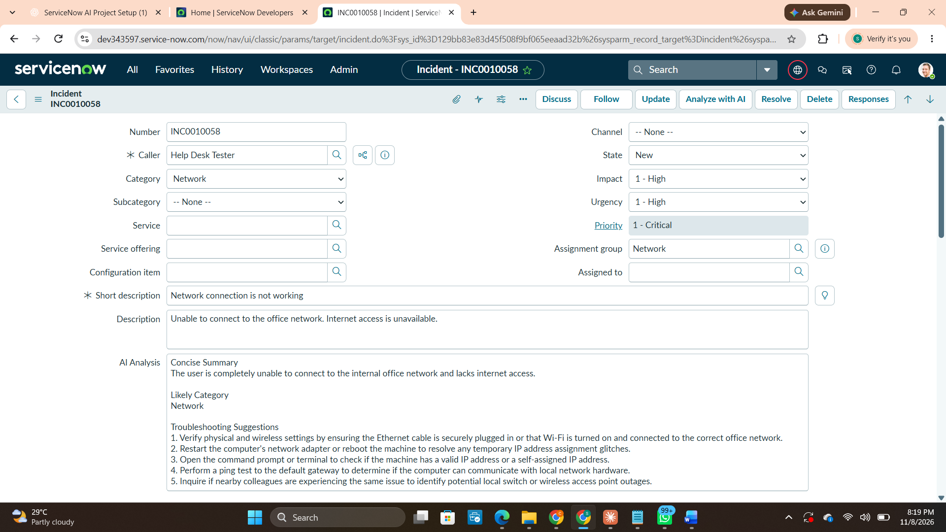
- Screenshot of a critical incident showing Priority 1 - Critical and Network assignment.

Screenshot of the printer incident showing Priority 3 - Moderate and Service Desk assignment.

- 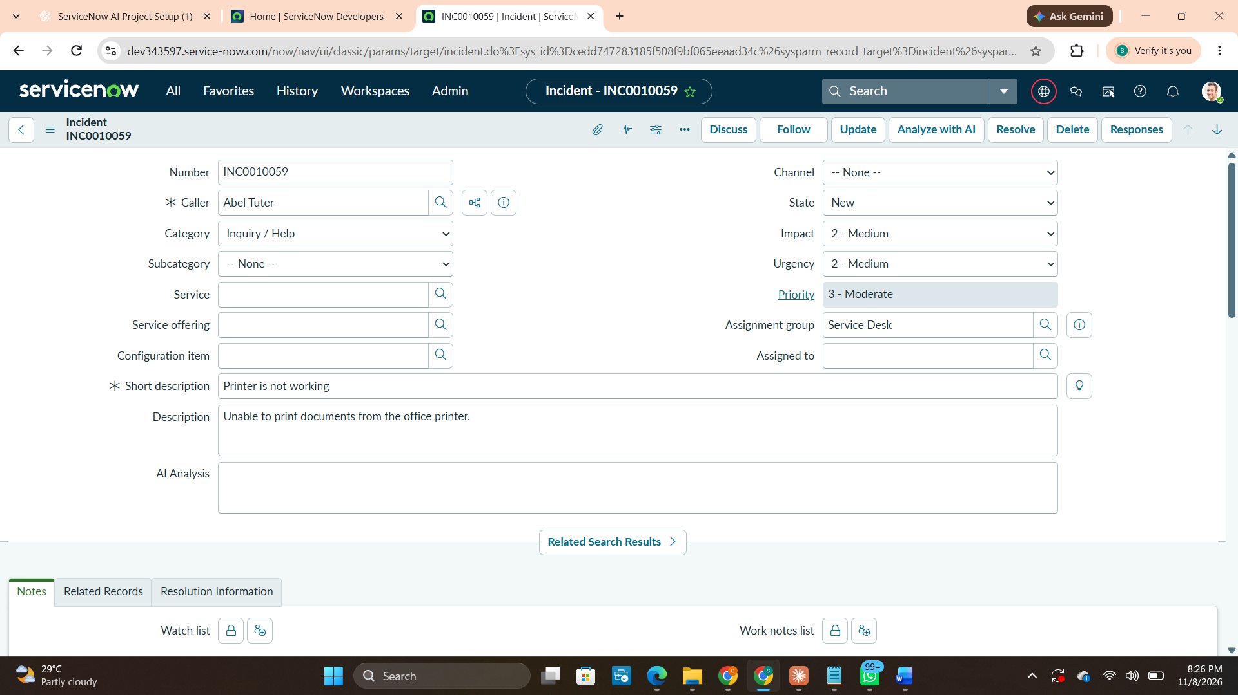
- Screenshot of the generated Gemini analysis and Network category.
- Screenshot of the Task SLA record for INC0010058 showing In Progress and Has breached = true
- 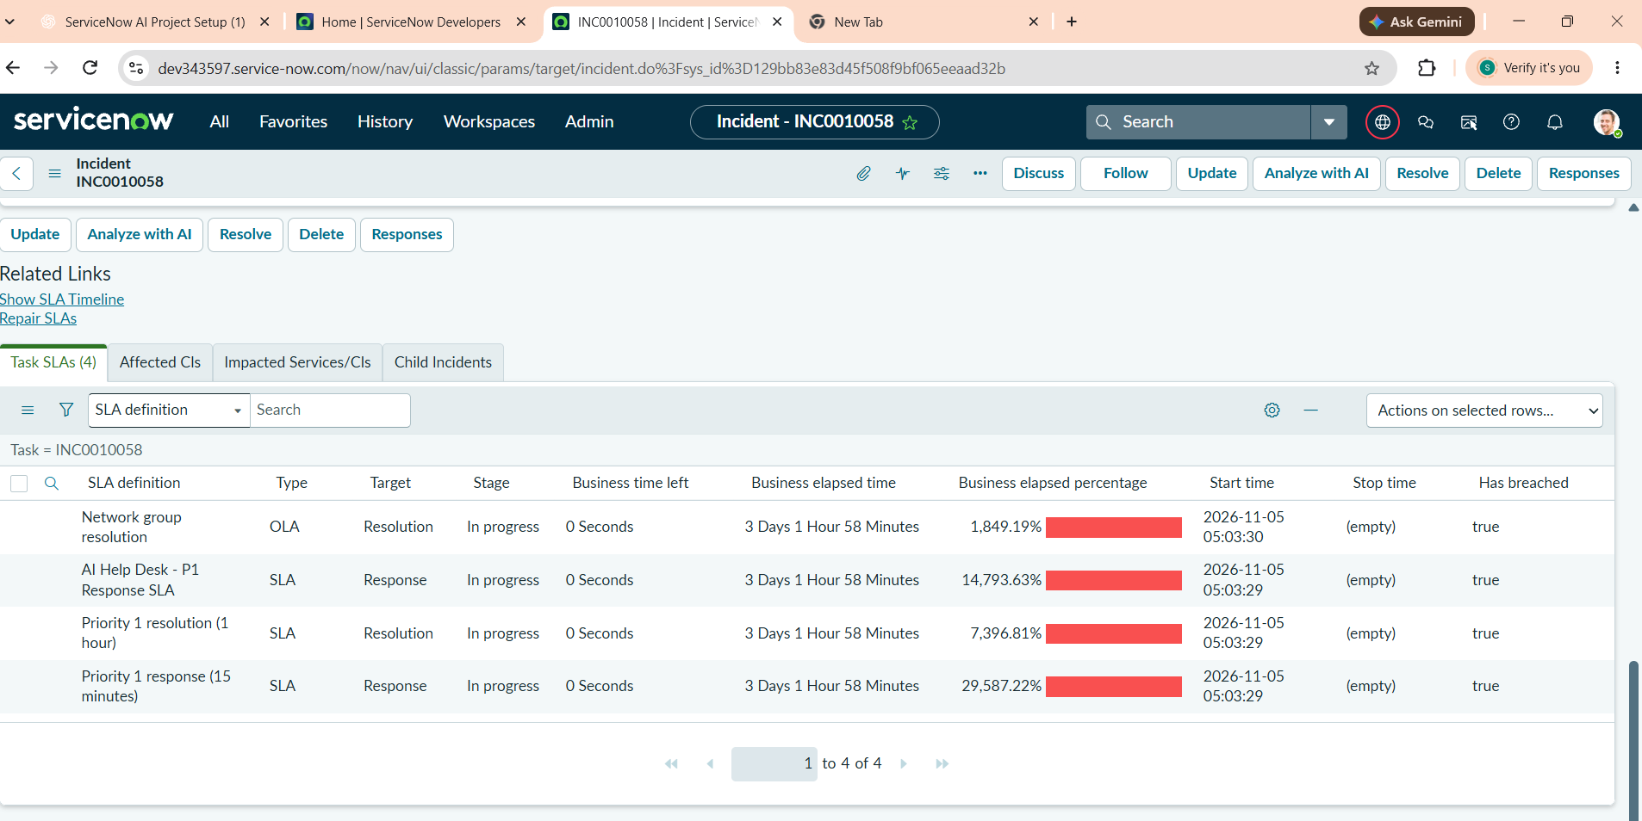.
- Screenshot of the Operations Dashboard with all three widgets.
- 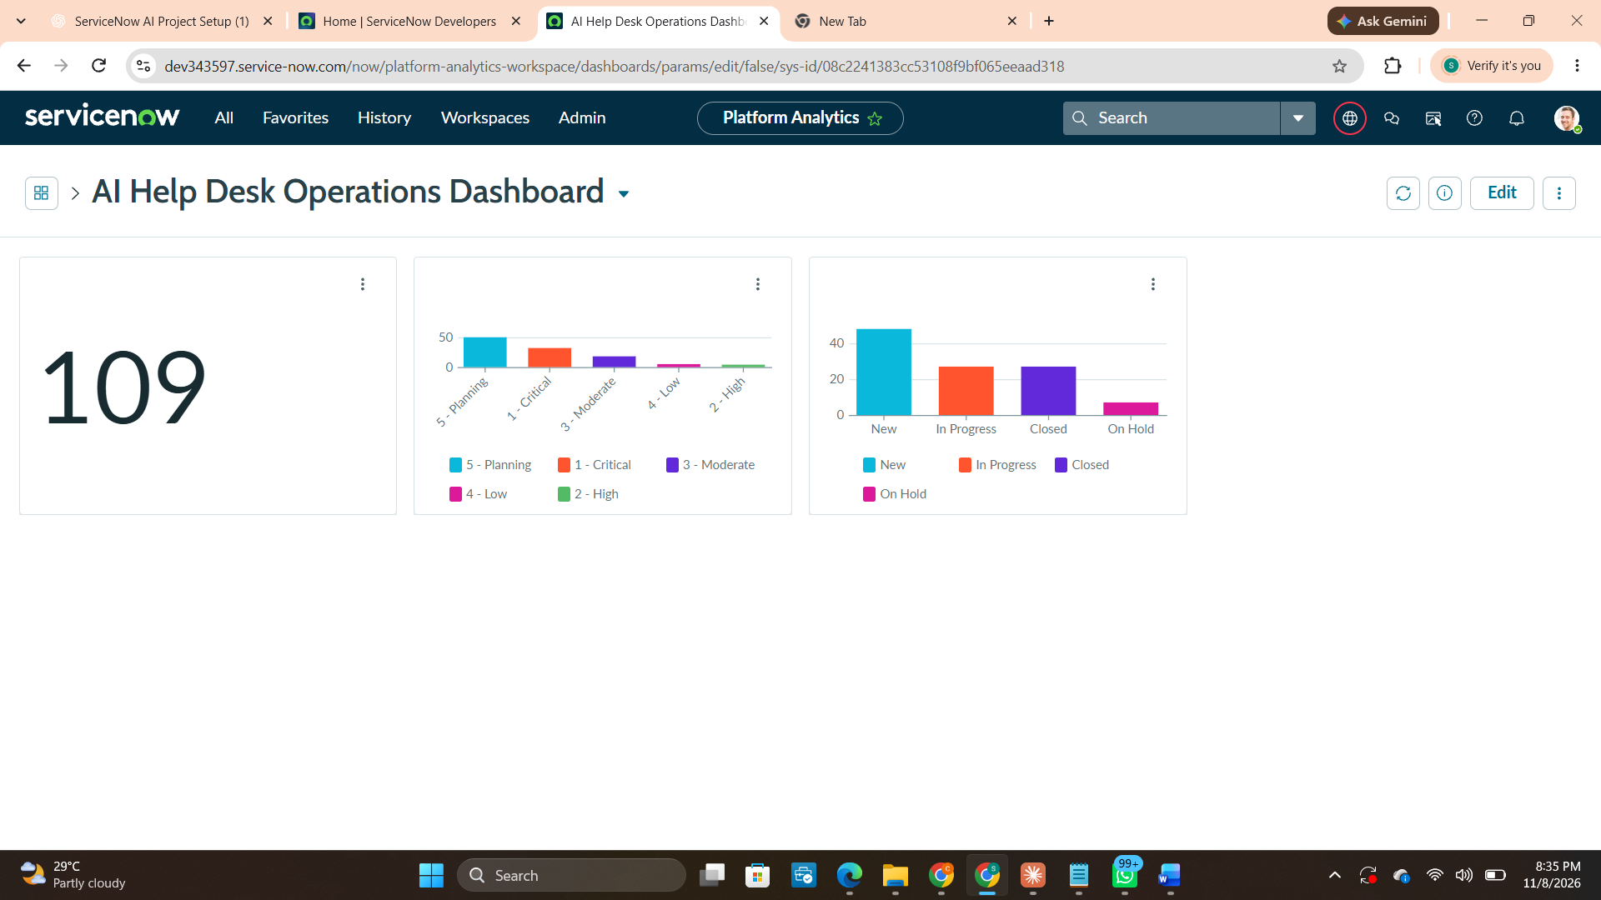
- Screenshot of the breached-SLA report filter and results.
- 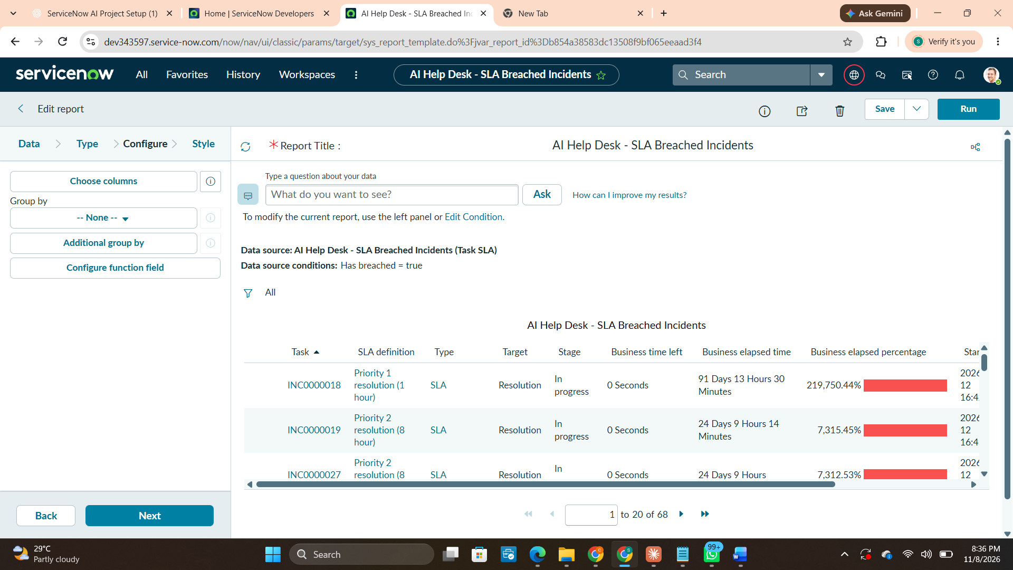
- Screenshot of the received custom email for INC0010057
- 

