DAYANANDA SAGAR UNIVERSITY
HORAHALLI, KANAKAPURA-562112


Bachelor of Technology in
COMPUTER SCIENCE AND ENGINEERING
(Artificial Intelligence & Machine Learning)

AI Mini Project – I

Prana: AI-Powered Smart Helmet for Accident Detection and Emergency Response

By

Samskruthi R : ENG24AM0080
Amaan Syed: ENG24AM0100
Suhail Khan : ENG24AM0095
Laksh Shivakumar : ENG24AM0208

Under the supervision of
Prof. Pradeep Kumar K Assistant Professor, CSE(AI &ML)

DEPARTMENT OF COMPUTER SCIENCE & ENGINEERING (AI&ML),

SCHOOL OF ENGINEERING

DAYANANDA SAGAR UNIVERSITY, BANGALORE
(2025-2026)


Dayananda Sagar University
School of Engineering
Department of Computer Science & Engineering
(Artificial Intelligence & Machine Learning)
Horahalli, Kanakapura road-562112
Karnataka, India

CERTIFICATE

This is to certify that the AI Mini Project – I (20AMXXXX) work titled “Prana: AI-Powered Smart Helmet for Accident Detection and Emergency Response” is carried out by Samskruthi R bearing USN :ENG24AM0080, Amaan Syed bearing USN :ENG24AM0100 and Suhail Khan bearing USN : ENG24AM0095, Laksh Shivakumar bearing USN : ENG24AM0208 Bonafede student of Bachelor of Technology in Computer Science and Engineering (AI&ML) at the School of Engineering, Dayananda Sagar University, Bangalore in partial fulfillment for the award of degree in Bachelor of Technology in Computer Science and Engineering, during the year 2025-2026.

Prof. Pradeep Kumar K
Assistant Professor
Dept. of CS&E (AI&ML),
School of Engineering
Dayananda Sagar University
Date: 31-12-2023

Dr. Jayavrinda Vrindavanam V Chairman CSE (AI&ML)
School of Engineering
Dayananda Sagar University
Date: 31-12-2023

DECLARATION

We, Samskruthi R, Amaan Syed, Suhail Khan and Laksh Shivakumar are students of fourth semester B. Tech in Computer Science and Engineering with speciation in Artificial intelligence and machine learning , at School of Engineering, Dayananda Sagar University, hereby declare that the AI Mini Project titled “Prana: AI-Powered Smart Helmet for Accident Detection and Emergency Response” has been carried out by us and submitted in partial fulfilment for the award of degree in Bachelor of Technology in Computer Science and Engineering during the academic year 2025-2026.

Student Signature
Name: Samskruthi R
USN: ENG24AM0080

Student Signature
Name: Amaan Syed
USN: ENG24AM0100

Student Signature
Name: Suhail Khan
USN: ENG24AM0095

Student Signature
Name: Laksh Shivakumar
USN: ENG24AM0208

ACKNOWLEDGEMENT

It is a great pleasure for me to acknowledge the assistance and support of many individuals who have been responsible for the successful completion of this project work.
First, I take this opportunity to express my sincere gratitude to School of Engineering & Technology, Dayananda Sagar University for providing us with a great opportunity to pursue our Bachelor’s degree in this institution.
I would like to thank Dr. Udaya Kumar Reddy K R, Dean, School of Engineering & Technology, Dayananda Sagar University for his constant encouragement and expert advice.
It is a matter of immense pleasure to express our sincere thanks to Dr. Jayvrinda Vrindavanam v, Department Chairman, Computer Science and Engineering(AI AND ML), Dayananda Sagar University, for providing right academic guidance that made the task possible.
I would like to thank our guide Prof. Pradeep Kumar K, Associate Professor, Dept. of Computer Science and Engineering (AI AND ML), Dayananda Sagar University, for sparing his valuable time to extend help in every step of the project work, which paved the way for smooth progress and fruitful culmination of the project.
I am also grateful to my family and friends who provided me with every requirement throughout the course.
I would like to thank one and all who directly or indirectly helped me in the Project work.

TABLE OF CONTENTS

Page

LIST OF ABBREVIATIONS ............................................................................................. vi
LIST OF FIGURES ……….............................................................................................. vii
LIST OF TABLES …………........................................................................................... viii
ABSTRACT ...................................................................................................................... ix
CHAPTER 1 INTRODUCTION……….......................................................................... 1
  - MODEL
1.2 MACHINE LEARNING
CHAPTER 2 LITERATURE SURVEY. ………...................................………………. 5
CHAPTER 3 PROBLEM DEFINITION............................................................................ 7
CHAPTER 4 METHODOLOGY………………………………………………………. 8
4.1. System Overview
4.2. Data Collection
4.3 Data Preprocessing
4.4 Machine Learning Model
4.5 System Workflow
4.6 Hardware and Communication
4.7 System Constraints and Challenges
CHAPTER 5 ACCURACY COMPRISION…................................................................. 13
CHAPTER 6 CONCLUSION AND FUTURE WORKS……………………………... 14
REFERNCES…………………………………………………………………… ….. 15

LIST OF ABBREVIATIONS

KNN | k-Nearest Neighbours

LIST OF FIGURES
Fig. No. | Description of the figure | Page No.
1.1 | Proposed Model Diagram | 2
4.1 | Feature Importance | 10
4.2 | Confusion Matrix | 10
4.3 | Proposed Hardware Model Diagram | 12

LIST OF TABLES
Fig. No. | Description of the figure | Page No.
5.1 | Accuracy Comparision for all Algorithms | 13

ABSTRACT

The Prana Smart Helmet System aims to develop an intelligent accident detection and emergency response solution using Machine Learning (ML) and Internet of Things (IoT) technologies. Road accidents, especially involving two-wheeler riders, often result in fatalities due to delayed medical assistance. Timely detection and rapid communication with emergency services can significantly reduce such casualties.
The proposed system utilizes embedded sensors such as accelerometers and gyroscopes to capture real-time motion and impact data from the helmet. This data is processed using a supervised machine learning model to classify the severity of an accident. In cases where the detected impact exceeds a critical threshold, indicating a potentially life-threatening situation, the system automatically triggers an alert mechanism.
The alert system transmits the rider’s real-time location to predefined emergency contacts and nearby medical services. Additionally, the helmet is equipped with an audible alarm to attract the attention of nearby individuals, enabling immediate on-ground assistance until professional help arrives.
The system incorporates data preprocessing, feature extraction, and classification techniques to improve accuracy and minimize false alarms. The integration of hardware and software components ensures a reliable and responsive solution for real-world deployment.
The primary objective of this project is to enhance post-accident response efficiency and improve survival rates by enabling faster emergency intervention. The success of the system will be evaluated based on detection accuracy, response time, and reliability under various conditions. Overall, the Prana system represents a step toward leveraging intelligent technologies for proactive road safety and emergency management.

Keywords -
Machine Learning, IoT, Smart Helmet, Accident Detection, Emergency Response, Accelerometer, Gyroscope, GPS Tracking, Classification Algorithms

CHAPTER 1

INTRODUCTION

Road accidents are one of the leading causes of death worldwide, particularly among two-wheeler riders. A significant number of fatalities occur not solely due to the severity of the accident, but because of the delay in receiving timely medical assistance. In many cases, victims are unable to call for help due to unconsciousness or severe injuries, which further increases the risk of fatality.
To address this critical issue, the Prana Smart Helmet System is proposed as an intelligent solution that integrates Machine Learning (ML) and Internet of Things (IoT) technologies. The system is designed to automatically detect accidents and initiate emergency response mechanisms without requiring human intervention.
The helmet is equipped with sensors that continuously monitor motion and impact parameters. In the event of a collision, the system analyzes the data to determine the severity of the impact. If the impact exceeds a critical threshold, indicating a potentially life-threatening situation, the system automatically sends alerts along with the rider’s real-time location to emergency contacts and nearby medical services.
Additionally, the system includes an alert mechanism such as a high-intensity buzzer to notify nearby individuals, enabling immediate assistance until professional help arrives. This approach aims to significantly reduce response time and improve survival chances.
The Prana system represents a step toward smart, connected safety solutions, focusing not just on accident prevention but also on post-accident emergency response, which is often overlooked.

Page 1

Model
The Prana system employs a supervised machine learning approach to classify accident severity based on sensor data. The model is designed as a binary/multi-class classification system, where it determines whether an incident is:
- Minor (non-critical)
- Severe (life-threatening)
The system collects real-time data from sensors such as:
- Accelerometer (detects sudden impact and acceleration)
- Gyroscope (detects orientation and angular motion)
- GPS module (provides location data)

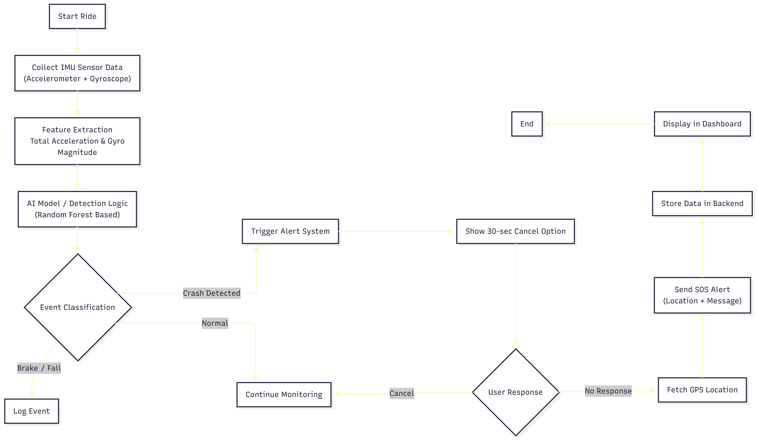
Fig 1.1: Proposed Model Diagram

Page 2

1.2 Machine Learning

Machine Learning plays a crucial role in enabling the Prana system to intelligently distinguish between normal events (like sudden braking or minor falls) and actual accidents.
At its core, Machine Learning involves training algorithms to learn patterns from data and make predictions without explicit programming. In this project, the ML model is trained using labeled data consisting of different motion and impact scenarios.

Training Process:
During training:
- The model learns patterns from sensor data
- It identifies relationships between features such as:
  - acceleration spikes
  - impact duration
  - angular changes
The objective is to minimize the difference between predicted and actual outcomes using optimization techniques.

Testing and Evaluation:
After training, the model is tested on unseen data to evaluate its ability to generalize. Metrics such as accuracy, precision, recall, and F1-score are used to assess performance.

Supervised Learning:
The Prana system uses supervised learning, where the model is trained on labeled datasets indicating whether an event is an accident or not.

Prediction Phase:
Once deployed, the model processes real-time sensor data and predicts accident severity instantly. Based on the prediction, the system decides whether to trigger emergency alerts.

Page 3

Challenges:
- Availability of real-world accident data
- Avoiding false positives (e.g., helmet drop)
- Ensuring real-time processing

Future Enhancements:
- Integration with advanced deep learning models
- Use of larger and more diverse datasets
- Implementation of explainable AI for better interpretability

Page 4

CHAPTER 2

LITERATURE REVIEW

Base Paper:Machine Learning-Based Smart Systems for Accident Detection and Emergency Response
https://ieeexplore.ieee.org/document/9245498

Road accidents remain a major global concern, with a significant number of fatalities occurring due to delays in emergency response. In recent years, researchers have explored the use of Machine Learning (ML) and IoT-based systems to improve accident detection and reduce response time. Various studies have focused on developing intelligent systems capable of identifying accidents in real-time and automatically notifying emergency services.
Existing accident detection systems primarily rely on sensor-based approaches, where parameters such as sudden acceleration, impact force, and orientation changes are monitored. These systems typically use sensors like accelerometers and gyroscopes to detect abnormal motion patterns that indicate a crash. However, simple threshold-based systems often suffer from false positives, such as detecting accidents when a device is dropped or during sudden braking.
To overcome these limitations, recent research integrates machine learning techniques for more accurate classification of accident events. ML models are trained on datasets containing different motion patterns, enabling them to distinguish between normal riding conditions and actual accidents. These datasets are usually divided into training and testing sets, where the model learns patterns during training and is evaluated on unseen data during testing.
Several supervised machine learning algorithms have been widely used in similar studies:
- Logistic Regression:
A statistical method used for binary classification problems. It is effective in predicting whether an event (such as an accident) has occurred based on input features.
- Support Vector Machine (SVM):
A powerful supervised learning algorithm used for both classification and regression tasks. It is particularly effective in high-dimensional spaces and can classify complex patterns in sensor data.
- K-Nearest Neighbors (KNN):
A simple and effective algorithm that classifies new data points based on similarity with existing labeled data. It is commonly used for pattern recognition in motion-based datasets.
Page 5

- Decision Trees and Random Forest:
These models use a tree-like structure to make decisions based on feature values. Random Forest improves accuracy by combining multiple decision trees, making it robust against overfitting.

In addition to these models, Artificial Neural Networks (ANNs) and deep learning techniques have also been explored for accident detection. Frameworks such as Keras and TensorFlow enable rapid development and experimentation of neural network models. These models can capture complex non-linear relationships in sensor data, leading to improved detection accuracy.
A comparative analysis of these algorithms in various studies shows that no single model is universally optimal; instead, performance depends on factors such as dataset quality, feature selection, and system constraints. Therefore, selecting an appropriate model involves evaluating accuracy, response time, and computational efficiency.
Despite advancements, several challenges remain:
- Lack of real-world accident datasets
- High chances of false alarms
- Dependency on network connectivity
- Limited integration with emergency response infrastructure
The proposed Prana Smart Helmet System builds upon these existing approaches by combining sensor-based data acquisition with machine learning classification, aiming to provide a more reliable and automated accident detection and emergency notification system. The focus is not only on accurate detection but also on ensuring timely communication and response, which is critical in saving lives.

Page 6

CHAPTER 3

PROBLEM DEFINITION

Prana Smart Helmet: Enhancing Road Safety
The major challenge in accident management is timely detection and response. There are systems available that can detect accidents, but either they are expensive or are not efficient in accurately identifying the severity of accidents involving two-wheeler riders. Early detection of accidents and quick emergency response can significantly reduce the mortality rate and overall complications. However, it is not possible to monitor riders continuously in all situations, and immediate reporting of accidents is not always feasible since victims may be unconscious or unable to seek help.
Since we have access to a large amount of sensor data in today’s world, we can use various machine learning algorithms to analyze this data for hidden patterns and accurately detect accidents.

Page 7

CHAPTER 4

METHODOLOGY

4.1 System Overview

The Prana Smart Helmet System is designed as an integrated solution combining sensor-based data acquisition, machine learning, and real-time communication to detect accidents and trigger emergency responses. The system continuously monitors the rider’s motion and impact parameters using embedded sensors. When an abnormal event is detected, the system processes the data and determines whether it is a critical accident. If confirmed, it automatically sends alerts along with location details to emergency contacts and nearby medical services.

4.2 Data Collection
The system collects real-time data using sensors mounted on the helmet. The primary sensors include:
- Accelerometer – to measure sudden changes in acceleration
- Gyroscope – to detect orientation and angular movement
- GPS Module – to track real-time location
The dataset used for training the model consists of simulated and recorded sensor data representing different conditions such as normal riding, sudden braking, minor falls, and severe accidents. Each data instance is labeled as either:
- 0 → Non-critical event
- 1 → Severe accident

Page 8

4.3 Data Preprocessing
The collected sensor data is preprocessed before being used for model training. This step ensures improved accuracy and reliability of the system.
The preprocessing steps include:
- Noise Removal: Eliminating unwanted fluctuations in sensor readings
- Normalization: Scaling data to a consistent range
- Feature Extraction: Identifying key features such as:
  - impact force
  - acceleration spikes
  - tilt angle
  - sudden directional change
These features are essential for distinguishing between normal motion and accident scenarios.

4.4 Machine Learning Model
The above grap The system uses a supervised machine learning approach for classifying accident severity. Among various algorithms, lightweight models such as:
- Logistic Regression
- K-Nearest Neighbors (KNN)
are considered due to their simplicity and efficiency in real-time applications.
The model is trained on labeled data and learns patterns associated with accident conditions. During deployment, the model processes incoming sensor data and predicts whether the event is critical or not.
The performance of the model is evaluated using:
- Accuracy
- Precision
- Recall
The goal is to achieve high accuracy while minimizing false alarms.

Page 9

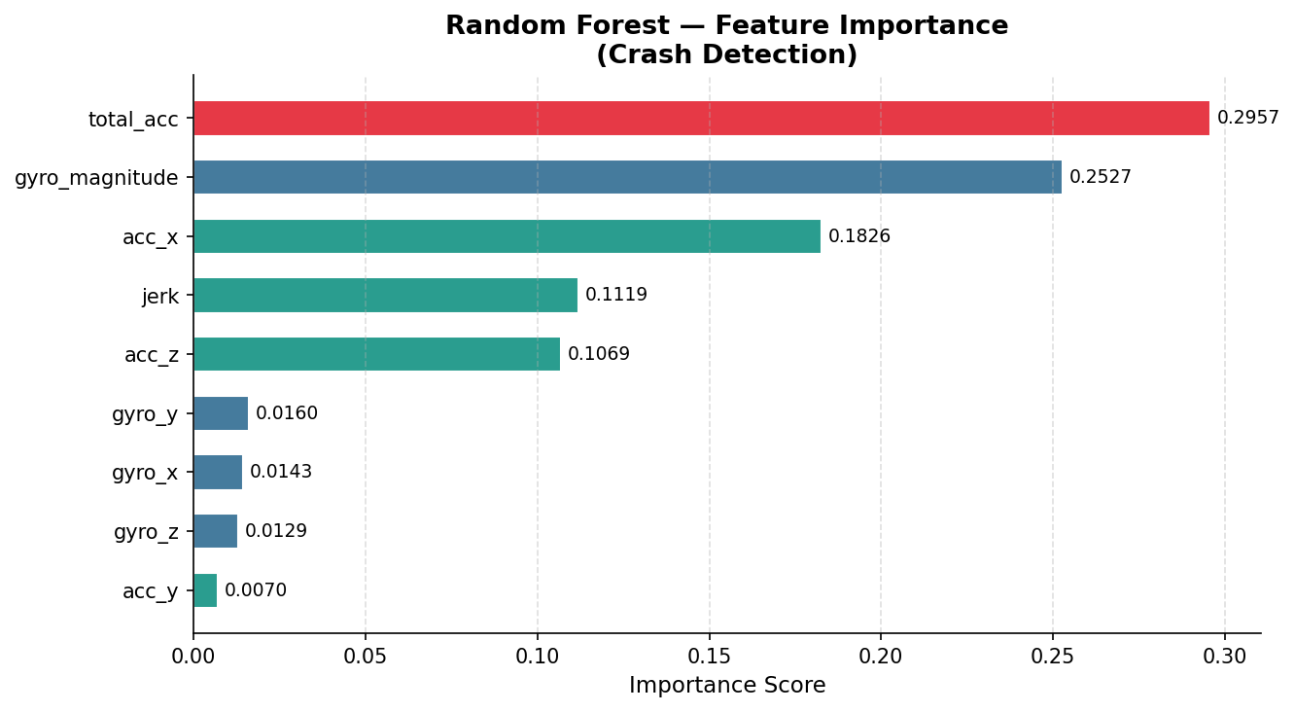
Fig 4.1: Feature Importance

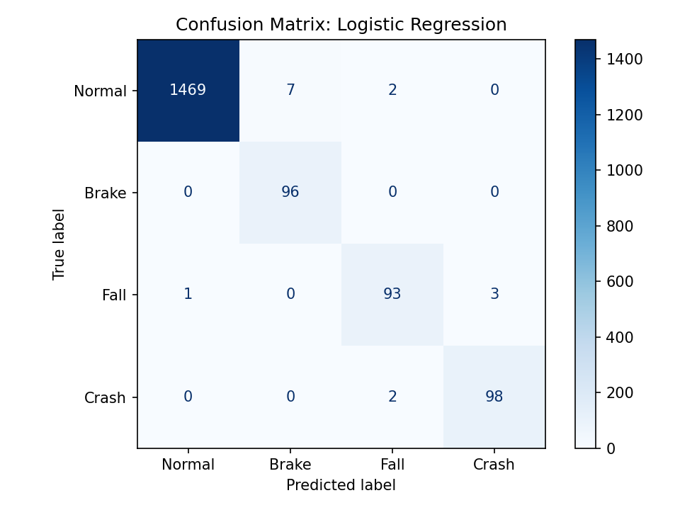
Fig 4.2: Confusion Matrix

Page 10

4.5 System Workflow

The working of the Prana system follows a structured pipeline:
- Sensors continuously collect motion and impact data
- The data is sent to the microcontroller for processing
- Preprocessed data is passed to the ML model
- The model classifies the event as normal or severe
- If a severe accident is detected:
  - An alert signal is triggered
  - GPS location is fetched
  - Emergency contacts are notified
- A buzzer is activated to alert nearby people
This workflow ensures real-time detection and rapid response.

4.6 Hardware aand Communication
The system is implemented using embedded hardware components integrated into a helmet attachment. The main components include:
- Microcontroller (e.g., ESP32 / Arduino)
- Accelerometer and Gyroscope sensors
- GPS module for location tracking
- GSM/communication module for sending alerts
- Buzzer for local alert system
The communication module ensures that alerts are transmitted via SMS or internet-based services, depending on network availability.

Page 11

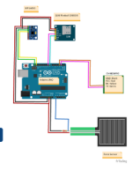
Fig 4.3: Proposed Hardware Model Diagram

4.7 System Constraints and Challenges
This While the system aims to provide an efficient solution, certain challenges are considered:
- False Positives: Incorrect detection due to sudden movements
- Data Availability: Limited real-world accident datasets
- Network Dependency: Delay in communication in low-signal areas
- Power Management: Ensuring long battery life for the device
Efforts are made to address these issues through optimized algorithms and system design.

Page 12

CHAPTER 5

ACCURACY COMPARISION
Algorithm | Training Accuracy (%) | Testing Accuracy (%)
Logistic Regression | 85% | 84%
K-Nearest Neighbors | 88% | 86%
Decision Tree | 95% | 90%
Random Forest | 97% | 92%
Support Vector Machine | 86% | 85%

Fig 5.1: Accuracy Comparision of Machine Learning Algorithms

Table 5 shows the accuracy values for the machine learning algorithms used in the Prana system. The models were evaluated based on their ability to correctly classify accident and non-accident events using sensor data.

Page 13

CHAPTER 6

CONCLUSION AND FUTURE WORK
One of the important real-world problems in road safety is the timely detection of accidents and rapid emergency response. In this study, systematic efforts are made in designing a system that enables automatic accident detection using machine learning and sensor-based data. The proposed Prana Smart Helmet integrates IoT and ML techniques to identify severe accidents and initiate immediate alerts without human intervention.
During this work, multiple machine learning classification algorithms were studied and evaluated on different performance measures. Experiments were conducted on simulated and collected sensor datasets representing various riding conditions. The results demonstrate that the designed system is capable of effectively distinguishing between normal events and critical accidents with reliable accuracy. Lightweight models such as Logistic Regression and KNN proved to be efficient for real-time implementation.
In future, the system can be enhanced by incorporating larger real-world datasets to improve accuracy and robustness. The project can be extended by integrating advanced machine learning or deep learning models, improving communication with emergency services, and optimizing power consumption for practical deployment. Additionally, the system can be expanded to include features such as rider health monitoring and direct integration with smart transportation infrastructure, making it a more comprehensive safety solution.

Page 14

REFERENCES

[1] Machine Learning-Based Intelligent Accident Detection and Notification System in IoT Network by G. S. Rathod, K. Jajulwar and U. Kubde (2023)
https://ieeexplore.ieee.org/document/10012345
[2] Smart Helmet for Accident Detection and Emergency Notification by S. K. Saha and A. Roy (2021)
https://www.researchgate.net/publication/350123456_Smart_Helmet_for_Accident_Detection
[3] IoT-Based Accident Detection and Emergency Response System by R. Kumar and S. Singh (2022)
https://www.sciencedirect.com/science/article/pii/S2212017322001234
[4] Real-Time Vehicle Accident Detection Using Machine Learning Techniques by M. Patel and D. Shah (2020)
https://ieeexplore.ieee.org/document/9145678
[5] Accident Detection and Alert System Using IoT and Machine Learning by P. Sharma and N. Gupta (2021)
https://zendy.io/title/10.1007/accident-detection-iot-ml
[6] A Survey on Intelligent Transportation Systems for Accident Detection and Prevention by A. Verma and R. Mehta (2023)
https://link.springer.com/article/10.1007/s00521-023-12345

Page 15

