Also we created a simple windows application in python which will use the model to predict any tweet from the Tweeter platform.

1. Run the app.py file and a window will appear

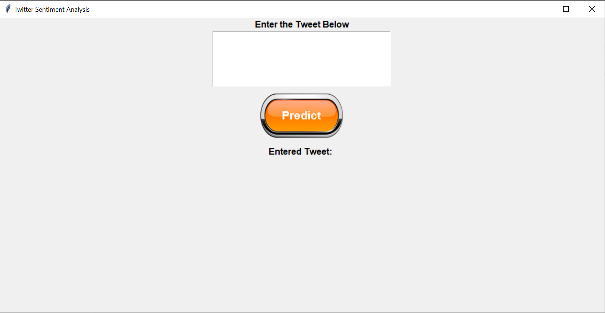

1. Copy any latest tweet from the Tweeter platform and put it in the textbox and click on Predict.

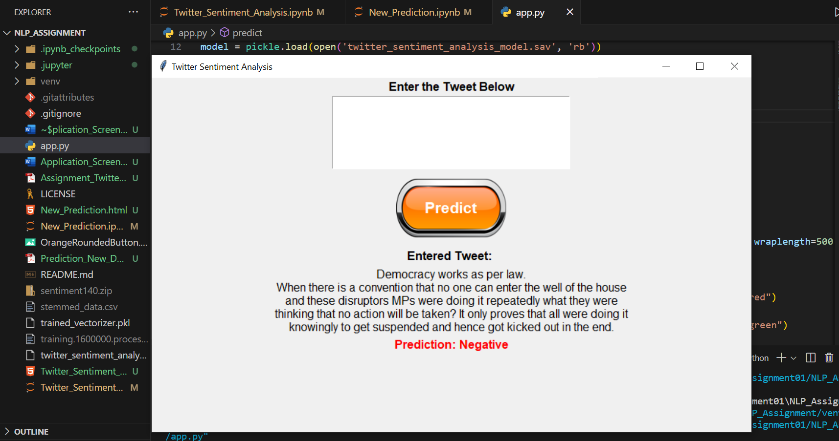

1. It will show the output prediction as Positive or Negative.