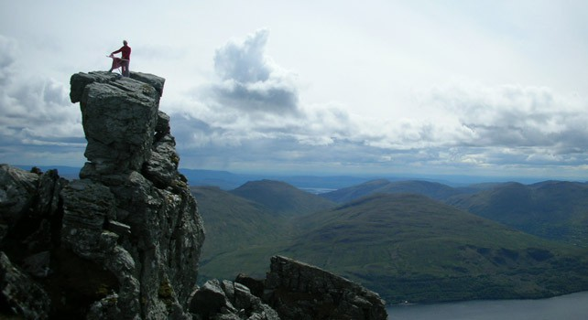History Contents:

Founded in Leicester by our lord and saviour Phil Shaw in 1997. Preferring the idea of rock climbing over ironing, he riskily combined the two activities into the best extreme sport the world would seen. In June 1999, Shaw, who goes by the name "Steam", went on a world tour to promote the sport. The trip took him to; the United States, Fiji, New Zealand, Australia and South Africa. An encounter with German tourists in New Zealand led to the formation of a group called "Extreme Ironing International", and the German Extreme Ironing Section or GEIS. Since then there have been world championships and the formation of the extreme ironing bureau.

As extreme ironing has branched off, the conditions can gain in extreme activity. For example, a branch of ironing has been developed that includes both bungee jumping and well-pressed clothing. Bungee ironing is what some would call the ultimate in the thrill of extreme ironing.