Climate change results in serious impacts, including rising temperatures in mountainous regions, shrinking glaciers, and altered precipitation patterns, all of which are amplified by human disturbances (Crozier, 2010; Pepin et al., 2015; Hock & Huss, 2021). In Central Asia’s arid regions, melting glaciers and altered snowmelt patterns are reshaping river flows and overfilling mountain lakes, as seen in the Tien-Shan mountains of Kyrgyzstan (Jansky et al., 2009; Meiners, 1997), accelerating the risk of natural disasters such as flooding. Alongside these changes, the post-Soviet collapse of state farms and land privatization forced many Kyrgyz households back into subsistence economies, concentrating livestock near villages and leaving distant pastures unused (Schmidt 2001; 2005; 2007). This shift has led to widespread overgrazing, which, combined with climate change, threatens both ecosystems and livelihoods (Ludi 2003) Without adequate land management and disaster mitigation strategies, the interaction between flooding and overgrazing may transform environmental stress into a humanitarian crisis. To bring light to these issues In September 2025, we studied ungrazed Ala Archa National Park and heavily grazed Alamedin Gorge in Kyrgyzstan to assess how climate change and grazing affect land, using the grazing contrast as our main hypothesis and quantifying ecological, hydrological, and geomorphic indicators through infiltration and vegetation measurements.
A-) Terminologies and Fieldwork Data.
1-Grazing: Grazing, along with soil and vegetation, affects infiltration and sediment production in rangelands (Coleman 1953; Branson et al. 1972). In this context, grazing alters soil and vegetation, with overgrazing typically reducing infiltration (Rhoades et al. 1964; Rauzi & Hanson 1966; Lusby 1970) and increasing erosion (Dunford 1949; Johnston 1962). Overgrazing disrupts carbon cycling, vegetation growth, soil moisture, and nutrient supply, while degraded rangelands combined with climate change increase flood risk (Azimi et al., 2020; Liu et al., 2020b; Owensby & Auen, 2020; Zhang et al., 2019).
2-Soil infiltration: Soil infiltration, the process by which surface water enters the soil, is a key factor in hydrological modeling, and flood dynamics, as it reduces floodwater and together with geomorphic changes like erosion and deposition, strongly influences flood behavior (Das et al., 2015; Hooke, 2016; Anni et al., 2020; Lili et al., 2008). Measuring infiltration capacity (soil infiltrability) is therefore essential for understanding how these processes respond to environmental or human-induced changes. Infiltrometers, such as the mini disk infiltrometer (MDI) are tools used to measure the rate at which water infiltrates into the soil. The MDI allows controlled water applications and provides precise measurements of infiltration rates in the field. In this study, we used the mini disk infiltrometer (MDI) to quantify soil infiltration.
3-Runoff: Runoff occurs when the infiltration capacity of the soil is exceeded. Infiltration is the main coefficient that controls how much rainfall enters the soil versus how much becomes surface runoff. Flooding is strongly influenced by runoff, which depends on land use, soil types, and the proportion of rainfall that becomes surface runoff, often leading to erosion, sedimentation, and property damage (Basri et al.,2022).
4-Vegetation: Quantifying composition of vegetation in field sites plays a key role in flood regulation by reducing runoff and mitigating flood hazards, along with other watershed features such as soil and land use (Egoh et al., 2008; Posthumus et al., 2010; Schulp et al., 2012; Mogollón et al., 2016; Nedkov & Burkhard, 2012; Smithers et al., 2016; Stürck et al., 2014). Vegetation patterns also affect the amount and spatial distribution of infiltration. Dahan et al. (2008) We quantified vegetation data using the appointed USDA key and used the data for Rangeland Hydrology and Erosion Model (RHEM) simulations.
5-Soil type: Different soil types have varying infiltration capacities, with sandy soils allowing more water to enter than clay soils. This affects the runoff coefficient, as soils with lower infiltration produce more surface runoff, linking soil properties directly to both infiltration and flood risk. (Basri et al.,2022).
6-Soil aggregate stabilitiy: Soil aggregate stability is a measurement of how well soil particles stick together to form aggregates (clumps) that resist breaking apart when exposed to water, wind, or mechanical stress. It matters in our case because it directly affects water infiltration (the more stable the
aggregates the easier water infiltrates through the soil) erosion resistance and soil health. Soil aggregate stability is a key property influencing soil sustainability. Aggregate stability tests aim to provide a reliable description and ranking of how soils respond to water, wind, and land management practices. ( Amézketa, 1998). A soil stability kit was used to quantify soil aggregat stability.
7-Soil resistance and compaction: Soil compaction is a key factor in flood and erosion studies as it influences infiltration, runoff, root growth, vegetation cover, and water retention. It determines how water moves through the soil and how easily erosion occurs. We measured soil compaction using a pocket penetrometer, which provides quick, portable, and immediate soil strength readings. Although less precise and limited to shallow depths compared to advanced models, it effectively assesses subsurface conditions without the need for drilling or sampling (Sanglerat, 1972).
B-)The Tool, The Rangeland Hydrology and Erosion Model (RHEM)
The Field data that was collected was later used for the Rangeland Hydrology and Eroison Model (RHEM). The Rhem model helps users estimate runoff and erosion on rangelands. By inputting common rangeland characteristics (The data we collected), the tool uses scientific equations to generate model inputs and run simulations. RHEM is a process-based model that applies principles of infiltration, hydrology, plant science, hydraulics, and erosion mechanics to predict runoff and erosion and to evaluate the effects of conservation practices.

C-)The Results:
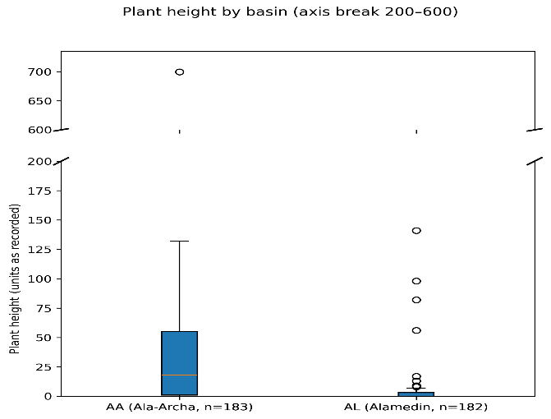
The data was plotted in the RHEM tool giving us quantifed results from our field project.
Figure 1. The two research sites plotted against plant height

The ungrazed Ala-Archa area supports taller and denser vegetation compared to the grazed Alamedin valley. This difference in vegetation cover could influence hydrological processes, as denser vegetation generally promotes greater infiltration and reduces surface runoff, while sparser, grazed areas may have higher runoff and lower infiltration rates.

https://books.google.com.tr/books?hl=tr&lr=&id=le3p-7ld8MwC&oi=fnd&pg=PP1&dq=what+is+%22penetrometer%22+%22tool%22&ots=w0bTYhWbjl&sig=VihCQmDLtFMdjP-A-ASwQLp2av0&redir_esc=y#v=onepage&q=what%20is%20%22penetrometer%22%20%22tool%22%20%22pocket%22&f=false
https://doi.org/10.1111/jfr3.12842
https://doi.org/10.1016/j.limno.2009.11.013
https://doi.org/10.3389/feart.2023.1306476
https://doi.org/10.1007/s11104-023-05894-y
https://ijabe.org/index.php/ijabe/article/view/10
Li, X., Feng, G., Zhao, C., & Shi, F. (2016). Characteristics of soil infiltration in the Tarim River floodplain. Environmental Earth Sciences, 75(9), 782.
McGinty, W. A., Smeins, F. E., & Merrill, L. B. (1979). Influence of soil, vegetation, and grazing management on infiltration rate and sediment production of Edwards Plateau rangeland. Rangeland Ecology & Management/Journal of Range Management Archives, 32(1), 33-37.
Li, P., Sheng, M., Yang, D., & Tang, L. (2019). Evaluating flood regulation ecosystem services under climate, vegetation and reservoir influences. Ecological Indicators, 107, 105642.
Basri, H., Syakur, S., Azmeri, A., & Fatimah, E. (2022). Floods and their problems: Land uses and soil types perspectives. In IOP Conference Series: Earth and Environmental Science (Vol. 951, No. 1, p. 012111). IOP Publishing.
Betson, R. P. (1964). What is watershed runoff?. Journal of Geophysical research, 69(8), 1541-1552.
DOI: 10.1007/s11629-011-2121-8

