Faculty of Information Engineering and Technology
Signals and Systems Theory — COMM 401
Prof. Ahmed El Mahdy
Eng.Reem

Audio Matching Using
Fourier Transform (FFT)

Project Report
Submitted by:
Sama Ismael
ID: 64-19880

1. Python Code

import numpy as np
import matplotlib.pyplot as plt
from scipy.io import wavfile

def read_audio_file(filename):
sampling_rate, audio_signal = wavfile.read(filename)
if audio_signal.ndim > 1:
audio_signal = np.mean(audio_signal, axis=1)
audio_signal = audio_signal.astype(np.float32)
return sampling_rate, audio_signal

def calculate_fourier_magnitude(segment):
segment = segment * np.hamming(len(segment))
fourier_result = np.fft.rfft(segment)
magnitude = np.abs(fourier_result)
return magnitude

def main():
audio_filename = 'quran.wav'
start_time_seconds = 15.0
clip_duration_seconds = 3.0
step_size_seconds = 0.1

sample_rate, full_signal = read_audio_file(audio_filename)
full_time_axis = np.arange(len(full_signal)) / sample_rate

start_index = int(start_time_seconds * sample_rate)
duration_in_samples = int(clip_duration_seconds * sample_rate)
end_index = start_index + duration_in_samples
query_clip = full_signal[start_index:end_index]
clip_time_axis = np.arange(len(query_clip)) / sample_rate

clip_magnitude = calculate_fourier_magnitude(query_clip)
frequency_axis = np.fft.rfftfreq(len(query_clip), 1 / sample_rate)

step_samples = int(step_size_seconds * sample_rate)
window_length = len(query_clip)
similarity_scores = []
time_steps = []
clip_normalization = np.linalg.norm(clip_magnitude)

for current_index in range(0, len(full_signal) - window_length + 1, step_samples):
current_window = full_signal[current_index:current_index + window_length]
window_magnitude = calculate_fourier_magnitude(current_window)
window_normalization = np.linalg.norm(window_magnitude)
if clip_normalization == 0 or window_normalization == 0:
similarity = 0
else:
similarity = np.dot(clip_magnitude, window_magnitude) / \
(clip_normalization * window_normalization)
similarity_scores.append(similarity)
time_steps.append(current_index / sample_rate)

best_index = np.argmax(similarity_scores)
detected_time = time_steps[best_index]
highest_score = similarity_scores[best_index]
detected_sample = int(detected_time * sample_rate)
matched_signal = full_signal[detected_sample:detected_sample + window_length]

print('Sampling frequency:', sample_rate, 'Hz')
print('Detected position:', detected_time, 'seconds')
print('Best similarity score:', highest_score)

if __name__ == '__main__':
main()

2. Results

2.1 Printed Output

Parameter | Value
Sampling Frequency | 44,100 Hz
Length of Full Signal | 891.46 seconds
Clip Length | 3.00 seconds
Original Clip Position | 15.00 seconds
Detected Position | 15.00 seconds
Best Similarity Score | 1.0000

3. Signal Plots
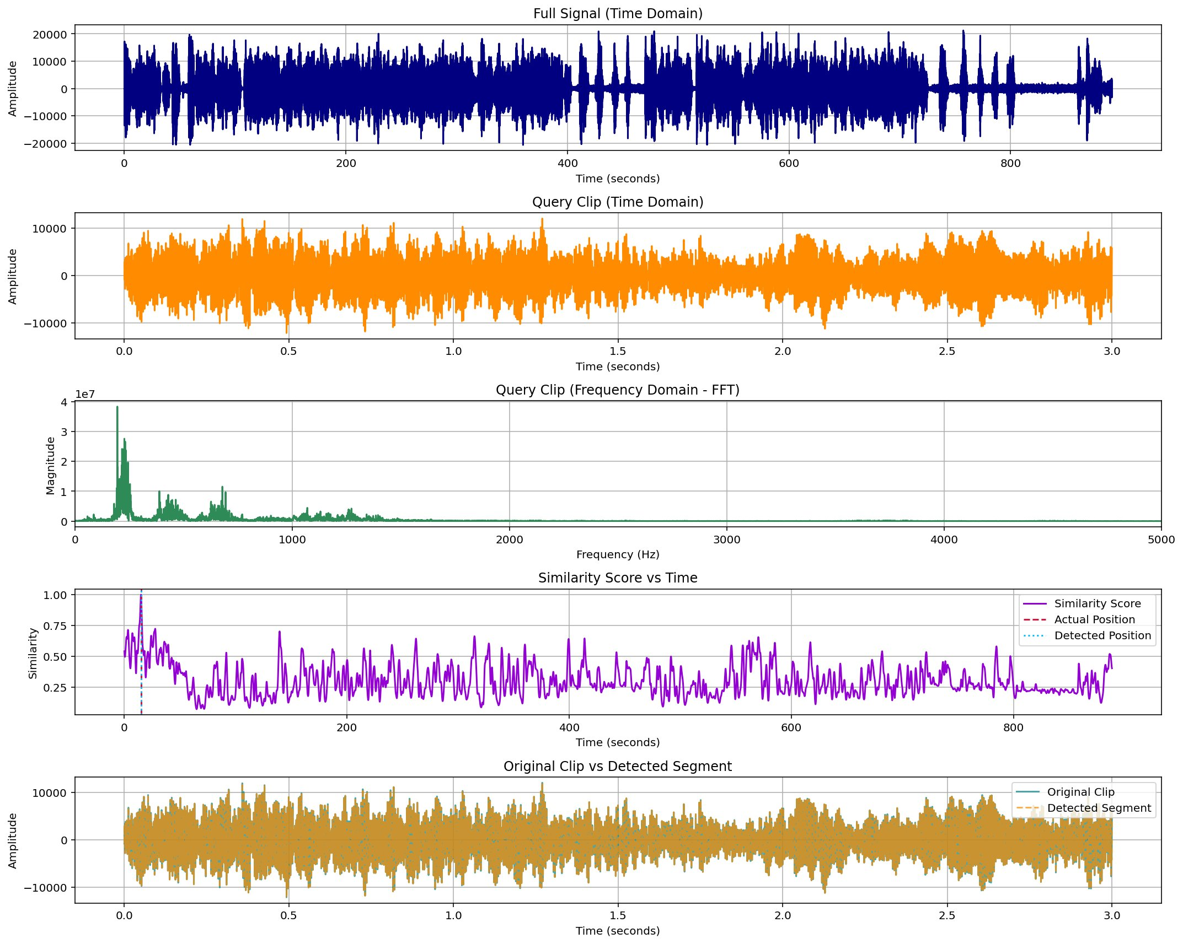
Figure 1 — All Plots (Combined View)

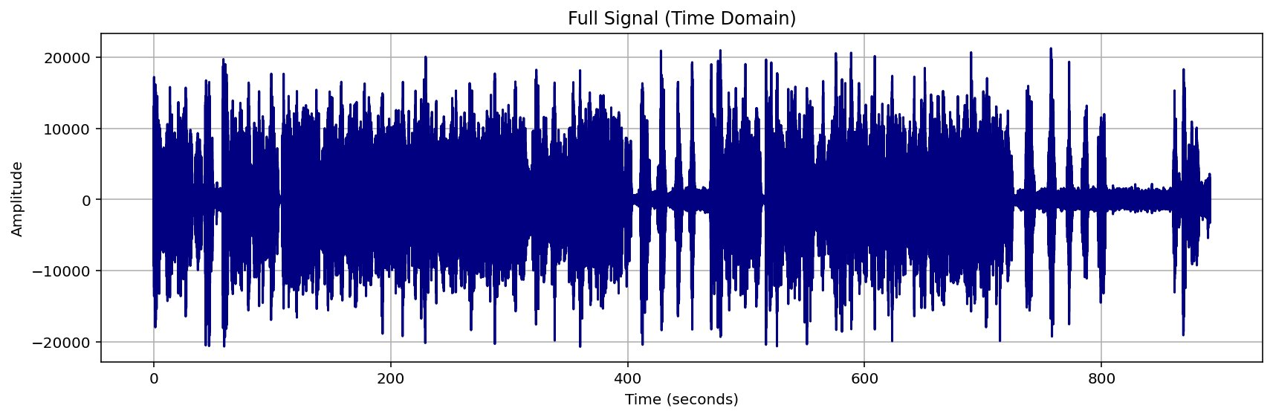
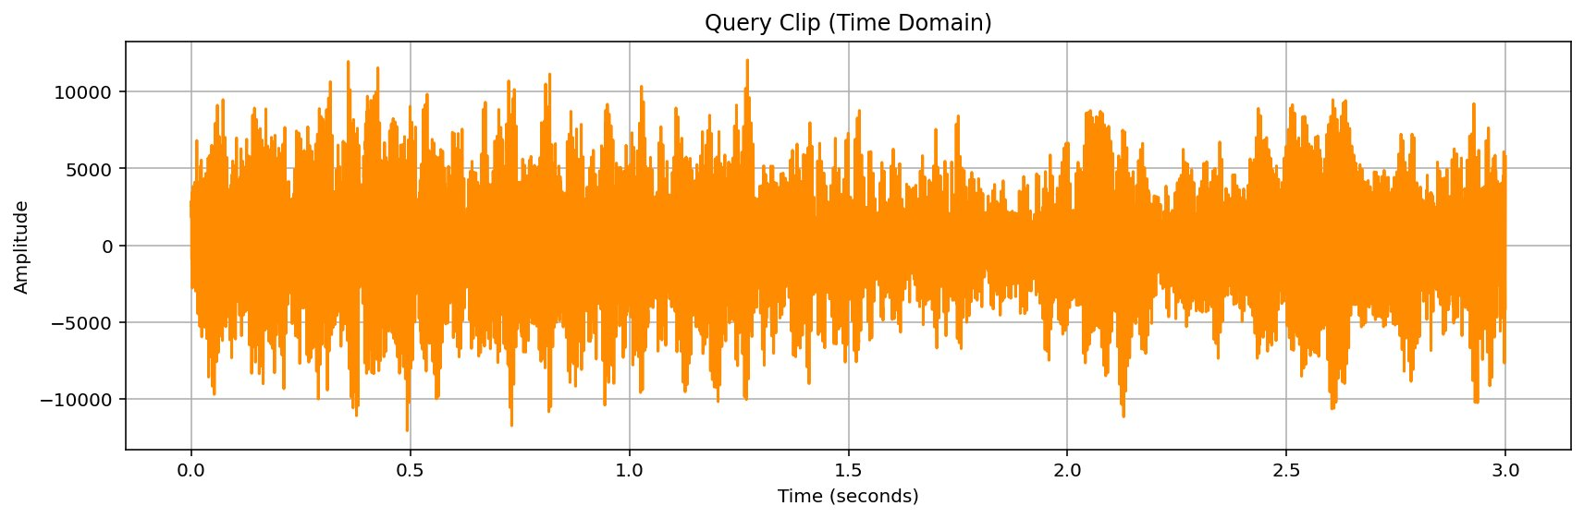
Figure 2 — Full Signal (Time Domain)

Figure 3 — Query Clip (Time Domain)
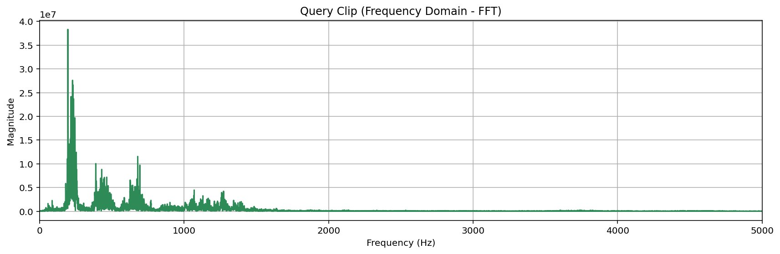
Figure 4 — Query Clip (Frequency Domain — FFT)
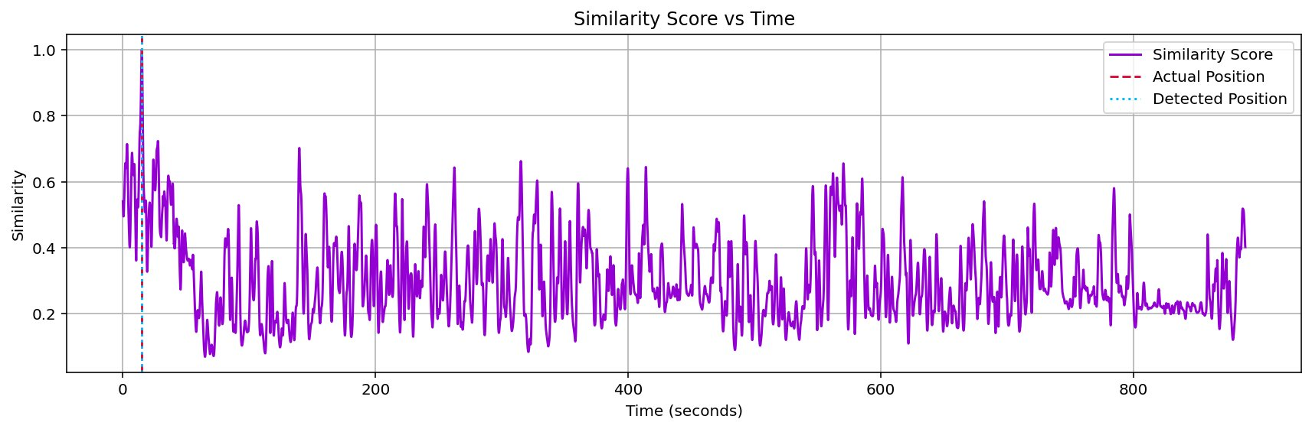
Figure 5 — Similarity Score vs. Time
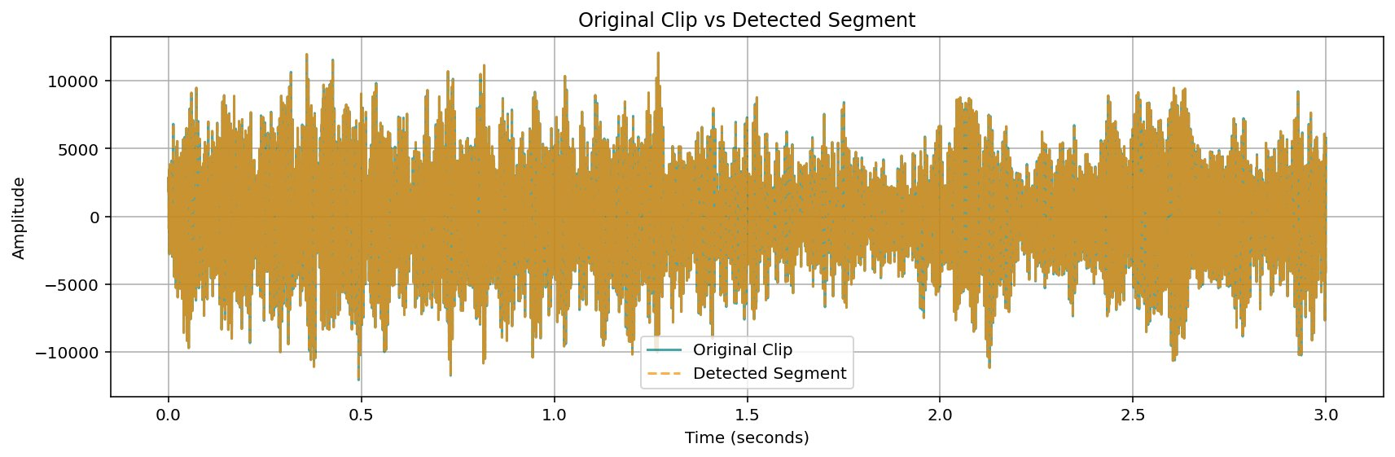
Figure 6 — Original Clip vs. Detected Segment

