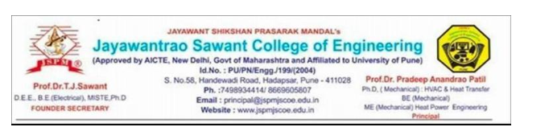
JAYAWANT SHIKSHAN PRASARAK MANDAL'S

Jayawantrao Sawant College of Engineering

T.E. Computer Engineering (2026-27) Computer Network System (CCE Activity–1) A Practical Network Implementation Report

CAMPUS NETWORK DESIGN, SIMULATION, AND TROUBLESHOOTING USING CISCO PACKET TRACER

Prepared By:

Name | Roll No.
Shubhankar Chavan | 3213
Shubham Panaskar | 3256
Aryan Janrao | 3237
Omkar Shewale | 3274

To design, simulate, configure, test, and troubleshoot a campus network using Cisco Packet Tracer.

Objectives
  - Design a small campus network using a router, switches, end devices, a server, and a printer.
  - Connect devices using appropriate Ethernet connections.
  - Configure two separate IP networks and their default gateways.
  - Configure router interfaces and verify their operational status.
  - Test connectivity using the ping command.
  - Demonstrate inter-network communication through the router.
  - Identify and troubleshoot an incorrect default gateway.
  - Save and verify the final network configuration.

Software / Devices Required

Sr. No. | Device / Software | Quantity
1 | Cisco Packet Tracer | 1
2 | Cisco 2911 Router | 1
3 | Cisco 2960 Switch | 2
4 | PC | 4
5 | Server | 1
6 | Printer | 1
7 | Copper Straight-Through Cable | 8

Network Topology
The campus network is divided into two IP networks. The router provides communication between the two networks. Switch0 serve

Router
/ \

G0/0 G0/1
/ \

Switch0 Switch1
/ | \ / | \

PC0 PC1 Server PC2 PC3 Printer

Device | Interface | IP Address | Subnet Mask | Default Gateway
Router | G0/0 | 192.168.10.1 | 255.255.255.0 | —
Router | G0/1 | 192.168.20.1 | 255.255.255.0 | —
PC0 | FastEthernet0 | 192.168.10.2 | 255.255.255.0 | 192.168.10.1
PC1 | FastEthernet0 | 192.168.10.3 | 255.255.255.0 | 192.168.10.1
Server | FastEthernet0 | 192.168.10.10 | 255.255.255.0 | 192.168.10.1
PC2 | FastEthernet0 | 192.168.20.2 | 255.255.255.0 | 192.168.20.1
PC3 | FastEthernet0 | 192.168.20.3 | 255.255.255.0 | 192.168.20.1
Printer | FastEthernet0 | 192.168.20.10 | 255.255.255.0 | Not available on selected printer model

Device Connections

Sr. No. | Device / Port | Connected To
1 | Router G0/0 | Switch0 Fa0/1
2 | Router G0/1 | Switch1 Fa0/1
3 | PC0 Fa0 | Switch0 Fa0/2
4 | PC1 Fa0 | Switch0 Fa0/3
5 | Server Fa0 | Switch0 Fa0/4
6 | PC2 Fa0 | Switch1 Fa0/2
7 | PC3 Fa0 | Switch1 Fa0/3
8 | Printer Fa0 | Switch1 Fa0/4

Step-by-Step Implementation

Create the topology
Added one Cisco 2911 router, two Cisco 2960 switches, four PCs, one server, and one printer.

Connect devices
Used Copper Straight-Through cables for the router-switch and end-device-switch connections.

Configure Router G0/0
Assigned 192.168.10.1/24 to G0/0 and enabled the interface.

Configure Router G0/1
Assigned 192.168.20.1/24 to G0/1 and enabled the interface.

Configure end devices
Assigned the IP addresses, subnet masks, and default gateways shown in the addressing table.

Verify interfaces
Used show ip interface brief to confirm both router interfaces were up/up.

Verify configuration
Used show running-config to inspect the saved interface configuration.

Test connectivity
Used ping to verify same-network and inter-network communication.

Router Configuration Commands
enable
configure terminal
interface gigabitEthernet0/0
ip address 192.168.10.1 255.255.255.0
no shutdown exit
interface gigabitEthernet0/1
ip address 192.168.20.1 255.255.255.0
no shutdown exit
end write

Verification and Testing

The following tests were performed during the implementation:

Test | Source → Destination | Observed Result | Status
PC0 → PC1 | 192.168.10.2 → 192.168.10.3 | 4 packets received, 0% loss | Successful
PC0 → Server | 192.168.10.2 → 192.168.10.10 | 4 packets received, 0% loss | Successful
PC0 → PC2 | 192.168.10.2 → 192.168.20.2 | 3 replies after first ARP-related timeout | Successful
PC2 → Printer | 192.168.20.2 → 192.168.20.10 | 4 packets received, 0% loss | Successful

8.1.Verification Command
show ip interface brief

Expected final state:
GigabitEthernet0/0 192.168.10.1 up up GigabitEthernet0/1 192.168.20.1 up up

A deliberate default-gateway error was introduced on PC2 to demonstrate troubleshooting.

Item | Details
Problem introduced | PC2 default gateway changed from 192.168.20.1 to 192.168.20.100.
Test performed | ping 192.168.10.2 from PC2.
Observed result | Request timed out.
Cause | PC2 had an incorrect default gateway, so it could not correctly forwar d traffic to the other network.
Solution | Changed the default gateway back to 192.168.20.1.
Verification | The same ping then returned replies, confirming that communication was restored.

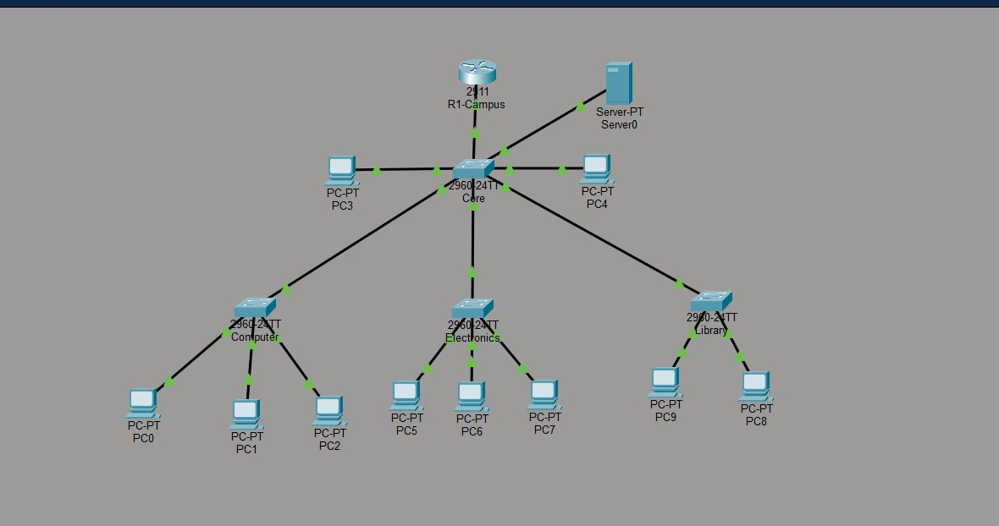

Figure 2: Router running configuration
The reference report records the router configuration with GigabitEthernet0/0 configured as 192.168.10.1/24 and GigabitEthernet0/

interface GigabitEthernet0/0
ip address 192.168.10.1 255.255.255.0
duplex auto speed auto

interface GigabitEthernet0/1
ip address 192.168.20.1 255.255.255.0
duplex auto speed auto
Additional evidence: PC0 connectivity tests, PC2-to-printer ping showing 4/4 replies, and the intentional wrong-gateway troubleshoo

Result
The campus network was successfully implemented in Cisco Packet Tracer. Both router interfaces were verified as up/up, devices

Conclusion
The campus network was successfully designed, simulated, configured, tested, and troubleshooted using Cisco Packet Tracer. The

The report retains the structure and contents of the supplied reference PDF, with the student group updated as requested.

No. | Section
1 | 1. Aim
2 | 2. Objectives
3 | 3. Software / Devices Required
4 | 4. Network Topology
5 | 5. IP Addressing Scheme
6 | 6. Device Connections
7 | 7. Step-by-Step Implementation
8 | 7.1 Create the topology
9 | 7.2 Connect devices
10 | 7.3 Configure Router G0/0
11 | 7.4 Configure Router G0/1
12 | 7.5 Configure end devices
13 | 7.6 Verify interfaces
14 | 7.7 Verify configuration
15 | 7.8 Test connectivity
16 | 7.9 Router Configuration Commands
17 | 8. Verification and Testing
18 | 8.1 Verification Command
19 | 9. Troubleshooting Demonstration
20 | 10. Evidence / Screenshots
21 | 11. Result
22 | 12. Conclusion
Student Group: Shubhankar Chavan (3213), Shubham Panaskar (3256), Aryan Janrao (3237), Omkar Shewale (3274).

