1. The mean degrees of the facebook edge csv is 36.05243. This means that each Source in the list has a mean of 36 connections. Here is a histogram showing the distribution of the number of connections for each source.

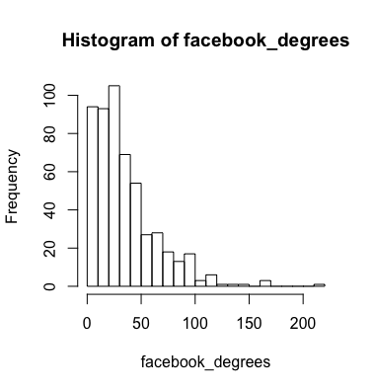

1. After comparing our Facebook degrees to a thousand random Poisson distributions we see that the cluster of our ks test values are

|  |  |  |  |  |  |  |  |
| --- | --- | --- | --- | --- | --- | --- | --- |
| Ks_value | .015 | .02 | .025 | .030 | .035 | .04 | Total |
| Counts | 108 | 176 | 185 | 165 | 111 | 111 | 856 |

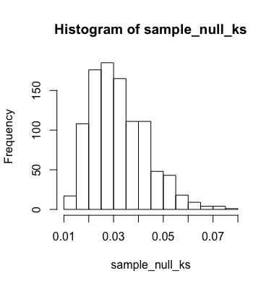

We reject the null hypothesis that this is a Poisson distribution and can conclude this does not align with a Poisson distribution. 85.6% of the KS values are between .015 and .04 and none of the values are close to 1.

When we run the power fit law test we see that the KS.p value is .94643376 and the ks.stat is .086176. Both of these values indicate that this would be a poor fit for a power law distribution as well. If you look at a histogram of the degrees at few break points it could give the illusion of being a good fit for a power law but if the more you break out the histogram the easier it is to see that it’s not a good distribution fit.