I went looking for 3 takeaways from the jitteredHeadCount data set. 1: I wanted to see when a player is most likely to find other players to play with and with what game. 2: I also wanted to see what a player should play if they did not want to see any other players. 3: Lastly I looked at what games spent the most time employing staff for empty tables.

1: There was a clear winner in the game code that had the most players playing it. S6 Outpaced everything with mean head count of 1994.6250 each hour. That is significantly higher than the second-place game code of ‘CR’. I set out thinking about what the best time and game is to play with other people but the top 5 games looked like they all had players at it for every single hour each week on average. Looks like someone arriving at any time of day could play with other people for the top 5 game codes of S6, C4, RO, SH and TP.

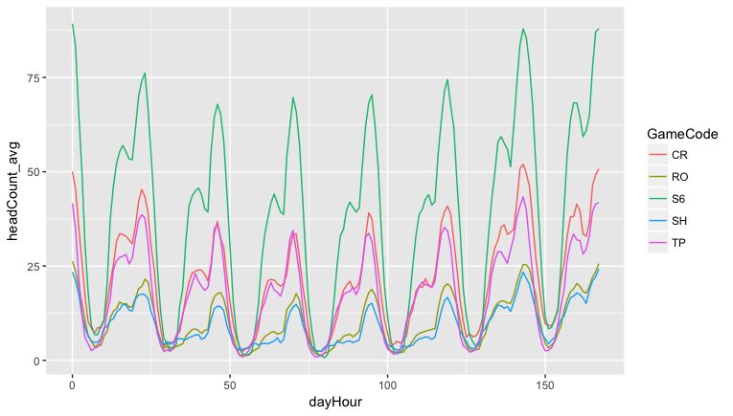

2: Figuring out how to play alone as a player was a little bit trickier. We had to have an open table but we also had to make sure that table was usually both empty and available. This means that on average there needed to be at least 1 open table and ideally probably more. This also meant that we didn’t want the player to have fewer than 1 table open on average, this would mean they would have to play with someone else or that there wasn’t even a game available.

What I ended up wanting to know was which game and at which hour was a player most likely to find at least 1 open table.   
  
Looks like Day 7 to 1 (can’t remember if this is Saturday or Sunday) at 22-23-1 hours of the day consistently had the most OPEN available tables. What is interesting about this is that these seem like high traffic times but it also looks like it makes it easiest to find a table with nobody at it.

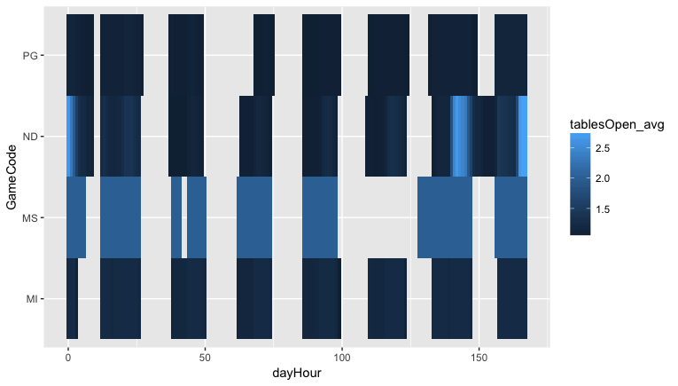

3: Finding out which table had the most hours of open tables turned out to be straightforward. You just need to sum the open tables for each hour of the games existence. After looking at the data I wasn’t satisfied that I was properly answering the question. I decided to look at what games had the most open table time as a ratio of the total time tables were held open. While on a net level this wouldn’t really tell me what was costing the most money it would let me know what game was least effective at filling the tables they did open. This data is obviously independent of the expected rake from the casino and is just looking at pure table times.

|  |  |  |  |  |  |
| --- | --- | --- | --- | --- | --- |
| **Rank** | **GameCode** | **openTables** | **occupiedTables** | **openTableTime** | **ratio** |
| **1** | BA | 73 | 18 | 55 | 0.75342466 |
| **2** | MQ | 3589 | 1035 | 2554 | 0.71161884 |
| **3** | ND | 8833 | 3188 | 5645 | 0.63908072 |
| **4** | PG | 8729 | 4366 | 4363 | 0.49982816 |
| **5** | PA | 1572 | 1101 | 471 | 0.29961832 |
| **6** | MR | 14992 | 10719 | 4273 | 0.28501868 |

Looks like BA and MQ are bad at filling tables with ratios of .75 hours of open unused tables per open table and .71 hours of open unused tables per open table. What is interesting is that MQ has much more up time and thus must be a type of game that easily makes money.