Title: Chicago Data LM

Script By: Sam Robinson

Question 1:

Analysis of Crude LM Equation

Crude LM equation: x = 1.11072534722201 y + 1.62186823446606

Slope Interpretation: For an increase in 1 crude value of hospitalizations we expect the admission rate to increase by 1.11072534722201 . We predict at 0 hospitalizations that the admission rate will be, 1.62186823446606 .

Comments: The equation does not make sense for real world analysis. When there are no hospitalizations we can't have a rate of hospitalizations. This is acceptable in understand that coefficient of the model.

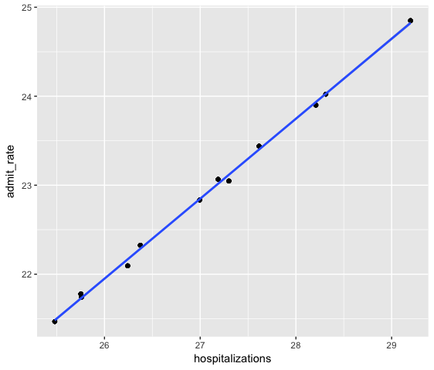

Analysis of Diff LM Equation

Diff LM equation: x = 1.0933676417376 y + 0.00116878592958968

Slope Interpretation: For an increase in 1 value of differences in hospitalizations we expect the admission rate to increase by 1.0933676417376 . We predict at no change in hospitalizations the admission rate will change by, 0.00116878592958968 .

Comments: We can see that when the difference in hospitalizations remains constant that our model does not predict a change in the rate of hospitalizations. It is encouraging seeing that with no rate change we can expect a stable rate of admission.

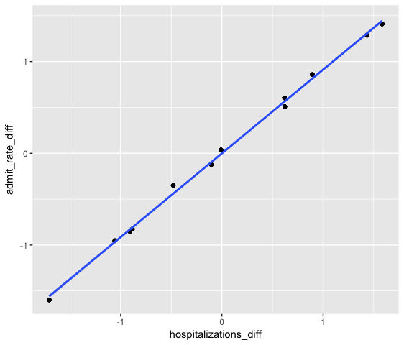

Question 2:

With our crude lm SSR value equaling 0.998275236965497 and our difference lm SSR value equaling 0.997966252260164 we can say that both models are close to equally good at predicting expected admission rates in hospitals. This is reinforced by equally low p-values for both models.