LeBron James Fan Page
My page about LeBron James

About LeBron
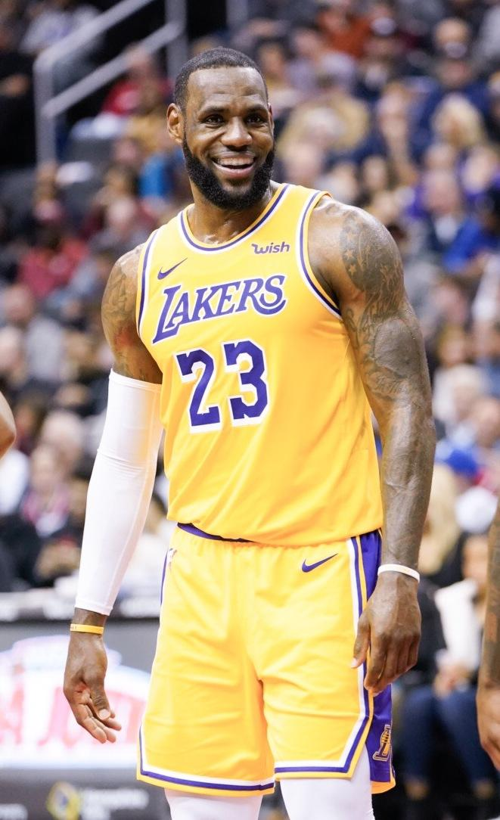LeBron James is a basketball player for the Los Angeles Lakers. He is known for scoring points and passing to his teammates.
He started playing in the NBA in 2003. He has played for the Cavaliers, the Miami Heat, and the Lakers.

His Career
LeBron has won NBA championships and has been an All-Star many times. He also won gold medals playing for Team USA.

Quick Facts
- Full name: LeBron Raymone James
- Birthday: December 30, 1984
- Position: Forward
- Team: Los Angeles Lakers
Made by a LeBron fan.
Photo credit: All-Pro Reels, Wikimedia Commons, CC BY-SA 2.0.

