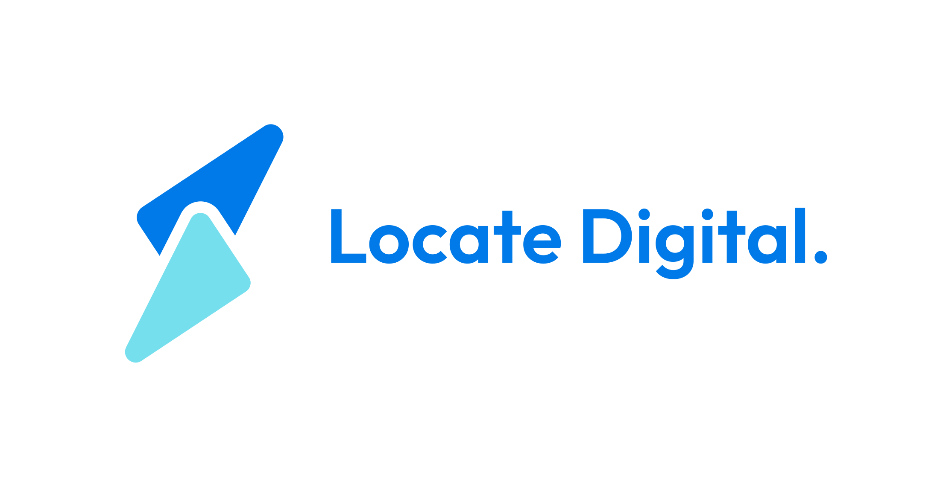 | We don't just market — we locate growth.

Client access guide
For new clients — how to grant us access to your accounts

This guide covers exactly how to give Locate Digital access to your accounts. Each section has step-by-step instructions written for someone who doesn't live in these platforms every day.
If you get stuck on any step, send a screenshot to sam@locatedigital.io and we'll sort it out.
The email to add for all platforms is: sam@locatedigital.io

What we need access to
Depending on what we're working on together, we'll need some or all of the following:
- Meta (Facebook and Instagram ads)
- Google Ads — paid search campaigns
- Google Analytics — website traffic data
- Google Business Profile — your Google Maps listing
- Your CRM or booking system — appointment and patient data (if applicable)
You don't need to do all of these at once. We'll tell you which ones apply to your engagement.

Meta
The central hub for your Facebook page, Instagram account, ad account, and pixel.
Note: If your business doesn't have a Meta Business Manager account yet, go to business.facebook.com and create one before following the steps below. It takes about 5 minutes.
Add us to your Business Manager
- Go to business.facebook.com
- Click Settings (gear icon, left sidebar)
- Under Users, click People
- Click Add people
- Enter sam@locatedigital.io
- Set role to Admin
- Click Next, then assign access to your Ad Account, Facebook Page, and Instagram Account
- Click Invite
Give us access to your Pixel (if one exists)
- In Business Manager, go to Settings → Data sources → Pixels
- Click on your pixel
- Click Add people, enter sam@locatedigital.io, set to Admin, click Save
If you don't have a pixel yet, don't worry — we'll create one and install it.

Google Ads
There are two ways to do this. Option A is preferred — it keeps your account under your ownership and lets us manage it from our end without needing your login.
Option A — Link to our manager account (preferred)
- Go to ads.google.com
- Sign in to your Google Ads account
- Click the tools icon (wrench) in the top-right corner
- Under Setup, click Access and security
- Click the Managers tab
- Click + to send a link request — we'll send you our manager account ID and you enter it here
- Click Send request
We'll accept from our end within 24 hours.
Option B — Add as a user directly
- Go to ads.google.com and sign in
- Click the tools icon (wrench) → Access and security
- Click the Users tab, then the + button
- Enter sam@locatedigital.io
- Set access level to Admin
- Click Send invitation

Google Analytics
Tracks who visits your website, where they come from, and what they do.
- Go to analytics.google.com
- Sign in with the Google account that owns the property
- Click the gear icon (Admin) in the bottom-left corner
- Under the Property column, click Property access management
- Click the blue + button in the top-right corner, then Add users
- Enter sam@locatedigital.io
- Under Role, select Editor
- Click Add

Google Business Profile
Your listing on Google Maps and Google Search — the panel that shows your address, hours, phone number, and reviews.
- Go to business.google.com
- Sign in and select your business
- Click Menu (three lines, top-left) → Business Profile settings
- Click Managers
- Click the Add button (person icon with a +)
- Enter sam@locatedigital.io
- Set role to Manager
- Click Invite

CRM or booking system (if applicable)
This only applies if we're pulling appointment or patient data for reporting. We'll let you know if this is relevant to your engagement.
Steps vary depending on what you use. Send us a note on your system and we'll send specific instructions for it.

How long does this take?
Most people get through all platforms in 20–30 minutes. The steps look long written out but each one is just a few clicks.
The only thing that can slow it down is if someone else controls the account — an old agency, a web developer, or an IT contact. If that's the case, let us know and we can help you chase the right person.

Questions?
Email sam@locatedigital.io or reply to your onboarding thread. We check daily.

