Design

Low Level

The detailed design diagrams and documents show the inner-workings of the project. They show exactly how each component interacts with one another. This provides those who are coding a far simpler job, as the ideas are already in place via these plans, so it is their jobs to only implement these ideas, and to put them into practice.

Ant Methods Sequence Diagrams

Here are the diagrams for the methods for the ant, and how they function in the game.

Ant Drop - Sequence Diagram

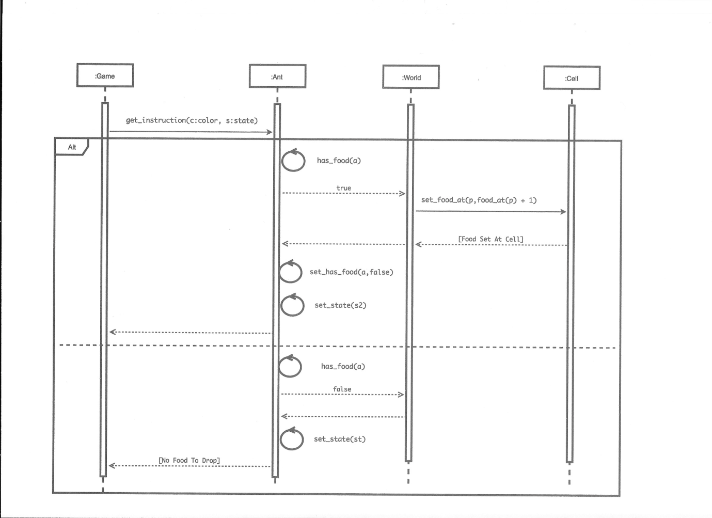

Ant Flip - Sequence Diagram

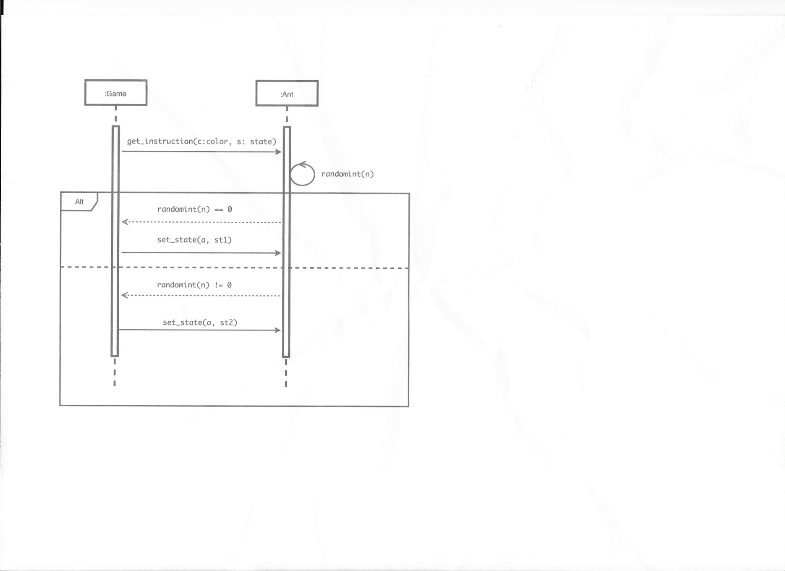

Ant Mark - Sequence Diagram

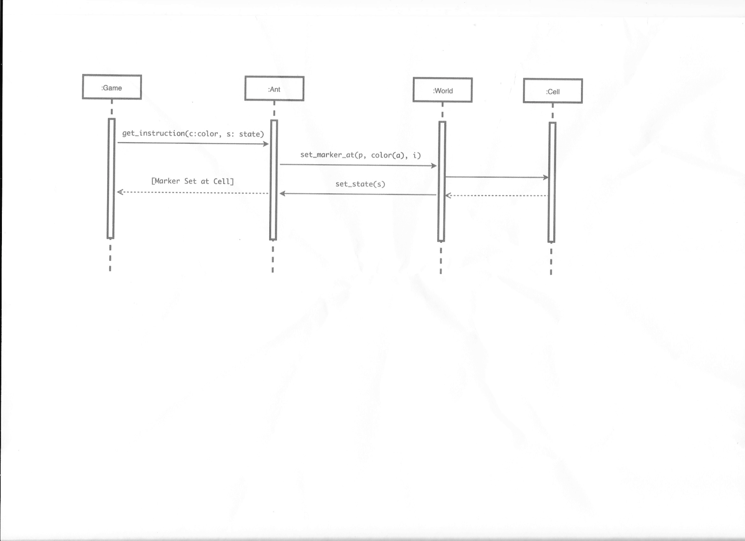

Ant Move - Sequence Diagram

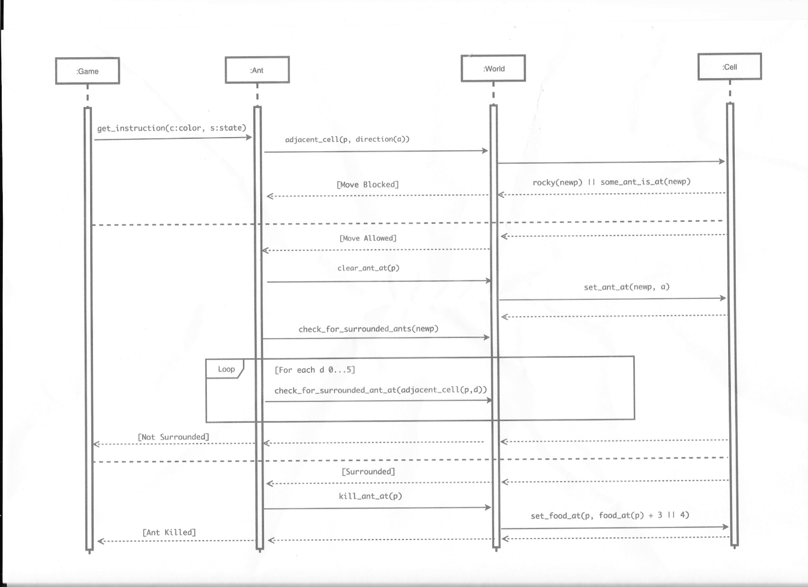

Ant Pickup - Sequence Diagram

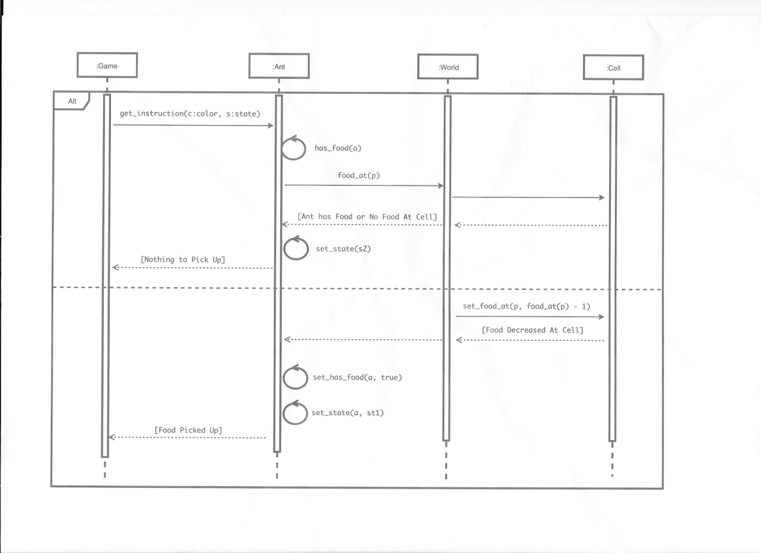

Ant Sense - Sequence Diagram

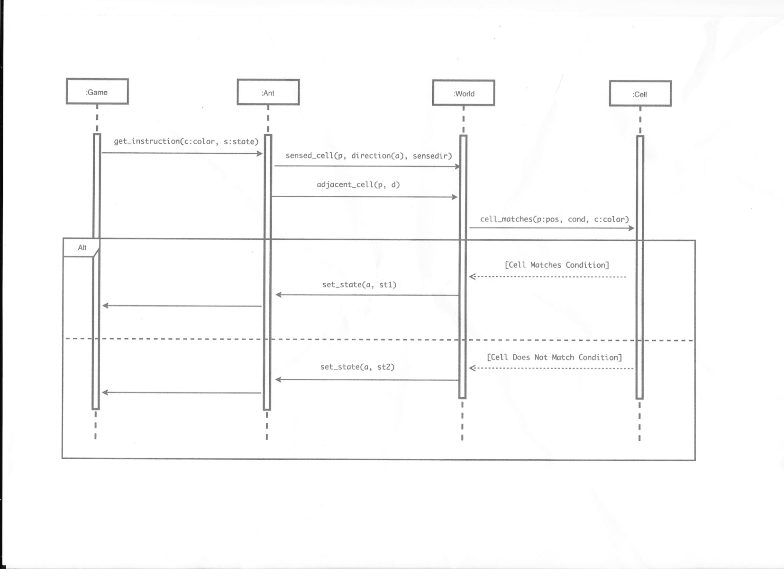

Ant Turn - Sequence Diagram

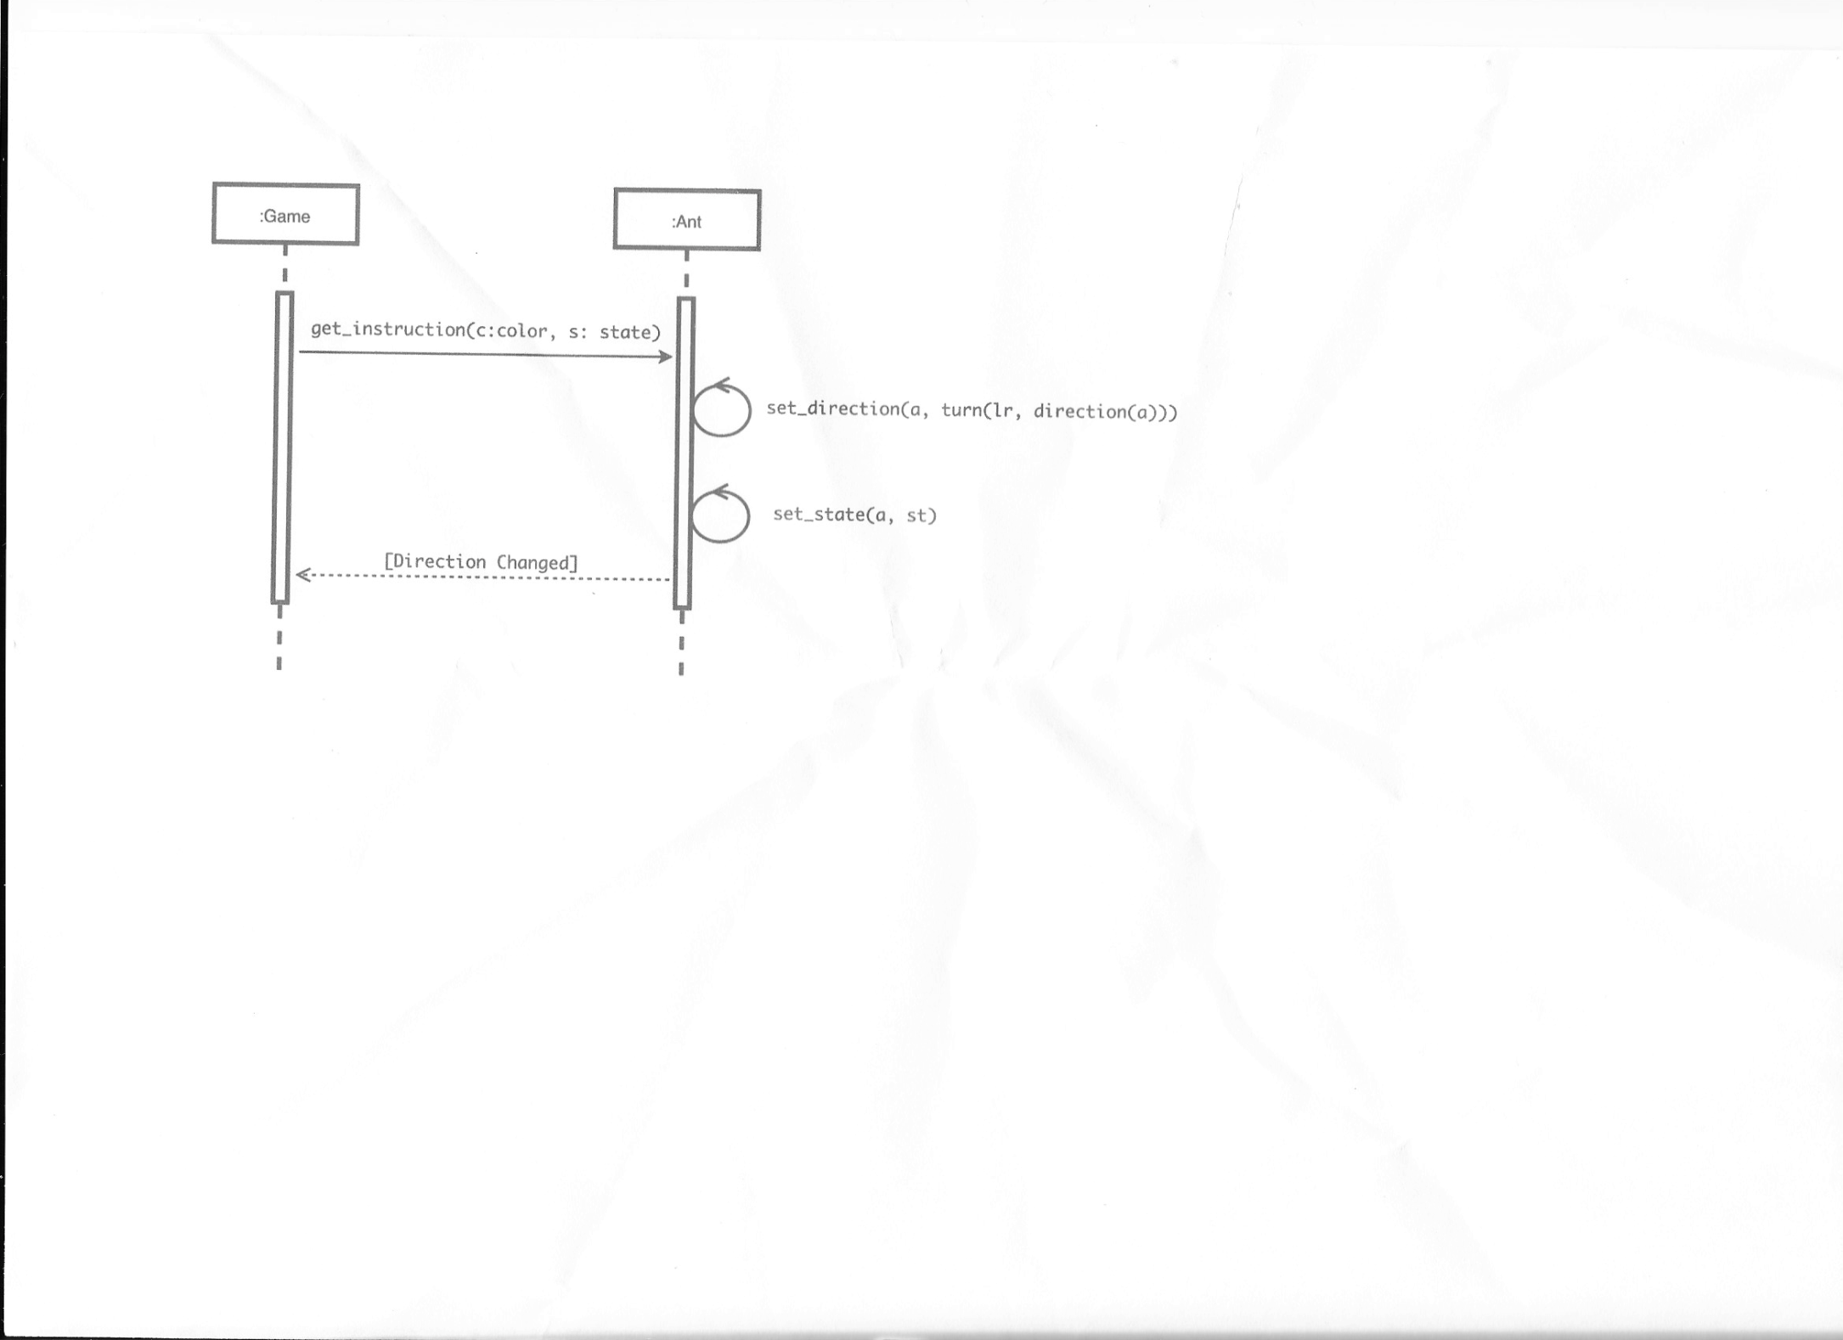

Ant Unmark - Sequence Diagram

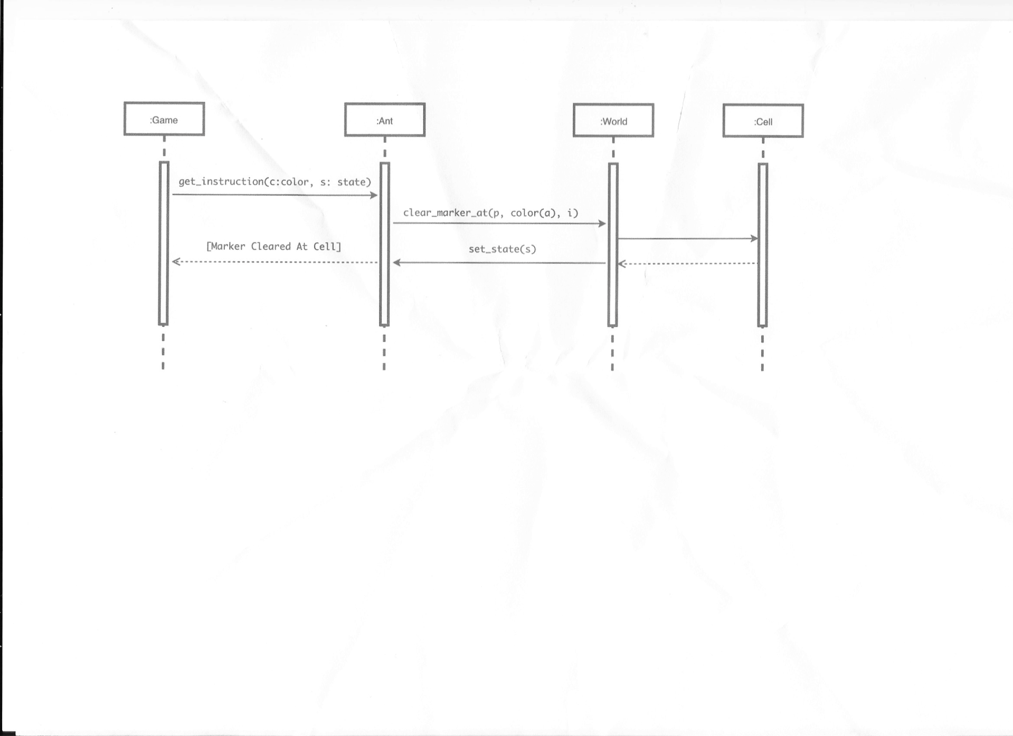

World Sequence Diagrams

Here is the diagram for the world execute function.

World Execute Instruction - Sequence Diagram

