|  |  |
| --- | --- |
| samwel natal njiku |  |
| P.O Box 3918 DAR ES SALAAM |  | |
| +255 767 952 016 ▪ natalsamuel23@gmail.com ▪ |  | |

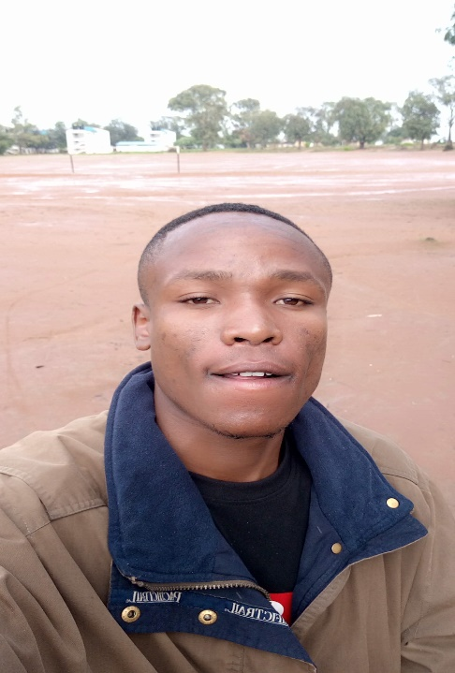Introduction

My name is Samuel, a software developer specifically in web and mobile application.

Most of my skills approximately 75% of my professional I have acquired through individual efforts with the help of online resources such as <youtube.com>, <stackoverflow.com>, <w3schools.com> etc. The remaining percent is contributed by university studies am taking right now.

I’m very curious with how ICT can do much in our life, which makes me more passionate to be a good software developer who utilizes ICT for the better of human life.

Currently, am taking bachelor of science in Information technology at Institute of Finance Management, Dar Es Salaam, Tanzania.

**Name:** Samuel Natal Njiku

**Born:** 9 Feb 1997

**Citizenship:** Tanzanian

**Education:** Bachelor of science in Information Technology, IFM.

**Skills:** Bootstrap, jQuery, JavaScript, java, PHP, Laravel, react.js, node.js, express, kotlin.

Experience

My experience is based on various individual projects I have gone through as a means of applying the programming knowledge and skills I have acquired. Below is a list of projects I have made:

* Social Like Forum web application with HTML, CSS, Bootstrap, jQuery, JavaScript, PHP and MySQL.

Features:

* Forum participants can register and login to the forum account.
* Participant can update and delete the account.
* Participant is able to post the article visible to other members of the forum.
* Participant can follow and unfollow, send message, liking to post, commenting to posts and viewing profile for each other.
* Participant can create, update or delete the post created.
* Full E-Commerce web application with HTML, CSS, Bootstrap, JavaScript, React.js, Laravel and MySQL.

Features:

* Customer can view product’s name, price and description.
* Customer can search items and filter them by category, price, size, and time
* Interactive shopping cart with increasing and decreasing item’s quantity, deleting cart’s items as well as purchasing items available on the cart.
* Adding items to the wish list for later purchase.
* Making transactions made possible with PayPal integration.
* Customer can view order’s status, transactions and his personal information such as credit cards, location address etc.
* Admin panel for managing all the application’s data.
* Movie theatre web application with HTML, CSS, Bootstrap, JavaScript, Laravel and MySQL.

Features:

* Customer can view, search and filter movies by their genre, schedule, theatre location etc.
* Customer can view movie’s trailer and synopsis and rates.
* Customer can book a seat/s by selecting them based on their location in the theatre and availability.
* Customer can pay for the seat/s online through PayPal.
* Admin panel for managing all the application’s data.
* Financial android mobile application built with Kotlin.

Features:

* Allow user to register and start his/her group for contributions and loans.
* Allow user to view his/her groups as well as requesting and join new groups based on location.
* It provides member a wallet that accept contribution as well as providing loans based on specified rules by group members.
* Allow group members to conduct online meetings through charting, audio or video calls.
* Allow user to view all ongoing activities of the group such as contributions made, loans provided, group members profiles, rules and principles of the group etc.
* Allow user to specify leadership structure as well as their privileges on the group.

Skills

1. Full stack web developer.

* Front-end: Technologies I’m skilled at are html, CSS, JavaScript, jQuery library, bootstrap framework and react framework.
* Back-end: PHP, java, laravel framework, node.js, and express.
* Database: MySQL, PostgreSQL and MongoDB.

1. Mobile application development: With java and Kotlin.
2. UI & UX Analyst: Designing and analyzing user interfaces and user experience for software applications.
3. Good at writing English but moderate in speaking.

Education

Certificate of primary education examination (CPEE)

2003 - 2010 ▪ At St. William Seminary, Diagwa, Singida.

Certificate of secondary education examination (CSEE)

2010 - 2014 ▪ At St. Patrick Seminary, Dung’unyi, Singida.

Advanced certificate of secondary education examination (ACSEE)

2015 - 2017 ▪ At Pugu Secondary School, Dar es Salaam.

Strength

* Ability to focus on a given task activity.
* Easy and quickly at learning and adapting new things.
* Tolerance working at challenging environments.
* Creativity