**Documentation:**

1. <https://www.youtube.com/watch?v=s4BjoJKJBe4&feature=youtu.be>

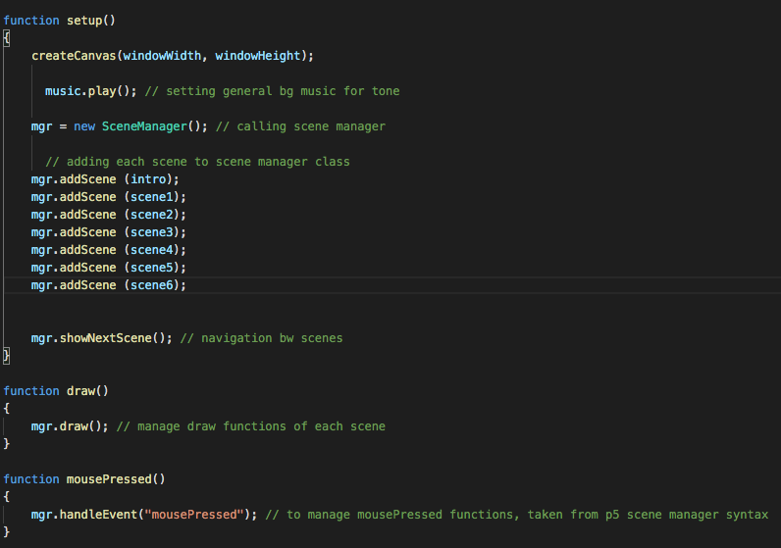

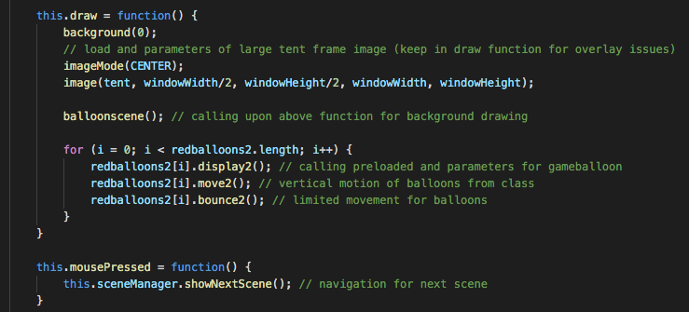

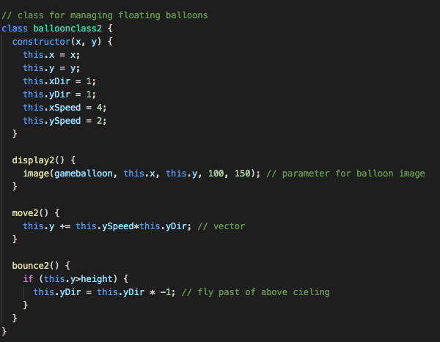

1. My final project is an interactive narration based on a short story by Ursula le Guin, and it tells the story as it is through visuals and abstract concept pieces. The name of the piece is The Ones Who Walked Away from Omelas, and is interactive, but not time-based. The full short story is up on my github.