**Digging In on Data:** Identifying At-risk Restaurants Using NYC DOHMH Data

*By: SB, Ted Stetzel, AS, CT   
STAT9660:Final Project, Baruch College*

# I. Executive Summary

The restaurant business represents a large portion of the New York City economy as both the city’s 8.5 million residents and the 47 million tourists who visit the city each year frequent the city’s +22,000 restaurants. The objective of this study is to help the DOHMH take a more proactive approach to restraint inspections by creating a predictive model that utilizes available data to identify at-risk restaurants that the agency can work with to prevent future complaints and closures. The potential benefits of this model include reduction of incident reporting to the DOHMH, increased tax revenue due to closure prevention, greater diversification of restaurants in New York City and a reduction in the DOHMH’s operating budget.

Targeting each restaurant’s previous score, various models including a Decision Tree, Regression Tree, PCA and Liner Regression models were created. All these models are used to analyze the dataset, help to interpret each factor. In conclusion it was determined that a regression based built using stepwise selection using a combination of Principle Component Variables to describe variability in the numerous violation types and other non-PCA variables was the best prediction model.

# II. Introduction

Dining out is a significant part of most people’s lives whether it is a special occasion or it is a daily occurrence. Depending on the restaurant, you may or may not be able to see how the food is prepared and have to go on good faith that the restaurant is preparing your food in a safe and sanitary way. Despite a large amount of trust being put into the people who prepare food and other preventative measures that have been put in place, problems still arise. Going out to eat and finding something unexpected in your food or getting sick afterwards can be an uncomfortable experience. Unsanitary conditions of restaurants can also cost city governments in terms of lost revenue from sales taxes, payroll taxes, and other tourism dollars.

This is especially important in New York City where dining out is big business. New Yorkers have the highest average spend for diner[1] and over 47 million tourist visit the city every year[2] so it should come as no surprise the city has a very rigorous restraint inspection system to protect its residents and visitors. Since 2010 the DOHMH has been assigning grades to the approximately 24,000 restaurants across all five boroughs. An A is top rating; this would require a restaurant to have 13 or less violation points. If a restaurant was cited with 14-27 violation points they would be rated a B, and if a restaurant has more than 28 violation points they would earn a C. If a severe instances it may be necessary for the DOHMH to shut down a restaurant if the violations are severe enough assuming they can’t be quickly remedied in time for reasonable reopening. If you’ve ever walked around NYC, you’ll likely notice restaurant will have their posting near the front door showing their latest score, which restaurants are required to post their score within feet of their main entrance as per the department of health guidelines. By design, the posting guideline keeps all restaurant owners honest and accountable of their inspection since some dimers would likely be hesitant to dine anywhere did not receive an A.

# III. Methodology

Given that the New York City Department of Health and Mental Hygiene (DOHMH) has a small portion of its staff of 6,000 dedicated to restaurant inspections, the agency has to take a reactive stance and rely heavily on complaints from residents to be alerted to violations of the sanitary code.[3] Unfortunately by the time a complaint is filed, a resident may already have become ill or injured as a result of their experience.

While this grading system encourage restaurants to meet the DOHMH’s requirements they can have a negative impact such lost tax revenue for the city or having property sit idle because a restaurant has been shut down a business for reasons that could have been prevented. Our study seeks to create a model that will help the DOHMH identify at-risk restaurants in order to provide these restaurants with extra assistance in order to prevent them from failing or scoring low in an inspection. The questions our study seeks to answer are:

* Are there a few benchmark violations that cause most restaurants to fail?
* Is location or cuisine type indicative of a passing or failing score?
* Does the average income of your patronage affect your likelihood to pass?

# IV. Data Preparation

The majority of the data was collected from NYC Open Data website. The New York Department of Health and Mental Hygiene (DOHMH) has made available a regularly updated list of New York City restaurant inspection results since the restaurant grading program started in July 2010. The data set is organized by events (such as inspections, re-openings and violations) so instead of being organized by restaurant, each of these +500,000 events is represented a row in the dataset. Since our study seeks to predict grades on a per restaurant basis, the data needed to be reorganized so that each row represents a restaurant and violations are tracked as separate columns associated with the restaurant in that row. To achieve this configuration we imported the event based data set in the form of a CSV file from NYC OpenData into Microsoft excel and created a pivot table.

Once the data was in a pivot table, it was first organized so that each restaurant unique ID (CAMIS) was a row and new columns were created for each of the violation types (a full list of all violations are provided in Appendix 1). Our group also wanted to investigate the effect that population and average income might have on restaurant grades. To do so we imported data made available by the University of Michigan’s Population Studies Center that listed the median household income between the years 2006-2010 for every U.S. zip code

# V. Data Exploration

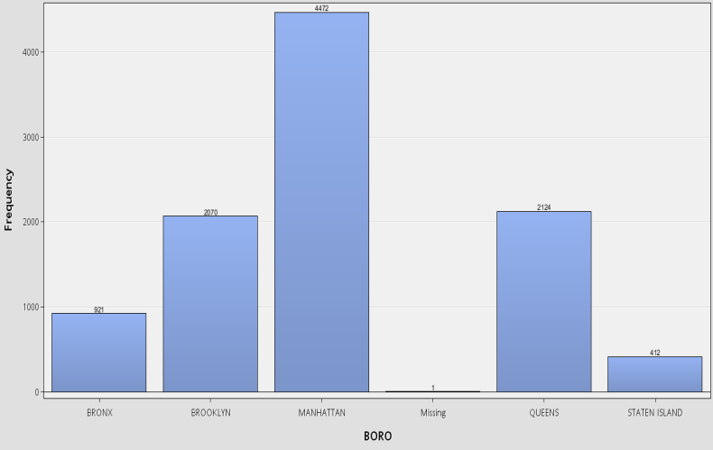Before building any models to find out which variables contribute the most to restaurant scores, an examination of the data was performed using SAS Enterprise Miner. First, the location of each restaurant was examined on a per- borough basis. Not surprisingly we found that the majority of points in our dataset are located in Manhattan followed by Queens and Brooklyn. This is expected since being the commercial hub of New York City, Manhattan has the highest concentration of restaurants. As for the cuisine description majority of the restaurants were classified themselves as American Restaurant followed by Chinese and Pizza. It would be interesting to explore the idea of how a cuisine type determines the food grade since factors such as ingredients and preparation procedures differ by cuisine.

Figure : Distribution of Restaurants in NYC by Borough

An inspection of previously assigned grade shows that the majority of the restaurants in the received a grade of A. This imbalance means that we may have to sample from the population of restaurants in order to have a more equal balance with our target, at-risk restaurants.

Delving into the variables which have the greatest impact on predicting our target variable we see that the four most important variables in order of importance are as follows*:*

* Last Inspection Date,
* Variable 08_A (Facility not vermin proof)
* Variable 02_G (Cold item held above 41º F)
* Number of Inspections, Variable 02_B
* (hot item not being held above 140 º F)

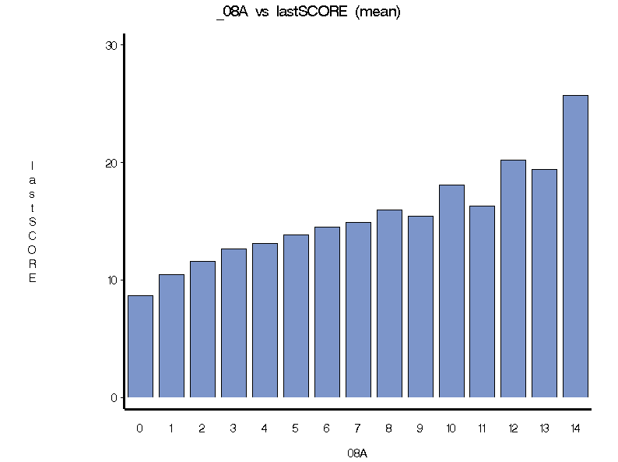Figure 2 shows the relation of the lastscore with variable _08A (Facility not vermin proof) which according to our initial exploration has the highest explanatory power.

Figure 2: Occurrence of Vermin Violations

It is interesting to note that in addition to the three violations which are expected to impact the score which eventually translates into the restaurant grade there are two more explanatory variables. These include the Last Inspection Date and Number of Inspections. At this stage, the potential importance of these two variables can be explained in the sense that once a restaurant has had a few inspections it becomes familiar with the evaluation criteria and better able to handle the inspection. Moreover when the last inspection date is recent a restaurant can gauge easily the latest patterns the inspectors are looking for. These initial patterns combined with our modelling results will better enable us to make predictions about the way the grading system works in New York.   
One interesting aspect of our data is that the income measures of the neighborhood do not play a very significant role in explaining the last scores that are received by the different restaurants in consideration. Normally we would expect that restaurants located in a higher mean income area would be of higher quality. We believe this can be explained from the fact that the grading system itself is keeping a check on the different restaurants in New York City. All restaurant owners are putting in substantial effort to get a decent grade regardless of the fact whether they are located in a rich neighborhood or not. Moreover the grading criteria are based on basic measures which can be easily employed by any food facility without intensive investment.

# VI. Data Analysis

## Decision/Regression Trees

In order distinctly bucket restaurants into an at-risk category we first tried decisions trees as a prediction model. Since our target variable last score is a continuous variable, a new binary variable named AtRisk was added to the model. All restaurants with a grade of 26 or higher were marked as AtRisk since they were a minor violation of being marked with a C grade. Additionally the full list of 22,000+ was sampled so that an equal proportion of A, B and C graded restaurant were evaluated into the model (654 per letter). Using a 60/40 training/validation a decision tree was built using the new AtRisk variable as the target. It should be noted that average prior score was removed from the model since it dominated the majority of the nodes.

The decision tree found that the most important variable was the presence of a single 05D (Hand washing facility not provided in or near food preparation area and toilet room) violation as the most important variable for determining if a restraint is at-risk. If a restaurant had at least one prior 05D and a 09C (Food contact surface not properly maintained), it was much more likely to be at-risk than those restaurants that haven’t had those two previous violations.

Taking a non-binary approach to the target variable provided very different results. Using a regression tree and targeting the last score variable showed that a restaurant with 2 or more 08A violation (facility not vermin proof) averaged a score of 17 compared to 24 to those that had one or fewer vermin violations. If a restaurant did not have a vermin violation, then the most important violation from the decision tree, 05D (Hand washing facility not provided) which dropped the average score by 5 points when present. Given that the overall the regression model performed better in terms of over fitting and the binary model did not have a vermin related violations highly ranked tree model, the linear regression model seems to be a better fit.

Though a decision tree model provided a lot of predictive information, one of the most important factors, average_score, dominated the model and could not be interpreted well in decision tree. Since the relationship between average_score and the last_score (target) is linear in nature, a linear regression model is more appropriate as a predicting model.

## Regression Analysis Introduction/Dimension Reduction

Given that our liner approach to decision tree proved promising we decided to analye the data using linear regression. Before a regression model could be created, some form of dimension reduction was required since the original data set contained over 100 prediction variables; so principle component analysis was utilized. Following PCA a stepwise variable selection was utilized to build a regression model.

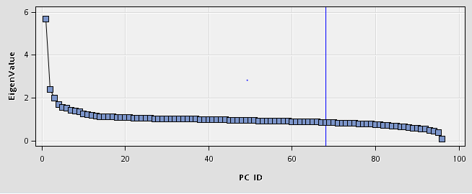Only the violation variables were used to create the PCA variables and variables such as cuisine type and borough were not included and lastScore was set as the target. We first set 0.8 of cumulative variance explained as the cut-off value for number of PCA variables to include however this required the inclusion of 68 principle components so that threshold was scrapped.

Figure 3: Cumulative variance explained for PCA eigenvalues

We then examined the eigenvalue plot (Figure 3) to visually inspect for the point when adding additional variables became meaningless. As expected, first few PCs had the greatest cumulative gains, and as others were added additional gains became very small. We concluded to include PC1, PC2, PC3, PC4, and PC5 to the new dataset. An examination of these variables showed the the following variables contributed highly to each of the chose PCAs:

|  |  |  |
| --- | --- | --- |
| **PC** | **ViolationCode** | **Description** |
| **PC1** | 08A | Facility not vermin proof. Harborage or conditions conducive to attracting vermin to the premises and/or allowing vermin to exist. |
| **PC2** | 15K | Operator failed to make good faith effort to inform smokers of the Smoke-free Act prohibition of smoking. |
| **PC3** | 10K | Immersion basket not provided, used or of incorrect size. |
| **PC4** | 06G | HACCP plan not approved or approved HACCP plan not maintained on premises. |
| **PC5** | 15K | Operator failed to make good faith effort to inform smokers of the Smoke-free Act prohibition of smoking. |

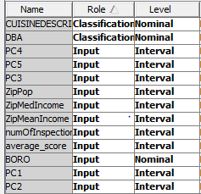We extracted the newly created PCA variables and then used Microsoft Excel’s “vlookup” function to combine these with non-PCA variables such as borough and cuisine type. In the end, we created a dataset containing PC1 to PC5, and all the other variables as seen in the chart to the right.

Figure 4: List of Variables entered into stepwise regression

## Stepwise Regression

To build the final model we used Stepwise regression (with a 60/40 training/validation sample). Using the results of the stepwise selection process to we could identify and exclude any variables those make little contribution to predict the target variable automatically. We set the last_score as the target, used the variables below as input or classifications, and rejected all the others.

We did not include type of cuisine as an input since there are too many types to provide an productive lift, Therefore, we only include one categorical factor-BORO (borough), which was one of the most import factors based on the results of data exploration and decision tree.

According to the output, average_score was entered first entered into the model, which matched showed that restaurants that have gotten A’s in the past will continue to get A’s. Number of inspections was the second variable to be included into the model and then PC1, PC2, PC5, BORO, and zip population entered the model consecutively. Instead of using all 11 varibles, the stepwise profess helped us filter cut the number down to 7 variables: BORO PC1 PC2 PC5 ZipPop average_score numOfInspections.

However, the estimate beta of ZipPop is almost 0 so we deleted this variable from our final model (Appendix 4 displays some important statistics and estimates). Based on result, we have the predictive equation below:



The R-square of the model is 0.231, and the validate average square error is 39.54 which is a little above the train average square error. Also, the plot in the Appendix 4 shows that there is no over-fitting within the model.

# VII. Conclusion

We considered all the analysis results from data exploration, decision tree, and principle components analysis, combing all the important factors to a new dataset (Grades3). Eventually, we ran the stepwise regression, reaching out to a predicting equation of the Score. R-square and MSE are decent of our model, which is a proof of a good predictive model.

The variables that contributed most to the model are ones that could be controlled by the restaurant. Factors such as medium income per zipcode provided no predictive insight. Instead prior violations played a critical part.

If this study were being performed with additional resources and proper funding it would be interesting to include additional data that would enable a more effective model. A few potential factors that would be interesting to delve into would be:

* How do being a Franchise, small chain or mom & pop compare to one another?
* Explore the relationship of other factors not available to during this study such as food price, outdoor seating, presence of a reservation system, and hours of operation.
* Is a good yelp rating indicative of a restaurant grade?
* Since vermin control is a powerful prediction factor, could we use information about upcoming construction in close proximity to a restaurant to predict grade?

**Appendix 1: List of Violation Codes**

|  |  |
| --- | --- |
| **Code** | **Violation Description** |
| **02A** | Food not cooked to required minimum temperature. |
| **02B** | Hot food item not held at or above 140º F. |
| **02C** | Hot food item that has been cooked and refrigerated is being held for service without first being reheated to 1 65º F or above within 2 hours. |
| **02D** | Precooked potentially hazardous food from commercial food processing establishment that is supposed to be heated, but is not heated to 140º F within 2 hours. |
| **02E** | Whole frozen poultry or poultry breasts, other than a single portion, is being cooked frozen or partially thawed. |
| **02F** | Meat, fish or molluscan shellfish served raw or undercooked without prior notification to customer. |
| **02G** | Cold food item held above 41º F (smoked fish and reduced oxygen packaged foods above 38 ºF) except during necessary preparation. |
| **02H** | Food not cooled by an approved method whereby the internal product temperature is reduced from 140º F to 70º F or less within 2 hours, and from 70º F to 41º F or less within 4 additional hours. |
| **02I** | Food prepared from ingredients at ambient temperature not cooled to 41º F or below within 4 hours. |
| **02J** | Reduced oxygen packaged (ROP) foods not cooled by an approved method whereby the internal food temperature is reduced to 38º F within two hours of cooking and if necessary further cooled to a temperature of 34º F within six hours of reaching 38º F. |
| **03A** | Food from unapproved or unknown source or home canned. Reduced oxygen packaged (ROP) fish not frozen before processing; or ROP foods prepared on premises transported to another site. |
| **03B** | Shellfish not from approved source, improperly tagged/labeled; tags not retained for 90 days. |
| **03C** | Eggs found dirty/cracked; liquid, frozen or powdered eggs not pasteurized. |
| **03D** | Canned food product observed swollen, leaking or rusted, and not segregated from other consumable food items . |
| **03E** | Potable water supply inadequate. Water or ice not potable or from unapproved source. Cross connection in potable water supply system observed. |
| **03F** | Unpasteurized milk or milk product present. |
| **03G** | Raw food not properly washed prior to serving. |
| **04A** | Food Protection Certificate not held by supervisor of food operations. |
| **04B** | Food worker prepares food or handles utensil when ill with a disease transmissible by food, or have exposed infected cut or burn on hand. |
| **04C** | Food worker does not use proper utensil to eliminate bare hand contact with food that will not receive adequate additional heat treatment. |
| **04D** | Food worker does not wash hands thoroughly after using the toilet, coughing, sneezing, smoking, eating, preparing raw foods or otherwise contaminating hands. |
| **04E** | Toxic chemical improperly labeled, stored or used such that food contamination may occur. |
| **04F** | Food, food preparation area, food storage area, area used by employees or patrons, contaminated by sewage or liquid waste. |
| **04G** | Unprotected potentially hazardous food re-served. |
| **04H** | Raw, cooked or prepared food is adulterated, contaminated, cross-contaminated, or not discarded in accordance with HACCP plan. |
| **04I** | Food item spoiled, adulterated, contaminated or cross-contaminated. Unprotected food re-served. |
| **04J** | Appropriately scaled metal stem-type thermometer or thermocouple not provided or used to evaluate temperatures of potentially hazardous foods during cooking, cooling, reheating and holding. |
| **04K** | Evidence of rats or live rats present in facility's food and/or non-food areas. |
| **04L** | Evidence of mice or live mice present in facility's food and/or non-food areas. |
| **04M** | Live roaches present in facility's food and/or non-food areas. |
| **04N** | Filth flies or food/refuse/sewage-associated (FRSA) flies present in facilitys food and/or non-food areas. Filth flies include house flies, little house flies, blow flies, bottle flies and flesh flies. Food/refuse/sewage-associated flies include fruit flies, drain flies and Phorid flies. |
| **04O** | Live animals other than fish in tank or service animal present in facility's food and/or non-food areas. |
| **05A** | Sewage disposal system improper or unapproved. |
| **05B** | Harmful, noxious gas or vapor detected. CO ~1 3 ppm. |
| **05C** | Food contact surface improperly constructed or located. Unacceptable material used. |
| **05D** | Hand washing facility not provided in or near food preparation area and toilet room. Hot and cold running water at adequate pressure to enable cleanliness of employees not provided at facility. Soap and an acceptable hand-drying device not provided. |
| **05E** | Toilet facility not provided for employees or for patrons when required. |
| **05F** | Insufficient or no refrigerated or hot holding equipment to keep potentially hazardous foods at required temperatures. |
| **05H** | No facilities available to wash, rinse and sanitize utensils and/or equipment. |
| **05I** | Refrigeration used to implement HACCP plan not equipped with an electronic system that continuously monitors time and temperature. |
| **06A** | Personal cleanliness inadequate. Outer garment soiled with possible contaminant. Effective hair restraint not worn in an area where food is prepared. |
| **06B** | Tobacco use, eating, or drinking from open container in food preparation, food storage or dishwashing area observed. |
| **06C** | Food not protected from potential source of contamination during storage, preparation, transportation, display or service. |
| **06D** | Food contact surface not properly washed, rinsed and sanitized after each use and following any activity when contamination may have occurred. |
| **06E** | Sanitized equipment or utensil, including in-use food dispensing utensil, improperly used or stored. |
| **06F** | Wiping cloths soiled or not stored in sanitizing solution. |
| **06G** | HACCP plan not approved or approved HACCP plan not maintained on premises. |
| **06H** | Records and logs not maintained to demonstrate that HACCP plan has been properly implemented. |
| **06I** | Food not labeled in accordance with HACCP plan. |
| **07A** | Duties of an officer of the Department interfered with or obstructed. |
| **08A** | Facility not vermin proof. Harborage or conditions conducive to attracting vermin to the premises and/or allowing vermin to exist. |
| **08B** | Covered garbage receptacle not provided or inadequate, except that garbage receptacle may be uncovered during active use. Garbage storage area not properly constructed or maintained; grinder or compactor dirty. |
| **08C** | Pesticide use not in accordance with label or applicable laws. Prohibited chemical used/stored. Open bait station used. |
| **09A** | Canned food product observed dented and not segregated from other consumable food items. |
| **09B** | Milk or milk product undated, improperly dated or expired or Thawing procedures improper. |
| **09C** | Food contact surface not properly maintained. |
| **10A** | Toilet facility not maintained and provided with toilet paper, waste receptacle and self-closing door. |
| **10B** | Plumbing not properly installed or maintained; anti-siphonage or backflow prevention device not provided where required; equipment or floor not properly drained; sewage disposal system in disrepair or not functioning properly. |
| **10C** | Lighting inadequate; permanent lighting not provided in food preparation areas, ware washing areas, and storage rooms. |
| **10D** | Mechanical or natural ventilation system not provided, improperly installed, in disrepair and/or fails to prevent excessive build-up of grease, heat, steam condensation vapors, odors, smoke, and fumes. |
| **10E** | Accurate thermometer not provided in refrigerated or hot holding equipment. |
| **10F** | Non-food contact surface improperly constructed. Unacceptable material used. Non-food contact surface or equipment improperly maintained and/or not properly sealed, raised, spaced or movable to allow accessibility for cleaning on all sides, above and underneath the unit. |
| **10G** | Food service operation occurring in room used as living or sleeping quarters. |
| **10H** | Proper sanitization not provided for utensil ware washing operation. |
| **10I** | Single service item reused, improperly stored, dispensed; not used when required. |
| **10J** | ''''Wash handssign not posted at hand wash facility. |
| **10K** | Immersion basket not provided, used or of incorrect size. Incorrect manual technique. Test kit and thermometer not provided or used. Improper drying practices. |
| **15E** | Out-of package sale of tobacco products observed. |
| **15H** | Sign prohibiting sale of tobacco products to minors not conspicuously posted. |
| **15I** | No Smoking and/or 'Smoking Permitted sign not conspicuously posted. Health warning not present on 'Smoking Permitted |
| **15J** | Ashtray present in smoke-free area. |
| **15K** | Operator failed to make good faith effort to inform smokers of the Smoke-free Act prohibition of smoking. |
| **15L** | Smoke free workplace smoking policy inadequate, not posted, not provided to employees. |
| **15S** | Flavored tobacco products sold or offered for sale. |
| **15T** | Original label for tobacco products sold or offered for sale. |
| **16A** | A food containing artificial trans fat, with 0.5 grams or more of trans fat per serving, is being stored, distributed, held for service, used in preparation of a menu item, or served. |
| **16B** | The original nutritional fact labels and/or ingredient label for a cooking oil, shortening or margarine or food item sold in bulk, or acceptable manufacturers documentation not maintained on site. |
| **16C** | Caloric content not posted on menus, menu boards or food tags, in a food service establishment that is 1 of 15 or more outlets operating the same type of business nationally under common ownership or control, or as a franchise or doing business under the same name, for each menu item that is served in portions, the size and content of which are standardized. |
| **16E** | Caloric content range (minimum to maximum) not posted on menus and or menu boards for each flavor, variety and size of each menu item that is offered for sale in different flavors, varieties and sizes. |
| **16F** | Specific caloric content or range thereof not posted on menus, menu boards or food tags for each menu item offered as a combination meal with multiple options that are listed as single items. |
| **18B** | Document issued by the Board of Health, Commissioner or Department unlawfully reproduced or altered. |
| **18C** | Notice of the Department of Board of Health mutilated, obstructed, or removed. |
| **18D** | Failure to comply with an Order of the Board of Health, Commissioner, or Department. |
| **18F** | Permit not conspicuously displayed. |
| **18G** | Manufacture of frozen dessert not authorized on Food Service Establishment permit. |
| **18I** | Choking first aid poster not posted. Alcohol and Pregnancy warning sign, inspection report sign; not posted. CPR sign not posted, equipment (resuscitation masks, adult & pediatric, latex gloves) not provided. |
| **20A** | Food allergy information poster not conspicuously posted where food is being prepared or processed by food workers. |
| **20B** | Food allergy information poster not posted in language understood by all food workers. |
| **20D** | Choking first aid poster not posted. Alcohol and pregnancy warning sign not posted. Resuscitation equipment: exhaled air resuscitation masks (adult & pediatric), latex gloves, sign not posted. Inspection report sign not posted. |
| **20E** | Letter Grade or Grade Pending card not conspicuously posted and visible to passersby. |
| **20F** | Current letter grade card not posted. |
| **22A** | Nuisance created or allowed to exist. Facility not free from unsafe, hazardous, offensive or annoying conditions. |
| **22B** | Toilet facility used by women does not have at least one covered garbage receptacle. |
| **22C** | Bulb not shielded or shatterproof, in areas where there is extreme heat, temperature changes, or where accidental contact may occur. |
| **22E** | ROP processing equipment not approved by DOHMH. |
| **99B** | Other general violation. |

We utilized the count function to record the number of times that each violation occurred at each restaurant. Additionally, we also imported several other fields from this set such as zip, borough, and cuisine type. Also, the table and remove duplicate values functions in excel were utilized to sort and reduce the data by most recent date to get each restaurant’s most recent inspection date and our target variable, most recent score. It was also at this point that restaurants that did not have an inspection date more recent than January 2013 were removed from the data set. Finally phone number, street and address were removed from the dataset at this point because they possess no predictive information.

**Appendix 2: Misc. Data Collection**

**1. xlsx to sas7bdat SAS code:**

In order to bring our data into SAS Enterprise Miner we used the import procedure in core SAS to transform the excel data set into a permanent SAS dataset. We then copied the corresponding sas7bdat created by SAS core into a library for import into SAS Enterprise Miner.

**PROC** **IMPORT** OUT= NYC.grades DATAFILE= "C:\sas\grades.xlsx"

DBMS=xlsx REPLACE;

SHEET="grades";

GETNAMES=YES;

**RUN**;

**2. Graphic representation of data cleanup/combination process:**



**3. List of all variables:**

Our initial data library is provided below.

|  |  |
| --- | --- |
| **Field** | **Description** |
| **NYC Open Data** | |
| **SCORE (Target)** | Date of the most recent inspection - only restaurants w/ grade more recent than 1/1/2013 |
| **CAMIS** | A unique ID used by NYC Health Department |
| **DBA** | The name of the restaurant |
| **BORO** | The borough of New York that the restaurant is located in |
| **ZIPCODE** | The zip code of the restaurant |
| **CUISINE DESCRIPTION** | The type of cuisine recorded by the health department. (e.g. Italian, American, Mexican, café ) |
| **INSPECTION DATE** | Date of the most recent inspection. |
| **_ViolationCode** | 98 columns containing the count of previous violations for that specific code. Full list is provided in Appendix 1 |
| **Derived from NYC Open Data** | |
| **NumPrevInspections** | Number of total previous inspections |
| **AvgPrevScore** | Average score from all previous exams |
| **www.psc.isr.umich.edu** | |
| **ZipPopulation** | Population for restaurants by zip code |
| **ZipMedianIncome** | Median income for restaurants by zip code |

**Appendix 3: Audited Data Points**

Audit Process  
Since the cleanup and transformation process required manual manipulation, we decided to perform an audit to ensure the integrity of the dataset was still intact before beginning the data exploration stage. In order to create a random sample for audit, all values where assigned a random number using the RAND() function in excel and then sorted from smallest to largest. The top 22 values (just over 0.1% of the sampling frame) where kept and audited. Each of these audit points was manually checked using the NYC Open Data website and original copy of the University of Michigan’s Population Studies Center Median income by zip excel sheet.

|  |  |  |  |  |
| --- | --- | --- | --- | --- |
| **#** | **audit number** | **CAMIS** | **DBA** | **Result** |
| 1 | 0.00000 | 50002480 | CITI CAFE/ROHATYN ROOM | OK |
| 2 | 0.00001 | 41016740 | SATGURU SWEETS & CATERING | OK |
| 3 | 0.00002 | 40974766 | CHIKALICIOUS DESSERT BAR | OK |
| 4 | 0.00009 | 50006377 | LOS TAQUITOS DEL TIO | OK |
| 5 | 0.00019 | 41685731 | GOLDEN KITCHEN | OK |
| 6 | 0.00024 | 41603386 | NEW HAPPY JOY | OK |
| 7 | 0.00024 | 41508258 | BELLA MAMA ROSE | OK |
| 8 | 0.00029 | 40806791 | GINGER'S BAR | OK |
| 9 | 0.00030 | 41467170 | HUNAN GLATT KOSHER | OK |
| 10 | 0.00034 | 41695257 | NO. 7 SUB | OK |
| 11 | 0.00042 | 41468049 | AU BON PAIN | OK |
| 12 | 0.00064 | 41407168 | HACHI | OK |
| 13 | 0.00068 | 40968428 | MR. DENNEHY'S | OK |
| 14 | 0.00070 | 41573878 | SURFISH BISTRO | OK |
| 15 | 0.00072 | 40728353 | UNIQUE LOUNGE | OK |
| 16 | 0.00079 | 41433965 | NO 1 CHINESE RESTAURANT | OK |
| 17 | 0.00084 | 40400096 | CIRCLE'S GRILL | OK |
| 18 | 0.00088 | 41313395 | FIVE NAPKIN BURGER | OK |
| 19 | 0.00093 | 40392063 | WALTER'S BAR | OK |
| 20 | 0.00094 | 41634185 | EMPELLON COCINA | OK |
| 21 | 0.00102 | 41340507 | SUBWAY | OK |

**Appendix 3-Part of Grades 3**



**Appendix 4 Stepwise regression output**

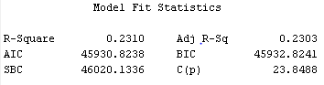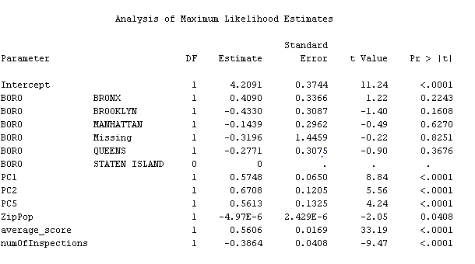

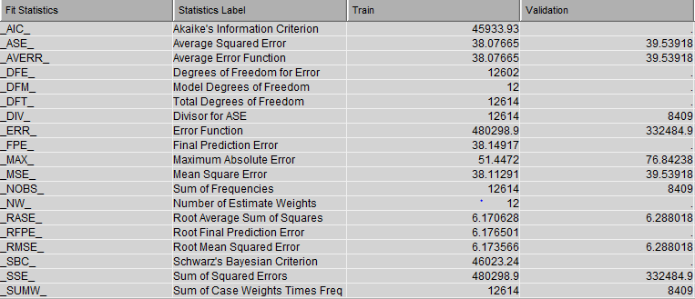

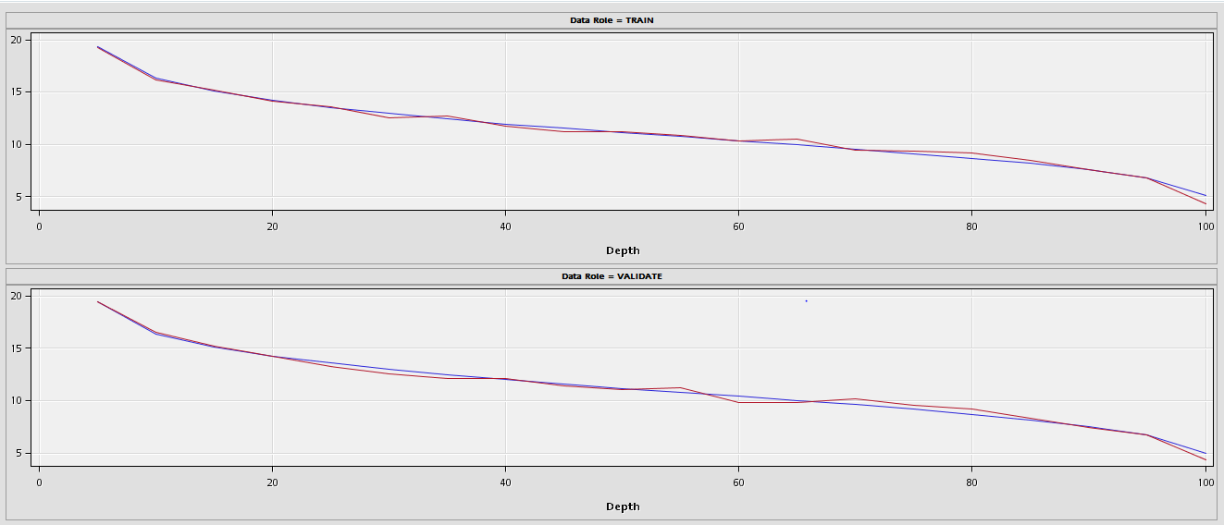

**Appendix 5 decision tree/regression tree output**

**Binary Decision tree:** 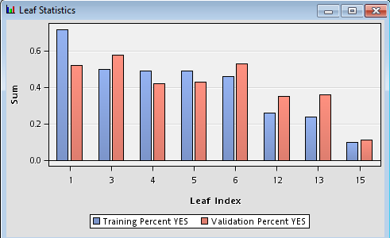

|  |  |  |  |  |  |  |  |  |  |  |  |  |  |  |  |  |  |  |  |  |  |  |  |  |  |  |  |
| --- | --- | --- | --- | --- | --- | --- | --- | --- | --- | --- | --- | --- | --- | --- | --- | --- | --- | --- | --- | --- | --- | --- | --- | --- | --- | --- | --- |
| |  |  |  | | --- | --- | --- | | **Statistics Label** | **Train** | **Validation** | | **Sum of Frequencies** | 1175.00 | 786.00 | | **Misclassification Rate** | 0.34 | 0.37 | | **Maximum Absolute Error** | 0.90 | 0.90 | | **Sum of Squared Errors** | 478.37 | 355.38 | | **Average Squared Error** | 0.20 | 0.23 | | **Root Average Squared Error** | 0.45 | 0.48 | | **Divisor for ASE** | 2350.00 | 1572.00 | | **Total Degrees of Freedom** | 1175.00 | NaN | |

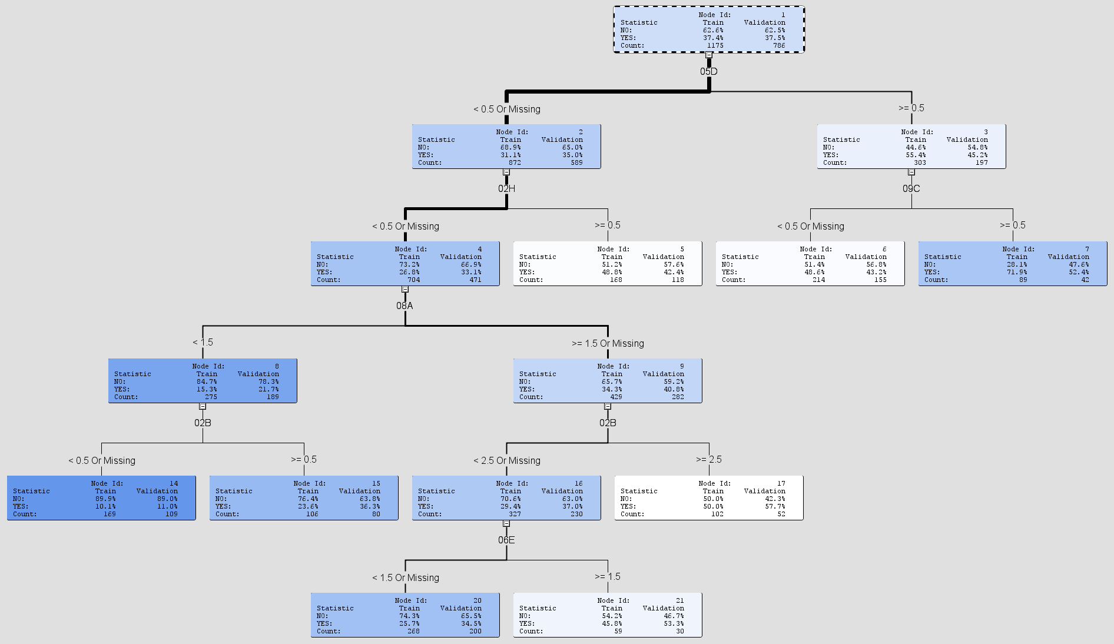

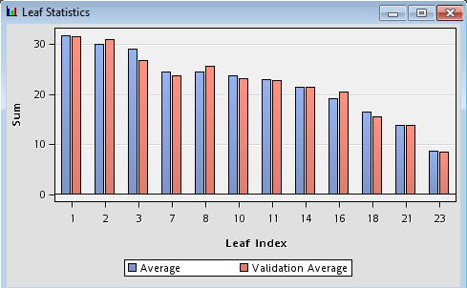**Regression tree:**

|  |  |  |
| --- | --- | --- |
| **Statistics Label** | **Train** | **Validation** |
| **Sum of Frequencies** | 1177.00 | 784.00 |
| **Maximum Absolute Error** | 75.96 | 43.95 |
| **Sum of Squared Errors** | 148125.16 | 109028.49 |
| **Average Squared Error** | 125.85 | 139.07 |
| **Root Average Squared Error** | 11.22 | 11.79 |
| **Divisor for ASE** | 1177.00 | 784.00 |
| **Total Degrees of Freedom** | 1177.00 | NaN |

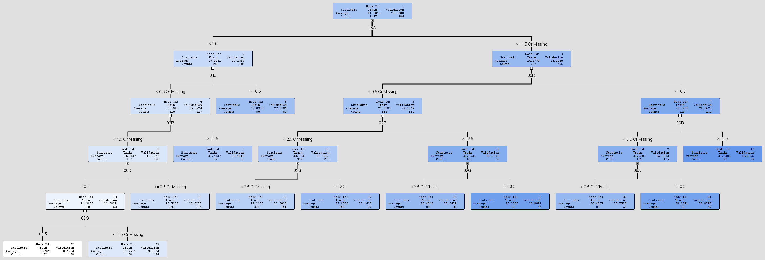

1. https://www.zagat.com/b/dining-trends-survey-tipping-pet-peeves-and-more#2
2. http://www.forbes.com/2010/04/28/tourism-new-york-lifestyle-travel-las-vegas-cities_slide_10.html
3. **Refrences**

   http://www.nyc.gov/html/doh/downloads/pdf/report/nycdohmh-triennial09-11.pdf