**IM101 – Advanced Database Systems**

**FT Lab Activity 2-3**



**NAME:** Gueta, Jhon-Allen N.

**STUDENT NO:** 23-2284

**YEAR/SECTION:** SBIT-2C

**DATE: 4/21/2025**



**Scenario:**

A company wants to manage employee salary increases and track those changes in a log table. They need to ensure that only authorized personnel can perform salary increases and that all changes are recorded for auditing purposes.

**Tables:**

* employees (employee_id, first_name, last_name, salary, job_title)

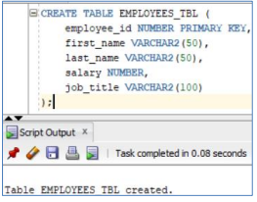

* salary\_log (log_id, employee_id, old_salary, new_salary, change_date, changed_by)

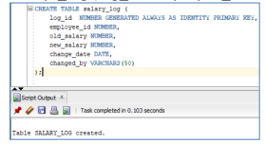

* authorized\_users (username)

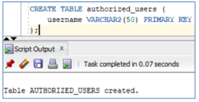

**Requirements:**

1. **Function:** Create a function is_authorized that checks if a given username is authorized to change salaries. The function should return TRUE if the user is authorized and FALSE otherwise.

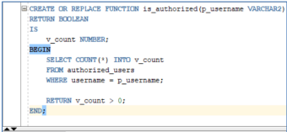

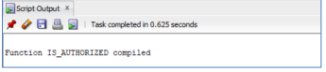

1. **Procedure:** Create a procedure update_salary that takes an employee ID, the new salary, and the username of the person making the change. The procedure should:
   * Use the is_authorized function to check if the user is authorized.
   * If the user is authorized, update the employee's salary and call a procedure to log the salary change.
   * If the user is not authorized, raise an exception.

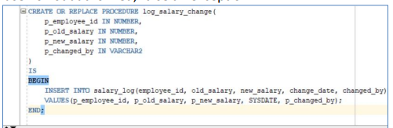



1. **Trigger:** Create a trigger salary_change_trigger that fires AFTER an update to the employees table's salary column. This trigger should:
   * Call a logging procedure to record the old salary, new salary, employee ID, change date, and the user who made the change. (You can assume the username is stored in a session variable, e.g., SYS_CONTEXT('USERENV', 'OS_USER')).

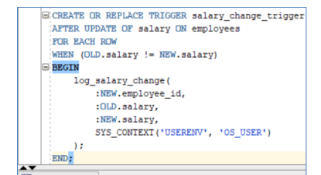

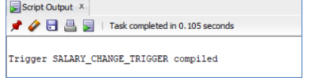

**Solution:**

Function to Check Authorization

Procedure to Update Salary

Procedure to Log Salary Change

Trigger to Automatically Log Salary Changes

**Testing the Components:**

Create the tables:

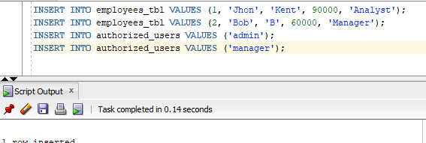

Test the function:

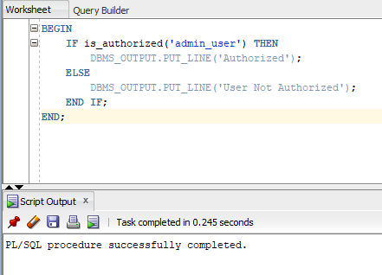

Test the procedure (as an authorized user):

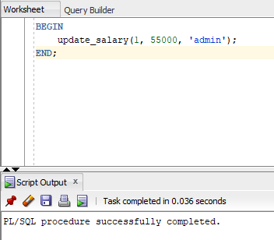

Test the procedure (as an unauthorized user):

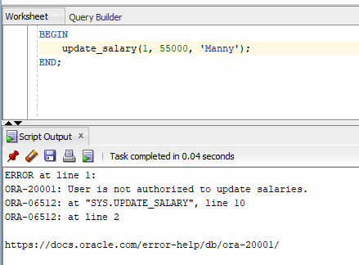

Test the trigger (by updating salary directly):  
