**How to fill NAN values in python?**

IMG_256

Python is a great language for doing data analysis, primarily because of the fantastic ecosystem of data-centric Python packages. ***Pandas***is one of those packages, and makes importing and analyzing data much easier.

Sometimes csv file has null values, which are later displayed as *NaN*in Data Frame. Just like pandas dropna() method manage and remove Null values from a data frame, fillna() manages and let the user replace NaN values with some value of their own.

IMG_257

Syntax

IMG_258

*DataFrame.fillna(value=None, method=None, axis=None, inplace=False, limit=None, downcast=None, \*\*kwargs)*

**value**: Static, dictionary, array, series or dataframe to fill instead of NaN.

**method**: Method is used if user doesn’t pass any value. Pandas has different methods like bfill, backfill or ffill which fills the place with value in the Forward index or Previous/Back respectively.

**axis**: axis takes int or string value for rows/columns. Input can be 0 or 1 for Integer and ‘index’ or ‘columns’ for String

**inplace**: It is a boolean which makes the changes in data frame itself if True.

**limit**: This is an integer value which specifies maximum number of consequetive forward/backward NaN value fills.

**downcast**: It takes a dict which specifies what dtype to downcast to which one. Like Float64 to int64.

\*\*kwargs : Any other Keyword arguments

IMG_259**Example #1:** Replacing NaN values with a Static value.

Read file:

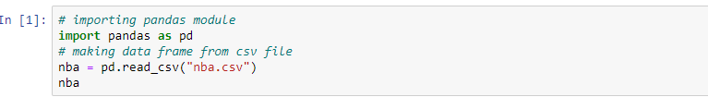

Now replace NaN values:

IMG_263

IMG_264**Example #2:** Using method Parameter

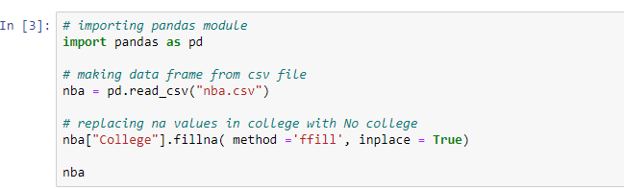

output:

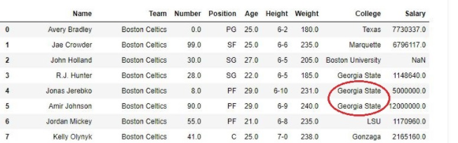

IMG_267**Example #3:** Using Limit-

>In this example, a limit of 1 is set in the *fillna()*method to check if the function stops replacing after one successful replacement of NaN value or not.

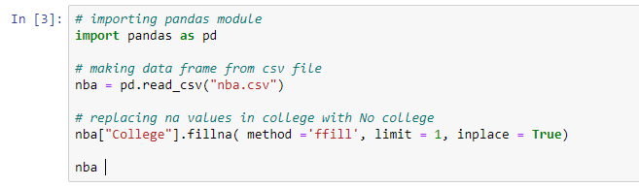

Output:

As shown in the output, The college column of 4th row was replaced but 5th one wasn’t since the limit was set 1.

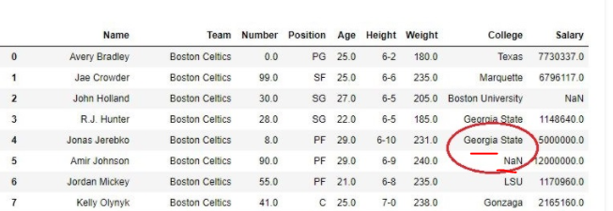

IMG_270

DONE

!!!.