

Sharda University
Plot No. 32-34, Knowledge Park III,
Greater Noida, Uttar Pradesh 201310

Laboratory Report
Deep Learning and its Applications Lab
CAL303

Department of Computer Science and Engineering
School of Computing Science & Engineering

Submitted By
Student Name | Samala Thanay Kumar
Student Id | 2023312537
Section/Group | CS K/01
Programme | B.Tech.
Department | Computer Science and Engineering
Session/Semester | 2025-26/06
Submitted To
Faculty Name | Dr.Jyothi Gautham

Table of Content
S. No. | Name of Experiment | Date of Experiment | Date of Submission | Signature | Remarks
Experiment No: 1 Date: 7 January 2026
AIM:
To implement a Single Layer Perceptron model and study the effect of different activation functions on its output for classification tasks.

THEORY:
A Single Layer Perceptron is the simplest form of an artificial neural network used for binary classification. It consists of:
- Input layer
- Weighted sum
- Bias
- Activation function
The perceptron computes the weighted sum of inputs and passes it through an activation function to produce the output.
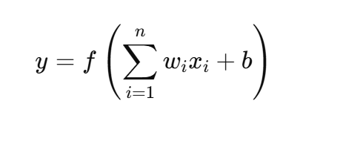
Mathematically:

Where:
- xi = input
- wi = weight
- b = bias
- f(⋅) = activation function

CODE :
import numpy as np
def step_function(x):
return 1 if x >= 0 else 0
def sigmoid(x):
return 1 / (1 + np.exp(-x))
def relu(x):
return max(0, x)
X = np.array([
[0, 0],
[0, 1],
[1, 0],
[1, 1]
])
Y = np.array([0, 0, 0, 1])
weights = np.random.rand(2)
bias = np.random.rand()
learning_rate = 0.1
epochs = 6
for epoch in range(epochs):
print(f"\nEpoch {epoch + 1}")
for i in range(len(X)):
net_input = np.dot(X[i], weights) + bias
output = step_function(net_input)
error = Y[i] - output
weights = weights + learning_rate * error * X[i]
bias = bias + learning_rate * error
print(f"Input: {X[i]}, Output: {output}, Error: {error}")
print("\nTesting with Sigmoid Activation")
for i in range(len(X)):
net_input = np.dot(X[i], weights) + bias
output = sigmoid(net_input)
print(f"Input: {X[i]}, Sigmoid Output: {output:.4f}")
print("\nTesting with ReLU Activation")
for i in range(len(X)):
net_input = np.dot(X[i], weights) + bias
output = relu(net_input)
print(f"Input: {X[i]}, ReLU Output: {output}")

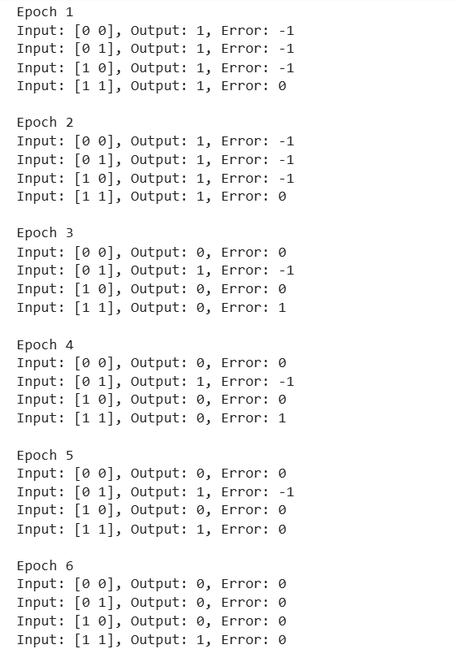
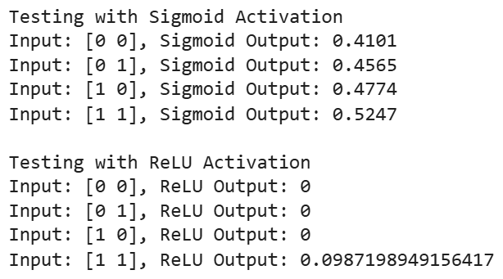

Experiment No: 3 Date: 7 January 2026
AIM:
To implement and analyze Linear Regression and Logistic Regression models on a housing dataset in order to predict house prices and classify them into high-value and low-value categories.

Dataset: The California Housing dataset contains information about houses in California, including features such as median income, house age, number of rooms, and population. The target variable represents the median house value for each district.

Linear Regression
Linear Regression is a supervised learning algorithm used for predicting a continuous numerical value. It models the relationship between independent variables and the dependent variable by fitting a straight line that minimizes the prediction error.

Logistic Regression
Logistic Regression is a supervised classification algorithm used to predict binary outcomes. It uses a logistic (sigmoid) function to estimate the probability of an instance belonging to a particular class, such as high-price or low-price houses.

CODE:

#Import Important Lib:

import matplotlib.pyplot as plt
import seaborn as sns
from sklearn.datasets import fetch_california_housing
from sklearn.model_selection import train_test_split
from sklearn.linear_model import LinearRegression, LogisticRegression
from sklearn.preprocessing import StandardScaler
from sklearn.metrics import mean_squared_error, confusion_matrix

# Load data
data = fetch_california_housing(as_frame=True)
X = data.data
y = data.target

# ---------------- Linear Regression ----------------
X_train, X_test, y_train, y_test = train_test_split(X, y, test_size=0.2, random_state=42)

lr = LinearRegression()
lr.fit(X_train, y_train)
y_pred = lr.predict(X_test)

# Plot: Actual vs Predicted
plt.figure()
plt.scatter(y_test, y_pred)
plt.xlabel("Actual Prices")
plt.ylabel("Predicted Prices")
plt.title("Linear Regression: Actual vs Predicted")
plt.show()
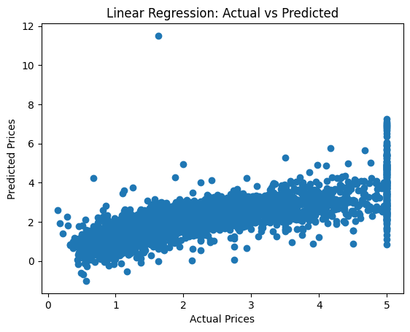

# ---------------- Logistic Regression ----------------
y_binary = (y > y.median()).astype(int)

X_train, X_test, y_train, y_test = train_test_split(
X, y_binary, test_size=0.2, random_state=42
)
scaler = StandardScaler()
X_train = scaler.fit_transform(X_train)
X_test = scaler.transform(X_test)
logr = LogisticRegression(max_iter=3000)
logr.fit(X_train, y_train)
y_pred = logr.predict(X_test)

# Plot: Confusion Matrix
cm = confusion_matrix(y_test, y_pred)
plt.figure()
sns.heatmap(cm, annot=True, fmt="d")
plt.xlabel("Predicted")
plt.ylabel("Actual")
plt.title("Logistic Regression Confusion Matrix")
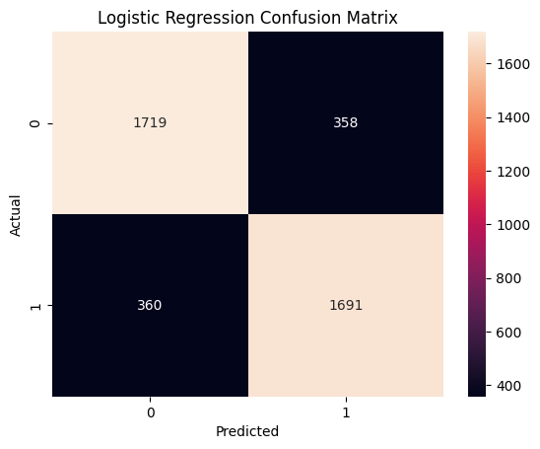
plt.show()

Experiment No: 5 Date: 7 January 2026
AIM: To design and train a Deep Neural Network (DNN) using Keras to predict the compressive strength of concrete based on its constituent materials.

Dataset : The Concrete Compressive Strength dataset contains measurements of cement, water, aggregates, and age of concrete. The target variable is the compressive strength of concrete, a continuous numerical value.

Deep Neural Network (DNN)
A Deep Neural Network is a multi-layer artificial neural network capable of learning complex non-linear relationships in data. It consists of an input layer, one or more hidden layers with activation functions, and an output layer used for prediction.
CODE:
import pandas as pd
import matplotlib.pyplot as plt
from sklearn.model_selection import train_test_split
from sklearn.preprocessing import StandardScaler
from sklearn.metrics import mean_squared_error, r2_score
from tensorflow.keras.models import Sequential
from tensorflow.keras.layers import Dense, Input
df = pd.read_csv("/content/concrete_data.csv")
X = df.iloc[:, :-1]
y = df.iloc[:, -1]
X_train, X_test, y_train, y_test = train_test_split(
X, y, test_size=0.2, random_state=42
)
scaler = StandardScaler()
X_train = scaler.fit_transform(X_train)
X_test = scaler.transform(X_test)
model = Sequential([
Input(shape=(X_train.shape[1],)),
Dense(64, activation='relu'),
Dense(32, activation='relu'),
Dense(1)
])
model.compile(optimizer='adam', loss='mse')
history = model.fit(
X_train, y_train,
epochs=50,
batch_size=16,
validation_split=0.2,
verbose=0
)
y_pred = model.predict(X_test)
print("Test MSE:", mean_squared_error(y_test, y_pred))
print("R² Score:", r2_score(y_test, y_pred))
plt.figure()
plt.plot(history.history['loss'], label='Training Loss')
plt.plot(history.history['val_loss'], label='Validation Loss')
plt.xlabel('Epochs')
plt.ylabel('MSE Loss')
plt.title('DNN Training Performance')
plt.legend()
plt.show()

plt.figure()
plt.scatter(y_test, y_pred)
plt.xlabel("Actual Strength")
plt.ylabel("Predicted Strength")
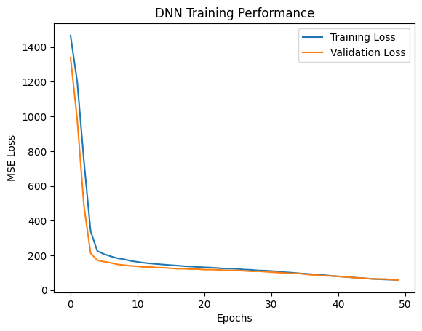
plt.title("Actual vs Predicted Concrete Strength")
plt.show()

