DATA ENCRYPTION OF FINANCIAL DETAILS IN ONLINE TRANSACTION
J Component Project

Samridhi Hisaria -20BCE0792 Raunit Garg-20BCE2089 Prashna Thapa-20BCE2750
Prateek M Koujalagi-20BCE2730
Vishakh Agrawal-20BCE0321

B.Tech. Computer Science and Engineering



School of Computer Science and Engineering Vellore Institute of Technology
Vellore

3rd, November, 2022

Abstract

Motivation:

Whenever you send personal information across the internet, be it passwords, credit card information or personal contact details, encryption stops others from seeing what you are doing.

Data is jumbled up in a manner so that when it travels through the internet it is completely unreadable, this stops hackers who may intercept the data from seeing what you’re doing, as all they’d receive is a random bunch of letters, numbers & symbols.

Aim:

Our Basic aim is to provide a fully secure system to transfer the information such that the information can’t be accessed by any third-party user.

Objective:

The objective of our project is that we are providing a fully secure system to transfer the information (CVV+Card Number), from receiver end to the sender end and vice versa, in such a way that the information can’t be accessed by any third-party user and used for fraud. The unique feature is that we are using randomization to select which algorithm to use for encryption, the system will randomly select which algorithm to use, by doing so we will make sure that no one is able to know which algorithm is being used for the current encryption.

- About Methodology.
  - Credit card details are taken as input from the user. (CVV + CARD NUMBER)
  - One out of the five encryption algorithms is selected at random.
  - The communication starts from the receiver's end. The receiver end performs randomization + key generation.
  - This is sent to the Sender end. The sender end encrypts the text using this information.
  - The Sender End sends the encrypted text to the receiver end.
  - Finally, the Receiver end decrypts it to obtain the plaintext.

- Expected Outcome.

The expected outcome is the creation of a strong and fast system that can encrypt the data in a randomized way, making it difficult for attackers to decrypt the data, whilst keeping it simple for the other end to decrypt the data with ease, not causing any trouble. The system is expected to successfully secure essential financial transaction details by relying on the security provided by

the encryption algorithms while also adding an additional layer of protection by adding the unpredictability of randomization.

- Efficiency Attained.

An eﬃcient and highly secure method of encryption-decryption will be proposed, tested, and implemented. The eﬃciency parameters will be calculated and compared with other methods' parameters to prove the eﬃciency of the proposed method.

KEYWORDS:

Online Transactions, Randomized, Multiple Algorithms, Attacks

Introduction

With the Contactless process of online transactions, there comes a huge list of security threats which need to be taken care of. If the Personal information of a user is compromised it could be used for spamming, identity theft and unsolicited marketing. So, it is very important that the information is kept secure. Credit cards hold a lot of essential information such as your name, credit card number, CVV etc. which in turn can provide access to all your bank account information and personal details to the attacker and you may get into a lot of trouble.
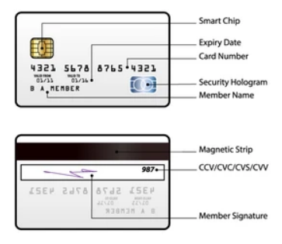

So, it is very important that all the information is passed safely.

- Backgraound of the project
The need to hide messages and their meaning from prying eyes (that is, encrypting them) probably surfaced not long after humankind invented writing.Encryption can be traced back to its religious use in ancient Egypt, and Greek and Roman military culture, to the World Wars and the creation of the first computer, to finally arrive at its modern use in the era of the World Wide Web.

Today, encryption is used in everyday modern life, and in most cases, users are unaware of it. Encryption is used mostly to handle transactions over insecure channels of communication, such as the internet.The increasing value of knowledge, and in modern times, data, has spurred the evolution of cryptography. The oldest known cryptography preserved religious or commercial knowledge and was then influenced by the need for secure military communication. The next drastic changes came when secure commercial and private communication became a general necessity. Since the 1980s, computers and the internet have increasingly come to dominate our lives. Thus, in the Information Age, all communication is best encrypted, regardless of it being between humans, machines, or humans and machines.

In modern cryptography, the security of encryption depends not on the encryption method (or algorithm) but the secrecy of the keys used for encryption and decryption.RSA introduced the concept of a public-private key pair for encryption. The public key is used to encrypt data, which can then only be decrypted with the corresponding private key.

For data at rest, AES 256 Bit (14 round CBC) is considered the best and is unbroken to this day. It uses the Rijndael block cipher with a symmetric-key algorithm.

For data in transit, e.g., secure websites, TLS 1.2 RSA is considered best. RSA claims that
2048-bit keys will be sufficient until 2030, and beyond 2030, 3072 bits should be used to ensure continuous security. NIST key management guidelines further suggest that 15360-bit RSA keys are equivalent in strength to 256-bit symmetric keys. This means that the strength of encryption now mainly depends on the length of the key being used

- Statistics

The world has seen a huge growth in online transactions (In comparison with 2019, online transactions grew by 80 per cent in 2020) these statistics are only continuing to increase. This, in turn, has increased the use of both credit and debit cards which are becoming the most popular mode of payment for purchases.

The 2020 Use of enterprise encryption technologies worldwide survey by Statista found that 56% of enterprise respondents said their internet communications had extensive encryption deployed. 27% had only partially deployed encryption for their internet communications.

A staggering 53% of companies left over 1,000 sensitive files and folders unencrypted and open to all of their employees, a 2019 global data risk report by Varonis found.

A data breach affecting more than one million compromised data records is rare, but not unheard of. IBM’s cost of a data breach 2021 report found that the average cost for 50 million to 65 million records involved in a data breach is an eye-watering $401 million.

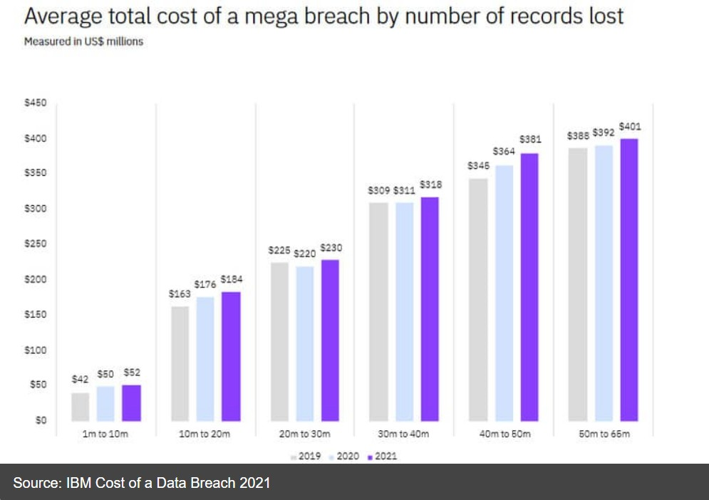

- Advantages and disadvantages of the various methods as well as the projects.

Encryption Advantage:

Everyone is nervous about the transition of confidential data to the cloud because several businesses consider that the cloud is not as reliable as their own data center. It is feasible for outsiders to access it while data is in the cloud, but clients’ and competitors’ data remain stored in the same storage place.

Due to the extreme cost and versatility, companies need the benefit of the cloud. The capacity to spin up or decommission servers when market requirements shift is part of this benefit. So, what happens if the service company asks to leave?

The virtualized contexts can provide multi-tenancy that includes greater flexibility and reduction in cost.

The service providers can access the data if they both contain encrypted data and keys used for encryption. To overcome this issue, processing data encryption in the cloud and preserving the encryption keys at the users’ end make sense. Although certain companies, no matter how simple the key security solution is, do not consider handling encryption keys. They have queries about backup, affordability, and rehabilitation from disasters.

Consumers use Payment cards for various transactions and require protection of the card and its related data. Most card consumers understand that their information and data related to this card are safe and secure. Therefore, encryption is one of the effective approaches used by PCI DSS (Payment Card Industry Data Security Standard).

If a data breach exists and personal data is destroyed, the compromised group must contact the individuals who are affected. Any jurisdictions have public notice with a safe harbor provision if the intercepted data is secured and if the security keys are not breached. Therefore, in an infringement, installing encryption and comprehensive key protection might save plenty of revenue.

Plenty of businesses are now giving online services that contain virtual offices, which are not protected by their very existence. There is a very real possibility for

the robbery of machines and storage. Many of these companies have insecure confidential data residing on these servers. Data encryption protects against data manipulation or unintentional destruction, and there are also greater capabilities for today’s security technologies. Imagine sending cryptographic keys to remote data only during working hours, meaning that if the lights go out, the code is unusable to everyone.

Encryption Disadvantages:

Dealing with encryption is a well-known technique to keep the data secure from unauthorized individuals and agencies. One of the major benefits of encryption is to provide data access for such an agency that is familiar with the keys and passwords used for the encryption of data. However, below are the few disadvantages of data encryption that require special attention.

The user would be unable to explore the encrypted file if the password or key got the loss. However, using simpler keys in data encryption makes the data insecure, and randomly, anyone can access it.

Data encryption is a useful data security technique; therefore, it requires plenty of resources like data processing, time consumption, usage of various algorithms for encryption, and decryption. Therefore, it is a bit of an expensive technique.

It is possible to establish arbitrary expectations and specifications that might jeopardize data encryption protection if an enterprise may not recognize any of the limitations enforced by encryption techniques.

When the user layers it for current systems and software, data protection techniques can be challenging. This may adversely impact routine processes inside the device.

Drawback to encryption can also be management of your keys. Lost and stolen keys are a big nightmare. One solution is to constantly change your encryption keys, if the key is stolen, it will soon expire anyway- if possible use tokens to accomplish this.

If you lose your key, or it's damaged/corrupt. Hopefully the source still has your original data, regenerate your keys and have your data re-encrypted and re-sent. If your data needs to be private, encryption is the only real solution.

Literature Survey / Related Works

Authors and Year (Reference) | Title (Study) | Concept / Theoretical model/ Framework | Methodology used/ Implementatio n | Relevant Finding | Limitations/ Future Research/ Gaps identified
Tony Cuadra, Iiyas Elkin  [1] | Secure RSA  Credit Card Transacti on System. | RSA algorith m | Two Atmel AT90S441 4  microcontrolle r which takes the account number and the transaction amount from the store clerk through the keypad,  displaying them on the LCD as they are being typed in. It then requests a key pair from the server using software UART. | how RSA algorith m is used for encrypti on of credit card details | due to the presence of high computation al power today, hackers could easily break the encryption if the know the type of algorithm is used
S.Aishk.De vi ka, Rani Dhivyaw A rya, [2] | Online Payme nt Fraud Prevent ion Using | triple des algorith | Whenever a new user registers, the credit card and debit card details are cross checked | how triple DES algorithm is implemente d for encryption | though triple DES algorithm is very secure yet the encryption

 | Crypto graphic Algorit hm TDES |  | and then only the user id is generated.  This allows only correct users to login each time. At the same time credit card and debit card details are verified each time whenever a customer buys product |  | process is very lengthy and time taking as we apply the encryption on the same data thrice
Gabriel Iwausko N [3] | Encryp tion and Tokeni zation based credit card securit y system | RSA  algorithm and Tokenization | The implementatio n of the RSA encryption and tokenization-b ased platform for securing credit card information was carried out on Microsoft Windows 7 Operating System environment on Pentium IV with 2.0 GHZ Duo Core Processor and 2 GB of RAM. APACHE  server and HTML with CSS, | how tokenizati on and rsa algorithm is used for encryption | Using the tokenized data requires it to be detokenized and retrieved from a remote service. This introduces a small increase in transaction time and while using it the user may sometime get locked in

JavaScript served as the frontend while MySQL
database from WAMP server and PHP were the backend on Mozilla Firefox browser
Himansh u Sharma [4] | Role of multi ple encr yptio n in secu re elect ronic tran smiss ion | RSA and Double DES Algorith ms | 1.It takes original confidential information as plaintext.  2.Employ Simple Hash Algorithm, result comes out as Message Digest.  3.Encrypt Message Digest multiple times with different encryption keys to generate more advance and complex Digital Signature.  4.Transmit the data with newly generated Digital | how more than one algorithm s can be used to encrypt the data | due to the presence of multiple layers of encryption  , the encryption process is very lengthy

 |  |  | Signature to the receiver side
Elaine Barker Nicky Mouha[5] | Recom mendat ion for Triple Data Encryp tion Algorit hm (TDEA  ) Block Cipher | Triple Data Encryption Algorithm (TDEA) | TDEA  functions incorporating the DEA cryptographic engine shall be designed in such a way that they may be used in a computer system, storage facility, or network to provide cryptographic protection to binary coded data. The method of implementatio n will depend on the application and environment. TDEA  implementatio ns shall be subject to being tested and validated as accurately performing the transformation s specified in | provides approved methods for generating cryptographic keys. provides recommendatio ns for managing cryptographic keys, including the keys used by the algorithm specified in this Recommendati on. | Triple DES is also vulnerable to meet-in-the middle attack because of which it give total security level of 2^112 instead of using 168 bit of key. The block collision attack can also be done because of short block size and using same key to encrypt large size of text. It is also vulnerable to sweet32 attacks.

 |  |  | the TDEA algorithm and in NIST Special Publications
Bruce Schneier[6] | Blowfish Algorithm with Examples | Blowfish Encryption Algorithm | Step1: Generation of subkeys Step2: initialize Substitution Boxes  Step3: Encryption | how blowfish algorithm is used for data encryption | due to the presence of high computation al power today, hackers could easily break the encryption if the know the type of algorithm is used
Miles E. Smld and Dennis K. Bransta d[7] | The Data Encryp tion Standar d: Past and Future | DES  Algorithm | The algorithm provides the user with a set of functions each of which transforms a 64-bit input to a 64-bit output. The user selects which one of over 70 quadrillion transformation functions are to be used by selecting a particular  56-bit key. Anyone | Many commercial and certain Government applications have already committed to the DES. DES is the basis of the Department of the Treasury’s Electronic Funds Transfer program, and the Federal Reserve System uses DES to encrypt connections | DES is designed to be secure as long as the secret key is kept secret, algorithms which are kept secret can make the attacker’s task more difficult since the algorithm often has to be deducted before the algorithm can be broken. Also if a known algorithm becomes

 |  |  | knowing the key can calculate both the function and its inverse, but without the key it is infeasible to determine which function was used, even when several inputs and outputs are provided. | between Depository Financial Institutions and Federal Reserve banks. In addition, manyfinanciala nd electronic business data applications already use DES and are unlikely to change for some time. | popular and is widely used, as is the case with the DES, it becomes a more attractive target for the attacker. Since the potential payoff is greater, the attacker may be willing to put forth an increased effort in breaking the algorithm
Kefa Rabah[8] | Theory and Implement ation of Data Encryptio n Standard: A Review | DES algorith m | There are two basic working principles of the classical ciphers: substitution and transposition are still important kernel and technique in the construction of the modern symmetric encryption algorithms.  The combination of substitution and transposition | Maximizing the benefits of a security upgrade-triple DES algorithm | DES is designed to be secure as long as the secret key is kept secret, algorithms which are kept secret can make the attacker’s task more difficult since the algorithm often has to be deducted before the algorithm can be broken. Also if a known algorithm becomes popular and is widely used, as is the case with

 |  |  | ciphers are implemented in one of the most important modern symmetric encryption algorithms, DES, which is the subject of this study |  | the DES, it becomes a more attractive target for the attacker. Since the potential payoff is greater, the attacker may be willing to put forth an increased effort in breaking the algorithm
Srinivas an Nagaraj  & V.Srinadth[9] | Data Encryptio n and Authentica tion Using Public Key Approach | Public key cryptography | Elliptic Curve Cryptography | Our proposed method is comparatively good performance at key generation and the confidential data is highly safe and reliable. The proposed algorithm increases the randomness of the used key | Encryption algorithms consume a significant amount of computing resources such as CPU time, memory, and battery power. In future, it can be enhanced by making this method compatible to encrypt multimedia data which have to be transmitted securely over unsecured channels.
Ratnadewi1  , Roy | Implement ation | Data Encryption | The DES algorithm takes the plain | 1. DES and 3DES text data cryptographic | the application of data writing

Pramono Adhie1 , Yonatan Hutama1 ,  A. Saleh Ahmar2,3, M I Setiawan4 [10] | Cryptogra phy Data Encryptio n Standard (DES) and Triple Data Encryptio n Standard (3DES)  Method in Communi cation System Based Near Field Communi cation (NFC) | Standard (DES)  Triple Data Encryption Standard (3DES)  Near Field Communicati on (NFC) | text in 64-bit blocks and converts them into ciphertext using 48-bit keys.  3DES uses triple times the DES process step used in encryption process and decryption process by using three key combinations. The effective length of the key used for encryption process and decryption process using 3DES  cryptographic method is 168 bits (consisting of three sub - key that each have a length of 56 bits), in contrast to DES  cryptographic method that uses a key with and effective | methods can be implemented on application of ACOS3 smart card data writing process and data reading process in NFC - based systems.  - The execution time of ACOS3 smart card data writing process and data reading process using DES cryptographic method is faster than 3DES cryptographic method.  - The execution time of the data reading process is faster than the data writing process for ACOS3 smart cards, using DES or 3DES cryptographic methods. | and data reading of ACOS3  smart card using DES and 3DES cryptographic method in NFC  - based systems. Contactless smart card and smart card reader that will be used in this research are ACOS3 8 KB  smart card and ACS ACR1252U  reader.

length of 56 bits

Overall Architecture

Detailed explanation of the overall architecture
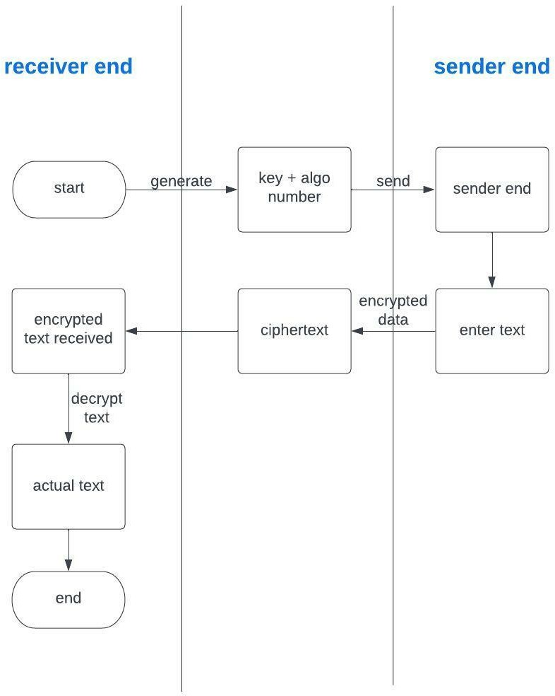

Methodology adapted-
    - Credit card details are taken as input from the user. (CVV + CARD NUMBER)
    - One out of the five encryption algorithms is selected at random.
    - The communication starts from the receiver end. The receiver end performs randomization + key generation.
    - This is sent to the Sender end. The sender end encrypts the text using this information.
    - The Sender End sends the encrypted text to the receiver end.
    - Finally, the Receiver end decrypts it to obtain the plaintext.

Dataset used-
We are not using any specific dataset, we are just going to input a random card number and cvv number to show the implementation of the project.

Tools used
Libraries and Packages Used
- Pycryptodome Python package
- Blowfish Python package Both Installed via pip
- OS Library
- base64 Library
- csv Library
- binascii Library
- sys Library

Code written in :
Python(Vs Code)

Proposed Methodology
ENCRYPTION ALGORITHMS USED:

- RSA:

- Generation of public key:

Select 2 prime numbers P and Q. First half of key= P*Q

Select a small exponent e which is an integer and its value lies between 1 and Ø(n). (Ø(n)= ((P-1)*(Q-1)).
Second half of key= e

- Generation of private key:

Private Key= d = (k* Ø(n)+1)/e where k is some integer.

- BLOWFISH:

- Generating subkeys: Both encryption and decryption processes require 18 subkeys which are stored in an array called P. P is initialized with digits of pi.

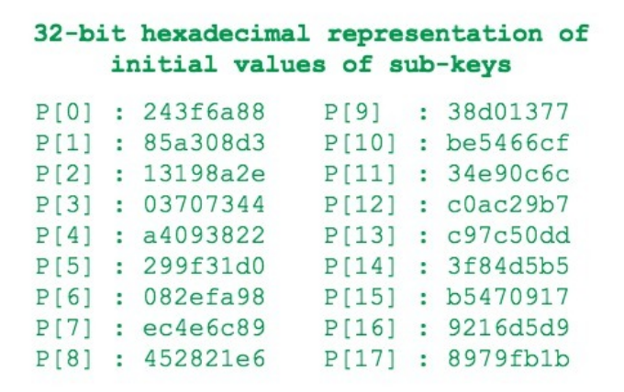

Each subkey changes with respect to the input key and this change follows the formula: P[i] = P[i] xor (i+1)th 32-bits of input key.
Where i={0,1,2,3,….,17}

The resultant array of subkeys is used for encryption and decryption.

- 4 S-boxes each with 256 32-bit entries are initialized with the P array.

- Encryption Occurs in 2 steps.

First we have rounds where each round takes plain text from the previous round and corresponding subkey as input.

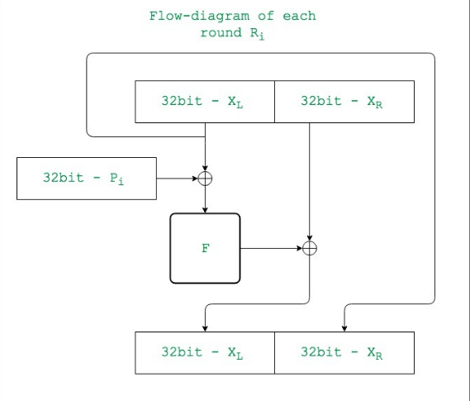

Where function F is as follows:

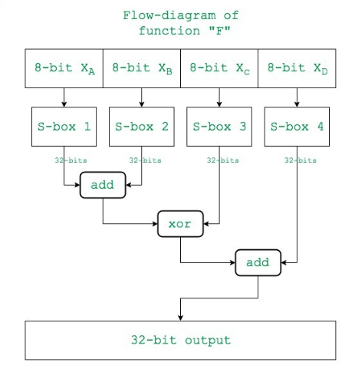

Then we go to the post processing step which is as follows:
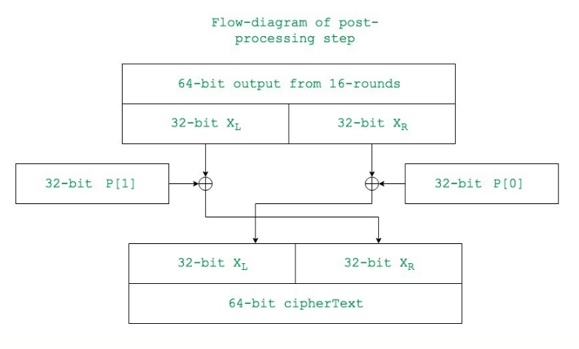

- Decryption follows a similar method, the only major difference is that the P array is used in reverse order.

- CAST-128
It is a 12 or 16-round Feistel network with a 64- bit block size and a key size of between 40 to 128 bits (but only in 8-bit increments).

The full 16 rounds are used when the key size is longer than 80 bits. Components include large 8×32-bit S-boxes based on bent functions, key-dependent rotations, modular addition and subtraction, and XOR operations. There are three alternating types of round function, but they are similar in structure and differ only in the choice of the exact operation (addition, subtraction or XOR) at various points.

- AES

Encryption involves 4 steps which are carried out in each round.

- Byte Substitution: 16 input bytes are substituted using an SBOX resulting in a matrix of 4 rows and columns.

- Shiftrows: All the rows of the matrix are shifted to the left and the entries that fall off are added to the rightmost side. Each row is shifted by n-1 bytes where n is the number of the row, the first row is not shifted as n-1 becomes 0.

- MixColumns: Each column of the matrix is transformed using a special function which takes the 4 bytes of a column as input and outputs 4 new bytes.

- Addroundkey: The 16 bytes are considered as 128 bits and XORed with the 128 bit round key, if in the last round the output is considered the Cipher Text. The Decryption process is

similar , the only difference is that the steps are done in reverse order.

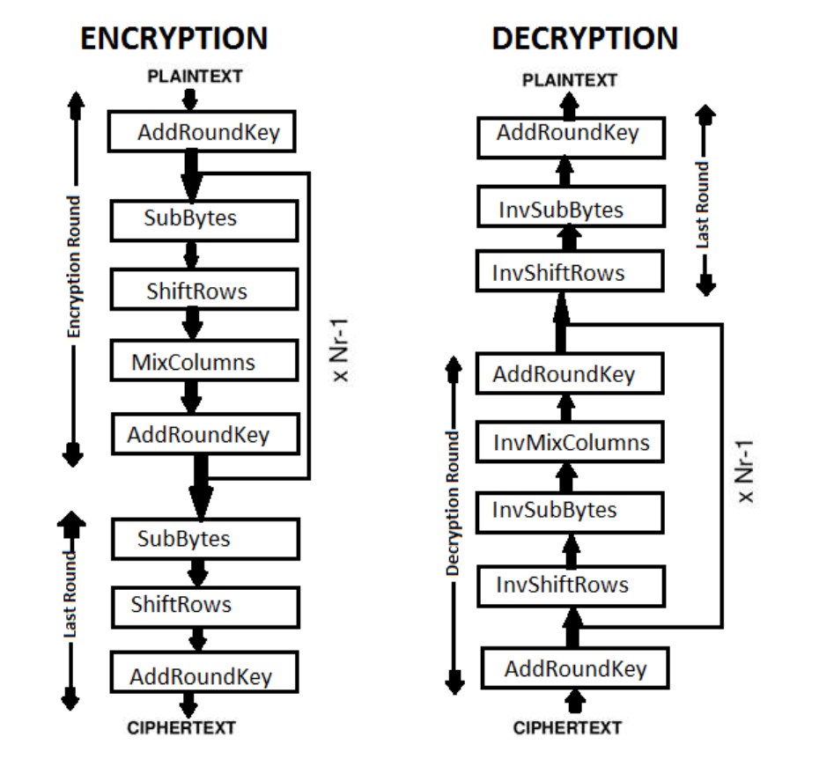

- TDES:

TDES uses 3 instances of DES on the same plain text. Each instance uses a different key selection method. All are different in the first instance,2 keys are the same in the second instance and all are the same in the third instance.

DES is carried out as follows:

- The 64 bit plain text is handed to an initial permutation(IP) function which performs an initial permutation on it.

- The IP function produces 2 halves of the permutated block as Left Plain Text (LPT) and Right Plain Text(RPT).

- LPT and RPT go through 16 rounds of encryption process

- Finally LPT and RPT are combined and a final permutation is performed to give a 64 bit ciphertext.

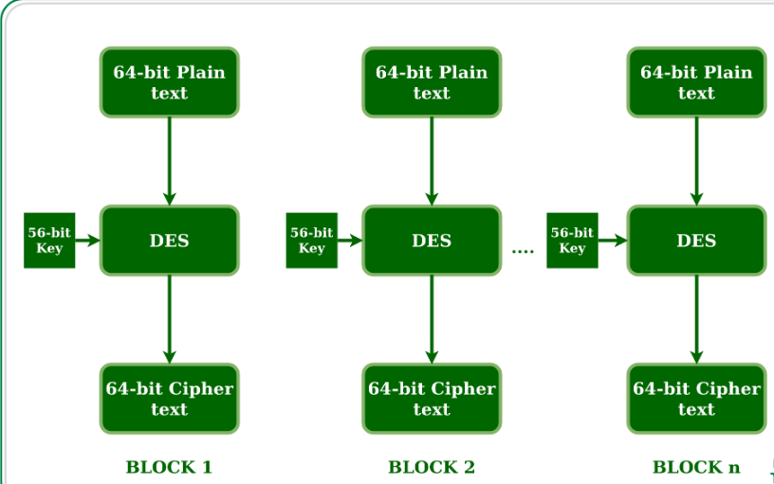
BRIEF EXPLANATION OF ALGORITHM CODES

RSA: To implement RSA we first generate the prime numbers p and q randomly using the randint() and check whether they are prime using checkprime() function if the generated value of p and q are not prime their values are incremented by one and this continues until the value of generated p and q becomes prime.We find the value of n and phi_n from p and q.we randomly generate the value of e such that e is relatively prime with phi_n by checking it with the gcd() function which is declared previously.Then we calculate the value of d from e,then we combine the private keys e and n in an array and also append the algorithm number for the rsa algorithm and read it into a csv file and send to the sender end from the receiver end.For encryption we generate the cipher text using compute(M,e,n) where M is the plain text,compute(a,b,m) is a function used for calculating a^b mod m quickly using exponentiation.If the value of plain text is greater than n, we extract 2 numbers from the plain text block-wise and then encrypt them serially and finally append them into a list.The ciphertext generated is read into the csv file and send to the receiver.The receiver receives the file from the sender decodes it into usable format and then the cipher text is divided into blocks and decrypted block by block using the formula compute(int(i),d,n) where i is each block .Then finally they are appended into a string and displayed.

- AES: To implement AES we first import AES and Random from the Pycryptodome library. The function symmetric() generates a randomized 16 byte(128 bit) key and we also generate a 16 byte long initialization vector via randomization. The new() function is used to create the cipher object and mode is set to CBC(Cypher Block Chaining). Encrypt() function is used to carry out the encryption, we also use a padding function to ensure that all data is consistent with the block size, which is essential for the algorithm to work. b64encode() is used to encode binary data that needs to be stored and transferred over media that are designed to deal with ASCII. For decryption we get the key, iv and ciphertext from the file and then we decrypt using the decrypt() function. Padding is removed using unpad() and decode() function is used to bring everything back to the normal format.

- TDES: To implement Triple DES ,at first we import DES3 from Pycryptodome library for the execution.To generate the keys ,we receive the 16 bits key from the symmetric() function and pad it to make 24 bits then using DES3.adjust_key_parity(key) we adjust the key parity to be used for tdes. We create the cipher object using the new() function and declare the mode as EAX object and declare nonce =b'0'.The ciphertext is generated using the key and the tdes cipher EAX object and plain text.The ciphertext generated is using cipher.encrypt() and encoded using the 'utf-8'and read into a csv file.To decrypt the function tripledesdecrypt(ciphertext,bkey) accepts the cipher text from the sender file and it is decoded back to a string using b64decode() and then the EAX cipher object is generated,and the final decrypted text is using cipher.decrypt()

- BLOWFISH: We are using library blowfish to implement blowfish. We first import urandom which helps in generating a random number. The key is generated using the blowfish.Cipher() function. Blowfish is implemented using CBC(Cipher Block Chaining) mode. the 8 bit initialisation vector is randomly generated using urandom function. Padding is done to ensure that all data is consistent with the block size, which is essential for the algorithm to work. Then the data is converted to bytes using encode() function. The encryption is done using the key and function cipher.encrypt_cbc() function. The encrypted text is decrypted using key and cipher.decrypt_cbc() , after decryption the data is converted to string using .decode() and the decrypted data is displayed.

CAST128: To implement CAST128 we first import CAST and Random from the Pycryptodome library. The function symmetric() generates a randomized 16 byte(128 bit) key and we also generate a 16 byte long initialization vector via randomization. The new() function is used to create the cipher object and mode is set to OPENPGP. Encrypt() function is used to carry out the encryption, we also use a padding function to ensure that all data is consistent with the block size, which is essential for the algorithm to work. b64encode() is used to encode binary data that needs to be stored and transferred over media that are designed to deal with ASCII. For decryption we get the key, iv and ciphertext from the file and then we decrypt using the decrypt() function. Padding is removed using unpad() and decode() function is used to bring everything back to the normal format.

Innovative component of the project:

Our project differs from other projects because we are using randomization to select one algorithm number out of the five. For each of the transactions that will take place, one of the five algorithms that we are using will be selected making it difficult for a third party to figure out which algorithm will be used hence decreasing the chances of fraud. So basically we are generating a random number by using the rand() function and its modulus 5 value is taken for the generation of the algorithm number that has to be used for encryption.

Results
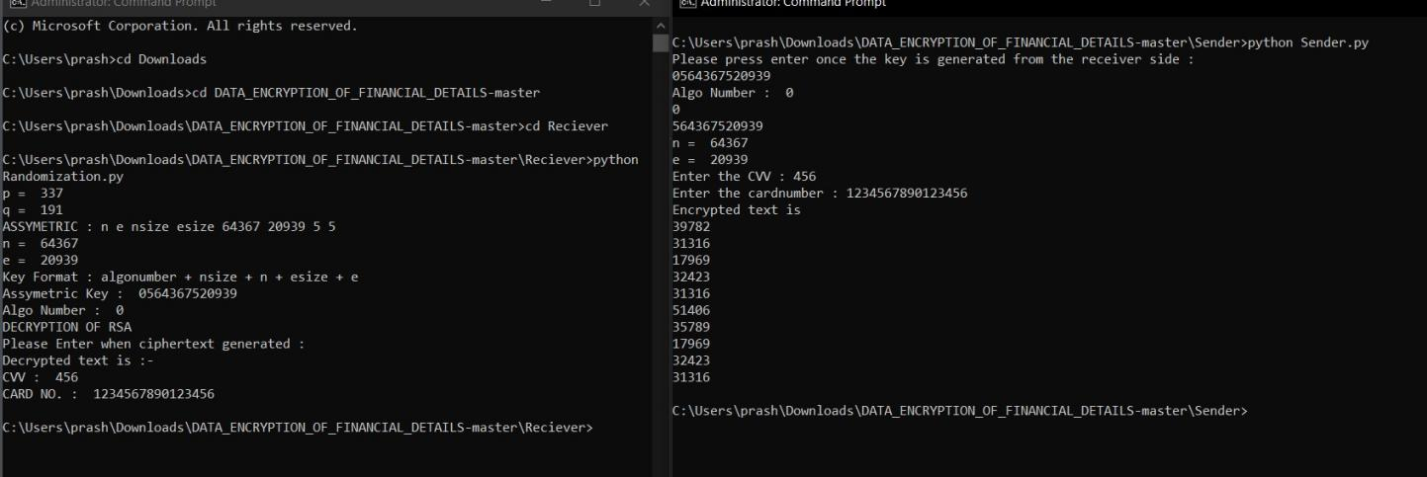
RSA OUTPUT

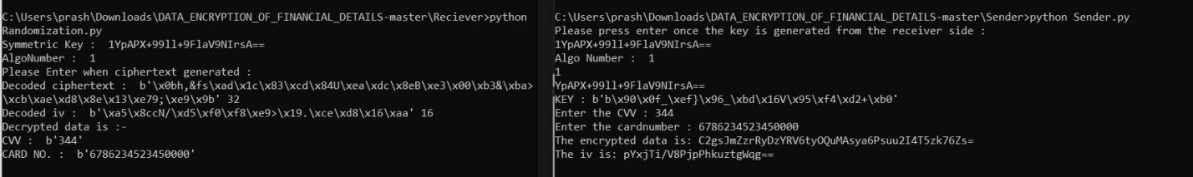
AES OUTPUT

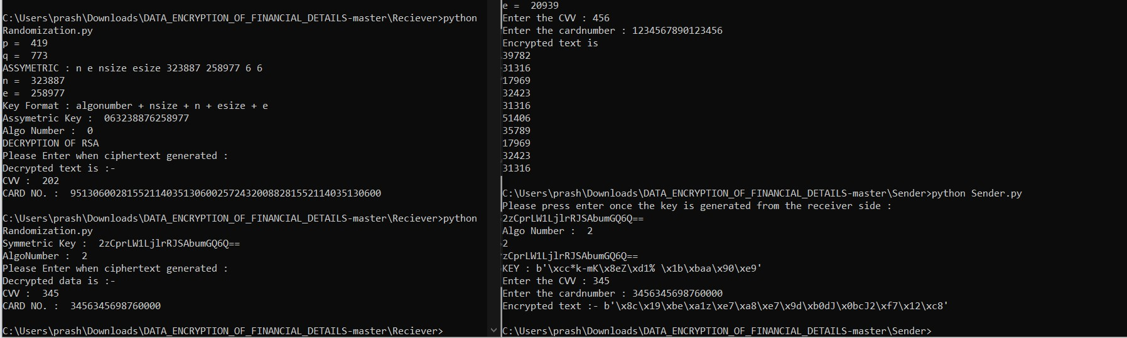

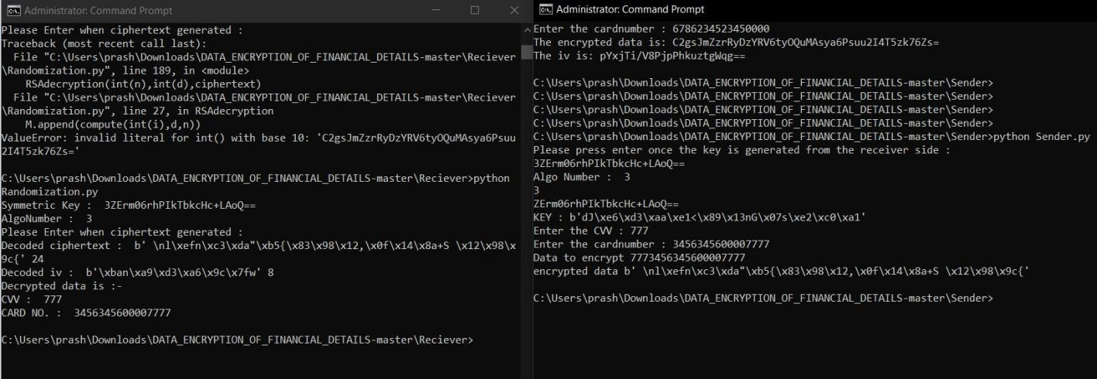
TDES OUTPUT
BLOWFISH OUTPUT

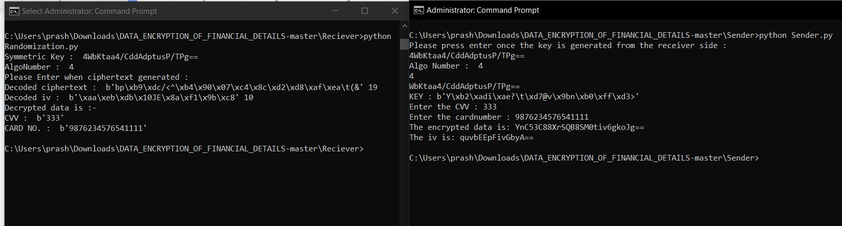
CAST-128 OUTPUT

Comparison and Analysis

- Analysis and Comparison of Algorithm Characteristics:

FACTORS | CAST 128 | TDES | BLOWF ISH | AES | RSA
KEY LENGTH | 128 bits | 168 (56*3)  bits | 448 bits | 128 bits | 2048 bits is the ideal length, length depends on size of prime numbers used
CYPHER | Symmetri | Symmetric | Symme | Symmetr | Asymmetric
TYPE | c Block | Block | tric | ic Block | Cypher
 | Cypher | Cypher | Block | Cypher
 |  |  | Cypher
DEVELOP | 1996 | 1995 | 1993 | 2000 | 1977
ED IN |  | (Derived
 |  | from DES
 |  | (1975))
SPEED | Fast | Slow | Fast | Fast | Slow
SECURITY | Relative ly less secure | Secure enough | Secure enough | Very Secure | Most Secure
BLOCK SIZE | 64 bits | 64 bits | 64 bits | 128 bits | NA
BASIC | Feistel | Feistel | Feistel | Substitution | Prime
STRUCTURE | Network | Network | Network | permutation | Factorization
 |  |  |  | Network

SECURITY LEVEL COMPARISON:

1. CAST-128:

by means of a known plaintext attack Key of CAST 128 can be known by linear cryptanalysis. It can be broken by 2^17 chosen plaintexts along with one related-key query in offline work of 2^48.

- TDES: Triple DES is vulnerable to meet-in-the middle attack because of which it give total security level of 2^112 instead of using 168 bits of key. The block collision attack can also be done because of short block size and using the same key to encrypt a large size of text. It is also vulnerable to sweet32 attacks.

- BLOWFISH: Blowfish is a very secure algorithm but Initial 4 rounds of blowfish are observed unprotected from 2nd -order differential attack.

- AES: No such kind of weakness has been observed in AES. Some initial rounds of AES are observed unprotected i.e. initial rounds can break by square method. 5. RSA: The strength and security of the RSA algorithm rely on the difficulty of factoring large numbers. So far there has been no mathematically proven method which can crack an RSA encryption of sufficient key length.

- Efficiency obtained should be included along with the metrics used.
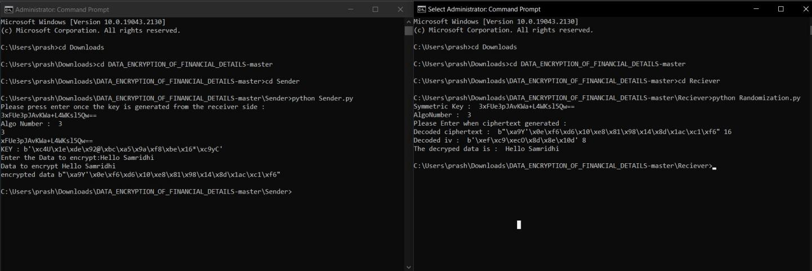
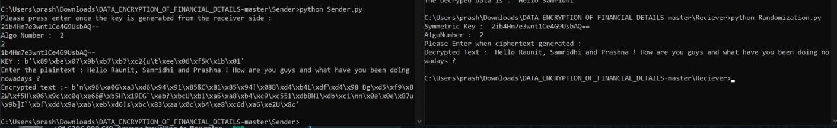

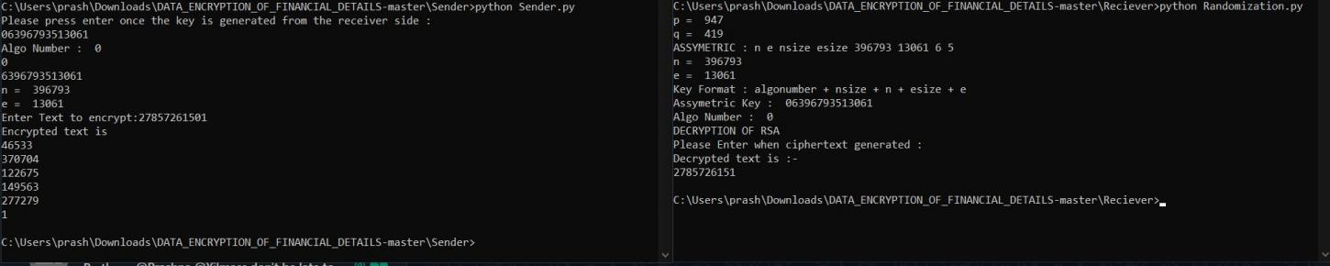

These three examples where we have put simple text, one long text with special characters and one integer which can be account number details of the user returns the exact same decrypted text. We can tell that the accuracy of the algorithms used in the encryption decryption of the details is 100%.

- Results can be represented in graphs along with its interpretation.
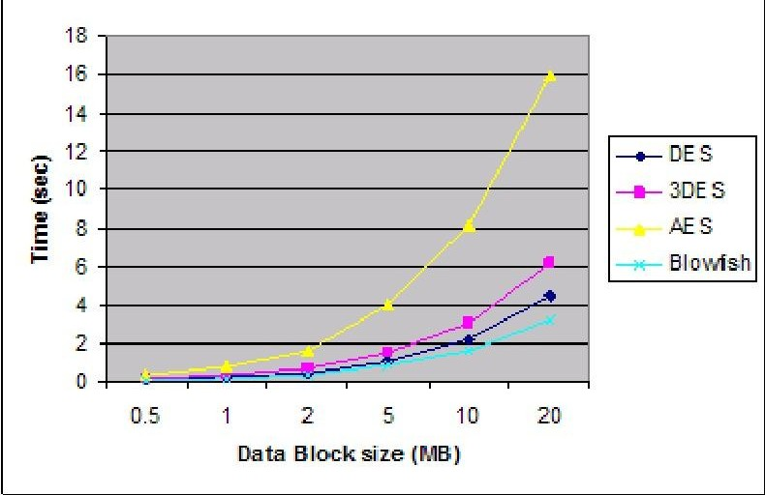

As the size of the data block to be transferred increases the time required to encrypt or decrypt also increases but differently for each algorithm.

The time increases the most for AES when it has to transfer the same size of data block compared to blowfish which requires the least time.

The time required for encryption and decryption for each algorithm in ascending order is: Blowfish , DES, 3DES, AES

Conclusion and Future Work

- Significance of the project.

The result is the creation of a strong and fast system that can encrypt the data in a randomized way, making it difficult for attackers to decrypt the data, whilst keeping it simple for the other end to decrypt the data with ease, not causing any trouble. The system successfully secures essential financial transaction details by relying on the security provided by the encryption algorithms while also adding an additional layer of protection by adding the unpredictability of randomization.

- Results and Efficiency obtained.

For RSA:

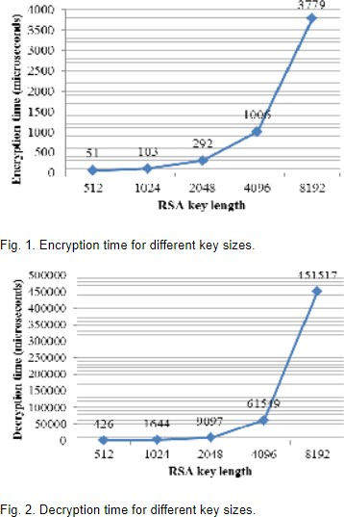

According to these graphs, as the size of the key increases the time required for encryption and description by the RSA algorithm also increases.

- Difficulties faced in performing the project.

While doing the project the major issue that we faced was implementing multiple algorithms which was complex and difficult.The other difficulty was coming up with the overall architecture of the project which uses randomization to choose any algorithm to encrypt the details.

- What could be done in the future? (Can it be improvised or not?)

We can add more algorithms in the randomization function and make it more complex.

References

- T.Cuadra, L.Elkin, “Final Project-Secure RSA Credit Card Transaction System,” 2000. https://people.ece.cornell.edu/land/courses/ece4760/FinalProjects/s2000/cuadra/final.html

- S.Aishwarya, K.D.R.Dhivya, “Online payment Fraud Prevention Using Cryptographic Algorithm TDES,” International Journal of Computer Science and Mobile Computing, Vol. 4, Issue. 4, pg.317 – 323, April 2015. https://ijcsmc.com/docs/papers/April2015/V4I4201581.pdf[Accessed: 22-Sep-2021].

- G.B.Iwasokun, T.G.Omomule, R.O.Akinyede , “Encryption and TokenizationBased System for Credit Card Information Security,” International Journal of Cyber-Security and Digital Forensics, August 2018. https://www.researchgate.net/publication/326753224_Encryption_and_TokenizationBased_Syste m_for_Credit_Card_Information_Security

- H.Gupta, V.K.Sharma, “ Role of Multiple Encryption in Secure Electronic Transaction,” International Journal of Network Security & Its Applications, Vol.3, No.6, November 2011 . https://www.researchgate.net/publication/286732622_Role_of_Multiple_Encryption_in_Secure_ Electronic_Transaction

- Blowfish Algorithm with Examples https://www.geeksforgeeks.org/blowfish-algorithm-with-examples/

- Y.M.koukou, S.H.Othman, “Comparative study of AES, Blowfish,CAST-128 and DES algorithm,” IOSR Journal of Engineering, Vol.6, Issue 6, June 2016 paper_published_2.pdf (sciencedev.net).

- Advanced Encryption Standard https://www.tutorialspoint.com/cryptography/advanced_encryption_stan%20dard.html

- Davis, R.(1978, 6 November).The data encryption standard in perspective.IEEE Communications Society Magazine

https://ieeexplore.ieee.org/abstract/document/1089771

- Elsevier, B.(1992 June).Picture data encryption using scan patterns.Elsevier B.V. https://www.sciencedirect.com/science/article/abs/pii/003132039290074S
- Coppersmith,D.(May 1994).The Data Encryption Standard (DES) and its strength against attacks.IBM Journal of Research and Development

https://ieeexplore.ieee.org/abstract/document/5389567

- Smid,M.E.(May 1988).Data Encryption Standard: past and future.Proceedings of the IEEE https://ieeexplore.ieee.org/abstract/document/4441/
- Elaine Barker, Nicky Mouha (July 2017) Draft NIST Special Publication 800-67 https://csrc.nist.gov/CSRC/media/Publications/sp/800-67/rev-2/draft/documents/sp800-67r2-draf t.pdf

[13]A. Nadeem; M.Y. Javed(27 February 2006)IEEE https://ieeexplore.ieee.org/abstract/document/1598556/

- Eli Biham, Adi Shamir (1993) Springer-Verlag https://books.google.co.in/books?hl=en&lr=&id=hy7jBwAAQBAJ&oi=fnd&pg=PA1&dq=schol arly+articles+on+data+encryption&ots=LAgG6Op4oM&sig=84Rte17Ozw32Q4YrcclQbLWuXh U

- SrinivasanNagarajaG.S.V.P.RajuDr.bV.Srinadtha(2015)Procedia Computer Science(International Conference on Computer, Communication and Convergence (ICCC 2015))https://www.sciencedirect.com/science/article/pii/S1877050915006705

- Mitsuru Matsui (01 January 2001) Department of EE & CS, University of Wisconsin,USA https://link.springer.com/chapter/10.1007/3-540-48658-5_1

- Abdel-Karim Al Tamimi (June 21st, 2010) IEEE https://citeseerx.ist.psu.edu/viewdoc/download?doi=10.1.1.117.6799&rep=rep1&type=pdf

- Edward F. Schaefer(04 Jun 2010)A SIMPLIFIED DATA ENCRYPTION STANDARD
ALGORITHM.Cryptologia. https://www.tandfonline.com/doi/abs/10.1080/0161-119691884799

- Rajdeep Bhanot, Rahul Hans.(12,December,2016)A Review and Comparative Analysis of Various Encryption Algorithms.International Journal of Security and Its Applications https://www.earticle.net/Article/A245530

- Garon G.,Outerbridge R.(01 September 1991)An examination of the sufficiency of the data encryption standard for financial institution information security in the 1990s.Association for Computing Machinery New York, NY, United States https://dl.acm.org/doi/abs/10.1145/126569.127016

Appendix

- Implementation Intricacies

  - Create a symmetric key of the appropriate length.
You have two options. You can provide a passphrase from which a key will be generated. Or you can provide a key.
    - If you provide a passphrase, you must store or remember the passphrase. If you store the passphrase online, the passphrase file should be readable only by you.
    - If you provide a key, it must be the correct size for the mechanism. For the procedure, see How to Generate a Symmetric Key by Using the dd Command. You can also use the pktool command. For the procedure and some examples, see How to Generate a Symmetric Key by Using the pktool Command.
  - Encrypt a file.
Provide a key and use a symmetric key algorithm with the encrypt command.

% encrypt -a algorithm [-v] \

[-k keyfile | -K key-label [-T token]] [-i input-file] [-o output-file]

3.
-a algorithm
Is the algorithm to use to encrypt the file. Type the algorithm as the algorithm appears in the output of the encrypt -l command.
-k keyfile
Is the file that contains a key of algorithm-specified length. The key length for each algorithm is listed, in bits, in the output of the encrypt -l command.
-K key-label
Is the label of a key in the PKCS #11 keystore.
-T token
Is the token name. By default, the token is Sun Software PKCS#11 softtoken. Is used only when the -K key-label option is used.
-i input-file
Is the input file that you want to encrypt. This file is left unchanged by the command.
-o output-file
Is the output file that is the encrypted form of the input file.

Project Codes Sender side:
from Crypto.Cipher import AES from Crypto.Cipher import DES3 from Crypto.Cipher import CAST import blowfish
from os import urandom

from base64 import b64encode

from base64 import b64decode from Crypto import Random
from Crypto.Util.Padding import pad from binascii import b2a_hex
import csv

#Assigning Algorithms Numbers :- #0 -> RSA
#1 -> AES

#2 -> TDES

#3 -> BLOWFISH

#4 -> CAST

def BlowfishEncrypt(key):

cipher = blowfish.Cipher(key)

iv = urandom(8) # initialization vector

# data=input('Enter the Data to encrypt:') cvv = input("Enter the CVV : ")
cardno = input("Enter the cardnumber : ") data = cvv+ cardno while((len(data)%8)!=0):
data=data+" "

res = data.encode('utf-8')

print("Data to encrypt",data)

ciphertext = b"".join(cipher.encrypt_cbc(res, iv)) print("encrypted data",ciphertext)
cipher =
[b64encode(ciphertext).decode('utf-8'),b64encode(iv).decode('utf-8')]

with open('ciphertext.csv', 'w', encoding='UTF8') as f: writer = csv.writer(f)

# write the data(cipher,iv) writer.writerow(cipher)

f.close()

def CASTEncrypt(key):

cipher = CAST.new(key, CAST.MODE_OPENPGP) cvv = input("Enter the CVV : ")
cardno = input("Enter the cardnumber : ") plaintext = cvv+ cardno
plaintext = plaintext.encode() msg = cipher.encrypt(plaintext) eiv = msg[:CAST.block_size+2]
ciphertext = msg[CAST.block_size+2:]

print("The encrypted data is:", b64encode(ciphertext).decode('utf-8'))

print("The iv is:", b64encode(eiv).decode('utf-8'))

cipher =
[b64encode(ciphertext).decode('utf-8'),b64encode(eiv).decode('utf-8')]

with open('ciphertext.csv', 'w', encoding='UTF8') as f: writer = csv.writer(f)

# write the data(cipher,iv) writer.writerow(cipher)

f.close()

def AESEncrypt(key):

cvv = input("Enter the CVV : ")

cardno = input("Enter the cardnumber : ") plain_text = cvv+ cardno
plain_text = plain_text.encode()

# Generate a non-repeatable key vector with a length # equal to the size of the AES block
iv = Random.new().read(AES.block_size)

# Use key and iv to initialize AES object, use MODE_CBC mode mycipher = AES.new(key, AES.MODE_CBC, iv)

ciphertext = mycipher.encrypt(pad(plain_text,AES.block_size)) print("The encrypted data is:", b64encode(ciphertext).decode('utf-8')) print("The iv is:", b64encode(iv).decode('utf-8'))
cipher =
[b64encode(ciphertext).decode('utf-8'),b64encode(iv).decode('utf-8')]

with open('ciphertext.csv', 'w', encoding='UTF8') as f: writer = csv.writer(f)

# write the data(cipher,iv) writer.writerow(cipher)

f.close()

def tripledesencrypt(bkey):

cvv = input("Enter the CVV : ")

cardno = input("Enter the cardnumber : ") msg = cvv+ cardno
key = pad(bkey,24)

tdes_key = DES3.adjust_key_parity(key)

cipher = DES3.new(tdes_key,DES3.MODE_EAX, nonce=b'0') ciphertext = cipher.encrypt(msg.encode('utf-8')) print("Encrypted text :-", ciphertext)

cipher = [b64encode(ciphertext).decode('utf-8')]

with open('ciphertext.csv', 'w', encoding='UTF8') as f: writer = csv.writer(f)
writer.writerow(cipher) f.close()

def compute(a,m,n): y=1
while(m>0):

r=m%2 if(r==1):
y=(y*a)%n a = a*a % n
m = m // 2 return y

def RSAencryption(n,e):

cvv = input("Enter the CVV : ")

cardno = input("Enter the cardnumber : ") M = int(cvv+ cardno)
d1=M

if M < n:

C=compute(M,e,n)

print("Encrypted text is:",C) else:
f=0 a=[]
C=[]

while d1>0:

mod=d1%100 a.insert(f,mod) f=f+1
d1= d1//100 a.reverse()
for i in a:

C.append(compute(i,e,n)) print("Encrypted text is") cipher = []
for i in C:

print(i) cipher.append(i)
with open('ciphertext.csv', 'w', encoding='UTF8') as f: writer = csv.writer(f)

# write the data(cipher) writer.writerow(cipher)

f.close()

with open("C:\\Users\\prash\\Downloads\\DATA_ENCRYPTION_OF_FINANCIAL_DETAILS-ma ster\\Reciever\\key.csv") as csv_file:

csv_reader = csv.reader(csv_file, delimiter=',') for row in csv_reader:
if(len(row) == 0): break
keyrecieved = row[0] csv_file.close()

#keyrecieved = input("Enter the key recieved by the reciever side : ") input("Please press enter once the key is generated from the receiver side
: ")

print(keyrecieved)

print("Algo Number : ",keyrecieved[0])

algonumber = keyrecieved[0] key = keyrecieved[1:] print(algonumber) print(key)

#Currently only for the 2 algorithms we have implemented if(algonumber == '0'):
nsize = int(key[0]) n = key[1:nsize+1]
esize = int(key[nsize+1]) e = key[nsize+2:] print("n = " , n)
print("e = ",e) RSAencryption(int(n),int(e))

elif(algonumber == '1'): key = b64decode(key) print("KEY :",key) AESEncrypt(key)

elif(algonumber == '2'): key = b64decode(key) print("KEY :",key) tripledesencrypt(key)

elif(algonumber == '3'): key = b64decode(key)

print("KEY :",key) BlowfishEncrypt(key)

elif(algonumber == '4'): key = b64decode(key) print("KEY :",key) CASTEncrypt(key)

Receiver side:
import random

from Crypto.Cipher import AES from Crypto.Cipher import DES3 from Crypto.Cipher import CAST import blowfish
from os import urandom

from Crypto.Util.Padding import unpad from base64 import b64decode
from base64 import b64encode from Crypto import Random
from Crypto.Random import get_random_bytes from Crypto.Util.Padding import pad
from binascii import b2a_hex import csv

#Assigning Algorithms Numbers :- #0 -> RSA
#1 -> AES

#2 -> TDES

#3 -> BLOWFISH

#4 -> CAST

def RSAdecryption(n,d,a): M=[]
for i in a:

M.append(compute(int(i),d,n)) print("Decrypted text is :-") plaintext = ""
for i in M:

plaintext += str(i) print("CVV : ",plaintext[0:3])
print("CARD NO. : ",plaintext[3:])

def compute(a,m,n): y=1
while(m>0):

r=m%2 if(r==1):
y=(y*a)%n a = a*a % n
m = m // 2 return y

def CASTdecryption(key,ciphertext,eiv): ciphertext = b64decode(ciphertext) eiv = b64decode(eiv)

print("Decoded ciphertext : ",ciphertext,len(ciphertext)) print("Decoded iv : ",eiv,len(eiv))
cipher = CAST.new(key, CAST.MODE_OPENPGP, eiv) decryptedText = cipher.decrypt(ciphertext)

print("Decrypted data is :-") print("CVV : ",decryptedText[0:3]) print("CARD NO. : ",decryptedText[3:])

def AESdecryption(key,ciphertext,iv): ciphertext = b64decode(ciphertext)

iv = b64decode(iv)

print("Decoded ciphertext : ",ciphertext,len(ciphertext)) print("Decoded iv : ",iv,len(iv))
# To decrypt, use key and iv to generate a new AES object mydecrypt = AES.new(key, AES.MODE_CBC, iv)

# Use the newly generated AES object to decrypt the encrypted ciphertext

decryptext = unpad(mydecrypt.decrypt(ciphertext), AES.block_size) #decrypttext = mydecrypt.decrypt(ciphertext)
print("Decrypted data is :-") print("CVV : ",decryptext[0:3])
print("CARD NO. : ",decryptext[3:]) def blowfishdecrypt(key,ciphertext,iv):
ciphertext = b64decode(ciphertext) iv = b64decode(iv)

print("Decoded ciphertext : ",ciphertext,len(ciphertext)) print("Decoded iv : ",iv,len(iv))
cipher = blowfish.Cipher(key)

data_decrypted = b"".join(cipher.decrypt_cbc(ciphertext, iv)) decrypttext=data_decrypted.decode()
print("Decrypted data is :-")

print("CVV : ",decrypttext[0:3]) print("CARD NO. : ",decrypttext[3:])

def tripledesdecrypt(ciphertext,bkey): key = pad(bkey, 24)
tdes_key = DES3.adjust_key_parity(key)

cipher = DES3.new(tdes_key, DES3.MODE_EAX, nonce=b'0') ciphertext = b64decode(ciphertext) plaintext=cipher.decrypt(ciphertext)
decrypttext = plaintext.decode('utf-8') print("Decrypted data is :-") print("CVV : ",decrypttext[0:3]) print("CARD NO. : ",decrypttext[3:])

def assymetricfinalkey(res): n = str(res[0])
e = str(res[1]) nsize = len(n) esize = len(e)
print("ASSYMETRIC : n e nsize esize",n,e,nsize,esize) key = str(nsize) + n + str(esize) + e
print("n = ",n)

print("e = ",e)

print("Key Format : algonumber + nsize + n + esize + e") return key

def randomize(): rand=random.randint(0,4) return (rand)
# rand=random.randint(40,4000) # return (rand%3)

def check_prime(n):

for i in range(2,n): if(n%i==0):
return 1

return 0 def gcd(a,b):
while(1):

temp=a%b

if temp==0:

return b

a=b b=temp
def asymmetric():

while(5):

p=random.randint(1,1000) while(check_prime(p)==1):
p=p+1 break
while(5):

q=random.randint(1,1000) while(check_prime(q)==1):
q=q+1 break
n=p*q

phi_n=(p-1)*(q-1) while(5):
e=random.randint(2,n-1) if(gcd(e,phi_n)==1):
break

k=0 while((1+(k*phi_n))%e!=0):
k+=1

d=(1+(k*phi_n))//e

res = [n,e,d]

print("p = ",p)

print("q = ",q) return res
# print("n is",n)

# print("e is",e)

# print("d is",d)

algonumber = randomize() # algonumber = 3
if algonumber == 0: #Meaning the algorithm is RSA(Assymetric) key = str(algonumber)
res = asymmetric()

key += assymetricfinalkey(res) d = res[2]
n = res[0] keys = [key]
print("Assymetric Key : ",key) print("Algo Number : ",algonumber)

with open('key.csv', 'w', encoding='UTF8') as f: writer = csv.writer(f)

# write the data(cipher,iv)

writer.writerow(keys)

f.close()

print("DECRYPTION OF RSA")
input("Please Enter when ciphertext generated : ") with
open("C:\\Users\\prash\\Downloads\\DATA_ENCRYPTION_OF_FINANCIAL_DETAILS-ma ster\\Sender\\ciphertext.csv") as csv_file:

csv_reader = csv.reader(csv_file, delimiter=',') for row in csv_reader:
if(len(row) == 0): break
ciphertext = row csv_file.close()
RSAdecryption(int(n),int(d),ciphertext)

else:

bkey = get_random_bytes(16) key = str(algonumber)
bkey1 = b64encode(bkey).decode('utf-8') key += bkey1

keys = [key]

with open('key.csv', 'w', encoding='UTF8') as f: writer = csv.writer(f)

# write the data(cipher,iv) writer.writerow(keys)

f.close() print("Symmetric Key : ",key)
print("AlgoNumber : ",algonumber)

input("Please Enter when ciphertext generated : ") with
open("C:\\Users\\prash\\Downloads\\DATA_ENCRYPTION_OF_FINANCIAL_DETAILS-ma ster\\Sender\\ciphertext.csv") as csv_file:

csv_reader = csv.reader(csv_file, delimiter=',') for row in csv_reader:
if(len(row) == 0): break
ciphertext = row[0] if algonumber!=2:
iv = row[1] csv_file.close()

if algonumber == 1: #AES AESdecryption(bkey,ciphertext,iv)
elif algonumber == 2: #TDES tripledesdecrypt(ciphertext,bkey)
elif algonumber == 3: #Blowwfish blowfishdecrypt(bkey,ciphertext,iv)
elif algonumber == 4: #CAST CASTdecryption(bkey,ciphertext,iv)

