**The mating pattern of *Littorina saxatilis* does not intervene during ecotype formation**

**Patterns of mating behaviour between ecotype populations of the rough periwinkle *Littorina saxatilis***

**The clinal pattern of sexual isolation in Littorina saxatilis**

*Samuel Perini,1 Kerstin Johannesson,1 Anja M. Westram2 and Roger K. Butlin,1,2*

1 Department of Marine Sciences – Tjärnö, University of Gothenburg, SE-452 96 Strömstad, Sweden

2Animal and Plant Sciences, University of Sheffield, Sheffield S10 2TN, UK

**Abstract**

The process of ecological speciation involves the evolution of diverging traits between populations living on distinct environments.

Biological traits can undergo fluctuations in their selective regime due to temporal and spatial variations of the strength of natural and sexual selection. This dynamic scenario is further compromised in non-allopatric populations where reproductive isolation depends profoundly on the development of premating barriers such as habitat preference and assortative mating. However, the outcomes from the interaction between evolutionary processes and reproductive barriers remain challenging to predict. The present study aims to determine the specific contributions to mate choice between two ecotypes of the intertidal species *Littorina saxatilis*, one adapted to withstand the wave action and the second one selected to oppose crab predation. The design was conducted on four different contact zones in the west coast of Sweden. Each sample consisted of 400 reference snails and 600 test snails whose shoreline position was recorded on site in three dimensions before their putatively adaptive phenotypes were measured in the laboratory. The mating behaviour was observed in a no-choice experiment and it was used for building a mating model that could predict the effect of mate choice and divergent selection in the species’ natural environment. Both sexual selection and assortative mating act on the shell size and the maximal advantage is achieved when males are small and females are approximately 50% larger. Nevertheless, the rare occurrence of the optimum size ratio in the wild mating pairs reveals a predominant impact of natural selection on the spatial distribution of the rough periwinkle across the contact zones.

The difference in size between males and females explained most of the variation in the probability of mounting success. While size is a crucial target of both sexual selection and assortative mating, the ecotype information or definition is not predictive for the evolution of sexual isolation in the rough periwinkle.

The rough periwinkle, *Littorina saxatilis*, occupies two distinct but connected microhabitats on the rocky shore where it forms two ecotypes that can be distinguished by size among other attributes. Besides being subject to divergent natural selection, shell size and shape have been demonstrated to explain a substantial proportion of individual sexual isolation and variation in copulation time between the morphs. However, the specific contributions to mate choice between the species ecotypes remain elusive. Our study design was conducted on four different localities in the west coast of Sweden. Each sample consisted of 400 reference snails and 600 test snails whose shoreline position was recorded on site in three dimensions before their adaptive phenotypic traits were measured in the laboratory. Finally, the mating behaviour was observed in a no-choice experiment and analysed using a Gaussian formulation in a Bayesian framework.

A preliminary study has been conducted on ecotype populations sampled in four different localities in the west coast of Sweden where 400 reference snails and 600 test snails have been collected at each site, recorded their position in three dimensions and randomly mated under standardised conditions. The initial results have indicated a compelling relationship between size and mating success. Particularly, males that are relatively smaller than females show increased mounting probability and longer copulation time. Assortative mating may result from a joint effect of relative size and other ecotype traits whose intensity may vary along the rocky shore habitat. If these traits are also influencing the mating behaviour of the snail, the information acquired from mating frequency may reflect the spatial variation of the extent of assortative mating between ecotypes of the intertidal snail.

**Introduction**

The evolution of reproductive isolation is a dynamic process that affects gene flow between closely related populations by either divergent selection or intrinsic barriers. The former driver of speciation leads to extrinsic reproductive isolation (e.g., ecological speciation) while the latter one generates intrinsic reproductive isolation (e.g., Bateson-Dobzhansky-Muller incompatibilities; Seehausen et al., 2014).

Although these two modes of speciation have now gathered strong theoretical and empirical support, the occurrence of extrinsic reproductive isolation has inspired many recent studies and reviews to tackle one of the major challenges in speciation research: the accumulation and maintenance of population divergence in the face of gene flow (references).

The origin of species from panmictic populations to two distinct species involves complex interactions between different types of reproductive barriers. Under the case of ecological speciation, hybridisation between incipient populations in a heterogeneous environment produces hybrids with both reduced viability (i.e., extrinsic postzygotic barriers) and low mating success (i.e., prezygotic barriers).

The main difference between the two modes of speciation is in the time scale of both the accumulation of reproductive barriers and the support from scientific studies. Intrinsic reproductive isolation originates from genetic incompatibilities and may consist of successive extrinsic barriers that decrease further the initial hybrid sterility and inviability (Dobzhansky, 1936; Muller, 1942; Coyne and Orr, 2004). Milestones of this speciation pattern are the prominent studies by Coyne and Orr (1997) and Nolte and co-workers (2013) on *Drosophila* species. On the other hand, extrinsic reproductive isolation occurs when hybrid fitness is reduced by divergent selective pressures and thus, through the interaction between genotype and environment (Seehausen et al., 2014). Intrinsic postzygotic barriers will accumulate later in the speciation continuum and they will be pulled at the environmental boundaries that separate incipient populations (Bierne et al., 2011). Therefore, speciation driven by divergent selection can arise in the face of gene flow as long as ecological or behavioural factors (extrinsic postzygotic barriers) and assortative mating or fertilisation (prezygotic barriers) counteract the homogenising effect of recombination. Nevertheless, the balance between strength of selection and recombination rate still present unresolved relationships (references). It is a very active topic in the field of speciation research, particularly under the scenario of ecological speciation with gene flow.

Predictions from theoretical models of ecological speciation have been recently reviewed and consolidated with empirical and genetic evidences (Nosil, 2012; Kopp et al., 2018). The definitions formulated and used to describe the process of ecological speciation have emphasised a general pattern underlying population differentiation (Schluter and Rambaut, 1996; Funk, 1998; Schluter, 2001; Rundle and Nosil, 2005; Schluter, 2009; Nosil, 2012). The process of species divergence often involves the evolution of different adaptive changes between populations living in distinct environments. These traits can be directly or indirectly under divergent natural selection and they can promote a genetic and ecological differentiation between populations. For instance, a variation in body size or habitat preference can influence the mating patterns of the organisms and particularly their strategy of mate-choice. Essentially, individuals adapted to different habitats will reduce gene exchange and increase reproductive isolation by mating assortatively.

Assortative mating is decisively implicated in speciation with gene flow because it provides a crucial prezygotic barrier between populations/species that exchange genes or migrants. Regardless of the main driver of speciation (i.e., divergent selection or intrinsic barriers), the production of low fitness hybrids is decreased by nonrandom mating between diverging individuals in geographical proximity (Seehausen et al., 2014; Jiang et al., 2013). However, the main challenge still consists of the identification of the prominent mechanisms of assortative mating that lead to speciation with gene flow (Kopp et al., 2018; Scordato et al., 2014).

The most recent review of the mechanisms involved in behavioural isolation has classified theoretical and empirical studies according to a preference/trait rule or a matching rule (Kopp et al., 2018). A preference/trait rule extends sexual selection theory to speciation models because the mate preference occurs for a separate set of specific mating traits. A matching rule stands for similarity-based systems in which the mate preference coincides with the mating traits. The difference between the two concepts holds critical consequences for the likelihood of speciation with gene flow and thus, for our understanding of the origin of species (reviewed in Kopp et al., 2018). The terms used throughout the present study follow the guidelines provided by Kopp and collaborators (2018) in order to strengthen the connection between the vocabularies of theoreticians and empiricists.

but the effect of sexual selection remains controversial (Bolnick and Fitzpatrick, 2007; Servedio, 2016). In fact, sexual selection may exert a stabilising effect on a trait with normal distribution and thus counteract the progress of speciation driven by divergent selection (Servedio and Kopp, 2012). Therefore, the question about the role of sexual selection in speciation with gene flow requires the supplement of empirical data. Potentially, informative answers may be acquired from experiments on magic traits (Nosil, 2012; Servedio and Kopp, 2012). These are target traits of divergent selection that are also responsible for nonrandom mating (Gavrilets, 2004). For example, shell size in the intertidal marine species *Littorina saxatilis* may comprise the typical double function of magic traits (Hollander *et al.*, 2005; Conde-Padín *et al*., 2008).

The rough periwinkle forms two ecotypes that can be distinguished by size among other adaptive characteristics and this variation of size follows a clinal pattern along an environmental transect. The species occupies the rocky shore habitat where the wave action constitutes one influential factor for its fitness. Populations of the exposed ecotype living on rocks have evolved a relatively large foot, thin shell, small size at maturation and they exhibit a bold behaviour. These adaptive traits allow the individuals to attach readily to the surface and protect themselves within the crevices of the rocks in order to contain the sweeping force of the waves. The rocky shores present also boulder areas which are barely reached by waves. Here, populations of the sheltered ecotype have developed a narrower foot and a thicker shell. They develop a larger shell and show a wary behaviour in response to perturbations. These specific traits have been shown to be locally adapted owing to crab predation (Johannesson *et al.*, 2010). Besides the results of the effect of divergent natural selection on ecotype formation, shell size and shape have been demonstrated to explain a great proportion of the individual sexual isolation and variation in copulation time, respectively (Hollander *et al.*, 2005; Conde-Padín *et al*., 2008). Hence, assortative mating represents a substantial reproductive barrier between the two ecotypes of *L. saxatilis*. Nevertheless, the contribution of the shell morphology to the reproductive isolation suggests a further distinction between the wave- and crab-snails that may not involve exclusively size. A preliminary analysis has been carried out on the mating duration of one Swedish rocky shore and it has produced a bimodal distribution of copulation durations (fig. 1). In the first part of this project I will combine this information with other three sampling sites in Sweden. I will use data about mating behaviour recorded for four contact zones of the two Swedish ecotypes (Exposed and Sheltered) in order to detect patterns of reproduction at different scales. Comparisons will be performed between ecotypes and between demes close to the areas of contact and those further away. These results will be applied for testing the “magic” role of shell size as the primary trait to determine the mating success between males and females of the species *L. saxatilis*. If mating behaviour will be similar at the different spatial scales, we could conclude that the mounting probability depends exclusively on the relative size of mating pairs (fig. 2) which in turn exerts a stronger influence than any other variation between ecotypes and/or demes on the ability of snails to reproduce assortatively.

The second part of the project will be focused on the relation between mating duration and fertilisation. During this phase, I will conduct laboratory experiments in order to assess the minimum copulation time required for the male to transfer successfully the sperm and fertilise the female eggs. The experimental design will introduce an additional perspective to the observations collected from the frequency of copulation time (fig. 1).

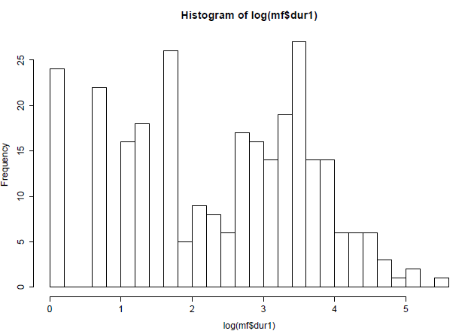

**Figure 1.** Histogram of all mating durations from the CZA experiments (log scale). There is quite a clear dip in frequency around 2 (equivalent to 7.5 minutes) and the peak of successful matings is at about 3.5 (33 mins). The experimental groups are at 5, 10 and 30 minutes (1.6, 2.3 and 3.4 on the log scale).

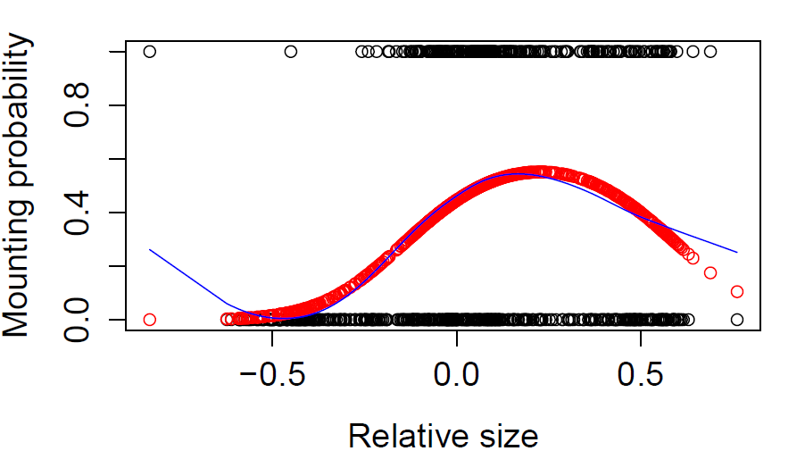

**Figure 2.** Probability of observed mounting behaviours against relative size of the paired female and male (female size – male size)/(female size + male size). Black circles are the observations (about 1000). Red circles follow the quadratic fit (on logit scale), which explains about 12% of the variance. The blue cubic spline shows that the quadratic fit is about the right shape of relationship

**Aim**

Expand knowledge about the reproductive behaviour of the rough periwinkle using data available from four Swedish locations. I will examine mating patterns at different spatial scales as other traits than size that differ between ecotypes may contribute to assortative mating. A preliminary analysis has shown that copulations are likely to last approximately 30 minutes on average. Nevertheless, the bimodal distribution of the frequency of mating durations obtained from one locality (CZA, fig. 1) deserves further attention. Assortative mating may result from a joint effect of relative size and other ecotype traits whose intensity may vary along the rocky shore habitat. If these traits are also influencing the mating behaviour of the snail, the information acquired from copulation durations may reflect the spatial variation of the extent of assortative mating between ecotype and/or between demes.

I will assess the influence of the duration of copulation on sperm transfer, initially in the E ecotype of *Littorina saxatilis,* with particular emphasis on the interpretation of short matings. Aborted copulations at 5, 10 and 30 mins will provide insight into the fertilisation process and offspring production. Short copulations (5 mins) are expected to be inadequate for sperm transfer whereas longer copulations (30 mins) are more likely to yield over time an effective transfer of sperm. Finally, intermediate copulations (10 mins) will be relevant for the description of postmating prezygotic patterns. Aborted copulations at 10 minutes may show whether females will produce offspring and if so whether they will produce fewer than the females mated for 30 minutes. The outcome will pave the way for further studies on the mechanisms involved during transfer and storage of sperm in the intertidal snail.

Estimates of assortative mating obtained from the contact zones of the Swedish and Spanish ecotypes will also be relevant for the evaluation of postcopulatory effects. The mating biology of the brooding periwinkle suggests a likely implication of cryptic female choice and/or sperm competition. The experimental design will comprise males from rocky shore habitats which show a suitable variation of shell size. Females will be reared under laboratory conditions, isolated from males, as unobserved matings will confound the level of paternity. Mating order and duration will be manipulated and their impact determined using microsatellite loci in parental and offspring snails, or genetically-determined colour markers.

**Materials and Methods**

SAMPLING

PHENOTYPES

NO-CHOICE MATING EXPERIMENT

GAUSSIAN MODELS

COMPUTER SIMULATIONS

**References**

Bolnick D.I. and Fitzpatrick B.M. 2007. Sympatric Speciation: Models and Empirical Evidence. *Annu. Rev. Ecol. Evol. Syst.*, **38**: 459–487.

Conde-Padín, P.A., Cruz R., Hollander J., Rolán‐Alvarez E.M. 2008. Revealing the mechanisms of sexual isolation in a case of sympatric and parallel ecological divergence. *Biol. J. Linnean Soc.*, 94: 513–26.

Funk, D.J. 1998. Isolating a Role for Natural Selection in Speciation: Host Adaptation and Sexual Isolation in Neochlamisus bebbianae Leaf Beetles. *Evolution*, **52**: 1744–1759.

Gavrilets, S., 2004. Fitness landscapes and the origin of species (MPB-41). Princeton, NJ: Princeton University Press.

Hollander, J., Lindegarth, M. and Johannesson, K. 2005. Local adaptation but not geographical separation promotes assortative mating in a snail. *Anim. Behav.*, **70**: 1209–1219.

Johannesson, K., Panova, M., Kemppainen, P., André, C., Rolan-Alvarez, E. and Butlin, R.K. 2010. Repeated evolution of reproductive isolation in a marine snail: unveiling mechanisms of speciation. *Philos. Trans. R. Soc. Lond. B Biol. Sci.*, **365**: 1735–1747.

Nosil, P. 2012. *Ecological speciation*. Oxford University Press.

Rundle, H.D. and Nosil, P. 2005. Ecological speciation. *Ecol. Lett.*, **8**: 336–352.

Schluter, D. 2001. Ecology and the origin of species. *Trends Ecol. Evol.*, **16**: 372–380.

Schluter, D. 2009. Evidence for Ecological Speciation and Its Alternative. *Science*, **323**: 737–741.

Schluter, D. and Rambaut, A. 1996. Ecological Speciation in Postglacial Fishes [and Discussion]. *Philos. Trans. R. Soc. Lond. B Biol. Sci.*, **351**: 807–814.

Servedio, M.R. and Kopp, M. 2012. Sexual selection and magic traits in speciation with gene flow. *Curr. Zool.*, **58**: 510–516.