Plasticity - Littorina offspring

Samuel

3/28/2020

For now, the data and results belong to the island CZA and phenotype thickness.

For each sample of population in both generations (parents and offspring), scaling was accomplished by substracting from the individual phenotype value the total mean phenotype and dividing by the total phenotype of generation zero (parents). Total meaning generation zero (parents) across all populations.

where and is the phenotype value of sample of population in the parental and offspring generations, respectively. Total mean of parents across all populations is and total is referred as . Then, for each parental and offspring population, we calculated mean and and used these measures as input for the regression model (Table 1; Fig. 1).

| scaled mean thickness (P) | scaled sd thickness (P) | scaled mean thickness (O) | scaled sd thickness (O) |
| --- | --- | --- | --- |
| 0.74461917 | 0.6704859 | -1.2444092 | 0.2813221 |
| 0.95585904 | 0.5828869 | -0.9659728 | 0.2312805 |
| 0.28092614 | 0.3496944 | -0.8396254 | 0.2015722 |
| 0.74273370 | 0.5506703 | -0.8070043 | 0.3403807 |
| 0.92468502 | 0.9682922 | -1.0521888 | 0.2293698 |
| 0.89533486 | 0.7133213 | -1.1795255 | 0.2319295 |
| 0.74412264 | 0.8113668 | -1.3176528 | 0.3008144 |
| 0.57124855 | 0.7019298 | -1.1512440 | 0.3094049 |
| 0.05787826 | 0.5038127 | -1.0865495 | 0.2923504 |
| -0.08231149 | 0.4180177 | -0.7201566 | 0.2315958 |
| -0.27474300 | 0.4637322 | -0.9301011 | 0.4746698 |
| -0.39377106 | 0.4460784 | -1.0289381 | 0.2524022 |
| -0.92986033 | 0.7062491 | -1.4241929 | 0.3971287 |
| -1.11957208 | 0.5139067 | -1.3768217 | 0.2236816 |
| -0.97903691 | 0.7025012 | -1.2596492 | 0.2419250 |
| -0.93335373 | 0.6337286 | -1.4030925 | 0.2387083 |
| -1.41975404 | 0.3207733 | -1.3565431 | 0.2545441 |

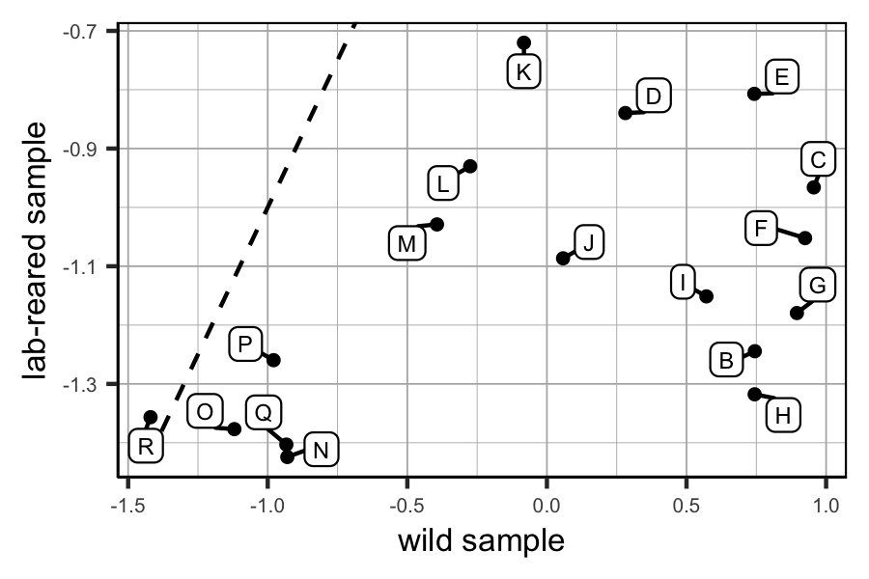

Figure 1. Scatter plot of the scaled data.

We defined a regression model with measurement error in x an y using Stan.

// The input data are vectors 'x' and 'sd_x' of length 'N'.  
data {  
 int<lower=0> N;  
 vector[N] x;  
 vector<lower=0>[N] sd_x;  
}  
  
// The parameters accepted by the model.  
parameters {  
 vector[N] x_lat;  
 vector[N] y_lat;  
 real alpha;  
 real beta;  
 real<lower=0> sigma;  
}  
  
transformed parameters {  
 vector[N] mu_yhat = alpha + beta * x_lat;  
}  
  
// The model to be estimated. We model the output  
// 'y_lat' to be normally distributed with mean 'mu_hat = alpha + beta * x_lat'  
// and standard deviation 'sigma'.  
model {  
 //x_lat ~ normal(0, 10);  
 alpha ~ normal(0, 5);  
 beta ~ normal(1, 5);  
 sigma ~ cauchy(0., 5);  
   
 x ~ normal(x_lat, sd_x);  
 y_lat ~ normal(mu_yhat, sigma);  
}

There were warning messages when using after scaling:

1: There were 59 divergent transitions after warmup. Increasing adapt_delta above 0.99 may help. See <http://mc-stan.org/misc/warnings.html#divergent-transitions-after-warmup>

2: There were 8059 transitions after warmup that exceeded the maximum treedepth. Increase max_treedepth above 10. See <http://mc-stan.org/misc/warnings.html#maximum-treedepth-exceeded>

3: There were 4 chains where the estimated Bayesian Fraction of Missing Information was low. See <http://mc-stan.org/misc/warnings.html#bfmi-low>

We can examine the Stan output to diagnose the above sampling problems (Fig. 2) and also look at the parameter estimate for *sigma* (Table 2).

## Warning in KernSmooth::bkde2D(x, bandwidth = bandwidth, gridsize = nbin, :  
## Binning grid too coarse for current (small) bandwidth: consider increasing  
## 'gridsize'  
  
## Warning in KernSmooth::bkde2D(x, bandwidth = bandwidth, gridsize = nbin, :  
## Binning grid too coarse for current (small) bandwidth: consider increasing  
## 'gridsize'  
  
## Warning in KernSmooth::bkde2D(x, bandwidth = bandwidth, gridsize = nbin, :  
## Binning grid too coarse for current (small) bandwidth: consider increasing  
## 'gridsize'  
  
## Warning in KernSmooth::bkde2D(x, bandwidth = bandwidth, gridsize = nbin, :  
## Binning grid too coarse for current (small) bandwidth: consider increasing  
## 'gridsize'

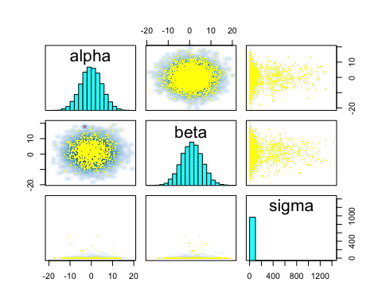

Figure 2. Divergent transitions diagnosis.

| par | mean | se_mean | sd | X2.5. | X25. | X50. | X75. | X97.5. | n_eff | Rhat |
| --- | --- | --- | --- | --- | --- | --- | --- | --- | --- | --- |
| alpha | -0.01 | 0.03 | 4.95 | -9.69 | -3.31 | -0.05 | 3.32 | 9.78 | 22834.56 | 1.00 |
| beta | 1.04 | 0.03 | 5.00 | -8.76 | -2.33 | 1.04 | 4.40 | 10.84 | 21256.98 | 1.00 |
| sigma | 17.79 | 7.03 | 69.43 | 0.49 | 2.48 | 5.26 | 11.70 | 87.43 | 97.44 | 1.05 |

Another alternative would be to try a mixed model with by population random effect.

Since we standardized the data we know that should be centered near 0 and near 1 (Table 2). We would also expect the fitted values to fall onto the 1:1 line (Fig. 3).

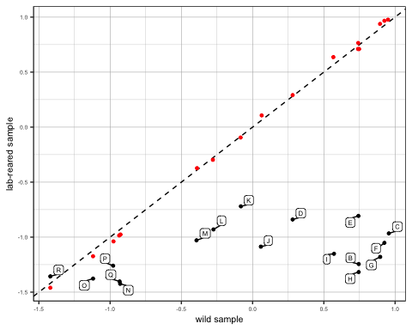

Figure 3. Scatter plot of the scaled data with fitted values.