Plasticity - Littorina offspring

Samuel

3/28/2020

For now, the data and results belong to the island CZA and phenotype thickness.

For each sample $i$ of population $j$ in both generations (parents and offspring), scaling was accomplished by substracting from the individual phenotype value the total mean phenotype and dividing by the total $SD$ phenotype. Total meaning generation zero (parents) across all populations.

$$\hat{x_{ij}}=\frac{x_{ij}-\overline{x_{T}}}{σ_{x_{T}}}.$$

$$\hat{y_{ij}}=\frac{y_{ij}-\overline{x_{T}}}{σ_{x_{T}}}.$$

where $x_{ij}$ and $y_{ij}$ is the phenotype value of sample $i$ in population $j$ of the parental and offspring generations, respectively. Total mean of parents across all populations is $\overline{x_{T}}$ and their total $SD$ is referred as $σ_{x_{T}}$. Then, within each parental and offspring population, we calculated mean and $SD$ and used these measures as input for the regression model (Table 1; Fig. 1).

Table 1. Mean and stadard deviation of scaled phenotype of parents (P) and offspring (O).

| scaled mean thickness (P) | scaled sd thickness (P) | scaled mean thickness (O) | scaled sd thickness (O) |
| --- | --- | --- | --- |
| 0.74461917 | 0.6704859 | -1.2444092 | 0.2813221 |
| 0.95585904 | 0.5828869 | -0.9659728 | 0.2312805 |
| 0.28092614 | 0.3496944 | -0.8396254 | 0.2015722 |
| 0.74273370 | 0.5506703 | -0.8070043 | 0.3403807 |
| 0.92468502 | 0.9682922 | -1.0521888 | 0.2293698 |
| 0.89533486 | 0.7133213 | -1.1795255 | 0.2319295 |
| 0.74412264 | 0.8113668 | -1.3176528 | 0.3008144 |
| 0.57124855 | 0.7019298 | -1.1512440 | 0.3094049 |
| 0.05787826 | 0.5038127 | -1.0865495 | 0.2923504 |
| -0.08231149 | 0.4180177 | -0.7201566 | 0.2315958 |
| -0.27474300 | 0.4637322 | -0.9301011 | 0.4746698 |
| -0.39377106 | 0.4460784 | -1.0289381 | 0.2524022 |
| -0.92986033 | 0.7062491 | -1.4241929 | 0.3971287 |
| -1.11957208 | 0.5139067 | -1.3768217 | 0.2236816 |
| -0.97903691 | 0.7025012 | -1.2596492 | 0.2419250 |
| -0.93335373 | 0.6337286 | -1.4030925 | 0.2387083 |
| -1.41975404 | 0.3207733 | -1.3565431 | 0.2545441 |

Mean and $SD$ of scaled mean thickness (P) = -0.0126468 and 0.8229823.

Mean and $SD$ of scaled mean thickness (O) = -1.1260981 and 0.221185.

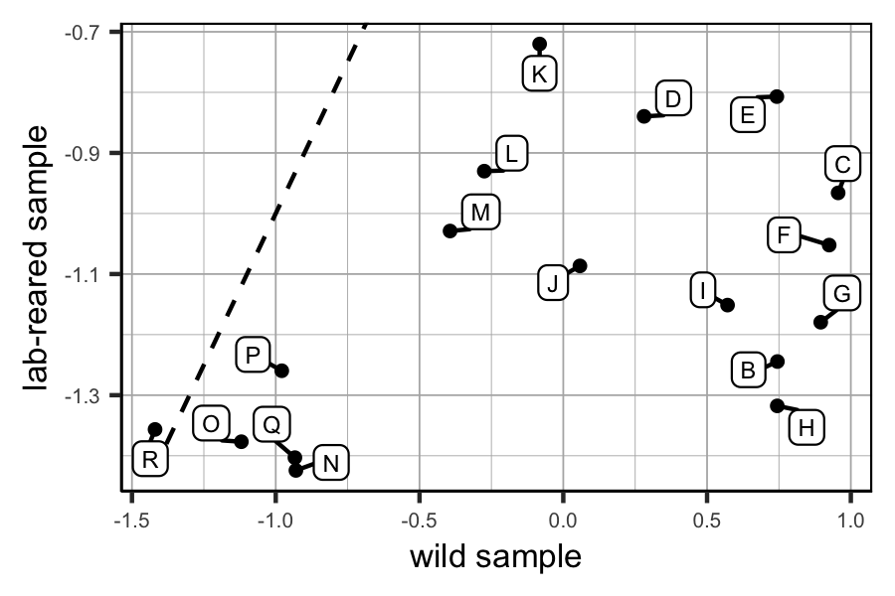

Figure 1. Scatter plot of the scaled data.

We defined a regression model with measurement error in x an y using Stan.