STEM degrees (Science, Technology, Engineering, and Math) are notorious for their difficulty. In the attempt to encourage more students to try for these programs, it is important to identify what features of the academic environment discourage aspiring students to eventually switch out. Calculus I and II are fundamental math courses that are required in almost every STEM discipline. To achieve our goal to identify what causes people to switch majors, we will look to see how often students entering Calculus I and aspiring to take Calculus II and beyond switch out of the Calculus track and why.

The response variable is whether a student is a switcher from calculus or a persister in calculus (*Switcher)*, which is a qualitative variable. The quantitative explanatory variables are standardized test scores (*StandardizedTest)*, instructor quality on a scale from 1 to 6 (*Teacher),* and student-centered practices (*ClassPractice)*. The qualitative explanatory variables are a student’s previous calculus experience (High School, College, None), major (STEM field, Engineering, Pre-Med, non-STEM, undecided), and Gender (Male, Female).

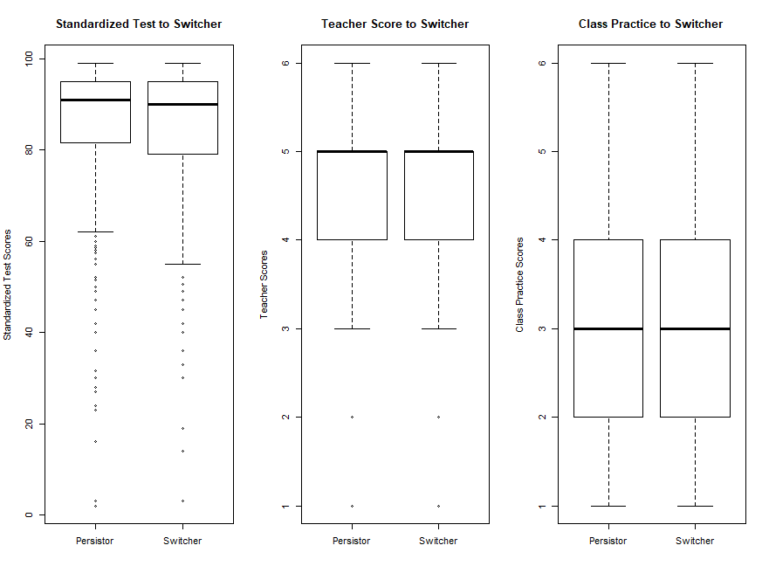

Figure 1: Boxplots of Standardized Test Scores, Teacher Scores and Class Practice Scores in regard to the persisters and switchers

|  |  |  |  |
| --- | --- | --- | --- |
| Table 1: Previous Calculus Experience for  Persisters and Switchers | | | |
| Calculus Experience | Persister | Switcher | Total |
| High School | 1058 (83.4%) | 210 (16.6%) | 1268 |
| College | 123 (84.2%) | 23 (15.8%) | 146 |
| None | 472 (80.5 %) | 114 (19.5%) | 586 |
| Total | 1653 | 347 | 2000 |

|  |  |  |  |
| --- | --- | --- | --- |
| Table 2: Majors of Persisters and Switchers | | | |
| Major | Persister | Switcher | Total |
| STEM Field | 379 (88.1%) | 51 (11.9%) | 430 |
| Engineering | 671 (95.6%) | 31 (4.4%) | 702 |
| Pre-Med | 319 (71.7%) | 126 (28.3%) | 445 |
| non-STEM | 145 (62.5%) | 87 (37.5%) | 232 |
| Undecided | 139 (72.8%) | 52 (27.2%) | 191 |
| Total | 1653 | 347 | 2000 |

|  |  |  |  |
| --- | --- | --- | --- |
| Table 3: Gender of Persisters and Switchers | | | |
| Gender | Persister | Switcher | Total |
| Male | 950 (86.4%) | 150 (13.6%) | 1100 |
| Female | 703 (78.1%) | 197 (21.9%) | 900 |
| Total | 1653 | 347 | 2000 |

Looking at the boxplots above, it doesn’t look like there’s a difference in the persisters and switchers when it comes to Teacher or Class Practice scores. There may be a small difference between persisters and switchers and their Standardized Test scores. From the contingency tables, the most obvious indicators of someone switching are non-STEM majors with 37.5% of non-STEM majors switching from the calculus track. Females switched a higher rate than men as 21.9% of the females switched in our training data set. If previous calculus experience has an effect, not having any previous calculus experience (19.5%) had a larger effect

|  |  |  |
| --- | --- | --- |
| Table 4: Model Parameter Estimates and  Standard Errors | | |
| Coefficient | Estimate | Standard Error |
| (Intercept) | -0.113 | 0.516 |
| PrevCalcCollege | 0.027 | 0.260 |
| PrevCalcNone | 0.213 | 0.142 |
| StandardizedTest | -0.011 | 0.004 |
| MajorEngineering | -1.018 | 0.239 |
| MajorPreMed | 1.073 | 0.187 |
| MajorNonSTEM | 1.526 | 0.206 |
| MajorUndecided | 1.030 | 0.225 |
| Teacher | -0.365 | 0.069 |
| ClassPractice | 0.135 | 0.061 |
| GenderFemale | 0.267 | 0.130 |

than having high school or college experience

After transforming from our log-results, we see that for every one additional point increase in a student’s standardized test score, we estimate a 1.1% decrease (95% CI: -2.1%,

-0.2%) in odds of a student switching from calculus, holding all else constant.

We tested

*H­o : student’s previous calculus experience makes no difference in a student switching from calculus*

with

*H­­a: student’s previous calculus experience does have an effect on students switching out of calculus*.

We found that a student’s previous calculus experience does not make a statistically significant difference (χ2 = 2.265, p-value = 0.322).

We also tested

*Ho: student’s intended major makes no difference in a student switching from calculus*

with

*H­­a: student’s intended major does have an effect on students switching from calculus.*

We found that there is a statistically significant difference in a student’s intended major (χ2 = 198.34, p-value < 0.001).

We wanted to know if there is a difference between men and women on the odds of switching from the calculus sequence. We found that women are 30% (95% CI: 1%, 69%) more likely to switch from the calculus sequence than men, holding all else constant.

In my own experience, because my intended major is statistics I took both Calculus I and Calculus II because they are required to graduate. I did take Calculus in high school and had a little experience in it, but I didn’t do very well in high school. Since I didn’t do well, I had to take calculus in college which could be why if someone does well in previous experience, you’re less likely to have to take calculus in college if they received college credit for it.

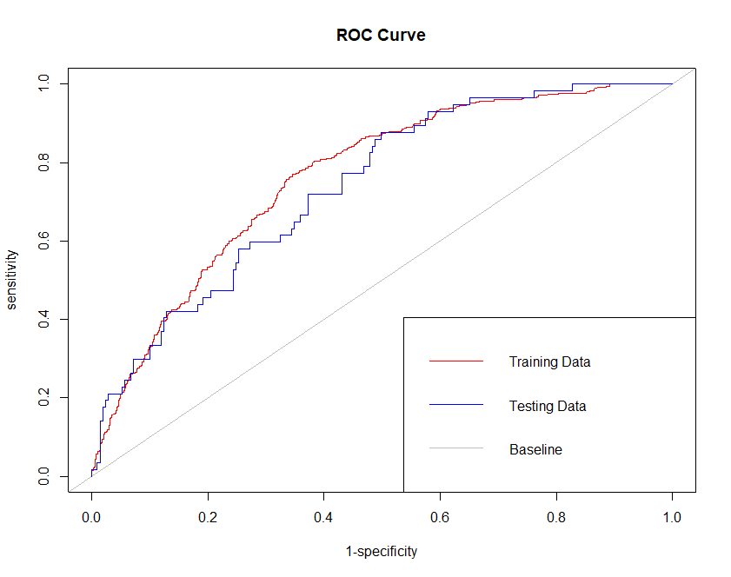

In order to determine how well our model can make predictions, we created a ROC curve. The larger the AUC (Area Under the Curve), the better our model was at predicting whether a student switches from the Calculus track. The AUC for our model was 0.76 (with 1 being a perfect prediction), which means our model did well at making predictions, although improvements could be made.