Software Requirement Specification
- Project Overview
The main objective is to design a method to eliminate the corruption from public distribution system by adopting multi model biometric system as secure method. Major commodities distributed include staple food grains, such as wheat, rice, sugar, and kerosene, through a network of public distribution shops (also known as ration shops) established in several states across the country. Many FPS dealers resort to malpractice with illegal diversions of commodities.
To eliminate such malpractices a robust mechanism is needed and such mechanism should be fool-proof so that malpractices can be completely avoided. To arrive such method we are proposing biometric authentication with online Signature and Hand gesture.
To achieve the objectives specified above we are proposing Automatic Rationing System with Multi Model Biometric Secure System. In this project Online Signature verification and Hand gesture using Accelerometer as biometric devices are proposed. Linking Adhar card and automatic deduction from bank accounts of customer during transaction are incorporated to eliminate manual intervention. All the data base system is read-only making the system even foolproof and no one can edit the data manually.

- External Interface Requirements
- User Interfaces :
The product must be usable from the text command line, particularly under operating systems where the command line is a standard common user interface (such as Linux). However, some guidelines do apply:
Help. Help should be available for all tools. Command-line tools should print a helpful message (if appropriate) if invoked with no arguments (if any command line tools are designed to accept input as a pipe, it is acceptable to forego this rule). If multiple options are available, the product should present a text menu detailing the probable choices rather than forcing the user to retype everything up to that point.
Feedback.Each tool should give feedback to the user describing the results of their last action; in other words, issue submissions should be acknowledged (with a response message from standard output, a follow-on web page, or return email) with some positive indication of the result.
Command-line options.:If command-line tools can accept arguments, they will support them according to the standards laid out in the GNU coding standards, and should support both short and long forms.

- Harware Interfaces :

Raspberry Pi
In the above block diagram for model A, B, A+, B+; model A and A+ have the lowest two blocks and the rightmost block missing (note that these three blocks are in a chip that actually contains a three-port USB hub, with a USB Ethernet adapter connected to one of its ports). In model A and A+ the USB port is connected directly to the SoC. On model B+ the chip contains a five-point hub, with four USB ports fed out, instead of the two on model B.
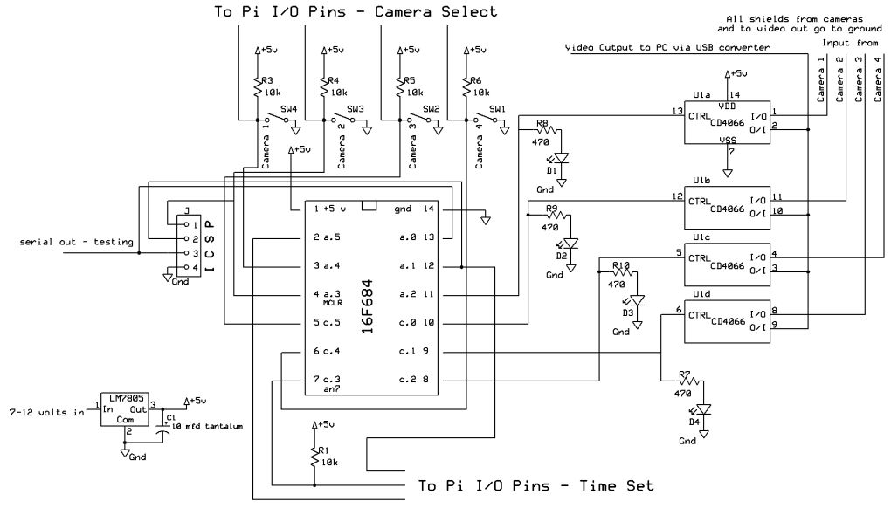
Figure 4.1 Raspberry Pi circuit Diagram

Processor
The SoC used in the first generation Raspberry Pi is somewhat equivalent to the chip used in older smartphones (such asiPhone / 3G / 3GS). The Raspberry Pi is based on the Broadcom BCM2835 system on a chip (SoC),^{[1]} which includes an 700 MHz ARM1176JZF-S processor, VideoCore IV GPU,^{[7]} and RAM. It has a Level 1 cache of 16 KB and a Level 2 cache of 128 KB. The Level 2 cache is used primarily by the GPU. The SoC is stacked underneath the RAM chip, so only its edge is visible.

RAM
On the older beta model B boards, 128 MB was allocated by default to the GPU, leaving 128 MB for the CPU. On the first 256 MB release model B (and model A), three different splits were possible. The default split was 192 MB (RAM for CPU), which should be sufficient for standalone 1080p video decoding, or for simple 3D, but probably not for both together. 224 MB was for Linux only, with just a 1080p framebuffer, and was likely to fail for any video or 3D. 128 MB was for heavy 3D, possibly also with video decoding (e.g. XBMC). Comparatively the Nokia 701 uses 128 MB for the Broadcom VideoCore IV. For the new model B with 512 MB RAM initially there were new standard memory split files released( arm256_start.elf, arm384_start.elf, arm496_start.elf) for 256 MB, 384 MB and 496 MB CPU RAM (and 256 MB, 128 MB and 16 MB video RAM). But a week or so later the RPF released a new version of start elf that could read a new entry in config.txt (gpu_mem=xx) and could dynamically assign an amount of RAM (from 16 to 256 MB in 8 MB steps) to the GPU, so the older method of memory splits became obsolete, and a single start elf worked the same for 256 and 512 MB Pis. The second generation has 1 GB of RAM.

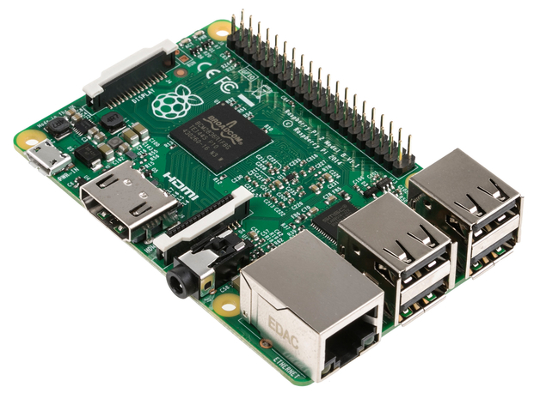
Figure 4.2 Raspberry PI

The Raspberry Pi is a series of credit card-sized single-board computers developed in the UK by the Raspberry Pi Foundation with the intention of promoting the teaching of basic computer science in schools.
The original Raspberry Pi and Raspberry Pi 2 are manufactured in several board configurations through licensed manufacturing agreements with Newark element14 (Premier Farnell), RS Components and Egoman. These companies sell the Raspberry Pi online.Egoman produces a version for distribution solely in China and Taiwan, which can be distinguished from other Pis by their red colouring and lack of FCC/CE marks. The hardware is the same across all manufacturers.
The original Raspberry Pi is based on the Broadcom BCM2835 system on a chip (SoC), which includes an ARM1176JZF-S700 MHz processor, VideoCore IV GPU, and was originally shipped with 256 megabytes of RAM, later upgraded (models B and B+) to 512 MB. The system has Secure Digital (SD) (models A and B) or MicroSD (models A+ and B+) sockets for boot media and persistent storage

In 2014, the Raspberry Pi Foundation launched the Compute Module, which packages a BCM2835 with 512 MB RAM and aneMMC flash chip into a module for use as a part of embedded systems.

The Foundation provides Debian and Arch Linux ARM distributions for download. Tools are available for Python as the main programming language, with support for BBC BASIC (via the RISC OS image or the Brandy Basic clone for Linux), C, C++, Java, Perl and Ruby.

As of 18 February 2015, over five million Raspberry Pis have been sold. While already the fastest selling British personal computer, it has also shipped the second largest number of units behind the Amstrad PCW, the "Personal Computer Word-processor", which sold eight million.

In early February 2015, the next-generation Raspberry Pi, Raspberry Pi 2, was officially announced. The new computer board will initially be available only in one configuration (model B) and features a Broadcom BCM2836 SoC, with a quad-coreARM Cortex-A7 CPU and a VideoCore IV dual-core GPU; 1 GB of RAM with remaining specifications being similar to those of the previous generation model B+. Crucially, the Raspberry Pi 2 will retain the same US$35 price point of the model B, with the US$25 model A remaining on sale.

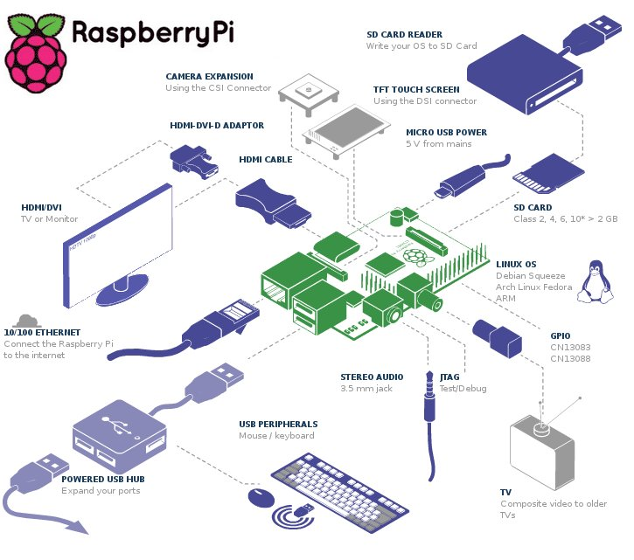
Figure 4.3 Raspberry Pi Architecture

Liquid crystal display
Main articles: Liquid-crystal display and Thin-film-transistor liquid-crystal display
There are multiple technologies that have been used to implement liquid crystal displays (LCD). Throughout the 1990s, the primary use of LCD technology as computer monitors was in laptops where the lower power consumption, lighter weight, and smaller physical size of LCDs justified the higher price versus a CRT. Commonly, the same laptop would be offered with an assortment of display options at increasing price points: (active or passive) monochrome, passive color, or active matrix color (TFT). As volume and manufacturing capability have improved, the monochrome and passive color technologies were dropped from most product lines.

TFT-LCD is a variant of LCD which is now the dominant technology used for computer monitors.

The first standalone LCD displays appeared in the mid-1990s selling for high prices. As prices declined over a period of years they became more popular, and by 1997 were competing with CRT monitors. Among the first desktop LCD computer monitors was the Eizo L66 in the mid-1990s, the Apple Studio Display in 1998, and the Apple Cinema Display in 1999. In 2003, TFT-LCDs outsold CRTs for the first time, becoming the primary technology used for computer monitors.The main advantages of LCDs over CRT displays are that LCDs consume less power, take up much less space, and are considerably lighter. The now common active matrix TFT-LCD technology also has less flickering than CRTs, which reduces eye strain.On the other hand, CRT monitors have superior contrast, have superior response time, are able to use multiple screen resolutions natively, and there is no discernible flicker if the refresh rate is set to a sufficiently high value. LCD monitors have now very high temporal accuracy and can be used for vision research.
What is Accelerometers
What are accelerometers used for?
Accelerometers are the stuff of rocket science—quite literally! ounted in spacecraft, they're a handy way to measure not just
Accelerator2changes in rocket speed but also apogee (when a craft is at its maximum distance from earth or another mass, so its acceleration due to gravity is at a minimum) and orientation (because tilting something changes the way gravity acts on it and the force it feels). Accelerometers are also widely used in inertial navigation and guidance system in such things as airplane and ship autopilots. Another very common use in transportation is in automobileairbags: when anaccelerometer detects a sudden change in a car's speed, signaling an imminent collision, it triggers an electrical circuit that makes the airbags inflate.If you have a modern cellphone, MP3 player, or handheld games console, it probably has an accelerometer built into it so it can sense when you tilt it from side to side. That's how an iPhone or an iPod Touch automatically figures out when to switch the screen layout from portrait to landscape. Many games and "apps" designed for gadgets such as iPhones work by sensing how hard or how fast you move or shake the case using tiny accelerometer chips inside
How do accelerometers work?
There are many different ways to make an accelerometer! Some accelerometers use the piezoelectric effect - they contain microscopic crystal structures that get stressed by accelerative forces, which causes a voltage to be generated. Another way to do it is by sensing changes in capacitance. If you have two microstructures next to each other, they have a certain capacitance between them. If an accelerative force moves one of the structures, then the capacitance will change. Add some circuitry to convert from capacitance to voltage, and you will get an accelerometer. There are even more methods, including use of the piezoresistive effect, hot air bubbles, and light.

What things should I consider when buying an accelerometer?
Analog vs digital - First and foremost, you must choose between an accelerometer with analog outputs or digital outputs. This will be determined by the hardware that you are interfacing the accelerometer with. Analog style accelerometers output a continuous voltage that is proportional to acceleration. E.g. 2.5V for 0g, 2.6V for 0.5g, 2.7V for 1g. Digital accelerometers usually use pulse width modulation (PWM) for their output. This means there will be a square wave of a certain frequency, and the amount of time the voltage is high will be proportional to the amount of acceleration.

If you are using a BASIC Stamp, or any other microcontroller with purely digital inputs, you will most likely need to go for a digital output accelerometer. The disadvantage here is that it requires you to use the timing resources of the microcontroller to measure the duty cycle, as well as performing a computationally intensive division operation.

If you are using a PIC/AVR/OOPIC/Javelin with analog inputs, or a completely analog based circuit, analog is almost always the best way to go. Depending on the compiler, measuring analog acceleration can be as simple as acceleration=read_adc(); and can be done in a few microseconds.

Number of axes - For most projects, two is enough. However, if you want to attempt 3d positioning, you will need a 3 axis accelerometer, or two 2 axis ones mounted at right angles.

Maximum swing - If you only care about measuring tilt using earth's gravity, a ±1.5g accelerometer will be more than enough. If you are going to use the accelerometer to measure the motion of a car, plane or robot, ±2g should give you enough headroom to work with. For a project that experiences very sudden starts or stops, you will need one that can handle ±5g or more.
Sensitivity - Generally speaking, the more sensitivity the better. This means that for a given change in acceleration, there will be a larger change in signal. Since larger signal changes are easier to measure, you will get more accurate readings.
Bandwidth - This means the amount of times per second you can take a reliable acceleration reading. For slow moving tilt sensing applications, a bandwidth of 50Hz will probably suffice. If you intend to do vibration measurement, or control a fast moving machine, you will want a bandwidth of several hundred Hz.

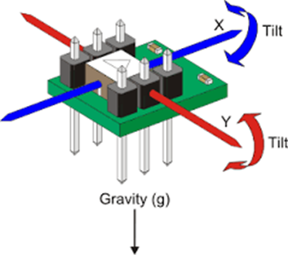
Impedance/buffering issues - This is by far the single most common source of problems in projects involving analog accelerometers, because so few people thoroughly read the required documentation. Both PIC and AVR datasheets specify that for A-D conversion to work properly, the connected device must have an output impedance under 10kΩ. Unfortunately, Analog Devices' analog accelerometers have an output impedance of 32kΩ. The solution to this is to use a low input offset rail to rail op amp as a buffer to lower the output impedance. As far as we know, the DE-ACCM is the only accelerometer solution that takes care of this problem for you
An accelerometer is an electromechanical device that will measure acceleration forces. These forces may be static, like the constant force of gravity pulling at your feet, or they could be dynamic - caused by moving or vibrating the accelerometer.

What are accelerometers useful for?
By measuring the amount of static acceleration due to gravity, you can find out the angle the device is tilted at with respect to the earth. By sensing the amount of dynamic acceleration, you can analyze the way the device is moving. At first, measuring tilt and acceleration doesn't seem all that exciting. However, engineers have come up with many ways to make really useful products with them.
An accelerometer can help your project understand its surroundings better. Is it driving uphill? Is it going to fall over when it takes another step? Is it flying horizontally or is it dive bombing your professor? A good programmer can write code to answer all of these questions using the data provided by an accelerometer. An accelerometer can help analyze problems in a car engine using vibration testing, or you could even use one to make a musical instrument.
In the computing world, IBM and Apple have recently started using accelerometers in their laptops to protect hard drives from damage. If you accidentally drop the laptop, the accelerometer detects the sudden freefall, and switches the hard drive off so the heads don't crash on the platters. In a similar fashion, high g accelerometers are the industry standard way of detecting car crashes and deploying airbags at just the right time.

PIC microcontrollers
The microcontrollers played revolutionary role in embedded industry after the invention of Intel 8051. The steady and progressive research in this field gave the industry more efficient, high-performance and low-power consumption microcontrollers. The AVR, PIC and ARM are the prime examples. The new age microcontrollers are getting smarter and richer by including latest communication protocols like USB, I2C, SPI, Ethernet, CAN etc.
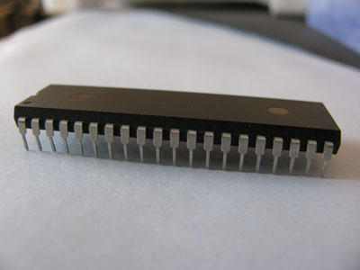
Development:
Since 1998, Microchip Technology continuously developed new high performance microcontrollers with new complex architecture and enhanced in-built peripherals. PIC microcontroller is based on Harvard architecture. At present PIC microcontrollers are widely used for industrial purpose due to its high performance ability at low power consumption. It is also very famous among hobbyists due to moderate cost and easy availability of its supporting software and hardware tools like compilers, simulators, debuggers etc. The 8-bit PIC microcontroller is divided into following four categories on the basis of internal architecture:

1. Base Line PIC
2. Mid-Range PIC
3. Enhanced Mid-Range PIC
4. PIC18

1. Base Line PIC
Base Line PICs are the least complex PIC microcontrollers. These microcontrollers work on 12-bit instruction architecture which means that the word size of instruction sets are of 12 bits for these controllers. These are smallest and cheapest PICs, available with 6 to 40 pin packaging. The small size and low cost of Base Line PIC replaced the traditional ICs like 555, logic gates etc. in industries.

2. Mid-Range PIC
Mid-Range PICs are based on 14-bit instruction architecture and are able to work up to 20 MHz speed. These controllers are available with 8 to 64 pin packaging. These microcontrollers are available with different peripherals like ADC, PWM, Op-Amps and different communication protocols like USART, SPI, I2C (TWI), etc. which make them widely usable microcontrollers not only for industry but for hobbyists as well.
3. Enhanced Mid-Range PIC
These controllers are enhanced version of Mid-Range core. This range of controllers provides additional performance, greater flash memory and high speed at very low power consumption. This range of PIC also includes multiple peripherals and supports protocols like USART, SPI, I2C and so on.

4. PIC18
PIC18 range is based on 16-bit instruction architecture incorporating advanced RISC architecture which makes it highest performer among the all 8-bit PIC families. The PIC18 range is integrated with new age communication protocols like USB, CAN, LIN, Ethernet (TCP/IP protocol) to communicate with local and/or internet based networks. This range also supports the connectivity of Human Interface Devices like touch panels etc.
Architecture:
PIC microcontrollers are based on advanced RISC architecture. RISC stands for Reduced Instruction Set Computing. In this architecture, the instruction set of hardware gets reduced which increases the execution rate (speed) of system.

PIC microcontrollers follow Harvard architecture for internal data transfer. In Harvard architecture there are two separate memories for program and data. These two memories are accessed through different buses for data communication between memories and CPU core. This architecture improves the speed of system over Von Neumann architecture in which program and data are fetched from the same memory using the same bus. PIC18 series controllers are based on 16-bit instruction set.

The question may arise that if PIC18 are called 8-bit microcontrollers, then what about them being based on 16-bit instructions set. ‘PIC18 is an 8-bit microcontroller’ this statement means that the CPU core can receive/transmit or process a maximum of 8-bit data at a time. On the other hand the statement ‘PIC18 microcontrollers are based on 16-bit instruction set’ means that the assembly instruction sets are of 16-bit.

The data memory is interfaced with 8-bit bus and program memory is interfaced with 16-bit bus as depicted in the following figure

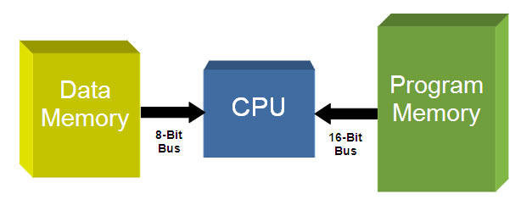

PIC 32 Harvard Architecture
PIC microcontroller contains an 8-bit ALU (Arithmetic Logic Unit) and an 8-bit Working Register (Accumulator). There are different GPRs (General Purpose Registers) and SFRs (Special Function Registers) in a PIC microcontroller. The overall system performs 8-bit arithmetic and logic functions. These functions usually need one or two operands. One of the operands is stored in WREG (Accumulator) and the other one is stored in GPR/SFR. The two data is processed by ALU and stored in WREG or other registers.

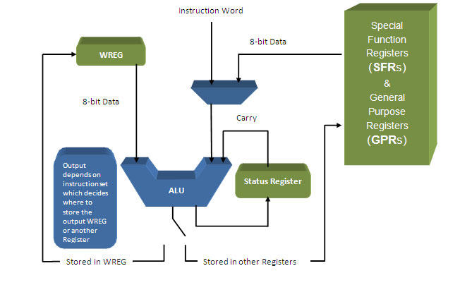
The above process occurs in a single machine cycle. In PIC microcontroller, a single machine cycle consists of 4 oscillation periods. Thus an instruction needs 4 clock periods to be executed. This makes it faster than other 8051 microcontrollers.

- Software Interfaces :

LINUX (UBUNTU):

Features

A default installation of Ubuntu contains a wide range of software that includes Libre Office, Firefox, Thunderbird, Transmission, and several lightweight games such as Sudoku and chess. Many additional software packages, including titles no longer in the default installation such as Evolution, GIMP, Pidgin, and Synaptic, are accessible from the built in Ubuntu Software Center as well as any other APT based package management tool. Execution of Microsoft Office and other Microsoft Windows applications can be facilitated via the Wine com through the use of a virtual machine such as Virtual Box or VMware kstation

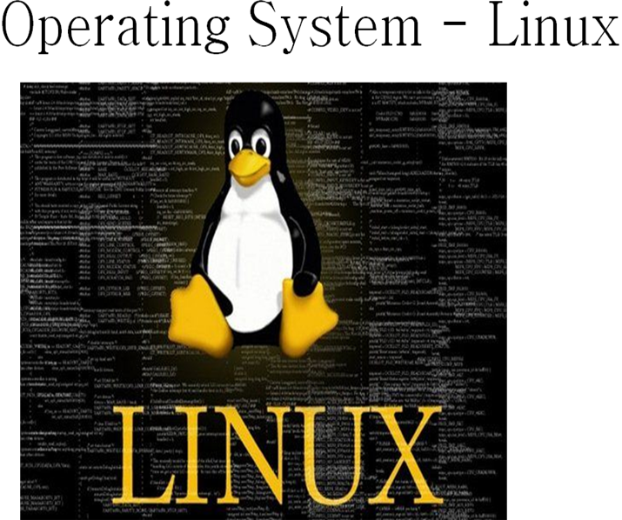
Following are some of the important features of Linux Operating System.
- Portable - Portability means softwares can works on different types of hardwares in same way.
- Open Source - Linux source code is freely available and it is community based development project.
- Multi-User - Linux is a multiuser system means multiple users can access system resources like memory/ ram/ application programs at same time.
- Multiprogramming - Linux is a multiprogramming system means multiple applications can run at same time.
- Hierarchical File System - Linux provides a standard file structure in which system files/ user files are arranged.
- Shell - Linux provides a special interpreter program which can be used to execute commands of the operating system. It can be used to do various types of operations, call application programs etc.
- Security - Linux provides user security using authentication features like password protection/ controlled access to specific files/ encryption of data.

Security
Ubntu's goal is to be secure "out-of-the box". By default, the user's programs run with low previleges and cannot corrupt the operating system or other user's files. For increased security,* the sudo tool is used to assign temporary privileges for performing adative tasks, which allows the root account to remain locked and helps prevent inexerienced users from inadvertently making catastrophic system changes or opening secrity holes.Policy Kit is also being widely implemented into the desktop to further harden he system. Most network ports are closed by default to prevent hacking. built-infiewall allows end-users who install network servers to control access. A GUI (GUI for Uncomplicated Firewall) is available to configure it. Ubuntu compiles its packages using GCC features such as PIE and harden its software. These extra features greatly increase security at the performance expense of 1% in 32 bit and 0.01% in 64 bit. The home and Private directories can be encrypted.

INSTALLATION
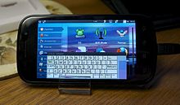
The system requirements vary among Ubuntu products. For the Ubuntu desktop release 14.04, a PC with at least 768 MB of RAM and 5 GB of disk space is recommended. For less powerful computers, there are other Ubuntu distributions such as Lubuntu and Xubuntu. As of version 12.04, Ubuntu supports the ARM architecture.Ubuntu is also available on PowerPC,and SPARC platforms,although these platforms are not officially supported.
Live images are the typical way for users to assess and subsequently install Ubuntu. These can be downloaded as a disk image (.iso) and subsequently burnt to a DVD and booted, or run via UNetbootin directly from a USB drive (making, respectively, a live DVD or live USB medium). Running Ubuntu in this way is typically slower than running it from a hard drive, but does not alter the computer unless specifically instructed by the user. If the user chooses to boot the live image rather than execute an installer at boot time, there is still the option to then use an installer called Ubiquity to install Ubuntu once booted into the live environment. Disk images of all current and past versions are available for download at the Ubuntu web site. Various third-party programs such as remastersys and Reconstructor are available to create customized copies of the Ubuntu Live DVDs (or CDs). "Minimal CDs" are available (for server use) that fit on a CD.
Additionally, USB flash drive installations can be used to boot Ubuntu and Kubuntu in a way that allows permanent saving of user settings and portability of the USB-installed system between physical machines (however, the computers' BIOS must support booting from USB).
In newer versions of Ubuntu, the Ubuntu Live USB creator can be used to install Ubuntu on a USB drive (with or without a live CD or DVD). Creating a bootable USB drive with persistence is as simple as dragging a slider to determine how much space to reserve for persistence; for this, Ubuntu employs casper.
The desktop edition can also be installed using the Netboot image (aka netbook tarball) which uses the debian-installer and allows certain specialist installations of Ubuntu: setting up automated deployments, upgrading from older installations without network access, LVM and/or RAID partitioning, installs on systems with less than about 256 MB of RAM (although low-memory systems may not be able to run a full desktop environment reasonably).
EMBEDDED C
In 2008, the C Standards Committee extended the C language to address these issues by providing a common standard for all implementations to adhere to. It includes a number of features not available in normal C, such as, fixed-point arithmetic, named address spaces, and basic I/O hardware addressing.
Embedded C use most of the syntax and semantics of standard C, e.g., main() function, variable definition, data type declaration, conditional statements (if, switch. case), loops (while, for), functions, arrays and strings, structures and union, bit operations, macros, unions, etc.
Embedded systems programming
Embedded systems programming is different from developing applications on a desktop computers. Key characteristics of an embedded system, when compared to PCs, are as follows:
- Embedded devices have resource constraints (limited ROM, limited RAM, limited stack space, less processing power)
- Components used in embedded system and PCs are different; embedded systems typically uses smaller, less power consuming components. Embedded systems are more tied to the hardware.
Two salient features of Embedded Programming are code speed and code size. Code speed is governed by the processing power, timing constraints, whereas code size is governed by available program memory and use of programming language. Goal of embedded system programming is to get maximum features in minimum space and minimum time.

Embedded systems are programmed using different type of languages:
- Machine Code
- Low level language, i.e., assembly
- High level language like C, C++, Java, Ada, etc.
- Application level language like Visual Basic, scripts, Access, etc.

NECESSITY
During infancy years of microprocessor based systems, programs were developed using assemblers and fused into the EPROMs. There used to be no mechanism to find what the program was doing. LEDs, switches, etc. were used to check for correct execution of the program. Some ‘very fortunate’ developers had In-circuit Simulators (ICEs), but they were too costly and were not quite reliable as well. As time progressed, use of microprocessor-specific assembly-only as the programming language reduced and embedded systems moved onto C as the embedded programming language of choice. C is the most widely used programming language for embedded processors/controllers. Assembly is also used but mainly to implement those portions of the code where very high timing accuracy, code size efficiency, etc. are prime requirements.
As assembly language programs are specific to a processor, assembly language didn’t offer portability across systems. To overcome this disadvantage, several high level languages, including C, came up. Some other languages like PLM, Modula-2, Pascal, etc. also came but couldn’t find wide acceptance. Amongst those, C got wide acceptance for not only embedded systems, but also for desktop applications. Even though C might have lost its sheen as mainstream language for general purpose applications, it still is having a strong-hold in embedded programming. Due to the wide acceptance of C in the embedded systems, various kinds of support tools like compilers & cross-compilers, ICE, etc. came up and all this facilitated development of embedded systems using C. Assembly language seems to be an obvious choice for programming embedded devices. However, use of assembly language is restricted to developing efficient codes in terms of size and speed. Also, assembly codes lead to higher software development costs and code portability is not there.

- Communication Interfaces :
Stylus pad
For signature capturing on iPads:
Wacom Intuos Creative Stylus.
Today, external sales forces in many industries (e.g. insurance, service and maintenance) are equipped with mobile tablets like iPads. The iPad is an ideal, flexible solution: It can be used for presentations on the customer’s premises as well as for data capturing by external sales or service staff – such as entering customer data or filling service reports.
A product that has been designed to bring professional creativity to the iPad is now also making its way into electronic signature: The Intuos Creative Stylus made by Wacom, the leader in stylus technology. If you are looking for a professional-grade stylus for the iPad that enables natural writing and signing, the Intuos Creative Stylus is your product of choice.
The natural writing experience is based on its pressure sensitivity and its palm rejection. The 2,048 levels of pressure sensitivity of the Intuos Creative Stylus mean that it reacts to the slightest touch, just like a normal pen on standard paper. And just like with real paper you can rest your hand on the iPad without interfering the writing process. The only thing which will be processed is your handwriting.
The combination of Wacom´s pressure sensitive stylus with the capacitive sensor from an iPad full fill use case scenarios for biometric signature processes and document workflows. The result of the signature process is now a more realistic rendering of digital ink. Based on the fact that the Intuos Creative Stylus does not only capture an image of the signature, but also the pressure of a handwritten electronic signature, this provides an enhanced evidence of a handwritten signature.
The Intuos Creative Stylus connects seamlessly with your iPad Mini, iPad 3 or iPad 4 through Bluetooth® 4.0 Smart Technology. This automatically enables pressure sensitivity, palm rejection and shortcut buttons when used with apps that integrate Wacom’s industry-leading technology. The screens on this site show mobile solutions from our partners SOFTPRO and XYZMO.
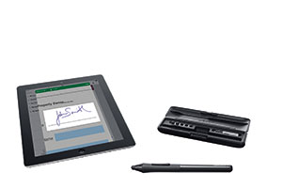
Signature pads: robust and reliable
Wacom’s signature pads provide industry-leading reliability.
Because our technology is embedded under the display, and not on signing surface, it delivers outstanding longevity. Unlike resistive technologies, Wacom products are not impacted by wear or scratches to the screen surface. Our patented EMR technology does not require batteries to power the pen and no wires to transmit signals, so they are maintenance free and will not fail if the tether is damaged. In addition to a robust design that provides years of service, our signature pads capture advanced biometric data for more accurate verification. The signature data can be transmitted securely with modern encryption capabilities. They also feature an ergonomic design that is comfortable to use and looks great on a counter, kiosk, or desk.

3.Functional Requirements

  - Functional Requirement 1.1:
functional id: functional req1
Title: User Registration
Description: A User Should register hand gesture and signature before buying the products.
Dependency : none

  - Functional Requirement 1.2:
functional id: functional req2
Title: User hand gesture Verification
Describtion: For implementing the hand gesture recognition device a 3-Dimentional accelerometer is used. Which is connected to Linux based Raspberry Pi 2 device. A suitable accelerometer library is installed so the readings are observed accurately. The observed readings are calculated to arrive at exact hand gesture pattern. This hand gesture is compared with already recorded hand gesture, if both are matched access control is granted otherwise denied. Dependency : Functional req1

  - Functional Requirement 1.3:
Functional id: functional req3
Title: User Signature verification
Description : The stylus pad is connected to micro controller and using a stylus pen the user will write his signature. The user’s signature is verified with signature in database which was captured previously when user is created. If both signatures match then the user is authenticated and the transaction is allowed to proceed.
Dependency: Function req1

  - Functional Requirement 1.4:
Functional id: functional req4
Title: Amount Transaction
Desciption : In case the hand gesture and signature verification are passed then the user will enter his Adhar card and details about his purchase. The purchase amount will be calculated and the user will authorize his bank account to transfer the amount in to retails account. The purchase will be completed and the data base regarding purchase is updated.
Dependency: functional req2 and req3

4.Software System Attributes
Following factors are used to measure software development quality:
Each attribute can be used to measure the product performance. These attributes can be used for Quality assurance as well as Quality control. Quality Assurance activities are oriented towards prevention of introduction of defects and Quality control activities are aimed at detecting defects in products and services.
Reliability
Measure if product is reliable enough to sustain in any condition. give consistently correctresults.
Product reliability is measured in terms of working of project under different working environment and different conditions.
Maintainability
Different versions of the product should be easy to maintain. For development its should be easy to add code to existing system, should be easy to upgrade for new features and new technologies time to time. Maintenance should be cost effective and easy. System be easy to maintain and correcting defects or making a change in the software.
Usability
this can be measured in terms of ease of use. Application should be user friendly. The system must be:
- Easy to use for input preparation, operation, and interpretation of output.
- Provide consistent user interface standards or conventions with our other frequently used systems.
- Easy for new or infrequent users to learn to use the system.
Portability
This can be measured in terms of Costing issues related to porting, Technical issues related to porting, Behavioral issues related to porting.
Correctness
Application should be correct in terms of its functionality, calculations used internally and the navigation should be correct. This means application should adhere to functional requirements.
Efficiency
To Major system quality attribute. Measured in terms of time required to complete any task given to the system. For example system should utilize processor capacity, disk space and memory efficiently. If system is using all the available resources then user will get degraded performance failing the system for efficiency. If system is not efficient then it can not be used in real time applications.
5.Performance Requirements:
At a minimum, a set of performance requirements should document the following:
- The maximum satisfactory response time to be experienced most of the time for each distinct type of user-computer interaction, along with a definition of most of the time. Response time is measured from the time that the user performs the action that says "Go" until the user receives enough feedback from the computer to continue the task. It is the user's subjective wait time. It is not from entry to a subroutine until the first write statement.
If the user denies interest in response time and indicates that only the result is of interest, you can ask whether "ten times your current estimate of stand-alone execution time" would be acceptable. If the answer is "yes," you can proceed to discuss throughput. Otherwise, you can continue the discussion of response time with the user's full attention.
- The response time that is minimally acceptable the rest of the time. A longer response time can cause users to think the system is down. You also need to specify rest of the time; for example, the peak minute of a day, 1 percent of interactions. Response time degradations can be more costly or painful at a particular time of the day.
- The typical throughput required and the times it will be taking place. This is not a casual consideration. For example, the requirement for one program might be that it runs twice a day: at 10:00 a.m. and 3:15 p.m. If this is a CPU-limited program that runs for 15 minutes and is planned to run on a multiuser system, some negotiation is in order.
- The size and timing of maximum-throughput periods.
- The mix of requests expected and how the mix varies with time.
- The number of users per machine and total number of users, if this is a multiuser application. This description should include the times these users log on and off, as well as their assumed rates of keystrokes, completed requests, and think times. You may want to investigate whether think times vary systematically with the preceding and following request.
- Any assumptions that the user is making about the machines the workload will run on. If the user has a specific existing machine in mind, make sure you know that early on. Similarly, if the user is assuming a particular type, size, cost, location, interconnection, or any other variable that will constrain your ability to satisfy the preceding requirements, that assumption also becomes part of the requirements. Satisfaction will probably not be assessed on the system where the program is developed, tested, or first installed.
Safety and Security Requirements.
Many software-intensive systems have significant safety and security ramifications and need to have their associated safety- and security-related requirements properly engineered. For example, it has been observed by several consultants, researchers, and authors that inadequate requirements are a major cause of accidents involving software-intensive systems. Yet in practice, there is very little interaction between the requirements, safety and security disciplines and little collaboration between their respective communities. Most requirements engineers know little about safety and security engineering, and most safety and security engineers know little about requirements engineering. Also, safety and security engineering typically concentrates on architectures and designs rather than requirements because hazard and threat analysis typically depend on the identification of vulnerable hardware and software components, the failure or exploitation of which can cause accidents and enable successful attacks. This leads to safety- and security-related requirements that are often ambiguous, incomplete, and even missing.
6.Database Requirement

The database should be able to store large number of readings. The database should not crash when the number of hits is high. The database should be flexible and querying should be fast.
Bank gateway:
Retail Branch: Customer Communication
this step, the system selects payees from GP PAYMENT with the following parameters
Payment status: finalized.
Payment type: net pay distribution.
Payment method: bank transfer.
7.Design Constraints

The database may crash when there is large number of querying to it, so the database should be created so that it is capable to store large number of data. The cloud platform may become slow when there is large number processing in it, so the cloud platform should be selected carefully. The sensor may produce incorrect result or burn when the voltage supplied is varied, so we must ensure that voltage supplied should not exceed specific values.

8.Other Requirements
Requirements are statements of what the system must do, how it must behave, the properties it must exhibit, the qualities it must possess, and the constraints that the system and its development must satisfya condition or capability needed by a user to solve a problem or achieve an objective

- a condition or capability that must be met or possessed by a system or system component to satisfy a contract, standard, specification, or other formally imposed document
- a documented representation of a condition or capability as in definition 1 or 2 [IEEE 1990a]
Requirements engineering emphasizes the use of systematic and repeatable techniques that ensure the completeness, consistency, and relevance of the system requirements [Sommerville 1997a]. Specifically, requirements engineering encompasses requirements elicitation, analysis, specification, verification, and management, where
- Requirements elicitation is the process of discovering, reviewing, documenting, and understanding the user's needs and constraints for the system.
- Requirements analysis is the process of refining the user's needs and constraints.
- Requirements specification is the process of documenting the user's needs and constraints clearly and precisely.
- Requirements verification is the process of ensuring that the system requirements are complete, correct, consistent, and clear.
- Requirements management is the process of scheduling, coordinating, and documenting the requirements engineering activities (that is, elicitation, analysis, specification, and verification) [Dorfman 1997a].

