*Indoor Navigation in AR using Unity*

| Tanmay Mane  *Dept. of Instrumentation engineering*  *Vishwakarma Institute of Technology* Pune  Pradyumna Kulkarni  *Dept. of Instrumentation engineering*  *Vishwakarma Institute of Technology*  Pune | Darshan Lohade Samrudha Kumbhar  *Dept. of Instrumentation engineering* *Dept. of Instrumentation engineering*  *Vishwakarma Institute of Technology Vishwakarma Institute of Technology*  Pune Pune  Venkateshprasad Kulkarni Sanika Patankar  *Dept. of Instrumentation engineering*  *Dept. of Instrumentation engineering*  *Vishwakarma Institute of Technology Vishwakarma Institute of Technology*  Pune Pune |
| --- | --- |

***Abstract****—* **This paper shows the indoor navigation in AR using Unity. Every people, at some point in their life, may get lost inside a large auditorium, struggled to find their exit point at the airport, or may get late to a lecture because they couldn’t find the right lecture hall at the university. But this way of getting lost inside complex and large venues could soon be a thing of the past. Nowadays, applications for indoor navigation for mobile devices are being common and they are needed for the people to find destinations inside large buildings. Different technologies as mesh for map creation, database uploading on cloud and integration on unity. These applications use pre-calculated paths and fixed background maps to lead the user to their destinations. Users of these systems need to have an understanding of how specifically indoor maps work and general map reading signals. In this paper, we put forward an indoor mapping which is extended to 3D feature with Augmented Reality, with a growing concern on commerce and general wayfinding.**

***Keywords: Unity, Mapping, AR, Navigation, 3D, mesh, cloud.***

# Introduction

Indoor Navigation or Mapping is a revolutionary concept that visualizes indoor venue and spatial data on a digital 2-Dimensional or 3-Dimensional map. It allows us to navigate through colleges, large malls, hospitals, auditoriums, etc.

In terms of complexity, Indoor Navigation is quite different compared to Outdoor Navigation. In the case of outdoor navigation, millions of people use the currently available technology like GPS as it does require much performance. Nowadays, built-in GPS and maps are found in modern smartwatches and smartphones. On the other hand, AR indoor navigation technology is quite complex as it consists of 3 modules that have to be categorized into the mapping of premises, populating the database, and user interface design. Augmented Reality (AR) depends on a dynamic, accurate 3D map that will enable experiences in the real-world. Showing people, assets, and places on a digital map enable solutions such as indoor navigation and indoor positioning.

# Related Work

There are two existing systems for indoor mapping which are Indoor mapping based on Bluetooth Beacons and Indoor Mapping based on Wi-Fi Fingerprinting using RSSI.

Bluetooth Beacons [2] are hardware transmitters. They are Bluetooth low energy devices that broadcast their identifier to the portable electronic devices nearby. The technology in these beacons enable tablets, smartphones, and other devices to perform actions when they are near to the beacons. To transmit a universally unique identifier, Bluetooth Beacons use Bluetooth low energy proximity sensing. These identifiers are then picked up by a compatible application or an operating system. Several bytes are also been sent together with the identifiers that can be used to determine the device’s physical location, track the customers, or can also trigger a location-based action on the device such as a check-in on the social media or path notification.

Wi-Fi Fingerprinting using RSSI is another existing system. RSSI is the acronym for the Received Signal Strength Indicator [3]. To the naked eyes, they are usually invisible. The power present inside the received radio signal can be measured using RSSI. Traditional finger printing is also RSSI-based, but there is a slight difference. There are several access points in traditional fingerprinting and it has relied simply on the recording of the signal strength from these access points that are in range. This information is then stored in a database along with the client device’s known coordinates in an offline phase. This stored information can be probabilistic or deterministic.

# Proposed Methodology

Here the proposed methodology, design and implementation is being discussed where how a software implementation can be done.

# 



# 

# 

# 

# 

# 

# 

# 

**Fig 1:** Flowchart of the proposed technique

### 

# Experimental Results

The above discussed design and implementation is experimented and the results are taken into consideration for the optimum evaluation. The following are the results of the designed project:

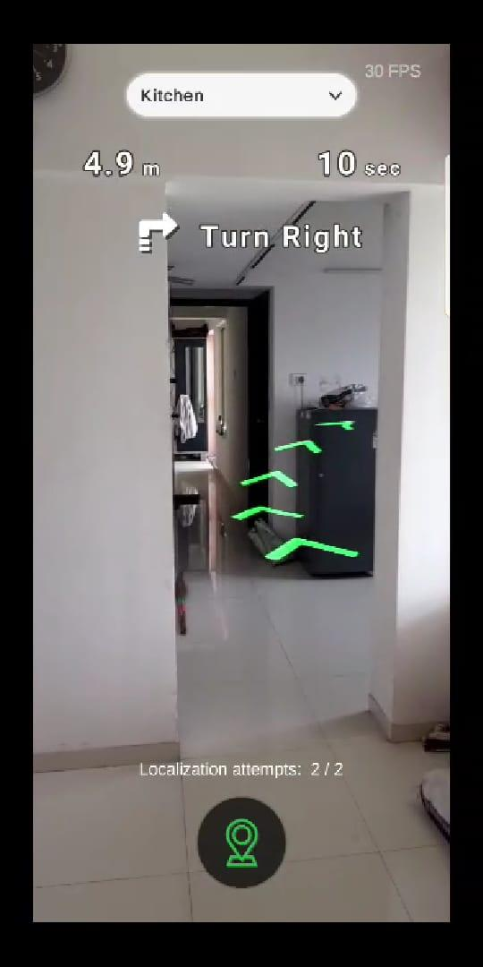

Fig: Route to Destination

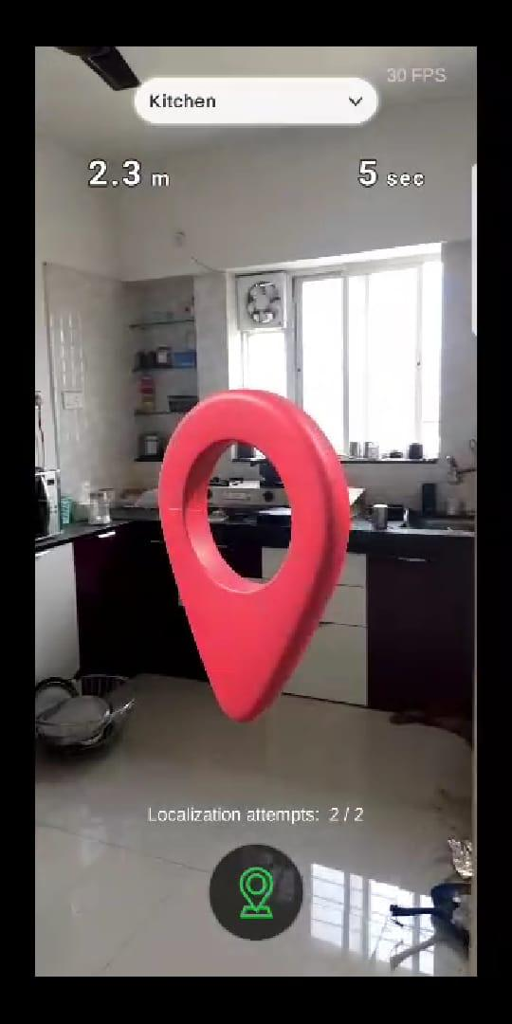

Fig: Destination View

These are the results which are accurate and the system is working properly without any errors.

# Conclusion

Successfully implemented the application and implemented the Arway indoor navigation and created a mesh database of are that have to be navigated , anyone with the apk will be able to navigate to the desired location

# References

* https://youtu.be/zq0wDY1jS7U
* <https://developer.arway.app/sign-up/>
* <https://docs.arway.app/>