**Live newspaper (AR based)**

Samruddha kumbhar-11810204

***Abstract*— this project is a base idea to for newspaper in AR , this project includes the features of unity and image target from vudoria .**

***Keywords—vufori, unityAR, image target***

**Introduction:**

Newspaper is a source of news that provides all the event and on going information, therefore many sources are working to provide this information to people with an convenient method , this search for the platform led to digital news ,all the newspaper are now shifted towards e-paper ,therefore as all the upcoming technology is working on AR based use , Augmented reality is vast subject of technology which deals with creating a real life experience trough an application.

Thus this project is about creating a newspaper that can be computed in AR, with help of unity , vuforia and image target this is project that gives brief about the concept to form AR newspaper, this project is compatible with only android with 8.0 version

**Implementation details:**

In order to create this project required pre-installation of unitystudio and AR foundation

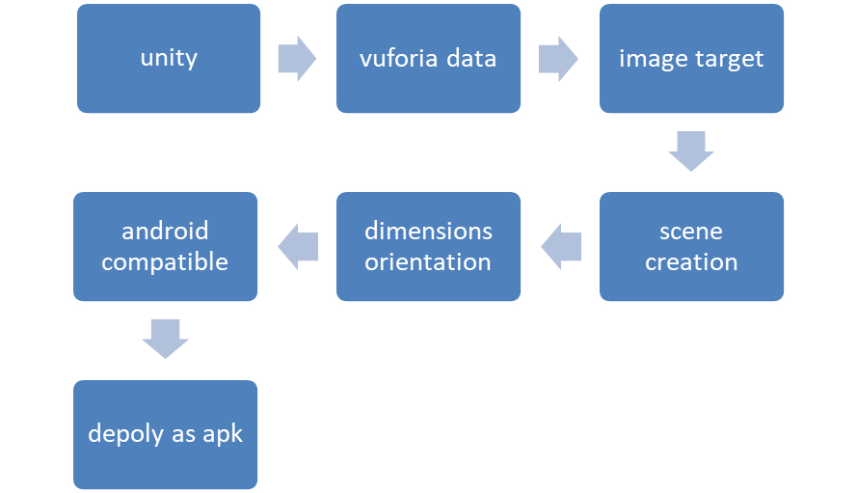

**Fig. 1: flowchart**

Unity

Unity is software studio used for multi application function, in this project to create scene unity is used ,in unity we can explore the Augmented Reality function and features for use in project .

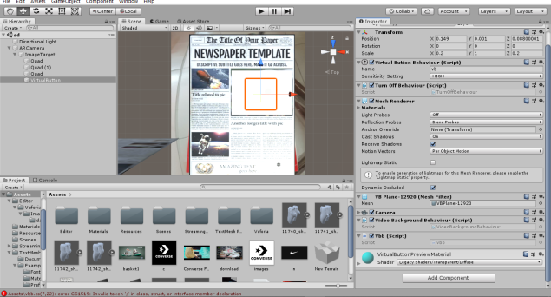 **Fig.2: unity studio**

Vuforia

Vuforia is a image targeting and image data base platform , to help and overcome with image target application vuforia is used , to get image target working in unity vuforia need to have data base of image to be targeted ,after the data base the vuforia need to be synced with unity in order to work the application 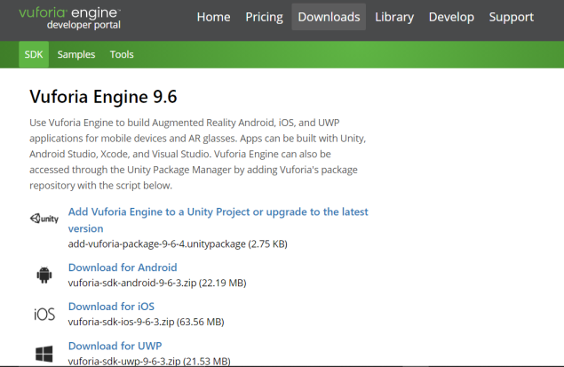

**Fig. 3. Vuforia**

After sync of vuforia with unity the scene screen need to be checked for image target and all the dimensions should match with the real world and the image target to make the scene precise.

The last stage of this algorithm is to deploy the application as apk for android and this done with the help of the unity sdk of android platform ,this allows project to be installed on android and work accordingly.

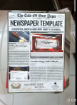

**Fig. 4: output from android**

**Results and discussion:**

The final output of this project will be the newspaper in AR that is it can be seen on android platform using android camera and image target ,vuforia successfully detects the target for AR and execute accordingly

**Conclusion and Future Scope:**

Unity and vufoira are the core aspect of the project , AR foundation is vast topic for application.

The future scope of this project can include many feature for the newspaper in AR , like to allow all the update to be directly serve from the server and every page can be zoom or resizing of paper in AR for easy reading , all event can be explained in 3d form for better understanding.

**References:**

Shaadi.com, 2009, Available at: http://www.shaadi.com (accessed on

18

th

July 2009).

[1] unity manual 2018

[2] vuforia (support section)

Ahuvia, A., & Adelman, M. (1992). Formal in-

termediaries in the marriage market: A typology

and review. Journal of Marriage and the Family,

54(2), 452-463.

[3] AR foundation unity 2018