

Experimental Learning Activity (B. Tech. – Ist Semester)

***BMI APP DEVELOPMENT***

***By:SAMARTH SINGH ADHIKARI(102203303)***

1. Problem statement:

Many people today do not have account of their fitness. They are taking it for granted. At least we should know in what category our fitness fall.

1. Study of the Pre-existing solutions :

Some of the pre-existing solution are not very appropriate as they are not showing correct categories for same values.

1. Compare the need with the existing solutions:

So I have made this app to showcase correct category according to data values input by users.

1. Identify the required specifications :

As the BMI is basic code ,it will run perfectly with android version 6 (Marshmallow) and above version.

Device must have storage of about 30mb to run the timer.

No internet connection is required.

1. Find the related software/hardware



***Android studio***

Android Studio is the official integrated development environment for Google's Android operating system, built on JetBrains' IntelliJ IDEA software and designed specifically for Android development. It is available for download on Windows, macOS and Linux based operating systems.

6) Design process: In this app user have to enter his/her height and weight according to which app will calculate bmi of user using the formula given in code. I have designed the app in which wight is in pounds.

1. Interfaces:

|  |
| --- |
|  |

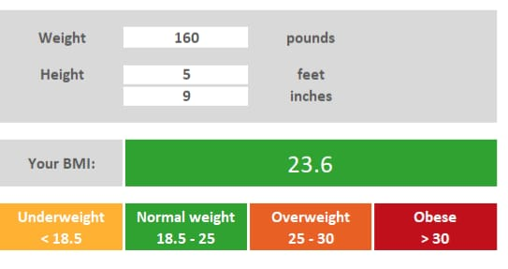

Coding/Implementation:

public class BMICalcUtil {

public static final BMICalcUtil instance = new BMICalcUtil();

private static final int CENTIMETERS_IN_METER = 100;

private static final int INCHES_IN_FOOT = 12;

private static final int BMI_IMPERIAL_WEIGHT_SCALAR = 703;

public static final String BMI_CATEGORY_UNDERWEIGHT = "Underweight";

public static final String BMI_CATEGORY_HEALTHY = "Healthy Weight Range";

public static final String BMI_CATEGORY_OVERWEIGHT = "Overweight";

public static final String BMI_CATEGORY_OBESE = "Obese";

public static BMICalcUtil getInstance() {

return instance;

}

public double calculateBMIMetric(double heightCm, double weightKg) {

return (weightKg / ((heightCm / CENTIMETERS_IN_METER) * (heightCm / CENTIMETERS_IN_METER)));

}

public double calculateBMIImperial(double heightFeet, double heightInches, double weightLbs) {

double totalHeightInInches = (heightFeet * INCHES_IN_FOOT) + heightInches;

return (BMI_IMPERIAL_WEIGHT_SCALAR * weightLbs) / (totalHeightInInches * totalHeightInInches);

}

public String classifyBMI(double bmi) {

if (bmi < 18.5) {

return BMI_CATEGORY_UNDERWEIGHT;

} else if (bmi >= 18.5 && bmi < 25) {

return BMI_CATEGORY_HEALTHY;

} else if (bmi >= 25 && bmi < 30){

return BMI_CATEGORY_OVERWEIGHT;

} else {

return BMI_CATEGORY_OBESE;

}

}}

1. Learning:

* Learned basic of Java.
* Became familiar with android studio.
* Gain knowledge about android development.