Enumeration of Interesting Solutions For Alloy
Formal Methods for Software Engineering WS25/26

Soumyakanta Pattanaik, Vaishnavi Dhavade
Bauhaus-Universität Weimar
Abstract. Alloy is a formal specification language based on relational logic [1]. When analyzing Alloy models, the solver can produce many satisfying instances, but not all of them are equally useful to the engineer. We present a tool for the automatic exploration of interesting Alloy instances. The tool implements six strategies that define different notions of interestingness: minimal instances, maximal instances, greedy diversity selection, memory-safe diversity, user-weighted scoring, and reference-guided search. We evaluate all strategies on seven Alloy models of varying complexity and show that memory-safe diversity achieves up to 58 percent higher average pairwise diversity compared to other strategies, while storing 80 percent fewer instances in memory. The tool provides a desktop GUI with graph visualization and an automated evaluation panel for comparing strategies side by side.
- Introduction
  - Background
Alloy is a specification language based on relational logic [1]. It lets engineers write a model of a system and then use the Alloy Analyzer to find concrete instances that satisfy the model. The Alloy Analyzer works by translating the model into a SAT problem and solving it. If a solution exists, it returns one instance. The engineer can then ask for more instances by pressing Next, and the solver finds more by adding a constraint that blocks the previous solution. Alloy is widely used for modelling things like data structures, access control policies, file systems, and communication protocols [2]. In all these cases the engineer wants to understand what the model allows and what it does not allow.
  - Motivation
The problem with the default behavior of the Alloy Analyzer is that it returns solutions in an order that is determined by the SAT solver internally [4]. This order does not have anything to do with what is useful or interesting for the engineer. For example, if you have a graph model with hundreds of valid instances, the first ten instances you see might all look almost the same. You would have to manually go through many solutions to find one that shows something new. Another problem is that for large models there can be thousands of solutions. You cannot look at all of them, and storing all of them in memory is not possible either. So, there is a real need for a tool that can pick out the interesting solutions without going through everything. We built this tool. It loads any Alloy model file, runs the solver, and uses different strategies to pick which solutions to show. It also has a graphical interface where It can be observed the solutions drawn as graphs.
- Problem Statement
Given an Alloy model $M$ with a run command $C$, let $S(M, C)$ denote the set of all satisfying instances. For large models $|S(M, C)|$ may be very large or unbounded.
We aim to pick automatically a small subset $R S(M, C)$ is interesting according to some criterion.

Minimal An instance is interesting if it has the fewest atoms and relation tuples. This shows the simplest possible case that still satisfies the model. Formally, $S* =\arg{\min_{sϵS}} score(s)$ where $score(s)$ counts all user defined atoms and tuples in s.
Maximal An instance is interesting if it has the most atoms and relation tuples. This shows the most complex case the model allows. Formally $S* =\arg{\max_{sϵS}} score(s)$.
Diverse (greedy) A set $R$ is interesting if it maximizes the pair-wise difference. We use greedy max-min strategy: $S_{k+1}=\arg{\max_{s∉R}\min_{r∈R}d(d, r)}$ where $d(s_{1},s_{2})$ is symmetric difference of the tuple sets of $s_{1}$ & $s_{2}$.
Diverse (memory-safe) same objective as greedy diversity but achieved without storing all instances. A rolling window of $k$ is maintained & updated as new instances are found.
User-weighted The score function is updated with user-defined weights ${score}_{w}\left(s\right)=\sum{{σϵSigs(M)}^{w_{σ}.|σ\left(s\right)|}}$ Where $w_{σ}$ is the weight assigned by the user. With this user can focus on the parts of the model that user care about.
Reference-guided Given reference instance $r$, find instances that are most similar to it $(arg min d(s, r))$ from $r$ or most different from it $(arg max d(s, r))$.
- Example & Intuition
Consider this simple Alloy model of a directed graph:
- sig Node {}
- sig Edge {
- from, to: one Node
- }

- fact NoSelfLoops {
- all e: Edge | e.from != e.to
- }

- fact NoDuplicateEdges {
- all disj e1, e2: Edge |
- not (e1.from = e2.from and e1.to = e2.to)
- }

- pred someGraph {}

- run someGraph for exactly 3 Node, 3 Edge

Listing 1.1 Simple graph model in Alloy

This model describes a directed graph with no self-loops and no duplicate edges. When you run it, the Alloy solver finds 19 satisfying instances.
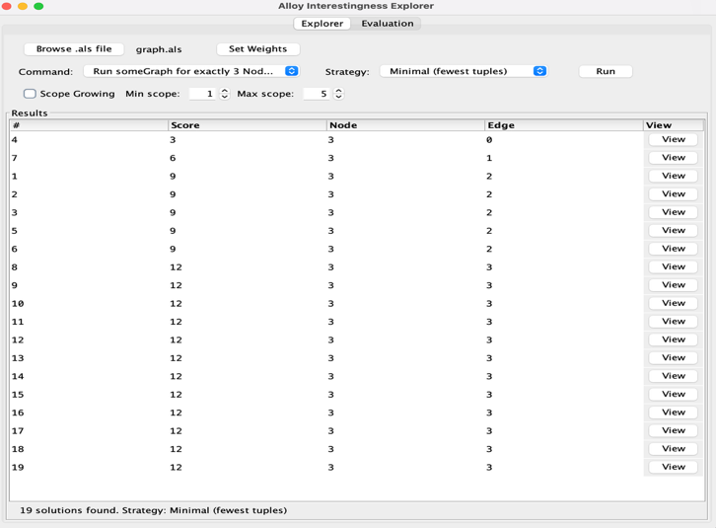

Fig 1.1 Alloy interestingness Explorer listing UI

All these instances have the same three nodes — Node$0, Node$1, Node$2 — but they differ in how the edges are connected. Some instances have edges that form a triangle, others form a path, and some have edges going in different directions.
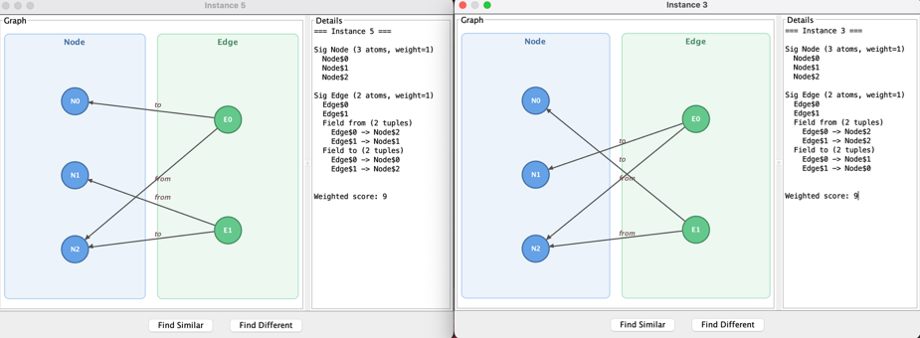

Fig 1.2 Difference Instance Window- Comparison Relation
We score each instance by counting its atoms and tuples. For each signature $σ$ and each of its fields $f$ in an instance $s$:
$$score\left(s\right)= \sum_{σ}{\left(\left|σ\left(s\right)\right|+ \sum_{fϵfields(σ)}{|f\left(s\right)|}\right)}$$

Built in signatures (univ, Int, seq/Int, String, none) are excluded from the count as they appear in every model and carry no model-specific information
- Implementation
We implemented the tool in Java. We used the Alloy API from the $org.alloytools.alloy.dist$JAR file for all solver interactions. The graphical interface is built with Java Swing. The implementation consists of approximately 1800 lines of code across 16 different classes in 3 packages.
  - Architecture
Our tool is implemented with Java and consists of 16 classes under 3 packages. The overall design separates the solver logic from the user interface so that each part can be understood and changed independently.
$alloy$ Contains all solver interaction and strategy logic. The ten classes in this package are: ModelLoader (loads .als files), Runner (enumerates solutions), Counter (scores instances by tuple count), DivPicker (greedy diversity se- lection), StreamDivRunner (memory-safe diversity), ScopeRunner (scope- growing search), Weights (per-signature weight configuration), Evaluator (runs all strategies and compares), EvalResult (holds evaluation metrics), and CmdInfo (wraps a command index and description).
$core$ Contains two classes: Config (holds model path and command index) and Main (entry point for console testing).
$ui$ Contains four classes: MainWindow (main GUI window with Explorer tab), GraphPanel (draws instances as directed graphs), WeightDlg (weight con- figuration dialog), and EvalPanel (Evaluation tab comparing all strategies).
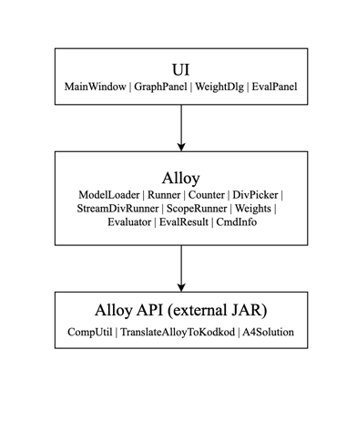

Fig 2.1. Architecture of the tool showing the three packages and their dependencies.

  - Code Example: Solver Interaction
We use the Alloy API provided by the $org.alloytools.alloy.dist$ JAR file for all interactions with the solver.
Loading a model is done in $ModelLoader$ using $CompUtil.parseEverything_fromFile$. This method reads the $.als$file, parses it, and returns a $CompModule$ object. The $CompModule$ contains all the signatures, facts, predicates, and run commands from the file. We call $module.getAllCommands()$ to get the list of commands and show them to the user in the dropdown menu. Enumerating solutions is done in $Runner$. We call $TranslateAlloyToKodkod.execute_command$ which translates the Alloy model into a Kodkod [3] relational formula, then into SAT boolean clauses, and runs the SAT solver. If a solution exists it returns an $A4Solution$ object. We then call $solution.next()$ in a loop to get more solutions. Every call to $next()$ adds a blocking clause to the SAT problem that says the next solution must differ from this one in at least one tuple. This is why you can see the clause count in the console output increase by one with every step.
- A4Solution current =
- TranslateAlloyToKodkod.execute_command(
- reporter,
- module.getAllReachableSigs(),
- command,
- options);

- int count = 0;

- while (current.satisfiable() && count < maxSolutions) {
- solutions.add(current);
- count++;
- current = current.next();
- }

Listing 2.1. Core enumeration loop using the Alloy API

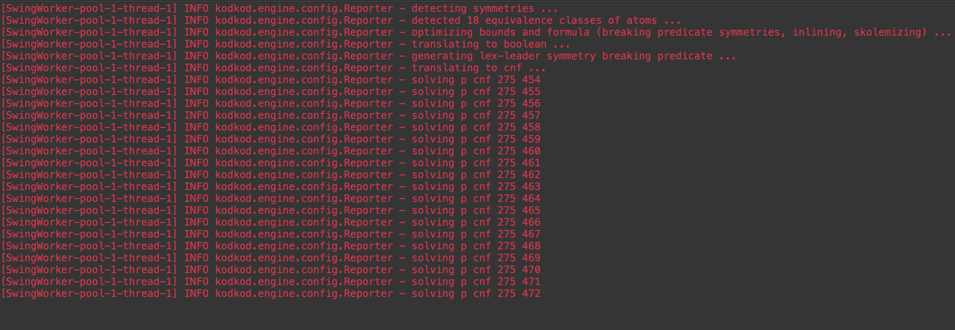

Fig 2.2 Console output showing SAT clause count increasing by one with each call to solution.next()

We stop the loop when either the solver reports no more solutions $satisfiable()$ returns false) or we reach the maximum limit of 50 solutions.
  - Diversity Measurement
The foundation of our diversity strategies is a way to measure how different two instances are from each other. We implemented this in $DivPicker$. The idea is to convert each instance into a set of strings where every atom and every relation tuple becomes one string. For example in $graph.als$ an instance with two edges might produce a set like {"Node:Node$0", "Node:Node$1", "Edge:Edge$0", "Edge.from:Edge$0->Node$1", ...}. Built-in signatures like $Int$ and $univ$ are excluded because they appear in every model and do not carry useful information. Once we have two sets we compute their symmetric difference. The symmetric difference is the set of elements that appear in one set but not both. A larger symmetric difference means the two instances are more structurally different.

- public int symmetricDifference(A4Solution a, A4Solution b) {
- Set<String> setA = toTupleSet(a);
- Set<String> setB = toTupleSet(b);
- Set<String> union = new HashSet<>(setA);
- union.addAll(setB);
- Set<String> inter = new HashSet<>(setA);
- inter.retainAll(setB);
- union.removeAll(inter);
- return union.size();
- }

Listing 2.2. The greedy diverse strategy

  - Memory-Safe Diversity
The StreamDivRunner class implements memory-safe diversity. It maintains a rolling window of k instances. For each new instance encountered during enu- meration, we compute its minimum distance to all currently selected instances. If this distance exceeds the minimum diversity of any existing selected instance, we replace that instance. This avoids storing the entire solution space while converging towards a diverse set.
  - Scope Growing
The ScopeRunner class implements scope-growing search. To support large mod- els where exhaustive enumeration is infeasible, rather than overriding the Alloy scope parameter (which caused API errors due to constraints on steps in static models), we use the scope value as a search budget: at scope level n, we check n solutions and record the best found so far. This gives early results quickly and improves them as the budget grows.
  - Graph Visualisation
Each instance is visualised as a directed graph in the $GraphPanel$ class. When the user clicks View on any row in the results table a detail window opens with the graph on the left and a text breakdown on the right.
The layout algorithm works as follows. We first collect all user-defined signatures from the instance. Each signature gets its own vertical column on the screen with a labelled box drawn around it. The colour of each box is picked from a fixed palette so different signatures are easy to tell apart. Within each column the atoms are placed at evenly spaced vertical positions.
Once the atom positions are calculated we draw the relations. For each field in each signature we read the tuples using $solution.eval(field)$ and draw an arrow from the first atom to the second atom in each tuple. The arrow starts and ends at the edge of the circle rather than the centre, which we calculate by shortening the line by the radius of the circle at both ends. The arrowhead is drawn as a filled triangle using the angle of the line. The field name is written as a label at the midpoint of the arrow.
Atom names are shortened for readability. $Node\$0$ becomes $N0$, $Edge\$1$ becomes $E1$, and so on.

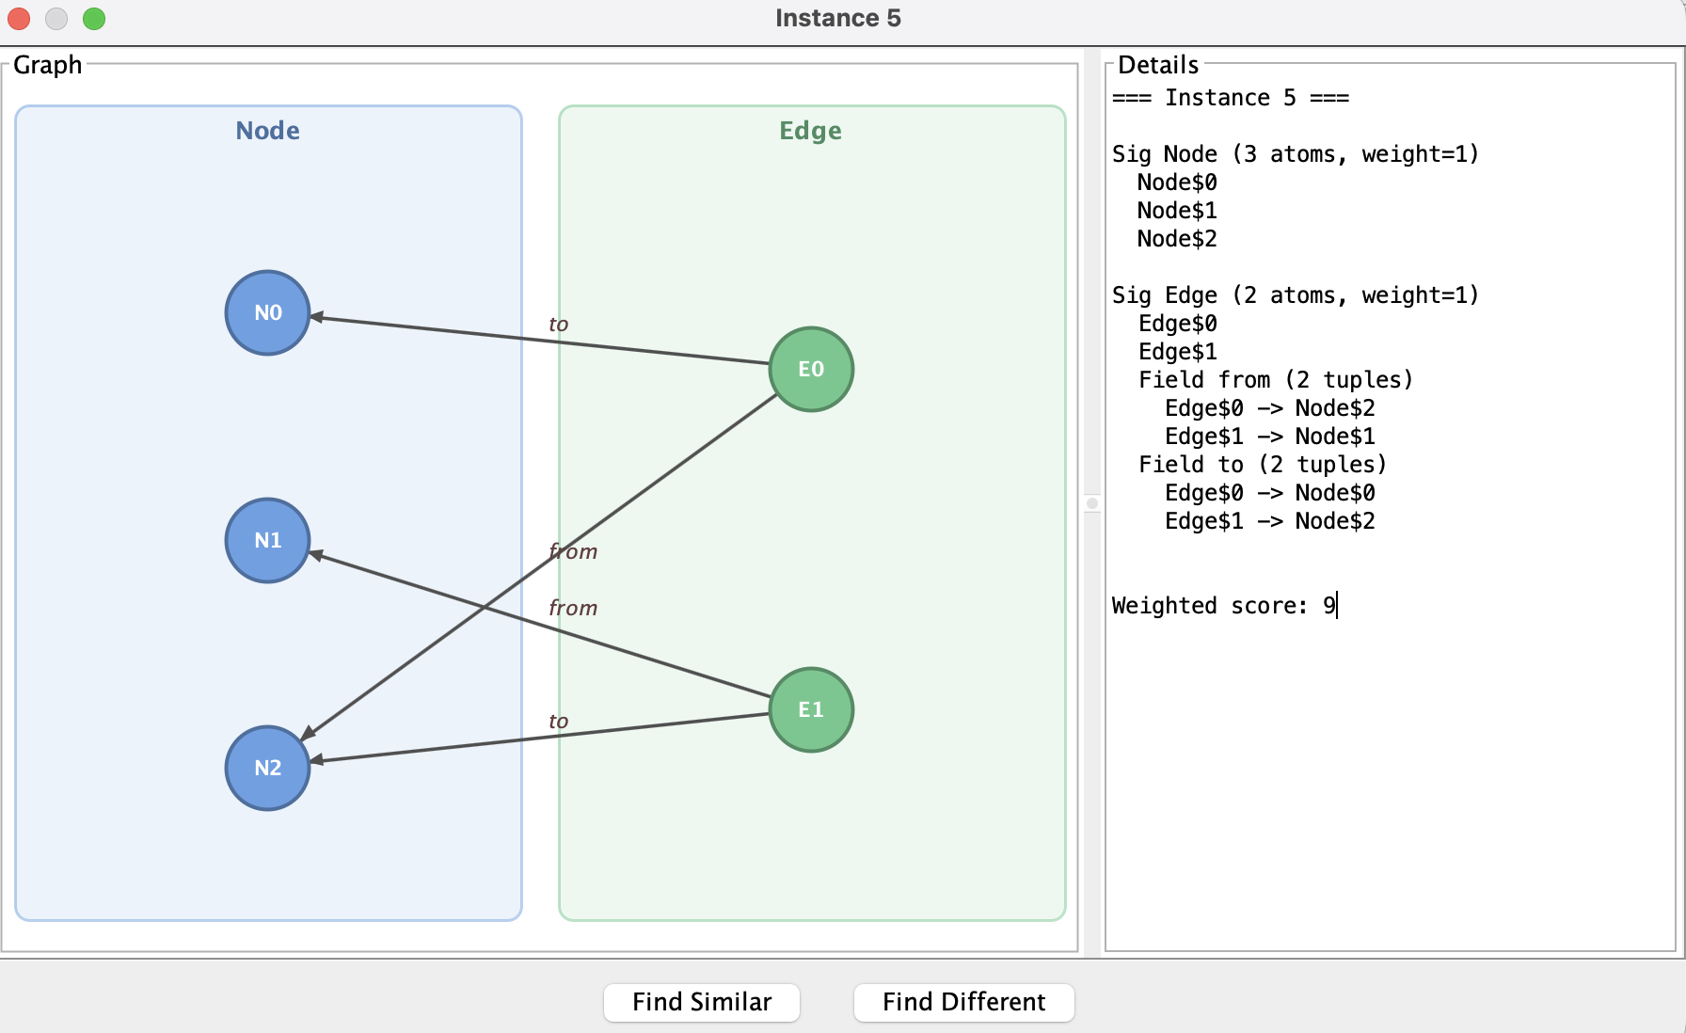
Fig 2.3. Instance detail window showing a graph with multiple sigs
  - Tool Usage
The tool provides a desktop GUI implemented in MainWindow with two tabs. The Explorer tab allows the user to:
- Select a command from a dropdown populated automatically by ModelLoader
- Choose an interestingness strategy
- Enable scope-growing mode with configurable min/max scope (handled by ScopeRunner)
- Set per-signature weights via WeightDlg, which updates a Weights object used by Counter when scoring instances
- View results in a table with dynamic columns named after the model’s sig- natures
- Click View on any instance to see a graph visualisation in GraphPanel along- side a text breakdown
- Click Find Similar or Find Different to search for instances relative to the viewed one using $DivPicker.symmetricDifference$

The Evaluation tab (EvalPanel) runs all strategies automatically on the loaded model using Evaluator and presents a comparison table showing: num- ber of instances found, minimum score, maximum score, average score, average pairwise diversity, and number of distinct structural fingerprints. The best values per column are highlighted in colour.

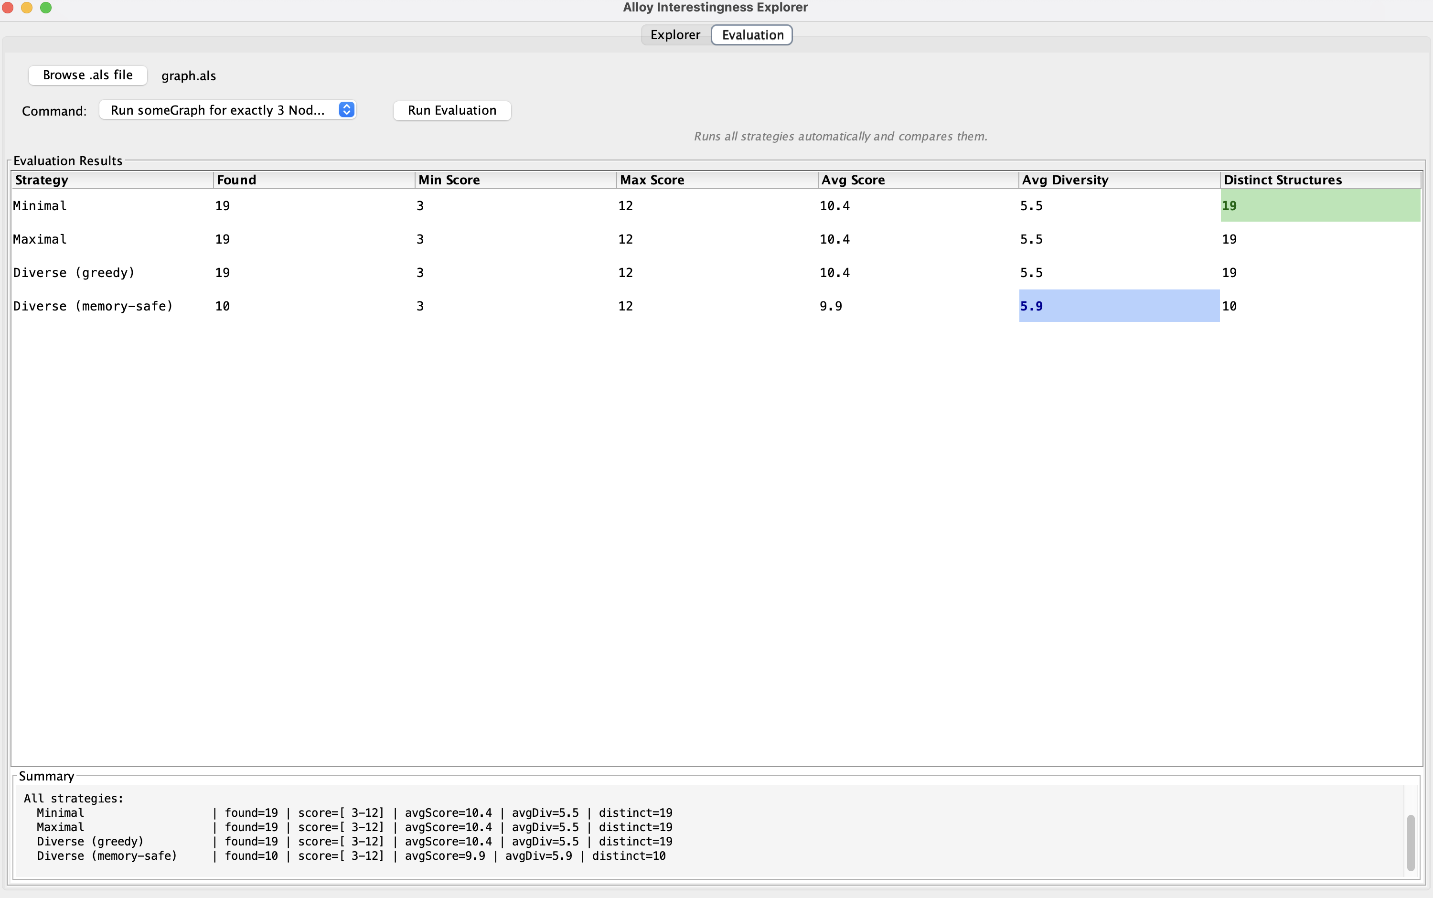

Fig 2.4. The EvalPanel with highlighted best values
  - Limitations
The following limitations apply about what our tool cannot do well.

Scope growing does not change the actual Alloy scope. We could not find a way to override the scope in the run command through the Alloy API without causing errors. Our workaround uses scope as a search budget, which is not the same thing. The actual scope of the model stays fixed at whatever the $.als$ file defines.

Enumeration-based strategies are limited to 50 solutions. We store at most 50 solutions in memory. For models with more solutions the Minimal, Maximal, and greedy Diverse strategies only see a sample of the full solution space. The memory-safe strategy does not have this problem.

The graph layout becomes crowded with many atoms. When a signature has many atoms all of them are placed in one vertical column, and with enough atoms the circles overlap. This makes the graph hard to read for larger models.

Only run commands are fully supported. Alloy files can also contain check commands for verifying assertions. Our tool lists these in the dropdown but the interestingness strategies do not have meaningful behaviour for assertions.

Alloy itself limits the practical model size. Because Alloy translates to SAT, the encoding size grows quadratically with the scope. Models with more than around 20 to 30 atoms per signature become very slow to solve. This is a fundamental limitation of the Alloy approach and not something our tool can fix.
- Evaluation
  - Models Used
We tested our tool on seven Alloy models of different sizes and complexity levels. Table 1 gives an overview of each model.

Model | Signatures | Key constraints | Solutions found
graph.als | Node, Edge | No self-loops, no duplicate edges | 19
family.als | Person | No self-parent, no symmetric parent | 50
network.als | Host, Connection | Symmetric connections | 10
social_network.als | Person, Post, Group | Admin is member, knows is symmetric | 50
stress_test.als | Node | No self-adjacency | 50
large_graph.als | Node, Label, Path | Connected graph, labels assigned | 50
access_control.als | User, Role, Permission, Resource, Session | Ownership requires permission | 50

Table 1. Models used in evaluation

graph.als is a simple directed graph with exactly 3 nodes and up to 3 edges. No self-loops and no duplicate edges are allowed. This is the smallest model we tested and we used it to understand the basic behaviour of each strategy.
family.als is a family tree model with 4 persons and a parent relation. No person can be their own parent and no two persons can be each other's parent at the same time.
network.als is a symmetric network with 3 hosts and 4 connections. Every connection must have a matching connection in the opposite direction. This model only has 10 total solutions which makes it useful for checking the behaviour of strategies when the solution space is fully exhausted.
social_network.als is a more complex model with 5 persons, 4 posts, and 2 groups. It has multiple relations including knows, likes, follows, and group membership. This model has a much higher tuple count per instance than the simpler models.
stress_test.als is a connected graph with 6 nodes and no label constraints. We created this model specifically to generate a large number of solutions and test how strategies behave when there are many instances to choose from.
large_graph.als is a connected labelled graph with 6 nodes, 3 labels, and path constraints. The solver needs over 1600 SAT clauses per instance for this model, which makes it the most computationally expensive model we tested.
access_control.als is a role-based access control model with 4 users, 3 roles, 4 permissions, 5 resources, and 3 sessions. It has complex constraints about which users can access which resources based on their roles. This model produces the highest scores and the highest diversity numbers of all models we tested.
  - Strategy Comparison
We ran the Evaluation tab on all seven models and collected the results shown in Tables 2 and 3. For each strategy we recorded how many instances were found, the minimum and maximum score, the average score, the average pairwise diversity, and the number of structurally distinct instances. The average pairwise diversity is computed by taking the symmetric difference between every pair of instances in the result set and averaging all those values. A higher number means the instances in the set are more structurally different from each other.

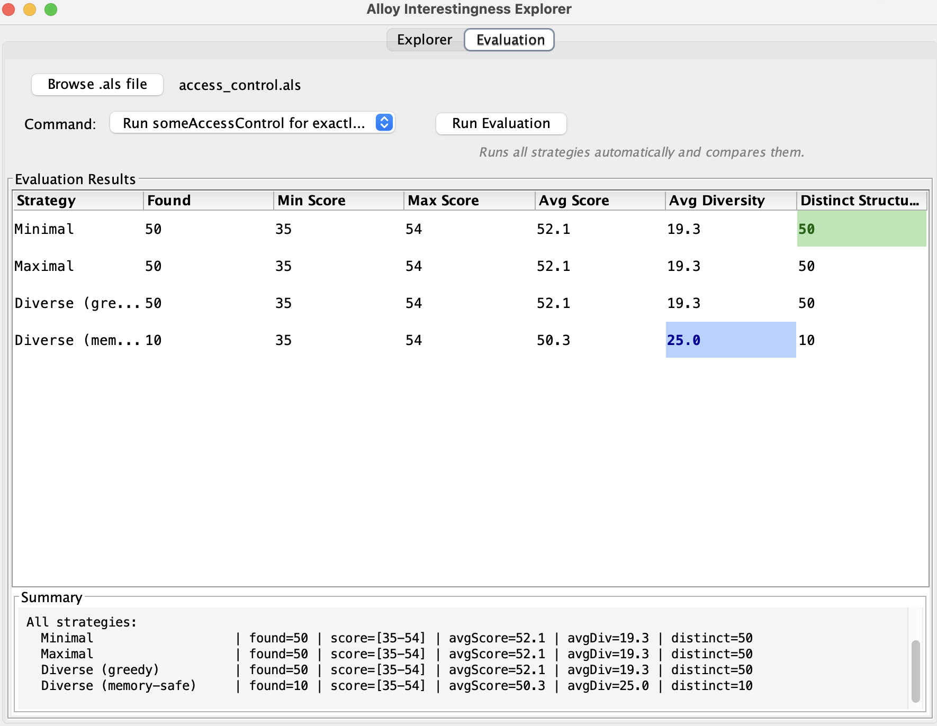

Fig 3.1 The best Avg. diversity un access_control.als

Model | Stretegy | Found | Min | Max | Avg. Score | Avg. Div | Distinct
graph.als | Minimal | 19 | 3 | 12 | 10.4 | 5.5 | 19
graph.als | Maximal | 19 | 3 | 12 | 10.4 | 5.5 | 19
graph.als | Diverse(greedy) | 19 | 3 | 12 | 10.4 | 5.5 | 19
graph.als | Diverse(mem-safe) | 10 | 3 | 12 | 9.9 | 5.9 | 10
family.als | Minimal | 50 | 6 | 10 | 8.3 | 4.5 | 50
family.als | Maximal | 50 | 6 | 10 | 8.3 | 4.5 | 50
family.als | Diverse(greedy) | 50 | 6 | 10 | 8.3 | 4.5 | 50
family.als | Diverse(mem-safe) | 10 | 4 | 10 | 8.0 | 4.9 | 10
network.als | Minimal | 10 | 3 | 15 | 12.6 | 8.2 | 10
network.als | Maximal | 10 | 3 | 15 | 12.6 | 8.2 | 10
network.als | Diverse(greedy) | 10 | 3 | 15 | 12.6 | 8.2 | 10
network.als | Diverse(mem-safe) | 10 | 3 | 15 | 12.6 | 8.2 | 10

Table 2. Results for graph.als, family.als, and network.als

Model | Stretegy | Found | Min | Max | Avg. Score | Avg. Div
social_network | Minimal | 50 | 51 | 68 | 56.1 | 14.5
social_network | Maximal | 50 | 51 | 68 | 56.1 | 14.5
social_network | Diverse(greedy) | 50 | 51 | 68 | 56.1 | 14.5
social_network | Diverse(mem-safe) | 10 | 51 | 59 | 55.4 | 22.8
stress_test | Minimal | 50 | 15 | 21 | 18.2 | 9.3
stress_test | Maximal | 50 | 15 | 21 | 18.2 | 9.3
stress_test | Diverse(greedy) | 50 | 15 | 21 | 18.2 | 9.3
stress_test | Diverse(mem-safe) | 10 | 16 | 21 | 18.3 | 9.8
large_graph | Minimal | 50 | 28 | 39 | 34.1 | 12.6
large_graph | Maximal | 50 | 28 | 39 | 34.1 | 12.6
large_graph | Diverse(greedy) | 50 | 28 | 39 | 34.1 | 12.6
large_graph | Diverse(mem-safe) | 10 | 28 | 40 | 34.2 | 19.3
access_control | Minimal | 50 | 35 | 54 | 52.1 | 19.3
access_control | Maximal | 50 | 35 | 54 | 52.1 | 19.3
access_control | Diverse(greedy) | 50 | 35 | 54 | 52.1 | 19.3
access_control | Diverse(mem-safe) | 10 | 35 | 54 | 50.3 | 25.0

Table 3. Results for social_network.als, stress_test.als, large_graph.als, and access_control.als
  - Memory-Safe Diversity vs Other Strategies
The most important finding from our evaluation is about the memory-safe diversity strategy. On every model except network.als, the memory-safe strategy achieved a higher average pairwise diversity than all other strategies, while storing only 10 instances instead of 50. Table 4 shows the exact numbers.

Model | Greedy avg div | Mem-safe avg div | Improvement
graph.als | 5.5 | 5.9 | +7%
family.als | 4.5 | 4.9 | +9%
network.als | 8.2 | 8.2 | +0%
stress_test.als | 9.3 | 9.8 | +5%
large_graph.als | 12.6 | 19.3 | +53%
social_graph.als | 14.5 | 22.9 | +58%
access_control.als | 19.3 | 25.0 | +30%

Table 4. Diversity improvement of memory-safe over greedy

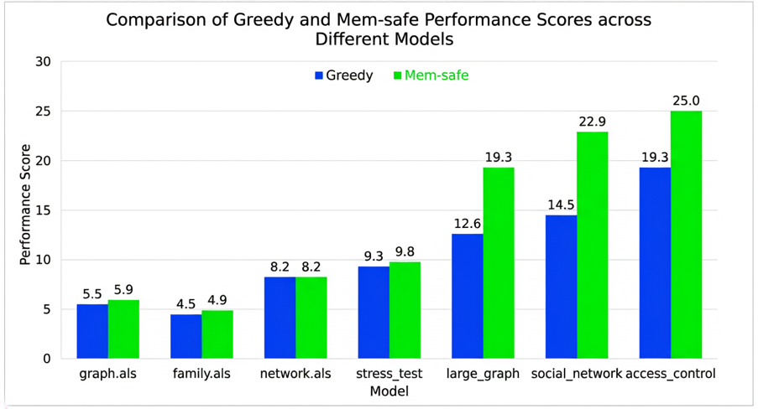

Fig. 3.2. Average pairwise diversity of Diverse (greedy) vs Diverse (memory-safe) across all seven models. Higher is better.
  - Runtime
Table 5 shows the measured runtimes for each model and strategy. The time was measured using $System.currentTimeMillis()$ in the background thread, from the start of the solver call to the end.

Model | Strategy | Time(ms)
graph.als | Minimal | 114
graph.als | Maximal | 36
graph.als | Diverse(greedy) | 23
graph.als | Diverse(mem-safe) | 34
family.als | Minimal | 22
family.als | Maximal | 21
family.als | Diverse(greedy) | 14
family.als | Diverse(mem-safe) | 32
social_network.als | Minimal | 25
social_network.als | Diverse(mem-safe) | 52
access_control.als | Minimal | 35
access_control.als | Diverse(mem-safe) | 75
large_graph.als | Minimal | 37
large_graph.als | Diverse(mem-safe) | 81

Table 5. Runtime measurements

All models run in under 200ms which is fast enough for interactive use. The user does not have to wait more than a fraction of a second to see results on any of our test models.
The memory-safe strategy is consistently a bit slower than Minimal because it scans more solutions up to 100 and computes pairwise distances during the scan. On access_control.als the memory-safe strategy takes 75ms compared to 35ms for Minimal. This is about twice as long but still well within an acceptable range for a desktop tool.
The Minimal strategy on graph.als shows an unusually high time of 114ms compared to other models. This happened because graph.als was the first model loaded in that session, so the Alloy API had to initialise its internal data structures for the first time. Subsequent runs on other models were faster because the JVM and the API were already warmed up.
  - Key Findings
We now summarise the five main findings from our evaluation.
Finding 1: Memory-safe diversity gives higher quality instances on complex models. The diversity improvement of memory-safe over greedy grows with model complexity. On graph.als the improvement is 7 percent. On social_network.als it reaches 58 percent. For simple models the difference is small. For complex models with many relations it is very significant.
Finding 2: When the solution space is fully exhausted all strategies produce identical results. On network.als, which has exactly 10 total solutions, all four strategies found the same 10 instances with the same average diversity of 8.2. This confirms that diversity strategies only add value when the solution space is larger than what can be stored at once.
Finding 3: Memory-safe trades coverage for quality. The memory-safe strategy stores 10 instances instead of 50, which is 80 percent less memory. But those 10 instances are more diverse than the 50 kept by the greedy strategy on every complex model we tested. This is exactly the right tradeoff when working with large Alloy models where storing everything is not practical.
Finding 4: Minimal and Maximal always find the true score extremes. On every model, the Minimal strategy correctly found the instance with the lowest score and Maximal correctly found the instance with the highest score. The only exception is that on family.als the memory-safe strategy actually found a lower minimum score of 4 compared to 6 for the other strategies. This happened because it scanned 100 solutions instead of 50 and found an instance that the others missed.
Finding 5: All strategies run fast enough for interactive use. The slowest measured run was 114ms and all others were under 100ms. Even the memory-safe strategy which scans up to 100 solutions only took 81ms on the most complex model. This means the tool gives results fast enough that the user does not experience any noticeable delay.
- Discussion & Conclusion
We propose a tool that automatically finds interesting Alloy instances using six strategies: Minimal, Maximal, Diverse (greedy), Diverse (memory-safe), user-weighted scoring, and reference-guided search. The tool works with any Alloy model file and presents results through a graphical interface with graph visualisation and an evaluation tab that compares all strategies automatically.
The main finding from our evaluation is that the memory-safe diversity strategy consistently achieves higher average pairwise diversity than the greedy strategy while storing 80 percent fewer instances. The improvement grows with model complexity, from 7 percent on simple models to 58 percent on complex ones. This makes it the best choice for large Alloy models where storing all solutions is not practical.
We also observed that diversity strategies only add value when the solution space is larger than what can be stored at once. On models with very few solutions all strategies produce identical results.
The main limitation of our tool is that scope growing does not actually change the Alloy scope due to an API restriction. Another limitation is that the graph layout becomes crowded for models with many atoms per signature.
In future work it would be useful to test the tool on real-world Alloy models from public repositories rather than only on models we created ourselves. A better graph layout algorithm and true scope variation through the API would also improve the tool significantly.

References
- Jackson, D.: Alloy: A Lightweight Object Modelling Notation. ACM Transactions on Software Engineering and Methodology 11(2), 256–290 (2002)
- Jackson, D.: Software Abstractions: Logic, Language, and Analysis. MIT Press, Cambridge, MA (2006)
- Torlak, E., Jackson, D.: Kodkod: A Relational Model Finder. In: Proceedings of the 13th International Conference on Tools and Algorithms for the Construction and Analysis of Systems (TACAS), pp. 632–647. Springer (2007)
- Eén, N., Sörensson, N.: An Extensible SAT-solver. In: Proceedings of the 6th International Conference on Theory and Applications of Satisfiability Testing (SAT), pp. 502–518. Springer (2003)

