# Website Prompt for Hec: Coach Sharmz' Bilingual English Coaching Site

## MISSION FOR HEC:

Build a professional, stylish bilingual (English & Chinese) website for Sharmaine Aquino’s personalized English coaching services—with a modern anime-inspired aesthetic and bold, business-ready vibe.

## Overall Theme & Vibe:

- Clean, professional design with *anime touches* (line art icons, soft transitions, subtle motion graphics)

- Color Scheme: Bold Red (#E63946), Black, Sleek Gray (#A8A8A8), and White

- Fonts: Modern, easy-to-read with personality (can lean slightly stylized for headings)

- Mood: Serious but fun; confident but friendly; you’re in expert hands but you’ll actually enjoy the ride

## SITE STRUCTURE & COPY GUIDE:

## ✩ HOME PAGE

Headline:

"Unlock Your English Voice with Sharmaine Aquino"

Subheadline:

Business-ready English coaching with a modern edge—and a vibe that makes learning feel like your favorite anime arc.

Call-To-Action Buttons:

- View Packages

- Book a Free Trial

- Meet Your Coach

Design Tips:

Include a light animated background (clouds, moving books, floating text bubbles) or city skyline silhouette.

## ✩ ABOUT COACH SHARMZ

“I’m Sharmaine Aquino, one of the pioneers of Business English mastery, coaching professionals and their families for over 18 years. My students have included doctors, executives, and big bosses from companies like TSMC, DELL, ByteDance, Tencent, Rednote, and Samsung. I’ve also coached their children—and all of them sharpened their conversational skills in my classes, often with a lot of laughter and great results. My sessions are one-on-one, always personalized, and yes—learning English with me can be serious and focused, but we don’t believe in boring. Progress should come with confidence and a good laugh.”

- Include career timeline or icons to highlight key milestones

- Option to add an anime-style avatar or sketch of Sharmaine in "coach pose"

## ✩ PACKAGES & PRICING

Section Title: "Find the Right Fit for You"

For Adult and Professional English learners

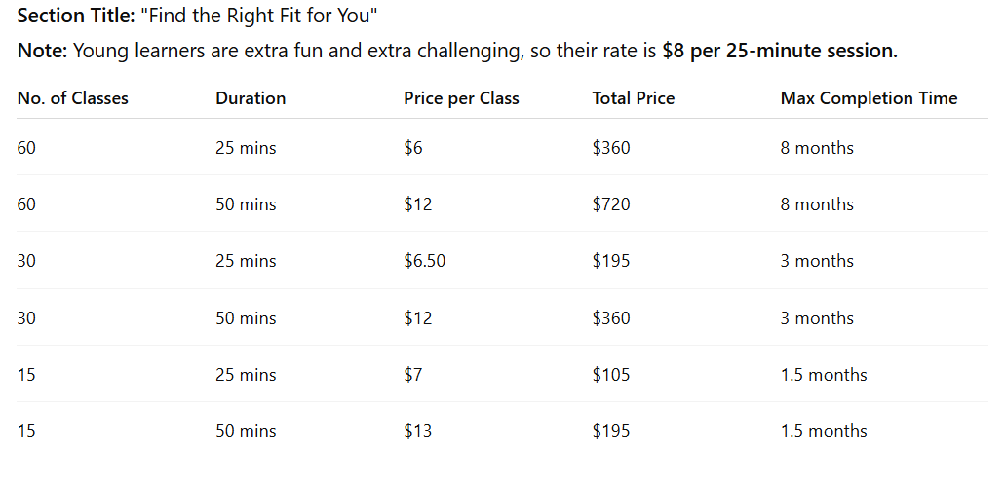

YOUNG LEARNERS

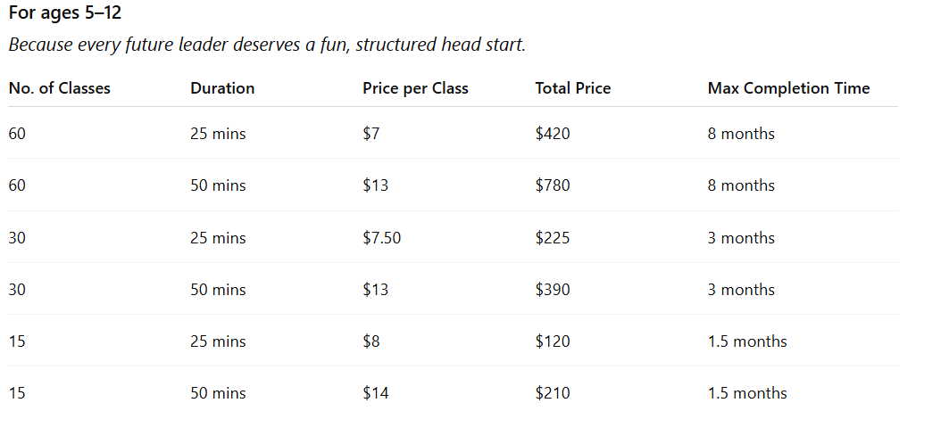

Categories:

- 💼 Boss Mode: Business English Mastery

- 🎯 Test Tamer: IELTS Speaking Review

- 👨‍👩‍👧 Parent Power-Up: English for You & Your Kids

- 🎤 Level Up Live: Real-Life Roleplay Practice

"Every session is built to challenge you—but we still keep it light when it counts."

## ✩ SPECIALTIES ("Where I Slay")

- Elevating business English to the next level

- Crushing IELTS speaking anxiety

- Real-world conversation mastery

- Helping parents become at-home English heroes

"Sessions are strategic, supportive, and designed to bring out the best in you—without the pressure cooker."

## ✩ CONTACT

Include a simple contact form: Name, Email, Message

Direct Contact Info:

- Email: sharmz_71@yahoo.com

- Phone: +63 917 417 7489

- Add icons/links for WhatsApp, WeChat

"I don’t bite—I correct gently and cheer like a coach with pom-poms and grammar flashcards."

## ✩ LANGUAGE TOGGLE

- English/Chinese toggle (top-right corner or floating)

- Can use Google Translate plugin for now, polish later

## ✩ OPTIONAL ADD-ONS (IF HEC IS FEELING EXTRA):

- Testimonials: Pop-up anime-style speech bubbles

- Progress Levels: Like game levels or manga-style transformation stages

- Coach’s Corner: Future blog with short grammar/vocab tips

## 😎 FINAL NOTE TO HEC FROM MOM:

I’m the coach who gets real results—and makes the learning journey one people actually enjoy. No dry lectures. No pressure. Just clarity, structure, and great energy.

Make the site pop. Let them feel my power.

Love,

Coach Sharmz

(a.k.a. The English Whisperer in Red & Black) 🧘‍♀️📘️🔥