Agentic AI Travel Itinerary System – Project Document (Starter Version)

Overall Layer, architecture, design pattern, Kafka Topic ,partitions:
Seeing the use cases and complexity of application I would suggest User layer.
Functional Layer:
Orchestration Layer, Communication layer, Agent Layer, Integration external layer, data layer, External system layer could be use on high level.
Architecture pattern:
we can use are Hub and spoke orchestration agent being central, then event driven using Kafka broker, producer and subscriber, topic, consumer group, Data layer could be blackboard we can use Redis, Postgres, vector base for short term, long term. Reasoning llm driven. Scalability we are using micro agent
Desing Pattern:
Reasoning pattern for main orchestrator, optimizer agent can use LLM.
Memory both short term and long term (Redis / Postgres/vector db) .
Tool Use MCP server for out service APIs
Reflection. preplanner Agent revaluates plan based on new data

Kafka & Topic :
Topic Parition
travel.requests user_id
agent.tasks task_type
agent.results agent_name
optimization.requests request_type
disruption.events event_type

2.1 Partition Distribution (conceptual every unique customer request goes to same partiion )

travel.requests (3 partitions):
P0: Simple requests (single destination, standard budget)
P1: Complex requests (multi-city, custom preferences)
P2: Urgent requests (immediate travel, replanning)
agent.tasks (5 partitions):
P0: Weather analysis tasks
P1: Budget optimization tasks
P2: Event detection tasks
P3: Transport routing tasks
P4: Preference learning tasks
agent.results (5 partitions):
P0: Weather agent results
P1: Budget agent results
P2: Event agent results
P3: Transport agent results
P4: Preference agent results
optimization.requests (2 partitions)
P0: Initial itinerary optimization requests.
P1: Re-optimization requests triggered by disruptions (e.g., flight delay, weather).
disruption.events (3 partitions)
P0: Flight delay and cancellation alerts.
P1: Severe weather warnings impacting destinations.
P2: Infrastructure disruptions (road closures, strikes, etc.).

Part 3: Expected Deliverables
1. System Architecture diagram with data and control flow.
Architecture Layers
- User Interface – input destination, dates, budget, preferences.
- Main Orchestrator – LLM-based reasoning and coordination.
- Message Bus – Kafka or RabbitMQ for async task distribution.
- Specialized Agents – Weather, Budget, Event, Transport, Preference.
- Optimizer Agent – combines results and generates itinerary.
- Replanner Agent – monitors for dynamic events and triggers re-optimization.
- MCP Server – handles authentication, rate limiting, caching, and logging.
- Data Layer – stores orchestration logs, optimization results, and preferences.
- External APIs – provide weather, travel, map, and event data.

Part 1: Simple Use Cases
Simple scenarios: Weather-based adjustment User wants to visit Goa in July. Suggest indoor attractions or alternate months (Dec–Feb)

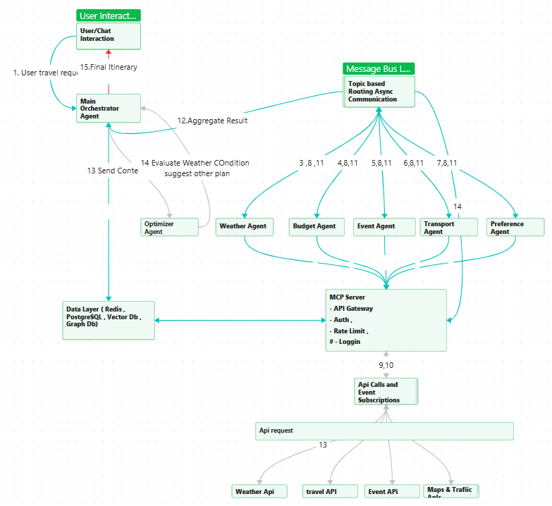

Step | Action
1 | The User submits a travel request — “Plan a trip to Goa in July.”
2 | The Main Orchestrator receives the request, extracts intent (destination, time, preferences), and publishes asynchronous tasks to the Message Bus.
3 | The Message Bus distributes tasks to all specialized agents: Weather, Budget, Event, Transport, and Preference.
4 | The Weather Agent receives its task and queries the MCP Server for live and historical weather data.
5 | The MCP Server authenticates and calls external Weather APIs (e.g., OpenWeather, Meteo).
6 | The Weather APIs return rainfall, humidity, and temperature forecasts for July in Goa.
7 | The Weather Agent analyzes this data and finds heavy rainfall with poor outdoor conditions, then sends this warning back to the Message Bus.
8 | The other agents (Budget, Event, Transport, Preference) execute normally via the MCP Server and return their processed data: – Budget Agent → within budget range.– Event Agent → few cultural events.– Transport Agent → roads accessible.– Preference Agent → prefers beaches.
9 | The Message Bus aggregates all agent responses and sends them to the Main Orchestrator.
10 | The Main Orchestrator detects that the Weather Agent flagged unfavorable conditions.
11 | The Orchestrator sends the full context to the Optimizer Agent for reasoning and alternative planning.
12 | The Optimizer Agent evaluates all constraints (weather, budget, user preferences) and generates options: – Suggest indoor activities (museums, cafes, wellness centers).– Recommend alternate months (December–February) for better weather.
13 | The Optimizer Agent returns the optimized recommendation to the Main Orchestrator.
14 | The Main Orchestrator compiles the final response, integrating the optimizer’s suggestions and other agent insights.
15 | The User Interface presents the personalized, weather-aware itinerary or alternate month recommendation to the user.

Part 2: Advanced / Difficult Use Cases
5 Dynamic re-planning Flight delayed by 6 hours. Re-adjust itinerary and notify stakeholders.

- Architecture Diagram (Mermaid or Image)
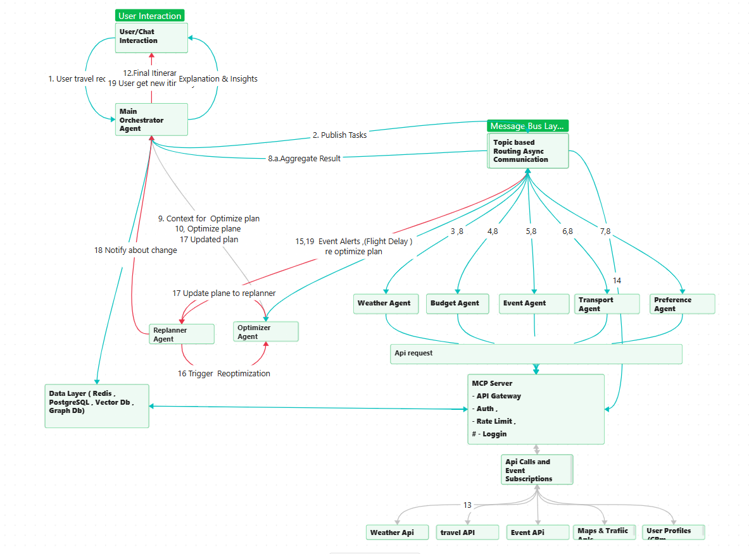

Step | Action Summary
1 | User submits travel request (destination, dates, budget, preferences).
2 | Orchestrator publishes tasks to message bus.
3–7 | Specialized agents process Weather, Budget, Event, Transport, and Preference tasks.
8 | Agents send results back to the message bus.
9 | Message bus aggregates results and returns them to orchestrator.
10 | Orchestrator sends data to Optimizer Agent.
11 | Optimizer returns optimized itinerary.
12 | Orchestrator delivers initial itinerary to user.
13 | MCP Server continuously monitors external APIs.
14 | MCP detects events (e.g., flight delay) and pushes trigger to message bus.
15 | Replanner consumes the trigger and decides if replan is needed.
16 | Replanner sends request to Optimizer for updated plan.
17 | Optimizer returns the revised plan to Replanner.
18 | Replanner forwards updated plan to orchestrator.
19 | Orchestrator notifies user with revised itinerary.

3. PEAS Framework
Performance Trip satisfaction , Quality of itinerary suggestions (comfort, cost, user satisfaction) , real type adaption
Environment API - weather, transport, events, user data.
Actuators LLM Reasoner , Notification system ,Optimizer Agent, Replanner Agent, Main Orchestrator.
Sensors Weather APIs, Transport Data, Event APIs, User Feedback.

4. Agent Collaboration Model
Message Bus (Kafka / RabbitMQ) enables asynchronous communication among agents.
Each agent subscribes to specific topics (e.g., weather.data, budget.data).
The Main Orchestrator aggregates and coordinates inter-agent communication.
Optimizer Agent integrates all agent responses for final itinerary generation.

Demo Json events and partitionar class :
Wwe will need partition or class so it can do hashing or similar algorithm to data for each customer goes to topic serially
{“ Customer_ID”:””,
“Topic””:”topic name”,
“from ”,” weather.data”,
“to”:”replanner.do”,
“payload”:{
”confidence”:”0.9”,}

5. AI Layer:

Rule Layer: Constraints budget, time
LLM Layer :Reasoning & summarization
Optimization : Multi – objective , trade off , Cost vs Comfort

6. Ethical & Responsible Consideration : (data privacy , explainability):
Privacy : Encryption
Explainability – Provide reason in reply
Transparency – confidence score
Accountability - if possible Human override and logging

7. Future enhancements (weather forecasting, GenAI summarization).

Predictive forcasting ( Develop Ml model for forcasting or use external service if it ovrkills system

Gen Ai summarization LLM can suggest daily plan & what will be needed to take with you , which taxi service is good , scam around happening , food , local programs , around areas

Part 4: Evaluation Criteria
• System Thinking:
- Hierarchical multiagent Architecture
- Clearly defined Weather, Budget, Event, Transport, Preference, and Optimizer Agents.
- Logical control and data flow across layers
• Autonomy:
-Agents Operate independently via kafka message
• Technical Depth:
-Use of APIs, ML, and message buses.
• Reasoning:
- Context aware LLM&Multi – objectice

• Ethics & UX:
-Privacy, transparency, and personalization.

