- SentinelShield is a lightweight educational Web Application Firewall (WAF) and intrusion-detection project.

- SentinelShield demonstrates the security workflow:

- Request → Inspection → Detection decision → Blocking or allowing → Logging → Dashboard analysis

- Tools Used:
- Git & Github
- Python
- Powershell

- Screenshots of results:
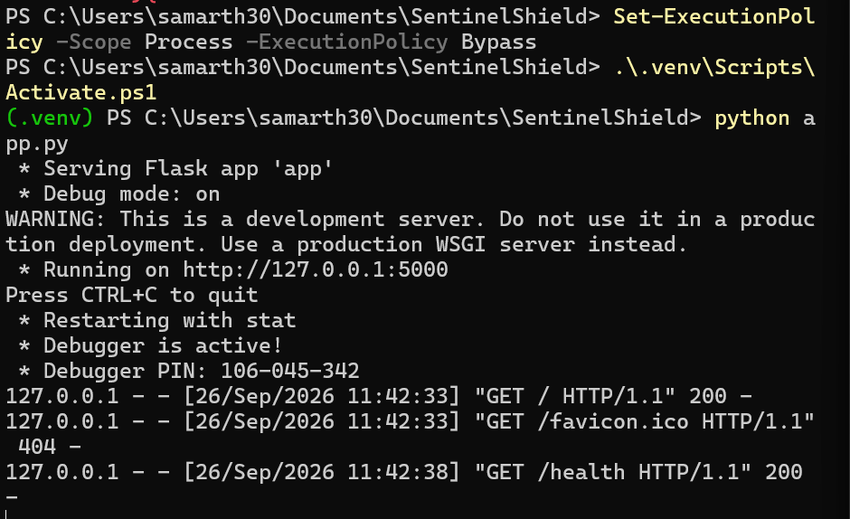

- Git & Github:

- Git creates local Git repositary, the history that will later pushed on Github.
- python:

- Whole Web Application Firewall the “SentinelShield” made with python programing language.
- (.venv) is virtual environment: packages stay project separate from computer.
- Activate.ps1 makes python & pip use that isoleted environment.
- Flask provide small web application for WAF.
- Powershell:

- Is a command-line shell, a scripting language & a configration management framework.
- Use to power users control operating systems , manage configrations, and automate repititive tasks.

- Default Network:

- 127.0.0.1:5000 is a default network address and “5000” is port to run and test web applications locally on our own computer.
- Logs:

- To see Logs means a kind of history like which kind of users visited on our applications to check they legitimate or not trough set of rules that made by us that allow or block Ips depending on which user is genuine or hacker.
- Get-Content .\logs\events.jsonl - this is the command to see logs for “SentinelShield”.

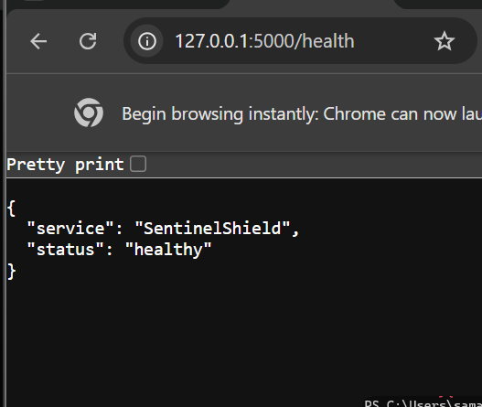

- /health is path to reach or see our application page.

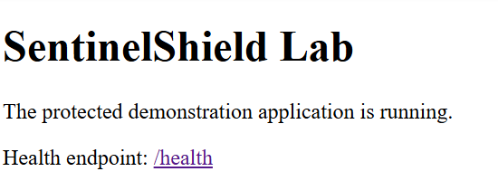

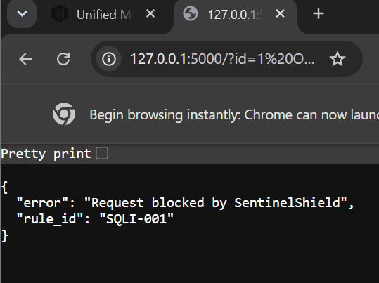

- SQLI:
Structured query language injection. It’s a type of Cyber Attack where malicious code is inserted into input fields like a login box or search bar to trick a database.
E.x., ‘ OR ‘1’=’1 its read as cmd in backend if the input field is not properly validate. Causes database leak.

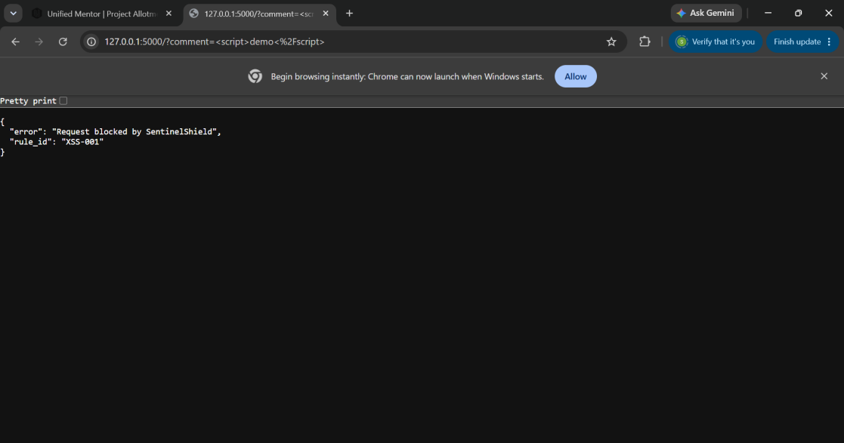

- Xss:
Cross site scripting. It is also a cyber attack where hacker inject some malicious script in input field. It’s show a temperory popup with message. Its execute or store on browser. So, every time user visit the page the popup will appear with messege.
Type-2 of cross site scripting is stored xss wich stored on web application server wich is very harmful. Whenever server read that its execute. E.x., Someone inject a payload in commentbox. So, whenever user reach their its stole data as per payload.
Type-3 Dom based attack. Also this is attack. E.x., when hacker load img but on error its set in event if show error then give me credentiels etc.

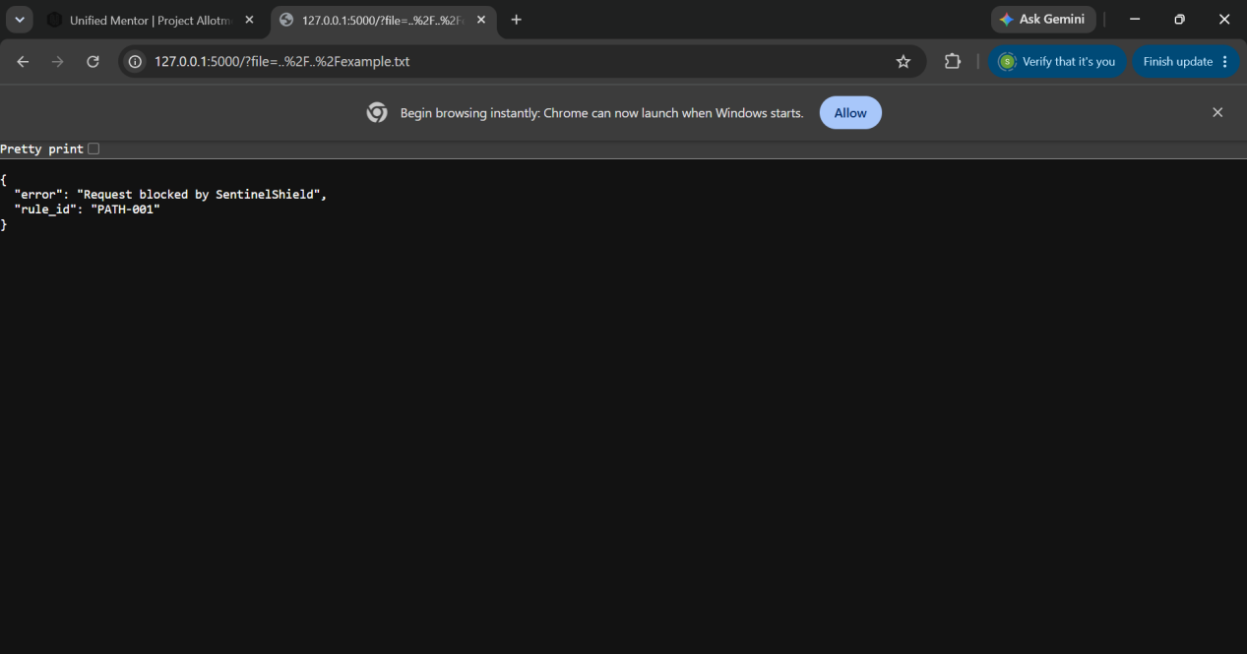
- Directory traversal Attack:
Its a vulnerability where hacker try to get users creditentials using path like ../../etc/passwd. In windows we use ’\’. this perform when there is a field for retrive data like (?file=cat.jpg) in URL.
As you can see in demonstration screenshot we test firewall to prevent this kind of attack.

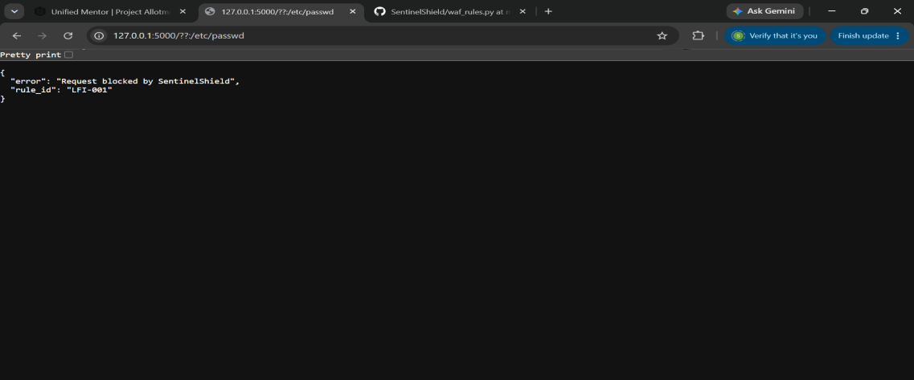

- LFI:
Local file inclusion attack. Quite similar to directory traversal attack but distinct.
In directory traversal attack you can read data but in LFI you can execute malicious file on server.
There are 2 types:
1.LFI(local file inclusion)
2.RFI(remote file inclusion)- in this hacker can use file that is located in their own server and inject on targeted server remotely.

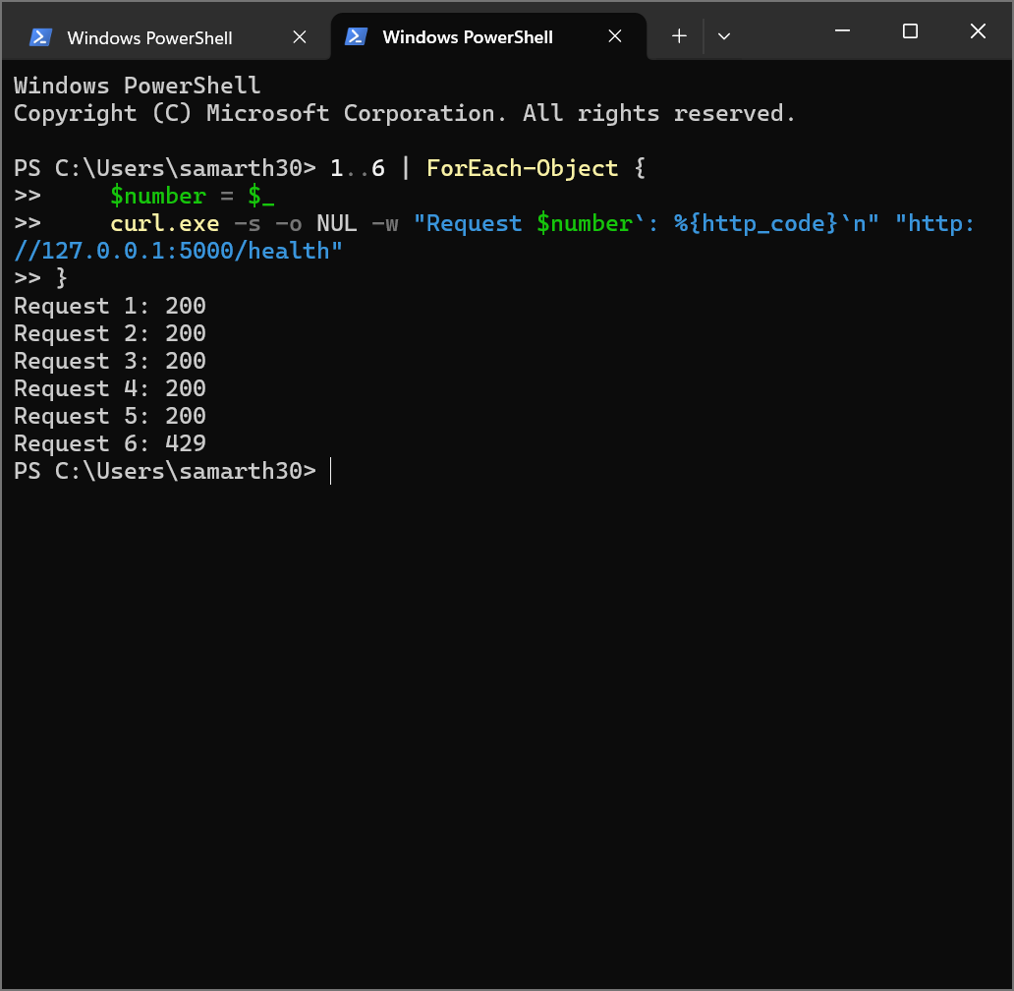

- In above screenshot use a rate limiter to prevent brute force attack. A hacker can try to login with combinations of username and password multiple times in few seconds to get login.
- As you can see in test one ip(user) send multiple request to login. So, our firewall block that ip address which user try to get login with.
- If number of request go above 5 then that ip block.

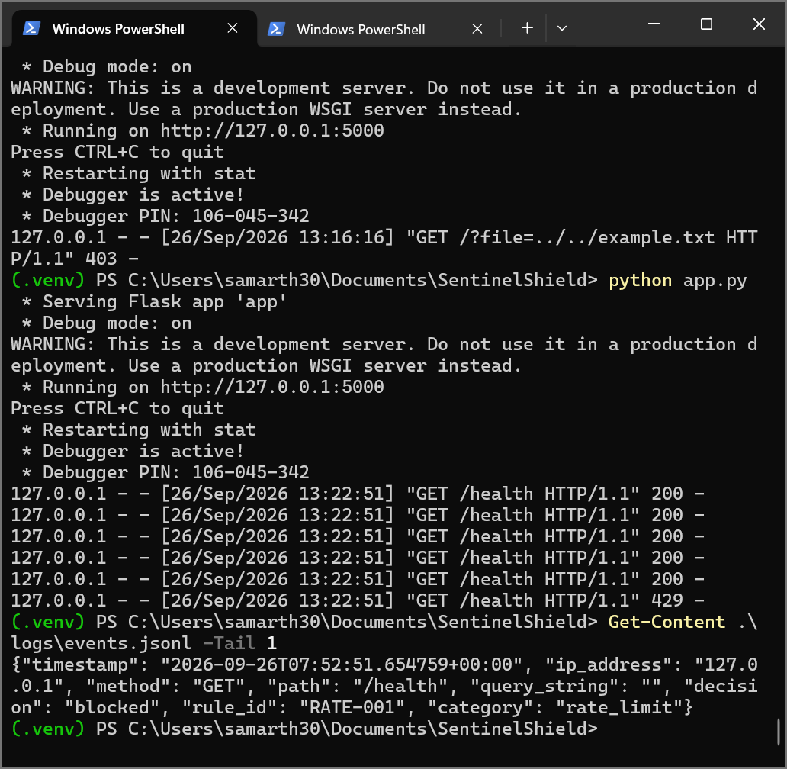

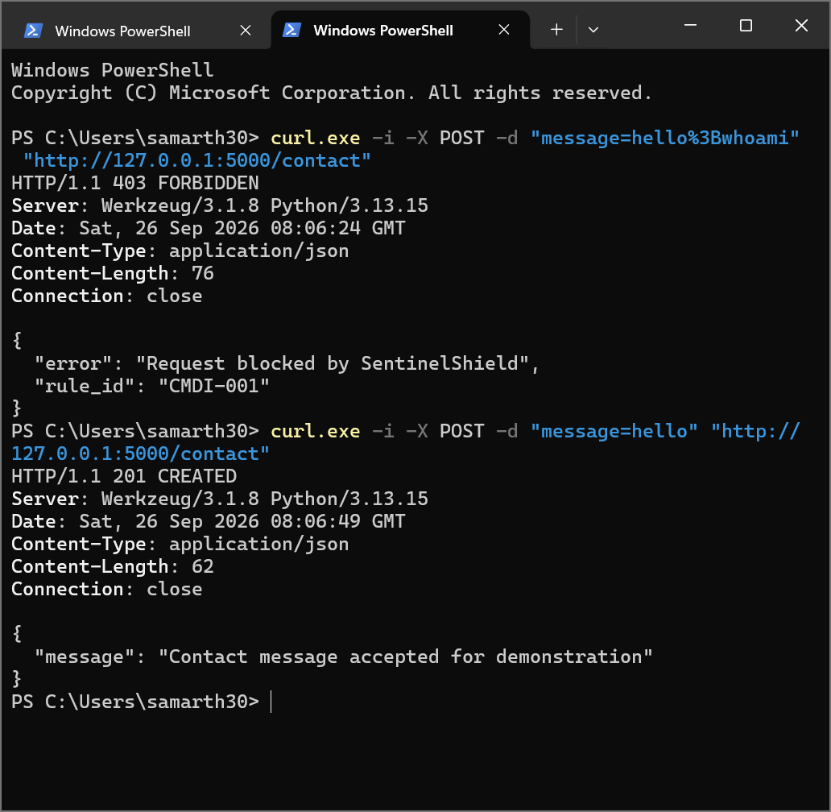
- Cmd:
Command line injection is a cyber attack and sub categaory of injection attack.
In this vulnerable website take input from users as command that execute on web server if the input field not properly senitised the user input.
E.x., $(whoami) is linux cmd

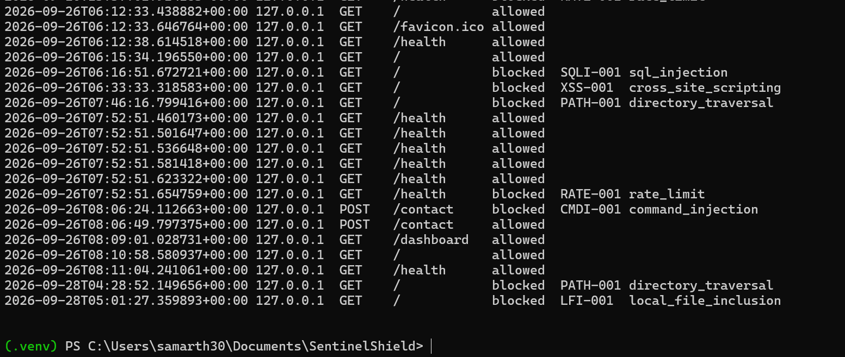

- Logs:
Above screenshot is showed the logs of “SentinelShield”.
Cmd to see logs:
Get-Content .\logs\events.jsonl |
ForEach-Object { $_ | ConvertFrom-Json } |
Format-Table timestamp, ip_address, method, path, decision, rule_id, category -AutoSize

- Dashboard:
It reads the json security log and summerise requests, blocks, attack categories, flagged IPs, and recent events.
- To see dashboard:
127.0.0.1:5000/dashboard(After establised the conneciton).
