**JOB APPLICATION TRACKER**

A React, Redux & ASP.NET Core Web API Project

Submitted by:

**Sameer Saurav**

Batch C3

Under the Supervision of **Ms. Jyoti Patil**

20th March 2025

## **Problem Statement:**

*Many job seekers apply for multiple jobs but struggle to track their applications, status updates, and interview schedules efficiently. This leads to missed opportunities, poor organization, and delayed responses.*

⚠️ **Key challenges Faced by Job Seekers:**

**✅ Tracking multiple job applications** (No proper organization)

**✅ No real-time notifications** for application status updates

**✅Lack of filtering & sorting** for jobs based on category, location, or salary

**✅No way to bookmark jobs or take notes** for reference

**Project Goals & Objectives**

**Goal:** Created an efficient **Job Application Tracker** to

help users manage applications and track job statuses

seamlessly.

**Objectives:**

✅ **Track job applications** with ease

✅**Search filter, and sort** job listings

✅**Bookmark** job applications

✅ **Secure Authentication** with JWT

✅ **Add, Edit & Delete applications** in just one click

**🧑‍💻Software Requirements:**

* **CODE EDITOR:** VS Code**,** Visual Studio 2022
* **FRONTEND:** React.js, NPM, Redux, CSS, Bootstrap
* **BACKEND**: .NET (8), C#, Web Browser (Chrome)
* **DATABASE**: SQL Server
* **TESTING API**: Post Man, Swagger

**💻Hardware Requirements:**

* **PROCESSOR**: 3.0 GHz quad-core processor
* **RAM**: At least 4GB of memory
* **OPERATING SYSTEM**: Windows (10 or Higher)

**Frontend & Backend Architecture**

**Frontend**

* Developed using **React.js** with **Redux** for state management.
* **React Router** is used for navigation.
* **Bootstrap** is used for responsive UI design.
* Implemented **Lazy Loading** for performance optimization.

**Backend**

* Built with **ASP.NET Core Web API.**
* Used **Entity Framework Core** for database interactions.
* **Endpoints** for user authentication, job listings, applications, and notifications.
* Implemented JWT**-based authentication & authorization.**

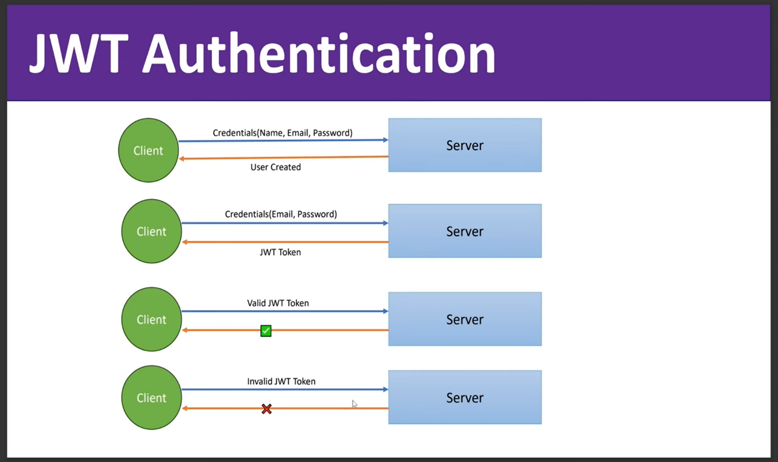

**Database**

* **Microsoft SQL Server** as the database.
* Tables: Users, Jobs, Applications, etc
* Used **Primary Key** for efficient querying.

**Components Breakdown & API Design**

**Frontend Components**

* **State Management**: Redux & React is used for managing job applications and user authentication.
* **Routing**: React Router handles navigation across pages.
* **UI Components**: Separate components for job listing, application form, filters, and user dashboard.
* **Navbar.jsx** – Displays navigation links
* **JobDetails.jsx** – Shows job details
* **JobFilter.jsx** – List all jobs with filters
* **FavoriteJobs.jsx** – Bookmark a job

**API Design**

**Endpoints**:

1. **/api/register** - Register a new user.

2. **/api/login -** Authenticate users and generate JWT tokens.

3**. /api/job/getall** - Fetch all available jobs.

4. **/api/jobsearch** – Filter jobs according to location, city, country.

5. **/api/applications/me** - Retrieve user-specific applications.

6. **/api/applications/:id** - Retrieve user-specific applications by id.

7. /**api/favorites** – Bookmark a Job.

8. **/api/applicants** – Admin can see user’s profile.

9. **/api/add/jobs** – Admin can create jobs.

10. **/api/update/jobs** – Admin can update or delete existing jobs.

**Database Design**

**JobTrackerDb (Database)**

**Users** **Jobs Applications JobApplications**

**Tables: -**

* **Users** (Id, Email, Password, Role)
* **Jobs** (Id, Title, Category, Country, City, Description, Fixed Salary)
* **Applications** (Id, Name, Email, Phone)

Data Flow Diagram of Project

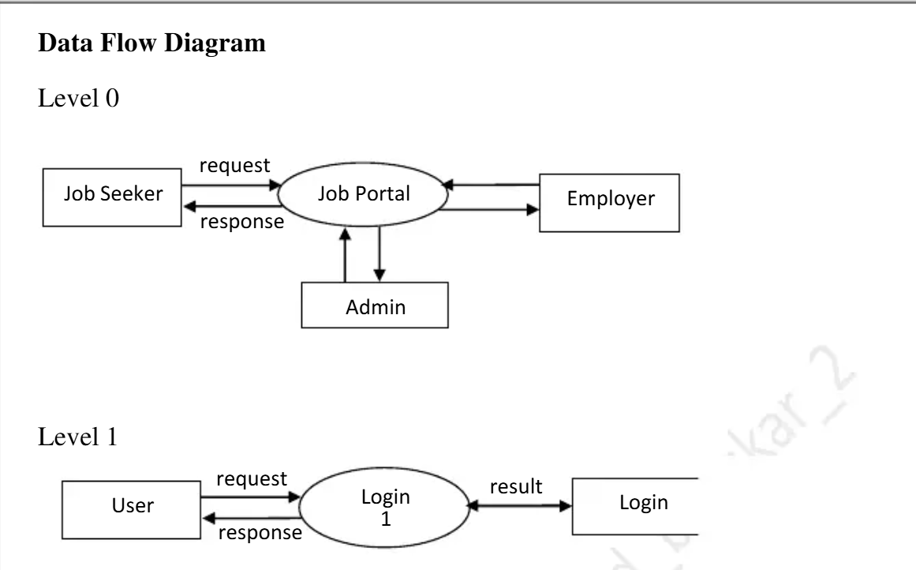

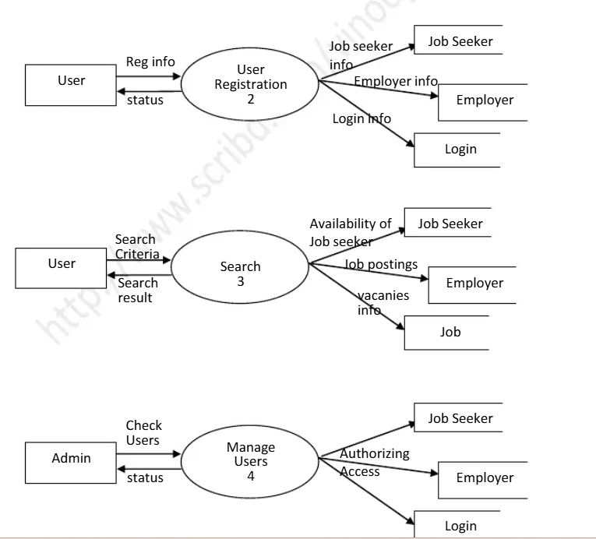

**Conclusion**

The **Job Application Tracker** project successfully streamlines the job search and application process by providing a user-friendly platform for job seekers and employers. With **a React.js frontend**, **ASP.NET Core Web API backend**, and **SQL database**, the system ensures efficient job listing, application management, and real-time status updates.

Key features such as **job filtering, sorting, bookmarking, real-time notifications, and status tracking** enhance the user experience, making job applications more organized and accessible.

For More details access the complete source code on **GitHub:** [**https://github.com/sam32190/JobTracker.git**](https://github.com/sam32190/JobTracker.git)