Name: LALITH PRASAD RAVINDRANATH 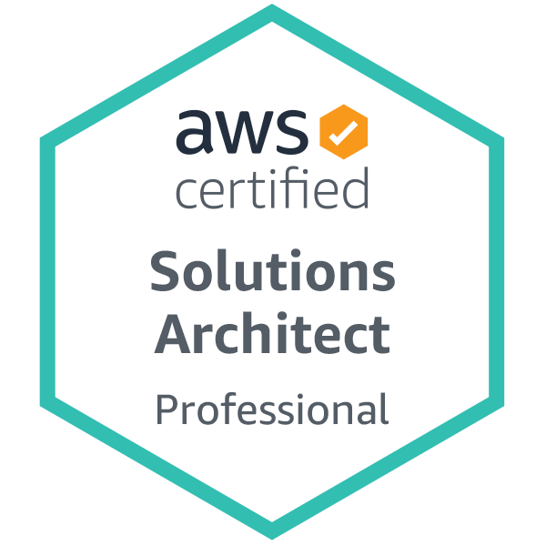
E-mail: lalitdeva01@gmail.com
Phone #: 229-296-2328
Work Authorization: U.S. Citizen
Education:
Master of Science in Electrical Engineering May 2012
University of Texas at Arlington, TX
Bachelor of Engineering in Electronics and Communication June 2007
P.D.A College of Engineering, Gulbarga, India

SUMMARY:

I was working with Samsung Electronics America as a Devops Engineer. And I also worked in Qualcomm as their Build and Release Engineer. Prior to that worked as a Release Engineer Intern with Research in Motion. I also worked as a System Administrator with Keane. I have a Masters in Electrical Engineering with the major in Wireless Communication. My Academics and work experience have afforded me a wealth of experience in the area of devops and automation.

I am currently seeking a technical position with a company that allows me to apply my current skills and knowledge, while continuing to expand my abilities in the area of system's testing development.

TECHNICAL SKILLS:

- DevOps Tools: Jenkins, Maven, Ansible, Chef, Kubernetes, Docker, Terraform
- Scripting and Programming Languages: Python, Perl, C, Shell Scripting, BASH
- Source Control Management Tools: GitHub, GitBash
- Bug Tracking Tools: Jira, Bugzilla
- Cloud Platforms: Amazon Web Services (EC2, EBS, EFS, S3, Cloudfront, Cloudwatch, IAM, SQS, RDS, ELB, Route53, Security groups)
- Monitoring Tools: AWS Cloud watch, Splunk, Grafana, Sensu
- SDLC: Agile, Waterfall
- Operating Systems: Linux, Ubuntu, Mac OS X, Windows

PROFESSIONAL SUMMARY:

- Implemented CI/CD pipelines involving Jenkins, Docker, Maven, Ansible and Github for complete automation from commit to deployment.
- Analyzed granular metrics of AWS resources through Cloudwatch and created Alarms.
- Used Terraform to automate creation of AWS resources such as ELB , EC2, security groups and S3 buckets.
- Used Ansible to assist in building automation policies.
- Designed and implemented automation deployment using jenkins to promote major releases, monthly releases, and patches from Development -> Integration/QA -> Staging/UAT -> Production.
- Redesigned infrastructure for high availability across multiple AWS availability zones.
- Dynamically scaled EC2 instances in AWS production environment through autoscaling.
- Experienced with the following components of AWS: EC2, EBS, EFS, S3, Cloudfront, Cloudwatch, IAM, SQS, RDS, Route53, ELB and EKS.

PROFESSIONAL EXPERIENCE:

Samsung Electronics America, TX, USA July 2013-July 2020
Job Title: Devops Engineer

- Implemented CI/CD pipelines involving Jenkins, Docker, Maven, Ansible and Github for complete automation from commit to deployment.
- Worked in all areas of Jenkins setting up CI for new branches, build automation, plugin management and securing Jenkins and setting up master/slave configurations.
- Responsible for nightly and weekly builds for different modules. Built and deployed the java applications onto different environments through Jenkins
- Worked on AWS EC2 Instances creation, setting up VPC, launching EC2 instances and worked on CloudWatch for providing high availability of applications and EC2 instances based on the load of applications.
- Developed scripts using Python Scripts and BATCH files for Automation of Activities and builds, multiple Scripting languages like Bash, Python, Shell.
- Created Docker images using a Docker File, worked on Docker container snapshots, removing images and managing Docker volumes.
- Used Jenkins for Continuous Integration and deployment in JBoss Application Server.
- Developed MAVEN Scripts to automate the build process and Shell/Perl scripts to automate the deployment process.
- Worked on AWS Features Enabling Virtualization of Samsung PTT Solution

Qualcomm Inc, TCS, San Diego, CA, USA Sep 2012-July 2013
Job Title: Build and Release Engineer

- Defined, implemented, and maintained build infrastructure and scripts for Windows Mobile.
- Wrote batch scripts, Perl/Python scripts, to automate the build install, and release process for Windows mobile product.
- Integrated, built and tested apps on Android mobile.
- Created jobs on continuous integration (CI) tool, Jenkins to perform daily builds of Android mobile product.
- Worked effectively with various teams across the organization.

Research in Motion, Seattle, WA, USA Aug 2011-May 2012
Job Title: Release Engineer Intern

- Support QA teams in code deployments, configuration, and tool maintenance for both manual and automated test environments
- Help build or select tools to enable efficient deployments and maintenance of various environments
- Work closely with Development, QA, and IT to define, implement and support automated deployment tools to enable efficient deployments and maintenance of various environments

Keane International Pvt. Limited, Bangalore, INDIA June 2007-June 2009
Job Title: System Administrator

- Experience in Linux Administration (Installation, Configuration, Tuning and Upgrades of Linux (RedHat and Oracle).
- Maintained maximum uptime and maximum performance capacity for enterprise production, QA and UAT/staging.
- Performed configuration of standard Linux and network protocols, such as SMTP, DHCP, DNS, LDAP, NFS, HTTP, SNMP.
- Developed various bash shell scripts to automate resource, job monitoring and alerting.

