A Comparative Deep Learning Study for VizWiz Image Captioning
EfficientNet-B4 with Transformer Decoding versus EfficientNet-B4 with LSTM and Bahdanau Attention
Report / Article Type Paper
Prepared from: Loading Data.ipynb and phase-2-and-3-faisal-shoaib.ipynb
Publisher: Sameer Hassan Khan

Item | Detail
Dataset | VizWiz-Captions validation image-caption data
Task | Automatic image captioning for accessibility-oriented images
Models | EfficientNet-B4 + Transformer; EfficientNet-B4 + LSTM + Bahdanau Attention
Main finding | Model 2 achieved the strongest validation loss and CIDEr score
Publisher | Sameer Hassan Khan

Contents
- Abstract
- Introduction
- Dataset and Research Context
- Data Loading, Cleaning, and Preparation
- Exploratory Outputs and Dataset Visualisations
- Model 1: EfficientNet-B4 Encoder with Transformer Decoder
- Model 2: EfficientNet-B4 Encoder with LSTM and Bahdanau Attention
- Evaluation Methodology
- Results and Comparative Analysis
- Qualitative Findings
- Limitations, Recommendations, and Future Work
- Conclusion
- Appendix: Notebook Outputs and Figures

Abstract
This paper presents a complete report-style study of an image captioning workflow built around the VizWiz-Captions dataset. The underlying notebooks perform the full project pipeline: loading and validating the image-caption data, cleaning low-quality captions, constructing image-level train, validation, and test splits, building vocabulary and PyTorch data loaders, training two neural captioning architectures, evaluating them with standard natural language generation metrics, and comparing their qualitative behaviour through generated captions. The first model combines an EfficientNet-B4 visual encoder with a Transformer decoder. The second model uses the same EfficientNet-B4 backbone but replaces the Transformer decoder with a two-layer LSTM supported by Bahdanau soft attention over a 14 by 14 semantic feature grid. The goal of the study is not only to report scores, but also to explain why each design decision matters in an accessibility-focused captioning task where images are often noisy, off-centre, low-light, or text-heavy. The final comparison shows that the attention-based LSTM model gives the best validation loss of 3.7752 and the strongest CIDEr score of 0.4574, while the Transformer model reaches a best validation loss of 4.0265 and CIDEr of 0.4247. Model 2 improves BLEU-1, BLEU-2, BLEU-3, BLEU-4, and CIDEr, although it slightly trails Model 1 on METEOR and ROUGE-L. These results suggest that spatial attention, repetition-controlled beam search, and careful training schedules are especially helpful for the VizWiz captioning setting. The report includes all relevant outputs, plots, dataset distribution graphs, training curves, metric tables, and qualitative visual comparisons extracted from the notebooks.

Introduction
Image captioning is the task of teaching a computer vision system to look at an image and produce a natural-language description of what is visible. At first glance, this may sound like a simple combination of object recognition and sentence generation, but the task is more demanding than classification because a successful caption must identify important objects, recognise their relationships, choose the right level of detail, and express the result in fluent language. In a normal image classification problem, the model might only need to say that an image contains a bottle. In captioning, it may need to say that a person is holding a small medicine bottle, that a computer screen is showing an error message, or that a box contains nutritional information. The problem therefore sits at the intersection of visual representation learning, sequence modelling, and language evaluation.
The VizWiz-Captions dataset makes this problem even more socially important and technically challenging. VizWiz images were collected in an accessibility context, where blind or low-vision users captured images and asked for assistance. Such images are often very different from carefully curated internet photographs. They may be blurred, partially framed, rotated, dark, cluttered, or focused on printed text. Many of the scenes are also ordinary household or personal objects rather than iconic objects staged for machine learning benchmarks. For that reason, the dataset is highly relevant for real-world assistive technology, but it also exposes weaknesses in captioning models that perform well on cleaner datasets.
This report transforms the supplied notebooks into a structured article-style paper. It follows the project pipeline from raw data inspection through final results. The first notebook, Loading Data, prepares the VizWiz-Captions validation data for modelling. It checks whether the JSON annotation file and image folder agree, removes poor-quality captions, groups captions by image, creates train-validation-test splits at the image level, builds a vocabulary, encodes captions, and confirms that the PyTorch data pipeline returns tensors with the expected shapes. The second notebook, Phase 2 and 3, builds two deep learning captioning systems and compares their performance. Together, the notebooks represent an end-to-end image captioning experiment.
The report is written in an article format because the project contains both experimental and explanatory components. It must tell the reader what data were used, how the data were cleaned, why the models were designed in a particular way, what losses and metrics were applied, what the numerical outputs show, and what limitations remain. The paper therefore combines technical reporting with interpretation. The central research question is: given the processed VizWiz captioning data, which of the two architectures produces a better balance of validation loss, automatic metric performance, and qualitative caption quality?

Dataset and Research Context
The dataset used in the notebooks is the VizWiz-Captions dataset, with a specific focus on the validation partition that was repurposed into internal training, validation, and testing subsets. The notebook first loads the official JSON annotation files and verifies the scale of the available data. The test JSON contains 8,000 images, the train JSON contains 117,155 annotations, and the validation JSON contains 38,750 annotations. For this project, the image folder used for modelling contains 7,750 JPEG files, and the validation JSON also records 7,750 image entries. The perfect match between the JSON image records and the image files on disk is a key quality check because any missing image would later cause a data loader failure or create a silent mismatch between captions and visual inputs.
Each image in the validation data has multiple captions, which is essential for image captioning. Multiple human references allow the evaluation system to recognise that more than one description can be correct. For example, one reference may describe a medicine bottle as a bottle of night-time medication, while another may describe it as cough syrup held in a hand. Both may be acceptable if they describe the same visual evidence. This matters because automatic metrics such as BLEU, METEOR, ROUGE-L, and CIDEr compare generated captions against human references. A single reference would make evaluation overly strict, while multiple references provide a fairer target.
The accessibility context of VizWiz also explains why the dataset includes a text_detected field. Many images taken by blind or low-vision users are aimed at packages, labels, computer screens, medication bottles, documents, and other objects where printed text is important. A captioning model may therefore need to describe both objects and readable text. The notebook visualisations show that only a portion of images and captions are marked as text detected, meaning that the model must handle a mixture of text-heavy and non-text scenes. This mixture has practical consequences: models trained only to recognise objects may struggle with screen prompts, food labels, or medicine packaging, while models trained to over-focus on text may miss object context.
Because the full training partition of VizWiz is large, the project uses the validation partition as a controlled working dataset. This is a reasonable educational and experimental choice: it allows the complete pipeline to be developed, trained, and evaluated within available computational resources. However, it also creates a limitation. The internal train, validation, and test subsets all originate from the same official validation partition, so the final scores should be interpreted as internal experimental results rather than a claim of state-of-the-art performance on the official benchmark. The strength of the project lies in its complete, reproducible pipeline and architecture comparison.

Key Dataset Outputs
Output | Value
Image files found on disk | 7,750 JPEG files
Validation JSON image records | 7,750 images
Validation JSON annotations | 38,750 captions
Missing files on disk | 0
Extra disk files | 0
Image-JSON filename match | Perfect / True

Data Loading, Cleaning, and Preparation
The data preparation notebook begins with reproducibility. A global random seed of 42 is set for Python random operations, NumPy operations, PyTorch CPU operations, and PyTorch GPU operations where available. Reproducibility is important because image captioning experiments involve random weight initialisation, random data shuffling, train-validation-test splitting, augmentation, and sometimes nondeterministic GPU behaviour. Setting the seed does not make every GPU operation perfectly deterministic, but it ensures that the main experimental choices, especially the data split, are stable enough to be checked and repeated.
After loading the JSON files, the notebook converts the images and annotations lists into pandas DataFrames. The images DataFrame contains 7,750 rows and 4 columns, while the annotations DataFrame contains 38,750 rows and 6 columns. The first rows show a typical structure: each image file is represented by a file name, URL, image ID, and text-detection flag, while each annotation contains a caption, image ID, precanned flag, rejection flag, annotation ID, and text-detection information. The merge step combines image records with captions by image ID, producing 38,750 caption rows. This merged table is the foundation for every later operation because it connects a caption string to the corresponding image file.
A major cleaning step removes low-quality captions. The VizWiz annotations include precanned captions and rejected captions. Precanned captions are generic responses that are not useful for training a model to describe visual content. Rejected captions are also unsuitable because they are judged to be poor or invalid. The notebook reports 5,167 precanned captions, which represent 13.3 percent of the dataset, and 964 rejected captions, which represent 2.5 percent. Some captions fall into both categories: 526 captions are both precanned and rejected. After filtering, the dataset contains 33,145 captions. This means 5,605 captions, or 14.5 percent of the original caption rows, are removed.
Caption filtering also affects images. Before filtering, there are 7,750 unique images. After filtering, 7,542 images remain. Therefore, 208 images are lost because all their captions were removed. This is an important trade-off. Keeping such images would require either generating artificial captions, using empty references, or allowing images without usable targets into the training loop, all of which would weaken the experiment. Removing them keeps the supervised learning signal clean. The notebook confirms that every remaining image has at least one valid caption, with a minimum of 1, maximum of 5, and average of 4.39 captions per image.
The next stage groups captions by image so that each image can be evaluated against all of its references. Grouping is not only a convenience; it is central to image captioning evaluation. During training, individual caption rows may be used to teach the model multiple phrasings for the same image. During evaluation, the generated caption should be compared with the full set of human captions. The grouped output includes examples such as an image with three captions describing a keyboard or an unidentified electronic object with buttons. This illustrates the natural variability of human captioning and why multi-reference evaluation is necessary.
The split is performed by image ID rather than by caption row. This is one of the strongest methodological choices in the notebook. If captions were split row by row, the same image could appear in both training and validation sets with different captions. That would cause data leakage: the model might learn the visual features of an image during training and then be evaluated on another caption of the same image. Splitting by image ID prevents that problem. The cleaned data are divided into 70 percent training images, 15 percent validation images, and 15 percent test images. The output reports 5,279 training images, 1,131 internal validation images, and 1,132 internal test images.
The saved processed artifacts include train, validation, and test CSV files, along with a vocabulary object and encoded captions. Later loading checks show 23,128 training rows, 5,017 validation rows, and 5,000 test rows. The vocabulary size is 4,656 tokens, with the padding token assigned ID 0. The model input check confirms image tensors shaped as [32, 3, 224, 224], caption tensors shaped as [32, 30], and length tensors shaped as [32]. These outputs prove that the prepared dataset is compatible with mini-batch training in PyTorch.

Exploratory Outputs and Dataset Visualisations
The notebook produces several exploratory plots that help explain the data before modelling. Caption length distribution is especially important in sequence learning. Very long captions increase memory use and training difficulty, while extremely short captions may not contain enough semantic detail. The histogram of caption lengths shows that most captions are relatively short, with a long tail of longer descriptions. The boxplot reinforces the same pattern: the median caption length is low, but outliers exist far beyond the central range. This supports the later decision to use a maximum caption length and padding mechanism.
The most frequent words with stopwords included are predictable function words such as articles and prepositions. This plot is useful because it reveals how much of the token distribution is dominated by grammar rather than image content. The corresponding plot without stopwords is more informative for visual semantics: common content words include terms related to objects, colours, packaging, screens, and everyday scenes. In an image captioning system, a strong model must learn both categories of words. Function words give fluency and sentence structure, while content words carry the visual meaning.
The vocabulary-size plot shows how the number of retained tokens changes as the minimum word frequency threshold increases. At a threshold of 1, the vocabulary is largest because it includes rare words. As the threshold rises, the vocabulary shrinks. This is a standard but important design trade-off. A larger vocabulary allows the model to represent more specific words, but it also increases the output classification problem and makes rare-word learning unreliable. A smaller vocabulary improves stability but pushes uncommon terms into the unknown token. The final vocabulary of 4,656 tokens is a moderate choice for an educational captioning experiment.
The text_detected distribution plots are also important. They show the proportion of images and captions associated with text. In the training split, about 35.9 percent of images have text detected at the image level, while about 31.7 percent of caption rows are marked as text detected. The validation and test splits show similar patterns, with image-level text detected around 35.3 to 35.5 percent and caption-level text detected around 31.2 to 32.5 percent. This consistency suggests that the split process preserved the text-detection balance reasonably well across subsets.
The distribution of valid captions per image shows that most images retain all five captions after filtering. In the training split, 3,623 images have five valid captions, while smaller groups have one, two, three, or four captions. The validation split shows 751 images with five valid captions, and the test split shows 744 images with five valid captions. This is a positive result because multi-reference evaluation is strongest when most images have several references. The plots also show that the cleaning process did not reduce the dataset to mostly single-caption images.
The sample images included in the notebook demonstrate why VizWiz is difficult. The examples include a frozen vegetable package, a balance or gift card, a computer screen with visible text and glare, a product label, and a flower or decorative image. Some of these require recognising printed text, some require identifying an object from a partial view, and some may be ambiguous even for humans. These samples justify the use of powerful pretrained visual encoders and attention mechanisms.
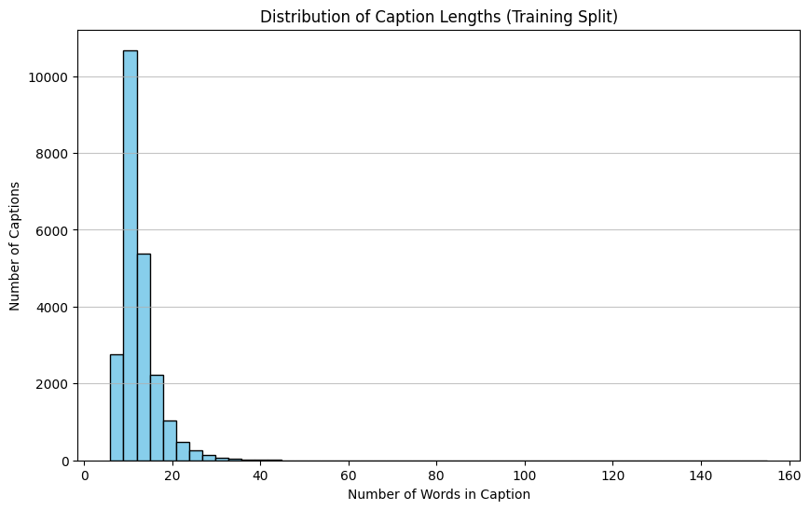
Figure 1. Histogram of caption lengths in the training split.
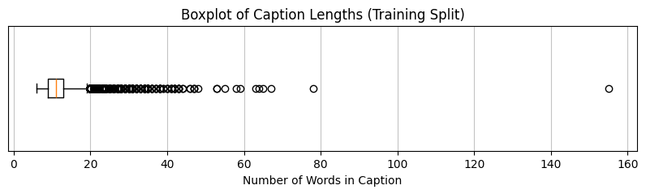
Figure 2. Boxplot of caption lengths in the training split.
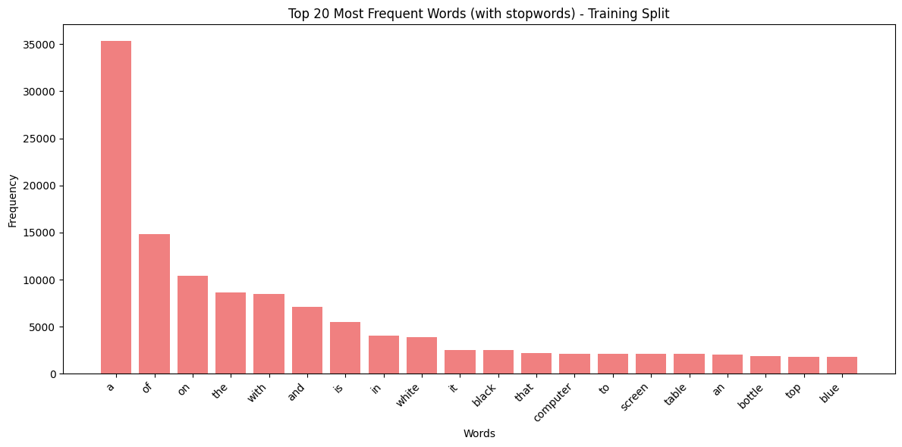
Figure 3. Top 20 most frequent words with stopwords included.
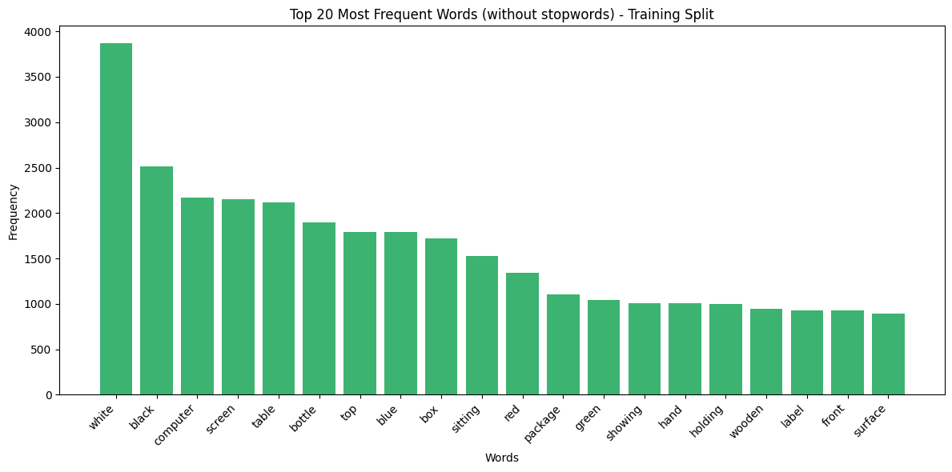
Figure 4. Top 20 most frequent words after removing stopwords.
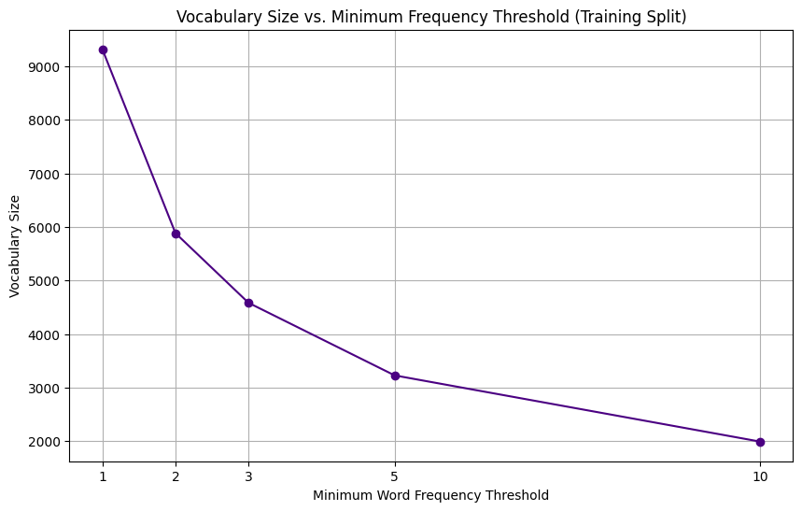
Figure 5. Vocabulary size as the minimum word-frequency threshold increases.
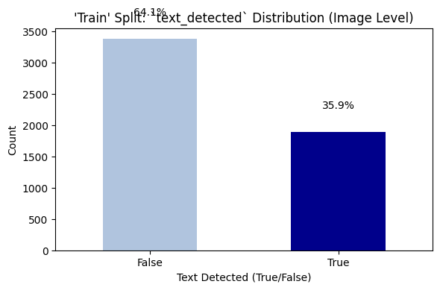
Figure 6. Training split text_detected distribution at image level.
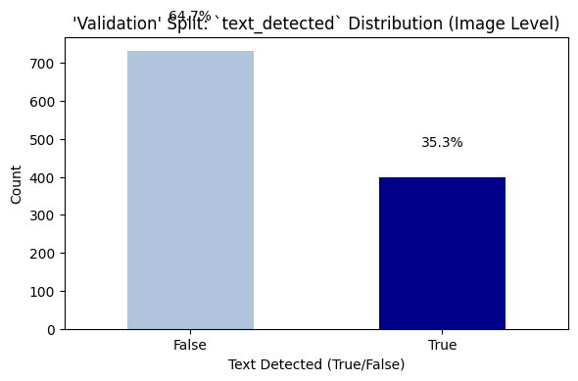
Figure 7. Validation split text_detected distribution at image level.
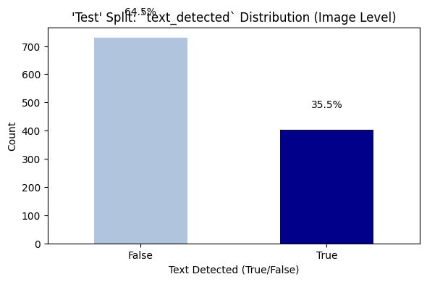
Figure 8. Test split text_detected distribution at image level.
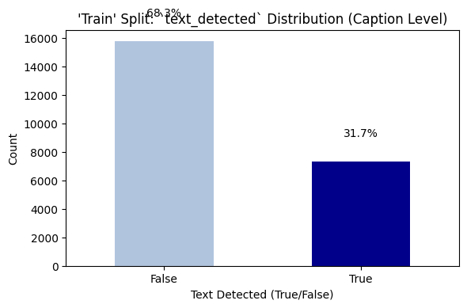
Figure 9. Training split text_detected distribution at caption level.
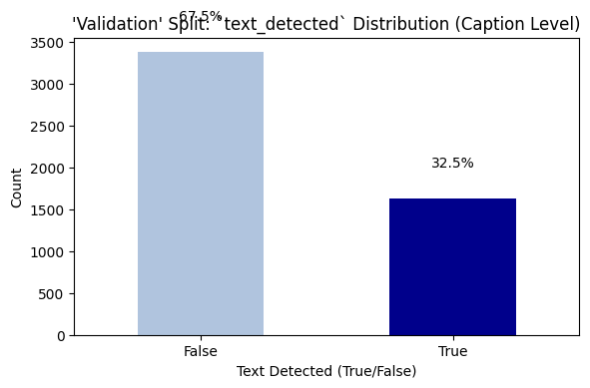
Figure 10. Validation split text_detected distribution at caption level.
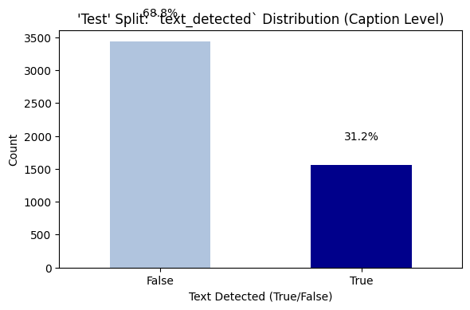
Figure 11. Test split text_detected distribution at caption level.
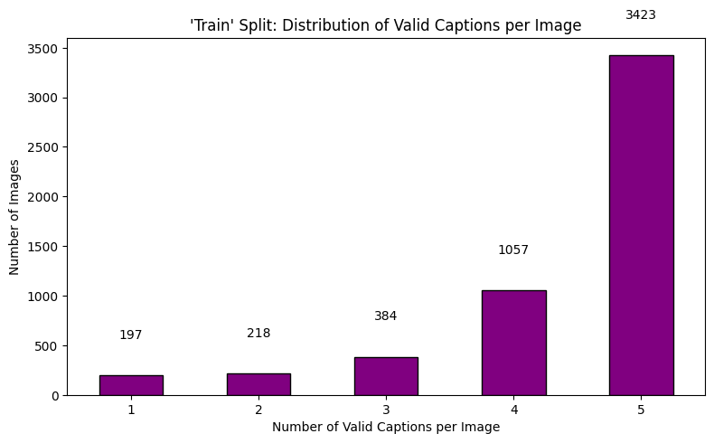
Figure 12. Distribution of valid captions per image in the training split.
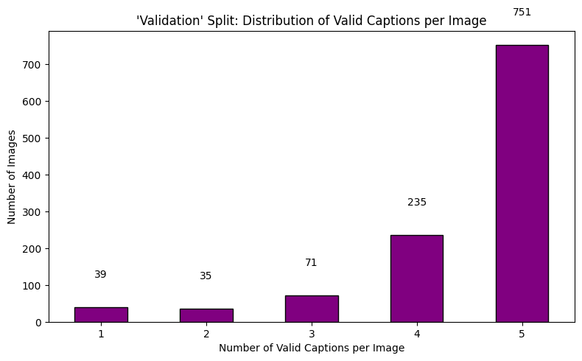
Figure 13. Distribution of valid captions per image in the validation split.
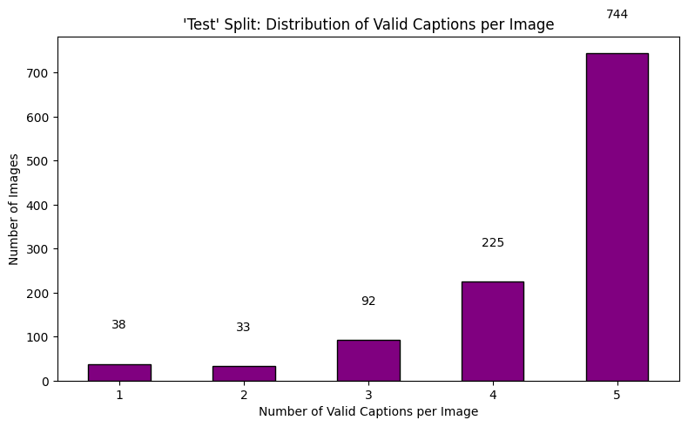
Figure 14. Distribution of valid captions per image in the test split.

Sample VizWiz Images from the Notebook
The sample images below are included because they make the dataset characteristics concrete. They show the variety of scenes and the frequent presence of text, glare, rotation, partial framing, and everyday packaging.
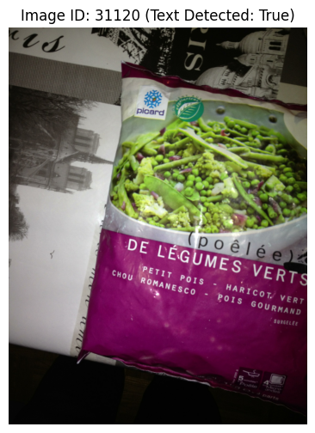
Figure 15. Sample image displayed during dataset inspection.

Figure 16. Sample image displayed during dataset inspection.
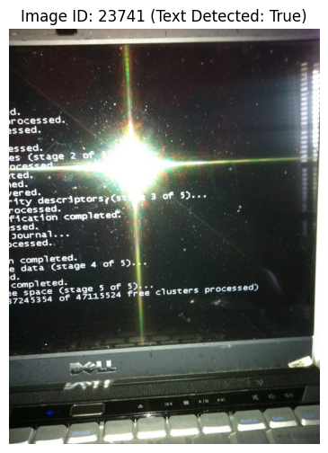
Figure 17. Sample image displayed during dataset inspection.
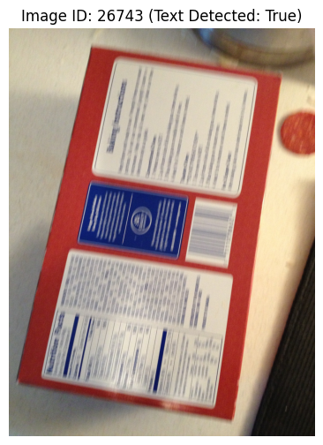
Figure 18. Sample image displayed during dataset inspection.

Figure 19. Sample image displayed during dataset inspection.

Model 1: EfficientNet-B4 Encoder with Transformer Decoder
Model 1 combines an EfficientNet-B4 encoder with a Transformer decoder. EfficientNet-B4 is a convolutional neural network architecture designed to provide strong visual features through compound scaling of network depth, width, and resolution. Using a pretrained EfficientNet backbone is sensible for this project because the VizWiz working dataset is not large enough to learn rich visual representations from scratch. The encoder converts each input image into a feature representation that the language model can use to produce words.
The decoder in Model 1 is Transformer-based. Transformers are widely used for sequence modelling because self-attention allows the decoder to relate words across the caption sequence without processing them strictly one step at a time. A Transformer decoder also uses positional encoding because attention alone has no built-in sense of word order. In the notebook, sinusoidal positional encoding is implemented to add sequence position information to the token embeddings. This design is appropriate for caption generation because the model must learn not only which words are likely, but also where those words belong in a sentence.
The Model 1 hyperparameters show a relatively large architecture: 34,358,136 total parameters and 33,697,824 trainable parameters. The training log reports ten epochs. Training loss decreases consistently from 4.9938 in epoch 1 to 2.6369 in epoch 10, which shows that the model continues to fit the training data. Validation loss, however, improves only until epoch 3, where it reaches 4.0265, and then gradually worsens. This is a classic sign of overfitting. The model becomes better at predicting the training captions but does not improve on unseen validation images after the early epochs. The notebook therefore selects epoch 3 as the best checkpoint.
Model 1 uses beam search decoding during evaluation. Beam search keeps several candidate caption sequences at each time step rather than greedily choosing only the highest-probability next word. The notebook also implements practical decoding safeguards: it suppresses padding, start, and unknown tokens; discourages repeated n-grams; and avoids ending captions with weak function words such as articles or prepositions. These constraints matter because neural captioning models can produce repetitive or unfinished phrases if decoding is left unconstrained.

Model 2: EfficientNet-B4 Encoder with LSTM and Bahdanau Attention
Model 2 redesigns the captioning system while keeping the EfficientNet-B4 visual foundation. Instead of using the Transformer decoder, it uses a two-layer LSTM decoder with Bahdanau additive attention. The major idea is to give the decoder a more explicit word-by-word mechanism for choosing which image region to focus on. In image captioning, attention is valuable because different words often refer to different parts of the image. A word like bottle may correspond to one region, label to another region, and hand to another. A single global image vector can lose this spatial information.
The upgraded encoder in Model 2 uses the final semantic EfficientNet feature map and upsamples it to a 14 by 14 grid, producing 196 spatial regions. This is a key improvement over relying on a single global vector or a coarse feature map. The notebook notes that an earlier version attended to a lower-level 14 by 14 stage, but those features were too low-level and produced diffuse attention. The final version preserves semantic strength while still providing enough spatial regions for attention visualisation and word-specific grounding.
Bahdanau attention computes a compatibility score between the current LSTM hidden state and each image region. The resulting attention weights are used to form a context vector, which is fed into the decoder. This allows the model to adjust its visual focus at each generated word. The LSTM is also initialised from the global image vector, giving the decoder a warm start based on the entire image. The prediction head combines the hidden state and context vector before producing vocabulary logits. These choices make Model 2 more explicitly multimodal at every decoding step.
Model 2 has 29,326,712 total parameters and 12,584,496 trainable parameters. It is therefore smaller in trainable size than Model 1, mainly because of different fine-tuning choices and decoder structure. The training strategy also changes. The model uses coverage regularisation for attention rather than forcing high entropy at every word. Coverage encourages the model to attend across useful image regions over the whole caption without requiring every individual word to use a flat attention distribution. Scheduled sampling is introduced gently after a teacher-forcing warm-up and is capped at 0.10. Lower label smoothing and a conservative encoder learning rate are used to support stable convergence.
The Model 2 training log shows a two-phase pattern. During the first five epochs, validation loss decreases from 4.5288 to 3.8743. At epoch 6, scheduled sampling begins and training loss temporarily rises, but the model then recovers and continues improving. The best validation loss is reached at epoch 15 with a value of 3.7752. Unlike Model 1, Model 2 continues improving late into training. This suggests that the attention-based design and training schedule generalise better on the internal validation set.
Model | Architecture | Total parameters | Trainable parameters | Best epoch | Best validation loss
Model 1 | EfficientNet-B4 + Transformer decoder | 34,358,136 | 33,697,824 | 3 | 4.0265
Model 2 | EfficientNet-B4 + LSTM + Bahdanau attention | 29,326,712 | 12,584,496 | 15 | 3.7752

Epoch | Model 1 train loss | Model 1 validation loss
1 | 4.9938 | 4.2921
2 | 4.0992 | 4.0776
3 | 3.7551 | 4.0265
4 | 3.4959 | 4.0267
5 | 3.2686 | 4.0368
6 | 3.0660 | 4.0706
7 | 2.8922 | 4.1039
8 | 2.7598 | 4.1324
9 | 2.6752 | 4.1399
10 | 2.6369 | 4.1464

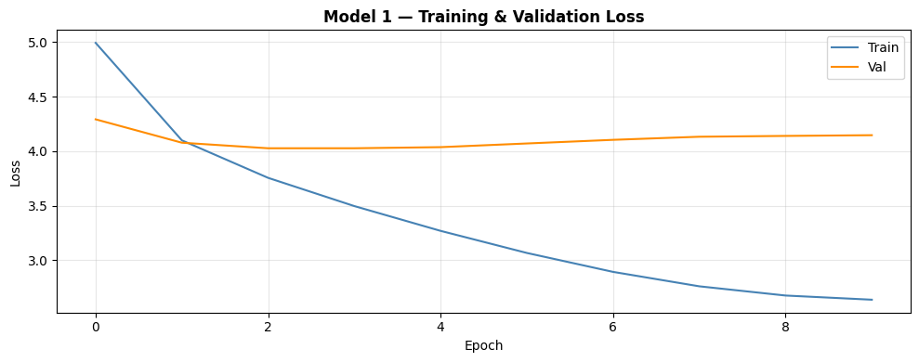
Figure 20. Model 1 training and validation loss curve.
Epoch | Model 2 train loss | Model 2 validation loss | Scheduled sampling ratio
1 | 5.1794 | 4.5288 | 0.000
2 | 4.4533 | 4.2152 | 0.000
3 | 4.1626 | 4.0386 | 0.000
4 | 3.9695 | 3.9378 | 0.000
5 | 3.8219 | 3.8743 | 0.000
6 | 4.7413 | 4.0573 | 0.010
7 | 4.3952 | 3.9573 | 0.020
8 | 4.1586 | 3.8968 | 0.030
9 | 3.9610 | 3.8584 | 0.040
10 | 3.8518 | 3.8371 | 0.050
11 | 3.7638 | 3.8161 | 0.060
12 | 3.7059 | 3.8010 | 0.070
13 | 3.6510 | 3.7883 | 0.080
14 | 3.6063 | 3.7831 | 0.090
15 | 3.5692 | 3.7752 | 0.100

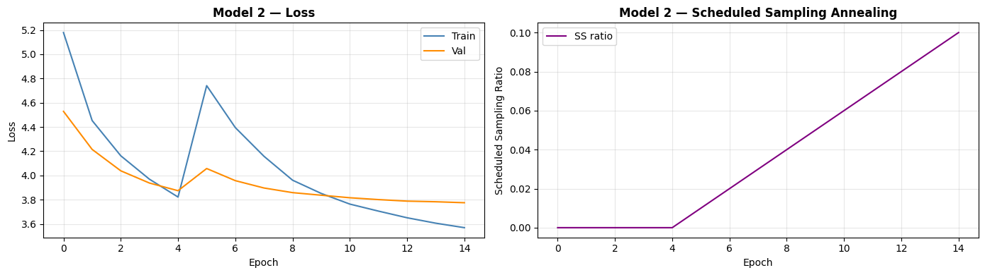
Figure 21. Model 2 training, validation loss, and scheduled sampling behaviour.

Evaluation Methodology
The project evaluates captioning with several complementary metrics. BLEU measures modified n-gram precision between generated captions and human references. BLEU-1 focuses on unigram overlap, while BLEU-4 requires longer phrase overlap. Higher BLEU scores usually indicate that generated captions contain words and word sequences also used by human annotators. However, BLEU can be harsh when a correct caption uses different wording from the references, so it should not be the only metric.
METEOR is designed to align generated and reference words more flexibly than BLEU. It can reward matches at the word level and is often considered more correlated with human judgement for captioning than pure n-gram precision. ROUGE-L is based on the longest common subsequence and therefore reflects sentence-level overlap while preserving word order. CIDEr is especially relevant for image captioning because it uses term-frequency style weighting across references and tends to reward captions that include informative, image-specific words rather than only generic phrasing.
The notebook evaluates both models on the internal validation and test splits using beam search with a beam size of 5. The reported main comparison uses the validation set, which contains 1,131 images. The test split contains 1,132 images and provides a secondary check. The use of multi-reference metrics is appropriate because most images retain multiple cleaned captions. The evaluation code computes BLEU, METEOR, ROUGE-L, and CIDEr, then prints both per-model results and relative improvements.

Results and Comparative Analysis
The numerical results show that Model 2 is the stronger architecture overall. On the validation split, Model 1 achieves BLEU-1 of 0.6010, BLEU-2 of 0.4072, BLEU-3 of 0.2729, BLEU-4 of 0.1796, METEOR of 0.3397, ROUGE-L of 0.4150, and CIDEr of 0.4247. Model 2 achieves BLEU-1 of 0.6094, BLEU-2 of 0.4153, BLEU-3 of 0.2816, BLEU-4 of 0.1900, METEOR of 0.3360, ROUGE-L of 0.4136, and CIDEr of 0.4574. Model 2 therefore improves all BLEU variants and CIDEr, while Model 1 remains slightly better on METEOR and ROUGE-L.
The relative improvements are meaningful. Model 2 improves BLEU-1 by 1.4 percent, BLEU-2 by 2.0 percent, BLEU-3 by 3.2 percent, BLEU-4 by 5.8 percent, and CIDEr by 7.7 percent. The increasing improvement from BLEU-1 to BLEU-4 suggests that Model 2 is not merely selecting better individual words; it is also producing somewhat better multi-word phrase structure. The CIDEr improvement is particularly important because CIDEr rewards informative caption content. In an accessibility dataset, a model that produces more image-specific captions is preferable to one that generates generic but fluent descriptions.
The small declines in METEOR and ROUGE-L should not be ignored. Model 2 is 1.1 percent lower on METEOR and 0.3 percent lower on ROUGE-L. This may indicate that Model 1 sometimes produces captions that align more closely with reference wording or sequence structure, even if Model 2 produces more distinctive content terms. It is common for captioning systems to trade off between generic fluency and image-specific detail. A model that says 'a close up of a box' may overlap with references often, while a model that attempts a more specific description may gain CIDEr but lose some sequence overlap if the exact phrasing differs.
Validation loss also supports Model 2. Model 1 reaches its best validation loss of 4.0265 at epoch 3 and then overfits. Model 2 reaches 3.7752 at epoch 15 and is still improving at the end of training. This difference is not just a small metric fluctuation; it reflects a different learning pattern. Model 1 has high capacity and rapidly fits the training data, while Model 2 uses an architecture and schedule that preserve generalisation for longer. The attention mechanism likely helps because the decoder is given spatial evidence at every word rather than relying heavily on a fixed global representation.
The test results broadly agree with the validation results. Model 1 reaches test BLEU-1 of 0.6125, BLEU-2 of 0.4197, BLEU-3 of 0.2777, BLEU-4 of 0.1827, METEOR of 0.3552, ROUGE-L of 0.4254, and CIDEr of 0.4361. Model 2 reaches test BLEU-1 of 0.6092, BLEU-2 of 0.4118, BLEU-3 of 0.2732, BLEU-4 of 0.1786, METEOR of 0.3377, ROUGE-L of 0.4126, and CIDEr of 0.4484. The test split therefore shows Model 2 still ahead in CIDEr, while Model 1 is stronger on several overlap metrics. This reinforces the interpretation that Model 2 is more content-informative, while Model 1 can sometimes align more closely with reference phrasing.
Metric | Model 1 validation | Model 2 validation | Model 2 change
BLEU-1 | 0.6010 | 0.6094 | +1.4%
BLEU-2 | 0.4072 | 0.4153 | +2.0%
BLEU-3 | 0.2729 | 0.2816 | +3.2%
BLEU-4 | 0.1796 | 0.1900 | +5.8%
METEOR | 0.3397 | 0.3360 | -1.1%
ROUGE-L | 0.4150 | 0.4136 | -0.3%
CIDEr | 0.4247 | 0.4574 | +7.7%

Metric | Model 1 test | Model 2 test
BLEU-1 | 0.6125 | 0.6092
BLEU-2 | 0.4197 | 0.4118
BLEU-3 | 0.2777 | 0.2732
BLEU-4 | 0.1827 | 0.1786
METEOR | 0.3552 | 0.3377
ROUGE-L | 0.4254 | 0.4126
CIDEr | 0.4361 | 0.4484

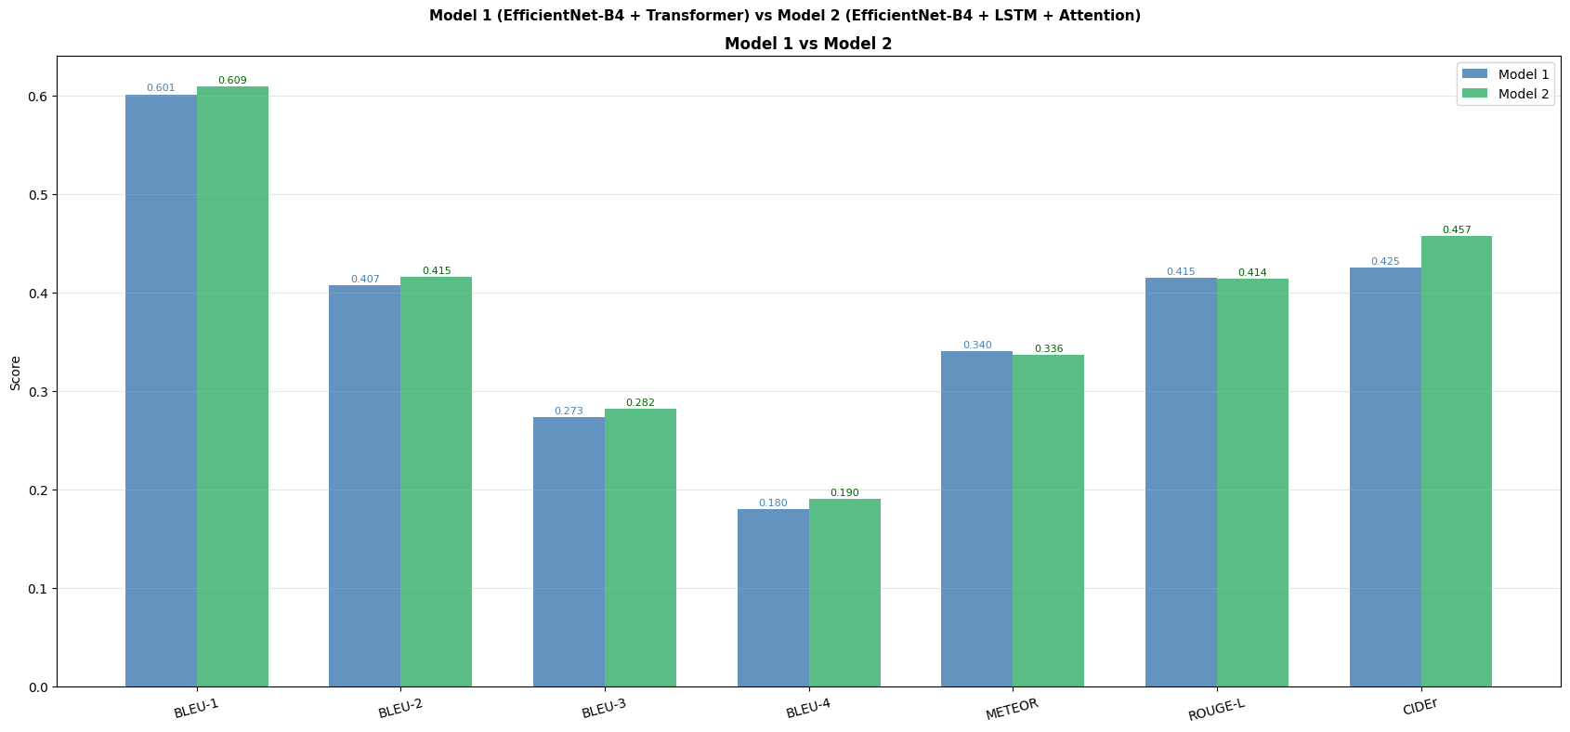
Figure 22. Validation metric comparison between Model 1 and Model 2.

Qualitative Findings
The qualitative comparison figure presents several images with generated captions from both models. Qualitative evaluation is necessary because automatic metrics cannot fully capture usefulness. A caption may obtain a decent n-gram score while missing the most important object, or it may be semantically helpful while using different words from the references. In assistive settings, usefulness is often more important than exact reference overlap. A visually grounded caption that identifies the object, screen, package, or text context may help the user more than a generic phrase with high overlap.
The qualitative outputs also reveal common captioning risks. Models may produce overly generic captions such as 'a close up of a...' or repeat common phrases learned from the dataset. They may fail to read text accurately, especially when the text is small, rotated, or partially visible. They may also hallucinate objects when the image is ambiguous. The repetition-constrained beam search helps reduce looping phrases, and the attention-based model gives a mechanism for inspecting which regions influence words, but neither method fully solves the problem of visual ambiguity or optical character recognition.
Model 2's design is particularly promising for qualitative analysis because attention maps can be visualised. Attention does not prove causal reasoning, but it can show whether the decoder is focusing on plausible image areas when producing key words. For example, if the model says 'screen' while attending to the monitor region or says 'bottle' while attending to the package region, the output becomes more interpretable. This is valuable in accessibility applications where users and developers need to understand failure modes.

Limitations, Recommendations, and Future Work
Several limitations should be recognised. First, the experiment uses the official validation partition as the source for internal train, validation, and test splits. This is appropriate for a constrained assignment workflow, but final claims should be validated on the full official training and validation/test partitions. Second, the models rely on a vocabulary-based decoder. Rare words and exact text in images are difficult because uncommon tokens may be mapped to unknown. This is a major issue for VizWiz because many images contain labels, brands, medicine names, prices, or screen messages.
Third, the automatic metrics are useful but incomplete. BLEU, METEOR, ROUGE-L, and CIDEr compare generated text against references, but they do not directly measure whether a caption is helpful for a blind or low-vision user. Future work should include human evaluation focused on usefulness, correctness, specificity, and harmful hallucination. For accessibility, a wrong caption may be worse than a vague one, especially for medicine, food, or safety-related images.
Fourth, neither model includes a dedicated OCR pipeline. Since around one third of the images or caption rows are associated with text detection, OCR could improve performance. A future system could combine visual features with recognised text tokens from an OCR engine. This would allow captions such as 'a blue screen with an error message' or 'a medicine bottle labelled night time' to be more accurate. OCR integration would also reduce the burden on the image encoder to infer words from pixels alone.
Fifth, training could be improved with stronger regularisation, data augmentation, and model selection. Model 1 overfits early, so early stopping, fewer trainable encoder layers, stronger dropout, or lower decoder capacity may help. Model 2 continues improving at epoch 15, suggesting that longer training may further improve validation loss, although this should be checked carefully to avoid overfitting. It would also be useful to run multiple seeds to confirm that the observed differences are stable rather than seed-specific.
The most practical recommendation is to treat Model 2 as the stronger base for future development. It has better validation loss, stronger CIDEr, and a more interpretable attention mechanism. The next version should keep the semantic 14 by 14 EfficientNet feature grid and Bahdanau attention, add OCR features, run longer training with careful early stopping, and include human evaluation. Model 1 should remain as a useful baseline because Transformer decoders are powerful, but in this experiment the attention-LSTM design better matches the dataset and training scale.

Conclusion
This report has converted the two notebooks into a complete article-style analysis of a VizWiz image captioning experiment. The data pipeline successfully loads the VizWiz validation images and annotations, verifies that all 7,750 image records match the disk files, removes 5,605 poor-quality caption rows, retains 7,542 usable images, and constructs leakage-safe image-level splits. The final processed data contain 5,279 training images, 1,131 validation images, and 1,132 test images, with a vocabulary of 4,656 tokens and validated PyTorch data loaders.
The modelling comparison shows two different approaches to caption generation. Model 1 uses an EfficientNet-B4 encoder with a Transformer decoder and reaches its best validation loss of 4.0265 at epoch 3. It then overfits, even though training loss continues to decline. Model 2 uses an EfficientNet-B4 encoder with a two-layer LSTM and Bahdanau attention over 196 semantic image regions. It reaches a better validation loss of 3.7752 at epoch 15 and improves BLEU and CIDEr performance on the validation split. The most notable gain is CIDEr, where Model 2 improves by 7.7 percent over Model 1.
The final conclusion is that the attention-based LSTM model is the better architecture for this project, especially when judged by validation loss and CIDEr. Its design is well matched to the VizWiz setting because it preserves spatial image information and allows word-by-word visual grounding. At the same time, the slight declines in METEOR and ROUGE-L show that no single metric tells the whole story. The best future system should combine Model 2's attention structure with OCR, stronger evaluation, and more data. Overall, the notebooks demonstrate a complete and thoughtful image captioning workflow, and the results provide a clear direction for the next phase of development.
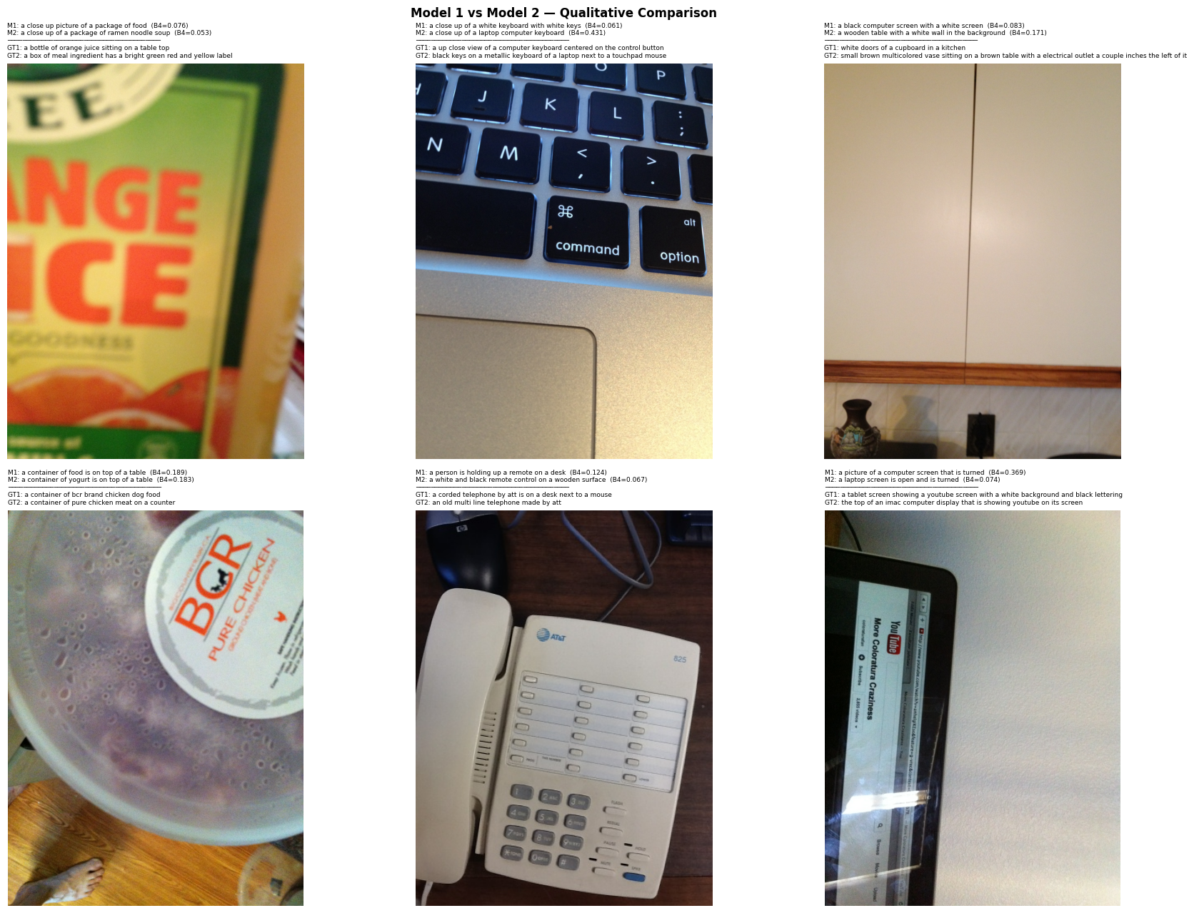
Figure 23. Qualitative comparison of generated captions from both models.

Appendix: Notebook Outputs and Figures
This appendix preserves the important printed outputs from the notebooks so that the report remains traceable to the actual runs.

Output A1. Initial dataset and file checks
Global random seed set to 42.
Unique file type found in validation folder: jpg.
Found 7,750 files.
Test data has 8,000 images.
Train data has 117,155 annotations.
Validation data has 38,750 annotations.
val.json images_df shape: (7,750, 4).
val.json annotations_df shape: (38,750, 6).
Total disk files: 7,750.
Total JSON image records: 7,750.
Missing files on disk: 0.
Extra files on disk: 0.
Perfect image-JSON match: True.

Output A2. Caption filtering summary
Total captions before filtering : 38,750
Precanned captions : 5,167 (13.3%)
Rejected captions : 964 (2.5%)
Both precanned and rejected : 526
Total captions after filtering : 33,145
Total captions removed : 5,605 (14.5% of dataset)
Unique images before filtering : 7,750
Unique images after filtering : 7,542
Images lost : 208
Captions per image after filter : min 1, max 5, mean 4.39

Output A3. Split and loader checks
Split by image_id: 70% train, 15% validation, 15% test.
Train images: 5,279.
Validation images: 1,131.
Test images: 1,132.
Loaded artifacts:
Train rows: 23,128 | Unique images: 5,279
Val rows: 5,017 | Unique images: 1,131
Test rows: 5,000 | Unique images: 1,132
Vocabulary size: 4,656
Pad token ID: 0
Validation batch image shape: torch.Size([32, 3, 224, 224])
Caption shape: torch.Size([32, 30])
Transform check passed.

Output A4. Model 1 evaluation output
Loaded Model 1 epoch 3 with validation loss 4.0265.
Model 1 Validation:
BLEU-1: 0.6010
BLEU-2: 0.4072
BLEU-3: 0.2729
BLEU-4: 0.1796
METEOR: 0.3397
ROUGE-L: 0.4150
CIDEr: 0.4247
n_images: 1131
Model 1 Test:
BLEU-1: 0.6125
BLEU-2: 0.4197
BLEU-3: 0.2777
BLEU-4: 0.1827
METEOR: 0.3552
ROUGE-L: 0.4254
CIDEr: 0.4361
n_images: 1132

Output A5. Model 2 evaluation output
Loaded Model 2 epoch 15 with validation loss 3.7752.
Model 2 Validation:
BLEU-1: 0.6094
BLEU-2: 0.4153
BLEU-3: 0.2816
BLEU-4: 0.1900
METEOR: 0.3360
ROUGE-L: 0.4136
CIDEr: 0.4574
n_images: 1131
Model 2 Test:
BLEU-1: 0.6092
BLEU-2: 0.4118
BLEU-3: 0.2732
BLEU-4: 0.1786
METEOR: 0.3377
ROUGE-L: 0.4126
CIDEr: 0.4484
n_images: 1132

Output A6. Final improvement summary
Model 2 vs Model 1 on validation metrics:
BLEU-1 +1.4%
BLEU-2 +2.0%
BLEU-3 +3.2%
BLEU-4 +5.8%
METEOR -1.1%
ROUGE-L -0.3%
CIDEr +7.7%
Key design changes: final EfficientNet semantic feature map upsampled to 14x14 regions; Bahdanau soft attention with coverage regularisation; gentler scheduled sampling capped at 0.10; lower label smoothing; lower encoder learning rate; repetition-constrained and length-normalised beam search.

