Increasing Candidate Solution Diversity by Updating Heuristics on ARC Prize Algorithm

Sam Byerly
Department of Computer Science
University of Missouri
Columbia, MO
seb88x@umsystem.edu
Sam Hirner
Department of Computer Science
University of Missouri
Columbia, MO
slh8d4@missouri.edu

The Abstraction and Reasoning Corpus (ARC) Prize is a competition created by François Chollet and Mike Knoop to accelerate progress toward artificial general intelligence (AGI). ARC tasks are presented as small grid-based puzzles where models must infer hidden rules from a few input–output examples and apply them to new test cases. These problems are trivial for humans but challenging for machines because they require abstraction and generalization. Our project explores and extends the solver ARC-AGI Without Pretraining, which builds a task-specific model from scratch using variational autoencoder–style compression and reconstruction. The baseline solver employs a strict heuristic, ranking candidate solutions by confidence while penalizing uncertainty and early training instability. Although this encourages convergence, it often suppresses diverse or partially correct solutions, resulting in modest performance. We modify the solver by softening the uncertainty penalty, replacing fixed early penalties with smooth decays, reducing the cost of exponential moving average (EMA) predictions, and adding a diversity bonus. These changes promote exploration and improve ranking stability. Experimental results show that the modified solver consistently generates more correct candidates and achieves higher pass@n accuracy than the baseline, highlighting the importance of heuristic design in bridging systematic reasoning and continuous optimization.

Introduction
The concept of Artificial General Intelligence or AGI has become an increasingly relevant task for programmers around the world to work towards. The ARC Prize is a competition launched by François Chollet and Mike Knoop with the goal of accelerating progress toward AGI. The tasks to be solved by the AGI models are fairly simple and trivial to a human, but much more complex for an algorithm to answer. This challenge has received attention from the AGI community because of the potential benefits of a successful algorithm. Traditionally, AI methods are for narrow tasks and have narrow benchmarks to measure success. However, AGI does not have a specified task, so it must work similarly to human reasoning, abstraction, and adaptability. Determining a reasonable means of benchmarking such qualities would be an important step towards developing AGI. Additionally, current models perform very poorly with general tasks. Through this competition, the organizers are aiming to close the gap between solving for general tasks and the capabilities of current models.
The ARC dataset is made up of small grid-based tasks where systems must infer abstract rules from just a few input–output examples and apply them to new cases [1]. The problems typically involve object manipulation (moving, rotating, or duplicating shapes), pattern completion (filling in symmetry or extending lines), relational reasoning (placing or coloring objects based on others), attribute transformations (changing size, color, or orientation), and multi-step compositions (chaining several rules together). These tasks are hard for AI because they require abstraction, compositionality, and generalization [1].
Several attempts have already been made to create a quality model to solve the tasks present through the ARC Prize Competition. Rather than develop a complete algorithm from scratch, we are looking to expand the capabilities of an existing solution by making modifications to the algorithm. We found and existing solution called ARC-AGI Without Pretraining. The original solver, ARC-AGI Without Pretraining, is designed to learn how to solve each ARC task from scratch rather than relying on a pretrained model. For each task, it constructs a model called the ARCCompressor, which encodes input/output grid pairs into latent/hidden variables and then decodes them to reconstruct outputs. Training proceeds by minimizing a loss function that balances two terms: the KL divergence (which regulates how much information passes through the latent space) and the reconstruction error (which measures how well predicted grids match the training examples). The solver uses a multitensor system to manage the complex grid structure across examples, colors, directions, and spatial dimensions, with layers specialized for communication across these dimensions. During training, a logger monitors KL contributions, reconstruction errors, and solution candidates. Candidate solutions are post-processed and ranked using heuristic scoring rules, and the most promising predictions are selected as the solver’s final outputs. By iteratively training on each task individually for a fixed number of steps, the solver discovers patterns directly from the task’s input/output pairs and produces test solutions without any external pretraining [2].
Our main goal is to improve the complex heuristic of this solver to improve the accuracy of the solver and reduce the volatility of its outputs.

Methods

Baseline Solver
Once we completed setting up the baseline solver we trained with the training dataset from the ARC Prize Competition [1] and tested on 10 problems to capture the accuracy of the algorithm. The original authors use a high performance computer, which we did not have access to, so we elected to set the number of training iterations at 1000 to keep the problem computationally viable.
The solver’s original heuristic is built around the idea that the most confident predictions should be treated as the most reliable solutions. Confidence here is measured directly from the model’s logit distributions: the raw scores before applying a softmax to produce probabilities. For each grid cell, the model assigns a score to every possible color. If one color has a very high logit compared to all the others, the distribution is “narrow,” meaning the model strongly favors that color. In contrast, if several colors have similar logits, the distribution is “broad,” and the model is effectively uncertain about which color is correct. The narrower the distribution over colors for each cell, the lower the uncertainty, and thus the higher the score. Specifically, each candidate’s score was computed as –10 times the average uncertainty, which heavily punished outputs with uncertain predictions. On top of this, two fixed penalties were applied. First, if training was still in its early stage (<150 steps), every candidate lost 10 points, making the system extremely cautious and preventing it from trusting unstable early guesses. Second, solutions derived from exponential moving average (EMA) logits, which maintain smooth predictions, were penalized by 4 points compared to raw logits, on the assumption that smoothed predictions lagged behind the most up-to-date candidate. While this original heuristic ensured that the solver quickly converged to confident-looking outputs, it has drawbacks: it tends to be overly rigid, potentially ignoring diverse but valid solutions, and it could lock onto early confident patterns even if they were wrong.

Modification
Once again, we trained and tested the solver on the same dataset; however, we made several changes to the heuristic with the intent of increasing the accuracy and learning rate of the solver.
The new heuristic introduces a more adaptive and exploratory approach designed to reduce premature convergence and improve accuracy. The penalty for uncertainty was softened to –5 × uncertainty, giving plausible but slightly less confident solutions a fairer chance of being considered. Instead of the old fixed –10 penalty during early training, a gradually decaying penalty is applied, shrinking smoothly as training progresses. This allows the solver to begin trusting its outputs earlier while still discouraging unstable guesses at the very start. The EMA penalty was also reduced from –4 to –1.5, acknowledging that EMA predictions provide valuable stability and should not be discarded outright. Importantly, a diversity bonus was added, rewarding candidate solutions that differ from the current top-ranked one, helping to prevent the solver from collapsing too quickly onto a single hypothesis. Together, these adjustments make the heuristic more flexible: it still prioritizes confident solutions, but it now better promotes exploration of the solution space making it more likely to discover correct but less obvious solutions in the challenging ARC environment. The differences in the two heuristics is outlined with Figure 1.
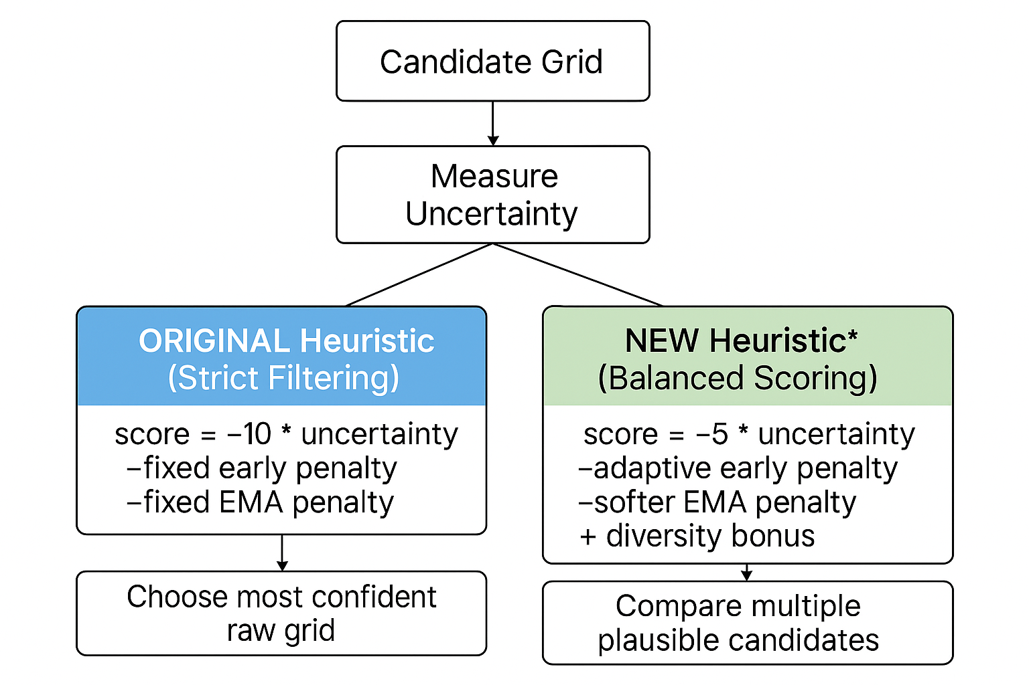
- Comparison of Heuristics

Connection to ai foundations

Intelligent Agents and PEAS Specifications
The ARC solver can be described as a rational agent whose objective is to discover correct output grids for unseen test inputs. Its performance measure is based on accuracy: solutions are judged correct only if they exactly match the ground-truth outputs provided in the dataset. Additional performance signals come from internal metrics such as KL divergence, reconstruction error, and heuristic solution scores, which all serve as guides during training. The environment in which the solver operates is the static set of ARC tasks, consisting of small symbolic input/output grids. This environment is fully observable but highly abstract: patterns are hidden and multiple plausible transformations can exist, making the task ambiguous and challenging.
The agent interacts with this environment through limited but targeted means. Its sensors include the training and test grids themselves, grid masks that indicate valid regions, and feedback signals such as reconstruction loss and uncertainty. Its actuators are the generation of candidate output grids, adjustments of grid size masks, and the updating of internal model weights via gradient descent. Together, these enable the agent to perceive the structure of a task, hypothesize transformations, and propose test outputs. Under this PEAS description, the solver is rational because it consistently chooses actions that maximize its expected success at solving ARC tasks given the information available [3].

Search Strategies
The ARC Prize solver departs from classical search algorithms like breadth-first search (BFS), depth-first search (DFS), and A*. Traditional search operates in a discrete state space, where each state represents a complete or partial grid configuration, and the algorithm explicitly enumerates states by maintaining a frontier of unexplored options [3]. For an ARC task requiring a 10×10 output grid with 10 possible colors per pixel, the state space contains 10^100 possible configurations: far too many to enumerate. In contrast, the solver performs search implicitly through optimization in a continuous parameter space of model weights (approximately one million dimensions). Rather than exploring individual grid configurations, the solver adjusts parameters θ that define a probability distribution P(output | input, θ) over all possible outputs simultaneously. Each parameter configuration represents not a single solution, but an entire ensemble of potential solutions with associated probabilities. The optimization process uses gradient descent to navigate this parameter space, moving toward regions that assign high probability to correct solutions. This approach can be understood as performing a compressed search: instead of explicitly visiting states s₁, s₂, s₃, ..., the solver implicitly explores exponentially many states through a parametric representation. While classical search provides completeness guarantees, this approach trades these guarantees for computational tractability, successfully searching a space that would be intractable for traditional algorithms.
The solver does implements gradient descent as continuous hill-climbing in high-dimensional parameter space. At each iteration, it computes the gradient ∇L(θ) indicating the direction of steepest increase in loss and moves opposite via
θ(t+1) = θ(t) - η∇L(θ_t) [3].
This is more efficient than discrete hill-climbing: with millions of dimensions, evaluating all neighbors would be prohibitive, whereas backpropagation computes the optimal direction in a single pass. The Adam optimizer enhances this with momentum (exponentially weighted averaging of past gradients to build "velocity") and adaptive per-parameter learning rates. These overcome common issues: momentum helps push through small local minima, while adaptive rates prevent oscillation in steep dimensions and accelerate in flat ones. Stochastic noise during sampling (z = μ + σε where ε ~ N(0,1)) effectively implements random-restart hill-climbing, exploring slightly adjusted positions each iteration. Like all local search, this provides no global optimum guarantee but significantly improves solution quality within reasonable computational time.
Lastly, the solver incorporates simulated annealing through temperature. The coefficient schedule c(t) = (0.01)^max(0, 1-t/100) modulates probability distributions for grid dimension selection. Early in training (t < 100), c grows from 0.01 toward 1.0: when small, the softmax over output dimensions is nearly uniform, allowing exploration of many grid sizes. As c increases, the softmax peaks around high-mask dimensions, forcing commitment to specific sizes. This mirrors classical simulated annealing's acceptance probability: using softmax with temperature τ = 1/c gives
P(dimension d) = e^(mask[d]/τ) / Σ_j e^(mask[j]/τ), where mask[d] is a score for dimension d as to how likely that dimension is correct and large τ creates exploratory distributions and small τ creates exploitative ones. By iteration 100, c freezes at 1.0 (zero temperature), accepting only improvements. This prevents premature convergence, which is necessary because early commitment to incorrect dimensions would be unrecoverable, whereas annealing ensures thorough exploration before exploitation.

Heuristics
The solver relies on a collection of heuristic mechanisms that together guide it toward high-quality solutions. At the core is the loss function L(θ)=KL(θ)+10⋅R(θ), which serves as a heuristic evaluation function during training. The KL divergence term penalizes overly complex latent encodings, enforcing simpler and more generalizable representations in line with Occam’s Razor. The reconstruction error R(θ), implemented via cross-entropy, quantifies how closely predictions reproduce training examples and acts as a direct measure of “distance to goal.” The coefficient of 10 encodes domain knowledge: in ARC, accurate reproduction of examples is valued far more than simplicity, so accuracy is weighted ten times more heavily. Unlike classical admissible heuristics in search, this loss is non-admissible; it operates in a non-convex optimization landscape with local minima [3]. The trade-off is intentional, converting discrete symbolic search into continuous optimization where gradient descent heuristically pushes solutions toward regions of high quality without guarantees of optimality.
Beyond the training loss, additional heuristics govern solution selection. Candidate outputs are scored by their uncertainty, with lower uncertainty corresponding to higher confidence and therefore higher scores. Fixed penalties are applied during early training (<150 steps) to prevent over-trusting immature solutions, while predictions based on exponential moving averages (EMA) are slightly down-weighted to reflect their lag relative to raw logits. These rules form a strict confidence-based ranking heuristic: narrow, confident distributions dominate, while diffuse predictions are penalized. Modifications to this heuristic can soften these effects, such as reducing the uncertainty weight, replacing fixed early penalties with smooth decay schedules, lowering EMA penalties, and even adding diversity bonuses to encourage exploration of alternative solutions. Together, these heuristics form a multi-layered guidance system: the loss heuristic directs optimization during training, while the scoring heuristics regulate how candidate outputs are selected, ensuring the solver balances simplicity, confidence, and exploration.

Constraint Satisfaction Problems
The ARC Prize tasks naturally form CSPs with variables (pixel colors at positions {pixel_{i,j}} plus {height, width}), domains (task-specific color palettes of 2-8 colors; dimensional ranges), and constraints (spatial patterns, transformation rules consistent across training examples). The solution space is enormous: approximately 5^100 × 30 × 30 ≈ 7×10^72 assignments for a typical task. Classical CSP algorithms fail fundamentally: backtracking search faces intractable branching, the constraints themselves must be learned rather than given, and there's no known constraint graph for propagation [3]. The solver instead uses soft constraints encoded in the loss function. Hard constraints become soft penalties: reconstruction error penalizes inconsistency with training patterns, KL divergence penalizes complexity, and architectural choices (directional layers, cumulative operations) bias toward spatial coherence. This transformation from hard to soft is crucial for gradient-based optimization; hard constraints provide no gradients, while soft constraints offer smooth guidance. The solver performs constraint satisfaction in continuous parameter space rather than discrete assignment space, sacrificing completeness guarantees to handle problems where constraint structure must be inferred.

Evaluation
After running the baseline and modified solver we captured the final guesses of several of the 10 test cases and the accuracy of the solver after each iteration. We are primarily interested in the volatility and accuracy of the solver. We did capture the duration of time required to train the model, but between the two methods, the time was comparable and not the target of the modified solver.
Additionally, one of the problems that can be qualitatively analyzed is shown in Figure 2, where, to a human, it is clear that the solution is to fill in the enclosed squares with yellow pixels.
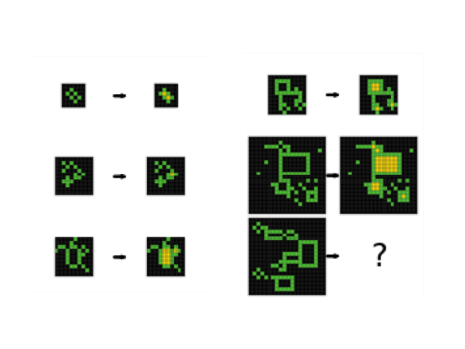
- Example ARC Prize Problem

Baseline Solver
Upon running the baseline solver, we uncovered the original capabilities and shortcomings of the algorithm. To qualitatively analyze the solver, we can analyze the results of its attempt at solving the example problem. Figure 3 shows what the solver produces for the example case at the end of training, including the sample average and its top guesses.

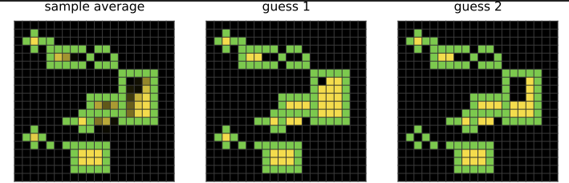
- Baseline Solver Solution to Example from Fig. 2
On the other hand, we can also analyze the solver’s success quantitatively through a pass@n graph. The pass@n graph shows how solver accuracy evolves over training when evaluated under different allowances for the number of guesses. Pass@1 measures the strictest case, counting only whether the solver’s top guess matches the correct answer. Higher values of n (such as pass@5, pass@10, or pass@100) relax this requirement, giving credit if the correct solution appears anywhere within the top n guesses. The x-axis tracks training steps, while the y-axis shows accuracy as the fraction of tasks solved correctly. Interpreting the curves reveals not just how often the solver is correct, but also where its strengths and weaknesses lie. If pass@1 accuracy is low but pass@10 or pass@100 is much higher, the solver is generating the correct answer but failing to rank it as its best guess. Figure 4 provides the pass@n graph for the baseline solver.
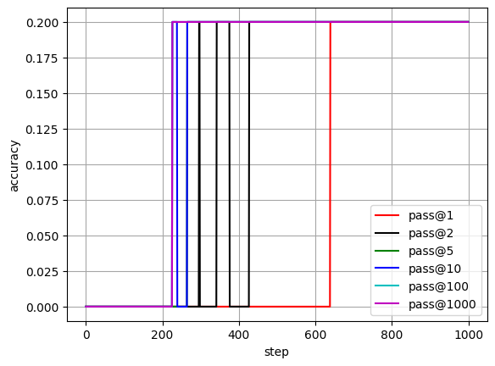
- Accuracy Plot (pass@n) for Baseline Solver
In the baseline solver, Figure 4 shows that performance remains very limited across training steps. Pass@1 accuracy is essentially zero until around step 600, where it briefly spikes to 20% before plateauing. Higher pass@n metrics barely diverge from pass@1, topping out at 20% accuracy. This means the solver is not consistently generating correct candidates, even if you consider multiple guesses. The sample average, guess 1, and guess 2 outputs from Figure 3 also reflect this: while they show some structural alignment with the problem (green boundaries, yellow fill patterns), the predictions are unstable and often miss finding the correct pattern. The jagged red curve of pass@1 further indicates that the heuristic scoring is volatile, sometimes ranking incorrect solutions highly while demoting correct ones.
In short, the baseline solver is weak in both candidate generation (not producing enough correct solutions) and ranking (when it does generate them, it doesn’t reliably pick the right one as guess 1). This is consistent with the strict confidence-based heuristic found in the baseline solver: the solver favors very confident but potentially wrong outputs, which causes accuracy to fluctuate and cap at low levels.

Modified Solver
We repeated our measurements with the qualitative and quantitative analysis using the same plots, but with the modified solver. Figure 5 provides the qualitative comparison to Figure 3 and Figure 6 provides the quantitative comparison to Figure 4.

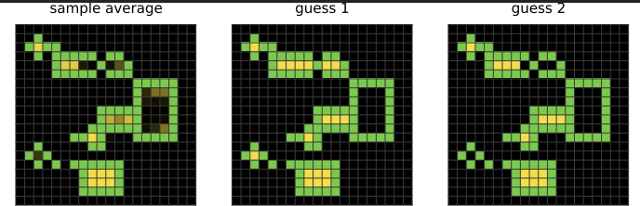
- Modified Solver Solution to Example from Fig. 2

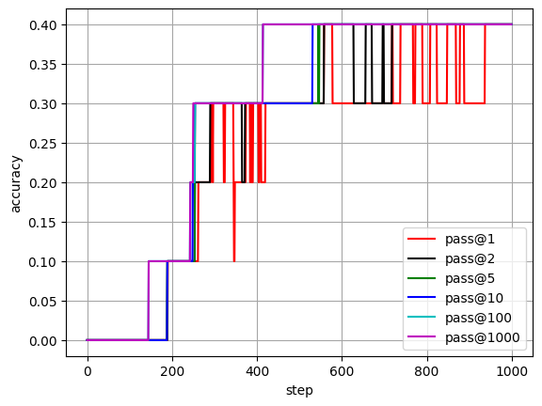
- Accuracy Plot (pass@n) for Modified Solver
The modified solver shows a much stronger learning curve. Starting near zero, accuracy climbs steadily in stages up to 40% by around step 500, at which point it plateaus. Pass@1, though still jagged, reaches significantly higher levels compared to the baseline’s 20%. More importantly, higher pass@n values climb smoothly and stabilize at 40%, indicating that the solver is consistently generating correct candidates in its top set of solutions. The outputs of Figure 5 also appear more coherent: the yellow fills are better aligned with the green structures, suggesting that the solver has learned the pattern more reliably.
This improvement is a direct reflection of the modified heuristic. By softening the penalty for uncertainty, applying a smooth decay to early training penalties, reducing the harsh EMA penalty, and adding a diversity bonus, the solver no longer discards potentially correct but less confident outputs. Instead, it explores a broader range of candidates and has a better chance of keeping correct solutions in the pool. The steadier growth in accuracy and higher pass@n values show that the solver is both generating more correct candidates and ranking them better than before.
The key difference between the baseline and modified solver lies in how the heuristics balance exploitation vs. exploration. The baseline heuristic was overly strict, relying heavily on narrow uncertainty and fixed penalties. This made it risk-averse: the solver latched onto early confident but often wrong guesses, limiting diversity and suppressing correct but less confident solutions. As a result, accuracy plateaued low, and pass@n curves clustered tightly together.
By contrast, the modified solver’s heuristics encourage exploration. The softer uncertainty weight and diversity bonus allow multiple plausible candidates to survive, while the smoother early-training penalty gives the model more room to stabilize before being judged harshly. This produces broader candidate pools, better ranking stability, and higher pass@n accuracies across the board. The trade-off is a still-jagged pass@1 curve, showing that picking the single best guess is still volatile, but overall performance is significantly improved.

V. Discussion & Conclusion

Key Takeaways
The experiments highlight how changes to heuristic design can significantly affect solver behavior on ARC tasks. The baseline solver demonstrated that strict confidence-based ranking leads to risk-averse search. By heavily penalizing uncertainty and imposing fixed costs on early training predictions, it converged rapidly but often to incorrect solutions, showing limited willingness to explore alternative solutions. This produced low pass@1 accuracy and narrow candidate pools. The modified solver illustrates the opposite: softening the uncertainty penalty, allowing penalties to decay smoothly with training steps, and reducing the bias against EMA outputs gave the model more room to keep multiple plausible candidates active. The addition of a diversity bonus explicitly encouraged exploration, preventing premature collapse onto a single solution. The result was a solver that consistently generated correct solutions in its candidate pool and achieved higher accuracies across the board. These findings reinforce the importance of balancing exploration (maintaining diversity of solutions) with exploitation (favoring confident predictions), showing that ARC performance depends as much on heuristic shaping as underlying model architecture.

Theory Connections
Placing these results in a broader AI context reveals parallels with classical search and rational agent theory. The solver can be described under the PEAS framework: its performance measure is task accuracy, the environment is the static ARC task set, its actuators are the generation and ranking of candidate solutions, and its sensors are the uncertainty and reconstruction error signals it receives [3]. Within this framing, the heuristics act as an evaluation function akin to those used in heuristic search. However, unlike admissible heuristics in algorithms like A*, which are guaranteed not to overestimate cost and thus ensure optimality, the solver’s heuristics are intentionally non-admissible [3]. They operate in a high-dimensional, non-convex optimization landscape where exact guarantees are infeasible, and instead provide gradient-based “rules of thumb” to push learning toward useful solutions. The weighting of KL divergence versus reconstruction error embodies a trade-off between simplicity and accuracy. Meanwhile, the scoring heuristics used during solution selection resemble bounded-rationality mechanisms: they favor plausible, lower-uncertainty candidates but also incorporate mechanisms for exploration. In this sense, the project bridges symbolic search traditions with modern continuous optimization, showing how heuristics can approximate rational decision-making where exhaustive search is impossible [3].

Future Work
Future directions include extending heuristic diversity further, such as adaptive weighting schemes that adjust penalties based on task characteristics, or learning approaches that tune heuristics across many ARC tasks. Finally, scaling experiments with more computational resources may reveal whether the improvements hold at larger training horizons (more training iterations), helping to evaluate whether heuristic refinement can meaningfully close the gap between narrow AI models and the generality targeted by the ARC competition.

References
- ARC Prize Foundation. “ARC-AGI-2 Dataset.” GitHub, 2025.
- Liao, I., & Gu, A. (2025). ARC-AGI without pretraining. Retrieved from https://iliao2345.github.io/blog_posts/arc_agi_without_pretraining/arc_agi_without_pretraining.html.
- S. Russell and P. Norvig, Artificial Intelligence: A Modern Approach, 4th ed. Pearson.

