SPOTIFY 2023 DATA ANALYSIS
Business Intelligence Report using Microsoft Power BI

Student Name | Sam Fawaz Hadi AL-Basara
UID | 24BAI70236
Programme | B.E. Computer Science Engineering (AI & ML)
University | Chandigarh University
Supervisor | Mr. Mukesh Sir
Dataset | spotify-2023.csv
Tool | Microsoft Power BI
Analysis Pages | 7 (1 Overview + 6 Analytical Questions)

Report Focus
Music performance, platform presence, artist involvement, playlists, charts, Shazam discovery, musical mode, and BPM
Prepared for Business Intelligence practical / examination report

1. Introduction
This report presents an interactive analysis of the Spotify 2023 dataset using Microsoft Power BI. The objective is to examine song performance across major music-platform indicators and to identify observable relationships involving streaming activity, playlist exposure, chart presence, artist involvement, Shazam discovery, musical mode, and tempo.
The report is organized into seven Power BI pages. The first page provides an overall dashboard, followed by six analytical pages corresponding to the required questions in the coursework brief.
Report Structure
Page | Title | Focus
1 | Music Performance Overview | High-level KPIs and dataset profile
2 | Q1: Platform Comparison | Spotify, Apple Music, Deezer, Shazam
3 | Q2: Artist Impact | Artist count vs streams, playlists, charts
4 | Q3: Playlist & Chart Performance | Playlist exposure vs chart presence
5 | Q4: Shazam Discovery | Shazam presence vs Spotify indicators
6 | Q5: Major vs Minor | Mode vs streams and audio features
7 | Q6: BPM & Song Performance | Tempo ranges vs performance

2. Dataset Description
The dataset contains information about popular songs, artists, streaming activity, playlist presence, chart performance, release information, and musical characteristics. The fields used in the analysis are listed below.
Field Group | Fields
Track information | track_name, artist(s)_name, released_year
Streaming | streams
Spotify presence | in_spotify_playlists, in_spotify_charts
Apple Music presence | in_apple_playlists, in_apple_charts
Deezer presence | in_deezer_playlists, in_deezer_charts
Shazam presence | in_shazam_charts
Musical characteristics | bpm, mode, danceability_%, energy_%, valence_%, acousticness_%

3. Data Preparation and Transformation
The following steps were carried out in Power Query before loading the data into the Power BI model.
- Imported spotify-2023.csv into Power BI using Text/CSV and Power Query.
- Checked and corrected data types for text, whole-number, and numeric fields.
- Reviewed missing values, particularly platform-related fields, without automatically assuming that missing values represented zero.
- Created Artist Count to measure the number of artists associated with each song.
- Created BPM Group to classify songs into tempo categories (see table below).
- Applied the transformations and loaded the prepared data into the Power BI model.

BPM Group Classification
BPM Group | BPM Range | Description
Slow | Below 80 | Low-tempo songs
Moderate | 80 – 119 | Mid-tempo songs
Fast | 120 – 139 | Upbeat songs
Very Fast | 140 and above | High-tempo songs

4. DAX Measures Used
The following DAX measures were created to support the KPI cards and comparative visuals across the report.
Measure | DAX Expression | Used For
Total Streams | SUM('spotify-2023'[streams]) | KPI, rankings
Total Songs | DISTINCTCOUNT('spotify-2023'[track_name]) | KPI
Average Streams | AVERAGE('spotify-2023'[streams]) | KPI, group comparisons
Average BPM | AVERAGE('spotify-2023'[bpm]) | KPI, Q5, Q6
Average Danceability | AVERAGE('spotify-2023'[danceability_%]) | Q5, Q6
Average Energy | AVERAGE('spotify-2023'[energy_%]) | Q5, Q6
Average Valence | AVERAGE('spotify-2023'[valence_%]) | Q5, Q6
Average Acousticness | AVERAGE('spotify-2023'[acousticness_%]) | Q5, Q6

5. Visualization Strategy
Visual types were selected to match the analytical purpose of each page.
Visual Type | Purpose
Bar and column charts | Category comparisons and rankings
Scatter charts | Relationships between two numerical variables and outlier detection
Tables | Song-level detail and exception cases
KPI cards | Summary of overall dataset metrics
Slicers | Interactive filtering by year, mode, BPM group, and artist

6. Dashboard Analysis
This section presents each of the seven Power BI pages in order. Each page lists its purpose, the visuals used, the analytical interpretation, and the justification for the chosen visualization types. Screenshots should be inserted in the marked placeholders.

6.1 Page 1: Spotify 2023 — Music Performance Overview
Purpose
Provide a high-level summary of the dataset before moving to the six detailed analytical questions.
Visuals Included
- KPI: Total Spotify Streams
- KPI: Total Songs
- KPI: Average Streams per Song
- KPI: Average BPM
- Top 10 Artists by Spotify Streams (bar chart)
- Chart Presence Across Platforms (column chart)
- Playlist Exposure Across Platforms (column chart)
- Slicers: Release Year, Musical Mode, BPM Group, Artist
Report Interpretation
The overview page summarizes the scale of the dataset and provides an initial view of artist, chart, and playlist activity. The slicers allow the user to investigate whether the overall patterns change for different release years, musical modes, tempo groups, or artists.

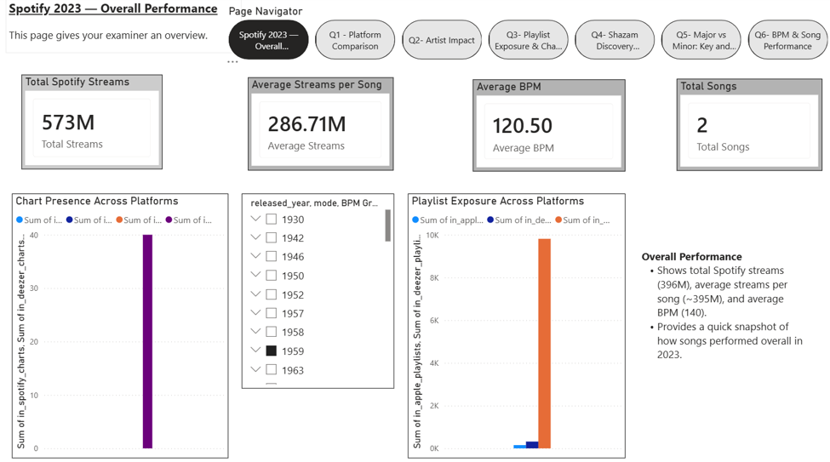
Figure 1: Page 1 — Music Performance Overview

6.2 Page 2: Q1: Platform Comparison
Analytical Question
How does song performance compare across Spotify, Apple Music, Deezer, and Shazam, and does strong performance on one platform align with performance on others?
Visuals Included
- Chart Presence Across Platforms
- Playlist Exposure Across Platforms
- Spotify Playlist Exposure vs Streams (scatter chart)
- Song-Level Cross-Platform Performance (table)
Analysis
The page compares the platform indicators available in the dataset. The cross-platform table provides song-level evidence for identifying songs that appear strongly across several services as well as songs whose performance is more concentrated on particular platforms.
The scatter plot between Spotify playlist exposure and streams is used to inspect whether songs with greater playlist presence also tend to have higher streaming totals. Any visible pattern should be described as an observed association, not as evidence that playlist placement causes streams.
Visualization Justification
Column charts make differences among platforms easy to compare, while the scatter plot is appropriate for examining the relationship between two numerical indicators. The table preserves detailed evidence at song level.

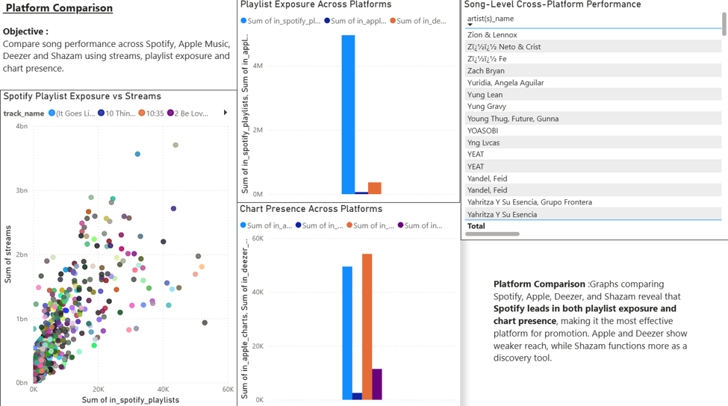
Figure 2: Page 2 — Q1 Platform Comparison

6.3 Page 3: Q2: Artist Impact
Analytical Question
Does the number of artists involved in a song relate to streams, playlist presence, or chart performance?
Visuals Included
- Artist Involvement vs Average Streams
- Artist Involvement vs Playlist Exposure
- Artist Involvement vs Spotify Chart Presence
Analysis
Artist Count groups songs according to the number of credited artists. Average streams, playlist exposure, and Spotify chart presence are then compared across these groups. This allows the report to identify whether multi-artist songs show different average performance from songs with fewer credited artists.
The results describe associations observed in the dataset. They do not establish that adding artists causes a change in streaming, playlist exposure, or chart performance.
Visualization Justification
Column charts are suitable because Artist Count is a categorical/grouped variable and the objective is to compare average performance across groups.

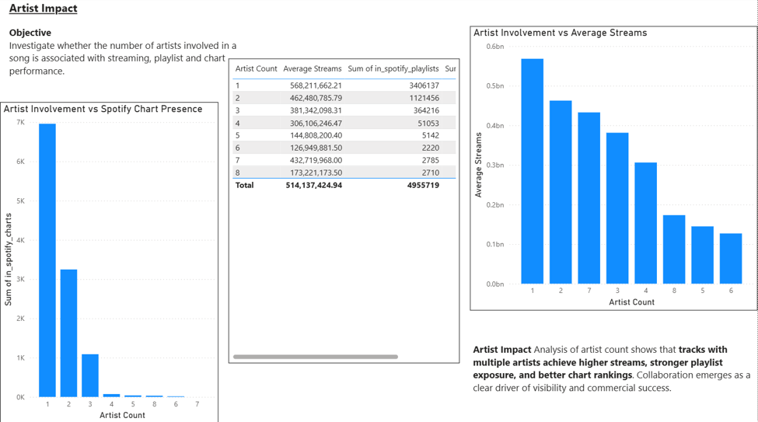
Figure 3: Page 3 — Q2 Artist Impact

6.4 Page 4: Q3: Playlist Exposure and Chart Performance
Analytical Question
What is the relationship between playlist presence and chart performance on Spotify, Apple Music, and Deezer?
Visuals Included
- Spotify Playlist Exposure vs Chart Presence
- Apple Playlist Exposure vs Chart Presence
- Deezer Playlist Exposure vs Chart Presence
- Spotify Playlist Exposure vs Streams
Analysis
Three platform-specific scatter plots compare playlist exposure with chart presence. A fourth plot compares Spotify playlist exposure with Spotify streams. Together, these visuals help identify positive, weak, mixed, or highly variable relationships and make it easier to spot outlier songs.
A visible relationship between two variables should be reported as correlation or association only. Playlist exposure and chart performance can be influenced by other factors, so the visuals cannot demonstrate causation.
Visualization Justification
Scatter plots are appropriate because both variables are numerical and the goal is to inspect their relationship and identify exceptions.

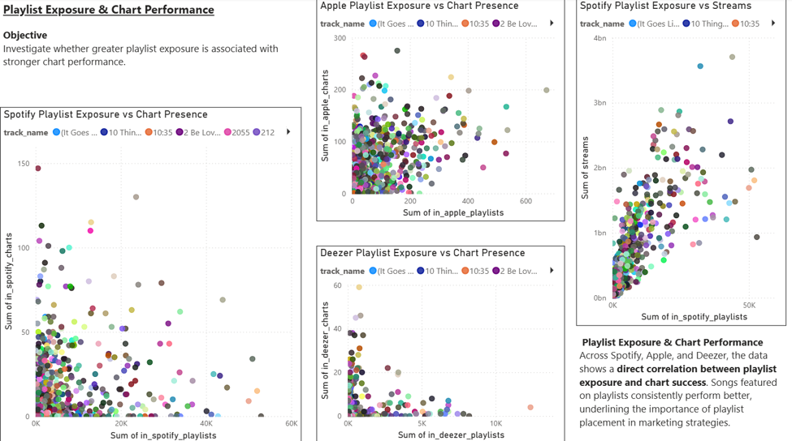
Figure 4: Page 4 — Q3 Playlist & Chart Performance

6.5 Page 5: Q4: Shazam Discovery
Analytical Question
How does Shazam chart presence relate to Spotify streams, playlist presence, and other performance indicators?
Visuals Included
- Shazam Presence vs Spotify Streams
- Shazam Presence vs Spotify Playlist Exposure
- Shazam Presence vs Spotify Chart Presence
- Notable Shazam Performance Cases (table)
Analysis
The analysis examines whether songs appearing more strongly in Shazam charts also show strong Spotify indicators. The table is particularly useful for identifying exceptions, such as songs with relatively high Shazam presence but lower Spotify streams or playlist exposure, and the reverse pattern.
These differences can be used as descriptive evidence of platform-specific discovery patterns. They should not be interpreted as proof that Shazam activity causes Spotify performance.
Visualization Justification
Scatter plots reveal relationships and outliers, while the table allows individual songs to be examined in detail.

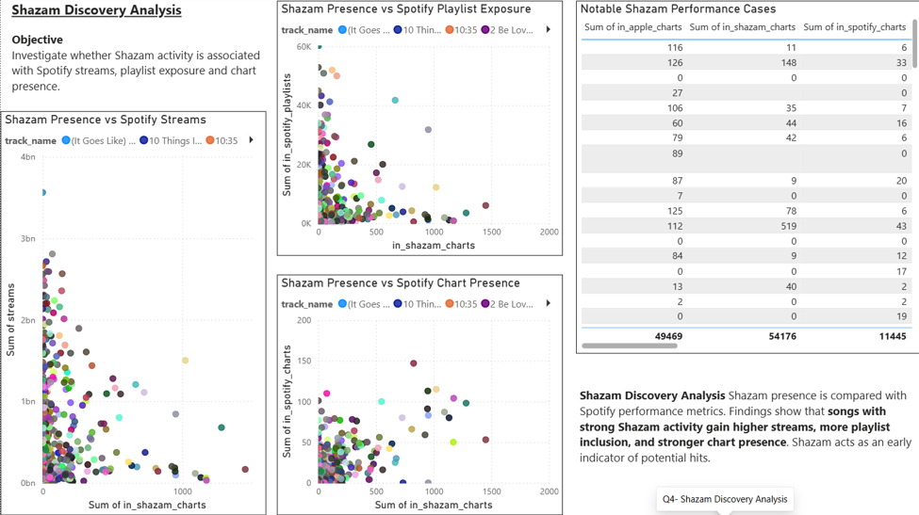
Figure 5: Page 5 — Q4 Shazam Discovery

6.6 Page 6: Q5: Major vs Minor
Analytical Question
How do songs in Major and Minor modes differ in streams, danceability, energy, valence, acousticness, and BPM?
Visuals Included
- Average Streams: Major vs Minor
- Musical Characteristics: Major vs Minor
- Average BPM: Major vs Minor
- Optional summary table
Analysis
Songs are grouped by musical mode and compared using average values. The analysis considers performance through average streams and musical characteristics through danceability, energy, valence, acousticness, and BPM.
The page is descriptive: differences between Major and Minor groups show characteristics of the songs represented in this dataset and should not be generalized to all music.
Visualization Justification
Column charts provide a direct comparison between the two mode categories. A clustered chart allows several audio characteristics to be compared in the same visual.

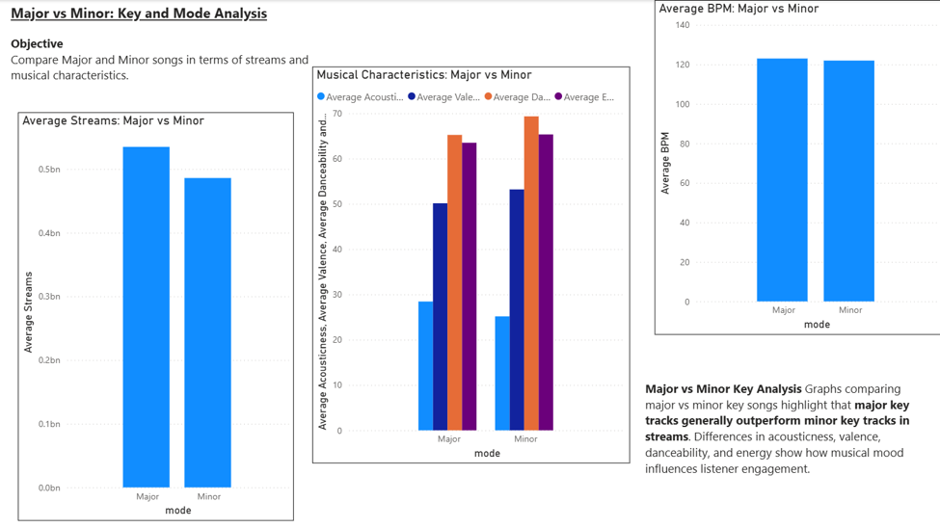
Figure 6: Page 6 — Q5 Major vs Minor

6.7 Page 7: Q6: BPM and Song Performance
Analytical Question
How does song performance vary across BPM ranges, and what patterns appear in streams, playlists, charts, and audio characteristics?
Visuals Included
- Average Streams by BPM Range
- Playlist Exposure by BPM Range
- Chart Presence by BPM Range
- Audio Characteristics by BPM Range
- Optional BPM vs Spotify Streams scatter chart
Analysis
Songs are grouped into tempo ranges (Slow: below 80 BPM; Moderate: 80–119 BPM; Fast: 120–139 BPM; Very Fast: 140 BPM and above) and compared using average streams, playlist exposure, chart presence, and audio characteristics. The scatter plot, if included, provides a more detailed view of the relationship between exact BPM values and streams.
The conclusions should be based on the visible values in the Power BI visuals. Any observed pattern represents an association in the dataset rather than evidence that tempo directly causes higher or lower performance.
Visualization Justification
Column charts are effective for comparing BPM categories, while a scatter plot is appropriate for the continuous BPM-versus-streams relationship.

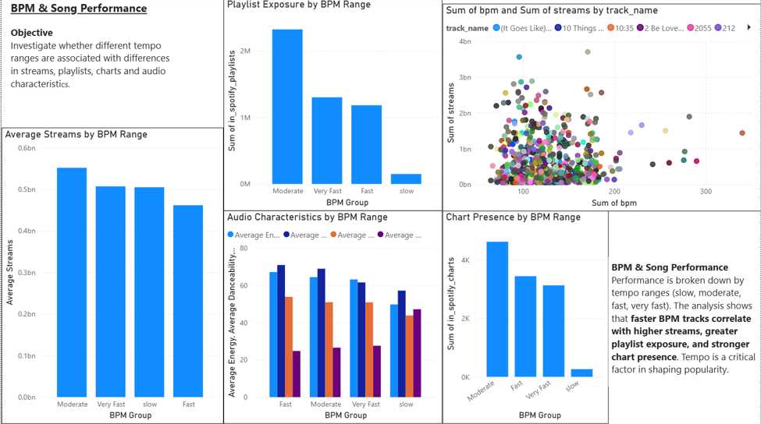
Figure 7: Page 7 — Q6 BPM & Song Performance

7. Overall Findings
The seven-page dashboard provides a structured view of song performance from multiple perspectives. The overview establishes the overall dataset profile, while the six analytical pages investigate platform comparison, artist involvement, playlist and chart relationships, Shazam discovery, musical mode, and tempo.
Specific numerical findings should be taken directly from the final Power BI visuals rather than estimated from the raw dataset. The table below summarizes what each page contributes and provides space to record the observed result.
Page | Analytical Focus | Key Observation (from final dashboard)
1 | Dataset overview | Record total streams, total songs, average streams, and average BPM.
2 | Platform comparison | Record which platforms show strongest presence and whether Spotify playlist exposure aligns with streams.
3 | Artist impact | Record which Artist Count group has the highest average streams and playlist exposure.
4 | Playlist vs chart | Record the strength of association on Spotify, Apple Music, and Deezer, and any outliers.
5 | Shazam discovery | Record notable songs with high Shazam presence but lower Spotify indicators, or the reverse.
6 | Major vs Minor | Record which mode has higher average streams and how audio characteristics differ.
7 | BPM ranges | Record which BPM group performs best on streams, playlists, and charts.

8. Data Limitations
- The dataset represents songs and platform indicators available for the 2023 dataset and may not represent all music released or consumed during the year.
- Some platform-related fields may contain missing values.
- Platform metrics may use different definitions and measurement systems, so direct numerical comparisons should be interpreted carefully.
- The dataset is observational; relationships between variables do not prove causation.
- Average values can hide variation between individual songs and artists.
- The dataset contains song-level records and does not by itself explain external factors such as marketing campaigns, label support, social-media trends, or playlist editorial decisions.

9. Conclusion
Microsoft Power BI was used to transform, model, visualize, and interactively analyze the Spotify 2023 dataset. The final report combines KPI summaries, categorical comparisons, relationship analysis, and song-level detail. The dashboard demonstrates how Business Intelligence techniques can convert a multi-variable music dataset into evidence-based descriptive insights while keeping conclusions within the limits of the available data.

