BUSINESS INTELLIGENCE LAB
UNIT 2 | SESSION 5
EXPERIMENT 5
Report Generation using Relational and Multidimensional Data on the Star Schema using Power BI
--------------------------------------------------------------------------------------------------------------------
1. AIM
To generate relational and multidimensional reports using the star schema developed in Experiment 3 and extended in Experiment 4, using table and matrix visuals, the Geo_Hierarchy, comparative charts, and an interactive dashboard in Microsoft Power BI for business decision-making.
2. OBJECTIVES
- To verify the existing star schema and relationships between Fact_Sales and the dimension tables.
- To generate a relational report displaying individual sales transactions.
- To apply sorting and visual-level filtering to transactional data.
- To create a multidimensional report using a geographical hierarchy.
- To perform drill-down and drill-up operations across Region, State, and City.
- To create comparative charts for category, region, customer, and yearly sales analysis.
- To develop an interactive dashboard using KPI cards and slicers.
- To interpret business insights from relational, multidimensional, comparative, and dashboard reports.
3. TOOLS / SOFTWARE REQUIRED
- Microsoft Power BI Desktop.
- Power BI file (.pbix) completed in Experiment 4.
- Fact_Sales table and dimension tables Dim_Customer, Dim_Product, Dim_Region, and Dim_Date.
- Power Query Editor, if data inspection or transformation is required.
- DAX (Data Analysis Expressions) for measures such as Total Sales, Total Profit, and Total Orders.
- Microsoft Excel for opening exported report data, if required.
4. DATASET USED
Dataset: Global Superstore dataset / the existing sales dataset used in Experiments 3 and 4.
The experiment uses the existing Power BI model rather than creating a new model. The main tables and fields include:
- Fact_Sales: Order ID, Sales, Profit, Quantity, and other transaction-level fields.
- Dim_Customer: Customer Name and customer-related attributes.
- Dim_Product: Product Name, Category, and product-related attributes.
- Dim_Region: Region, State, City, and Geo_Hierarchy.
- Dim_Date: Date attributes, including Year where available.
The exact field names depend on the model created in the previous experiments. The reports must use the existing fields and relationships in the supplied .pbix file.
5. THEORY

5.1 Star Schema
A star schema consists of a central fact table connected to dimension tables. In this experiment, Fact_Sales is connected to Dim_Customer, Dim_Product, Dim_Region, and Dim_Date to support sales analysis.

5.2 Relational Report
A relational report displays individual sales transactions in a table. Sorting and filtering help identify high-value orders and profitable transactions.

5.3 Multidimensional Report
A multidimensional report summarizes sales, profit, and quantity across dimensions. The Geo_Hierarchy enables analysis from Region to State and City using drill-down and drill-up operations.

5.4 Comparative Analysis
Comparative analysis uses charts to examine sales by category, profit by region, top customers, and yearly sales trends. It helps identify business patterns and compare performance.

5.5 Interactive Dashboard
An interactive dashboard combines KPI cards, charts, and slicers. Total Sales, Total Profit, and Total Orders can be analyzed using Region, Category, and Year filters to support business decisions.
6. PROCEDURE

Part A: Reopen and Verify the Model
Step 1: Open the .pbix file saved at the end of Experiment 4.
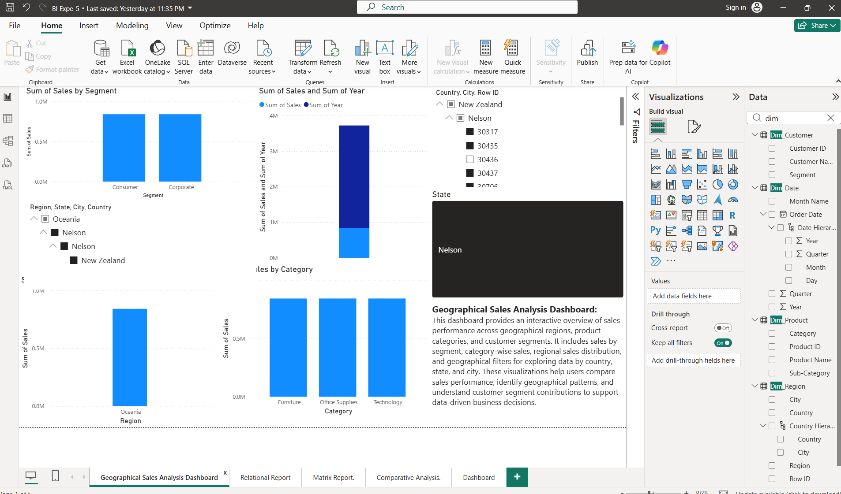
Step 2: Switch to Model view and verify the relationships between Fact_Sales and the four dimension tables: Dim_Customer, Dim_Product, Dim_Region, and Dim_Date.
Step 3: Confirm that all four relationships are many-to-one (*:1).
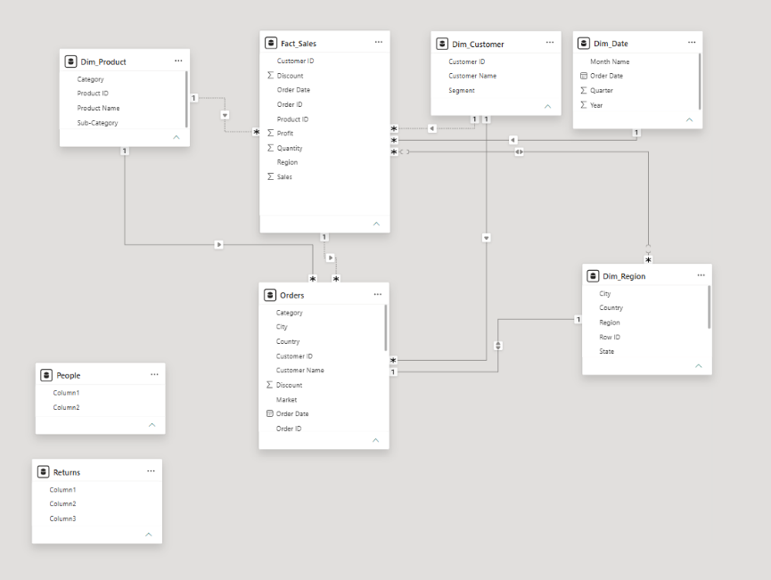

Step 4: Expand Dim_Region and verify that Geo_Hierarchy contains Region, State, and City in the correct order.
Step 5: Open the Slice, Dice, and Drill pages and confirm that their visuals display data correctly.

Part B: Build the Relational Report
Step 6: Add a new page and name it Relational Report.
Step 7: Insert a Table visual.
Step 8: Add the following fields in order:
- Order ID from Fact_Sales.
- Customer Name from Dim_Customer.
- Product Name from Dim_Product.
- Region from Dim_Region.
- Sales from Fact_Sales.
- Profit from Fact_Sales.
Step 9: Sort the Sales column in descending order.
Step 10: In Filters on this visual, add Profit and set the condition to is greater than 0. Apply the filter.
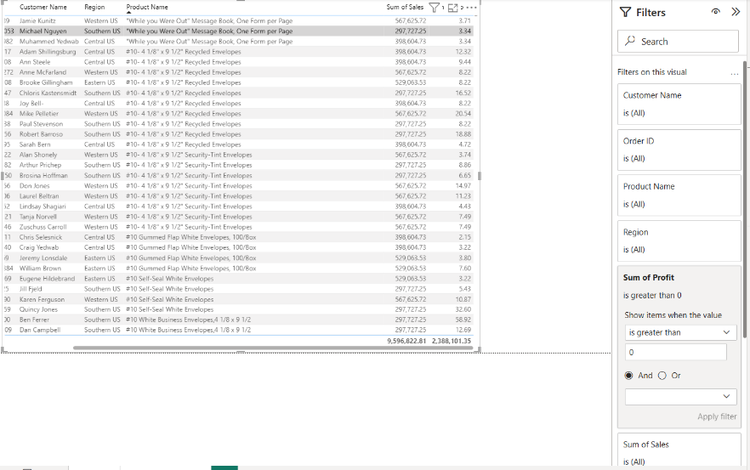
Step 11: Export the table using the ellipsis menu (…) and select Export data. Save as Excel if available, or CSV otherwise.
Step 12: Record the number of rows remaining and the Customer Name and Product Name in the first row.

Part C: Build the Multidimensional Report
Step 13: Add a new page named Matrix Report.
Step 14: Insert a Matrix visual.
Step 15: Drag Geo_Hierarchy from Dim_Region into Rows.
Step 16: Add Total Sales and Total Profit to Values. Use existing measures or create them if necessary.
Step 17: Add Quantity from Fact_Sales to Values and ensure that its summarization is Sum.
Step 18: Expand the hierarchy from Region to State and then City.
Step 19: Use drill-up or collapse controls to return to higher geographical levels.
Step 20: Compare the City-level Total Sales, Total Profit, and Quantity with the same State's results on the Drill page from Experiment 4.
Observation: Record whether the Matrix and Drill page show matching values when equivalent filters and calculations are applied.
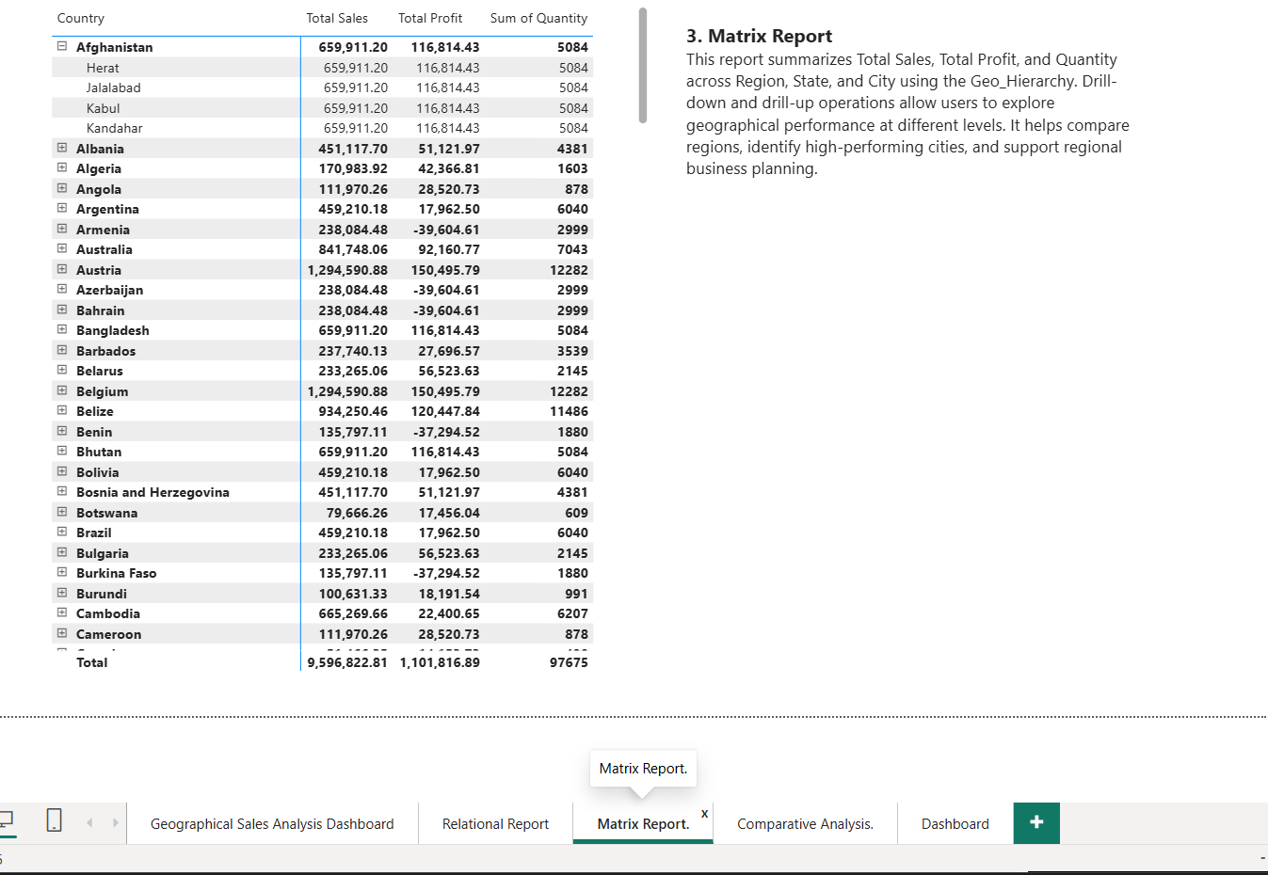

Part D: Build the Comparative Analysis Report
Step 21: Add a new page named Comparative Analysis.
Step 22: Create a column chart using Category from Dim_Product and Total Sales. Set the title to Sales by Category.
Step 23: Create a bar chart using Region from Dim_Region and Total Profit. Set the title to Profit by Region.
Step 24: Create a bar chart using Customer Name as the axis and Total Sales as the value.
- Open Filters on this visual.
- Change Customer Name to Top N.
- Enter 10.
- Add Total Sales to By value.
- Apply the filter.
- Set the title to Top 10 Customers by Sales.
Step 25: Create a line chart using Year from Dim_Date on the X-axis and Total Sales on the Y-axis. Set the title to Sales Trend by Year.
Step 26: Arrange all four charts neatly on the page.
Observation: Compare the category, regional, customer, and yearly trends with the individual transactions in the Relational Report.
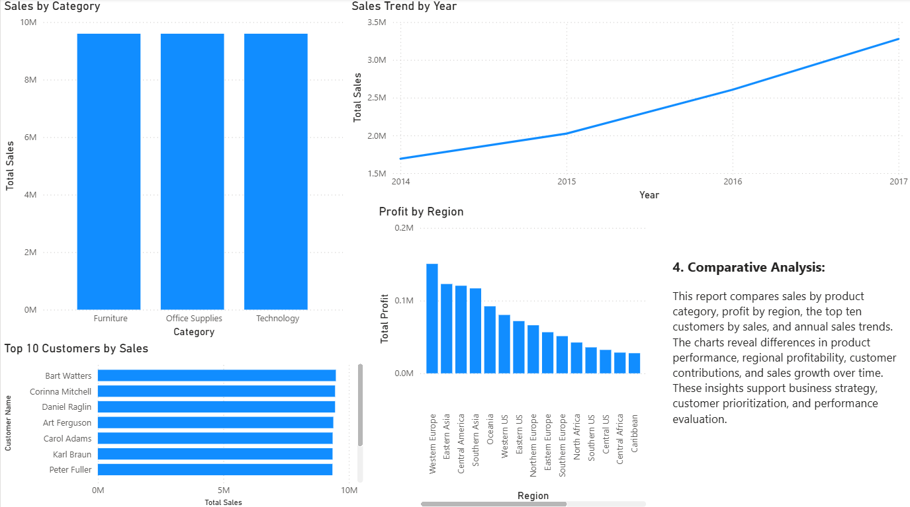

Part E: Build the Interactive Dashboard
Step 27: Add a new page named Dashboard.
Step 28: Create three Card visuals for Total Sales, Total Profit, and Total Orders.
If the measures do not exist, create them using the appropriate fields:
Total Sales = SUM(Fact_Sales[Sales])
Total Profit = SUM(Fact_Sales[Profit])
Total Orders = DISTINCTCOUNT(Fact_Sales[Order ID])
Step 29: Copy the four charts from Comparative Analysis onto the Dashboard.
Step 30: Add three slicers:
- Region from Dim_Region.
- Category from Dim_Product.
- Year from Dim_Date.
Step 31: Arrange the cards at the top, slicers along the side or top, and charts in the remaining space.
Step 32: Select different values in each slicer and verify that the cards and charts respond correctly.
Step 33: If a visual does not respond, check Edit interactions and confirm that the slicer filters that visual.
Step 34: Clear the slicer selections and verify that the dashboard returns to the overall view.
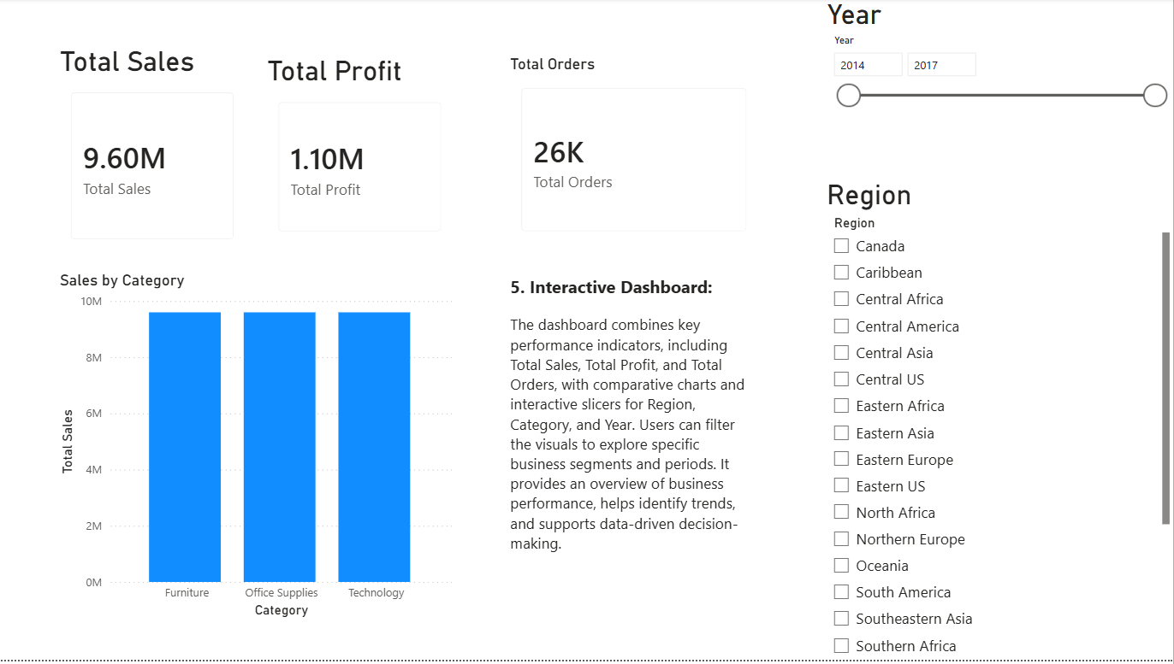

Part F: Summary and Interpretation
Step 35: Complete the following table using your actual Power BI observations.
Report Type | Fields or Measures Used | Key Observation | Business Use
Relational Report | Order ID, Customer Name, Product Name, Region, Sales, Profit | Displays individual profitable transactions sorted by Sales. | Order verification and transaction analysis.
Multidimensional Report | Geo_Hierarchy, Total Sales, Total Profit, Quantity | Summarizes performance across Region, State, and City. | Regional performance comparison.
Comparative Analysis | Category, Region, Customer Name, Year, Total Sales, Total Profit | Compares categories, regions, customers, and yearly trends. | Business planning and performance evaluation.
Dashboard | Total Sales, Total Profit, Total Orders, Region, Category, Year | Combines KPIs, charts, and interactive filters. | Performance monitoring and decision-making.

7. RESULT
Relational and multidimensional reports were generated using the existing star schema in Power BI. The Table visual supported transaction-level analysis, the Matrix visual enabled geographical analysis through Geo_Hierarchy, and comparative charts highlighted sales and profit patterns. An interactive dashboard combined KPI cards, charts, and slicers to support business decision-making.

8. LEARNING OUTCOMES
- Generate relational reports using transactional business data.
- Create multidimensional reports using an existing hierarchy and star schema.
- Apply sorting, filtering, aggregation, and drill operations.
- Design an interactive dashboard using Power BI visuals.
- Interpret business insights from different reporting approaches.

