BUSINESS INTELLIGENCE LAB
UNIT 2 | SESSION 7
EXPERIMENT 7
Integration of Advanced Analytics with BI Reports using Microsoft Power BI

1. AIM
To integrate advanced analytics with Business Intelligence reports using Microsoft Power BI and generate business insights, strategic recommendations, and executive presentations that support organizational decision-making.
2. OBJECTIVES
- To reuse the existing Power BI reports, Executive Dashboard, and Business Scorecard developed in Experiments 5 and 6.
- To analyze sales performance and profitability across regions.
- To analyze profitability by product category and customer segment.
- To analyze monthly and yearly sales trends and compare sales growth with profit growth.
- To identify business strengths, weaknesses, and opportunities supported by Power BI evidence.
- To prepare a Business Insight Report with findings, recommendations, and supporting screenshots.
- To prepare a Recommendation Summary Sheet and a 6-slide Executive Presentation outline.
- To justify every recommendation with data-driven evidence and measurable KPIs.
3. TOOLS / SOFTWARE REQUIRED
- Microsoft Power BI Desktop.
- Existing Power BI project file (.pbix) from Experiments 5 and 6, saved as BI_Experiment_7.pbix.
- Global Superstore Dataset.xlsx.
- Power Query Editor for data inspection, if required.
- DAX (Data Analysis Expressions) for KPI and analytical measures.
- Microsoft PowerPoint for the Executive Presentation.
- Microsoft Word / Excel for the Business Insight Report and Recommendation Summary Sheet.
4. DATASET USED
Dataset: Global Superstore Dataset (Kaggle).
Source: https://www.kaggle.com/datasets/apoorvaappz/global-super-store-dataset
The experiment reuses the same Power BI file and data model built in Experiments 5 and 6. No new project was created and no existing dashboards were rebuilt. The dataset covers sales transactions from 2014 to 2017 across global regions, product categories, and customer segments.
The important fields used in this experiment are:
- Order ID: Identifies individual orders.
- Order Date: Supports monthly and yearly trend analysis.
- Sales: Represents sales revenue.
- Profit: Represents profit generated from sales.
- Region / Country: Represent geographical sales areas.
- Category: Identifies product categories (Furniture, Office Supplies, Technology).
- Segment: Identifies customer segments (Consumer, Corporate, Home Office).
- Customer Name: Identifies customers.
5. THEORY
5.1 Advanced Analytics in Business Intelligence
Advanced Analytics in Business Intelligence focuses on transforming data into actionable insights. While traditional BI reports present information, advanced analytics helps identify trends, opportunities, business challenges, and improvement areas. Organizations use analytical reports and dashboards to support strategic planning and decision-making.
5.2 Analytical Techniques Used
Power BI enables advanced analytics through the following techniques, all of which are applied in this experiment:
- KPI Analysis: Monitoring Total Sales, Total Profit, Total Orders, and Profit Margin.
- Trend Analysis: Studying monthly and yearly sales movement over time.
- Comparative Analysis: Comparing sales and profit across regions, categories, and segments.
- Ranking: Ordering regions and customers by sales or profit to find leaders and laggards.
- Segmentation: Filtering performance by region, category, and year using slicers.
- Target Analysis: Comparing actual results with predefined targets in the Business Scorecard.
5.3 Business Scenario
Global Superstore management has observed that sales are increasing but profitability is not growing at the expected rate. Senior management requires an analytical review of business performance. Acting as Business Intelligence Consultants, the Power BI reports and dashboards are used to identify issues, discover opportunities, and recommend corrective actions.
5.4 Strengths, Weaknesses, and Opportunities
Term | Meaning in this analysis
Strength | An area where the data shows the business is performing well, such as a region with high sales and healthy profit.
Weakness | An area where the data reveals poor performance, such as negative profit or high sales with a very low margin.
Opportunity | An area where a specific management action could improve a measurable KPI.

5.5 Analytical Measures
The following measures from Experiment 6 are reused. Profit Margin is the key measure for testing whether profit is keeping pace with sales.
Profit Margin (%)
Profit Margin % = DIVIDE([Total Profit], [Total Sales], 0)
Year-over-Year Sales Growth (%)
YoY Growth % = (Sales Current Year - Sales Previous Year) / Sales Previous Year
Share of Total
Sales Share % = Region Sales / Total Sales
Profit Share % = Region Profit / Total Profit
A region whose profit share is much lower than its sales share is earning less than the company average margin. This comparison is used to identify high-sales, low-profit areas.

6. PROCEDURE
Part A: Analyze Existing Reports and Dashboards
Step 1: Opened Microsoft Power BI Desktop, loaded the existing Global Superstore project from Experiments 5 and 6, and saved a separate copy as BI_Experiment_7.pbix. The dataset loaded correctly and all report pages were available: Geographical Sales Analysis Dashboard, Relational Report, Matrix Report, Comparative Analysis, Dashboard, Executive Dashboard, and Business Scorecard.
Before filtering, the Executive Dashboard and Matrix Report give the overall business position for 2014 to 2017:
KPI | Value | Source visual
Total Sales | 9,596,822.81 (9.60M) | Matrix Report total, Scorecard card
Total Profit | 1,101,816.89 (1.10M) | Matrix Report total, Scorecard card
Total Orders | About 25,750 (26K) | Scorecard card (5.15 × 5,000 target)
Profit Margin | 11.5% | Total Profit / Total Sales

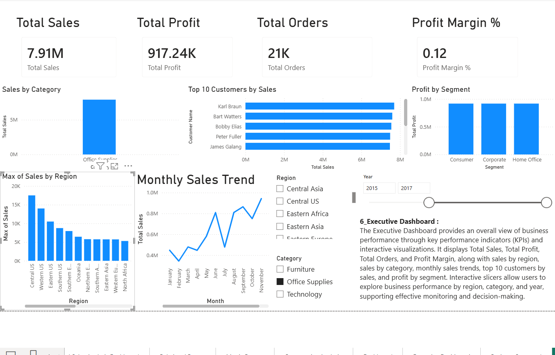
Figure 1: Executive Dashboard (Year slicer 2015 to 2017) showing Sales 7.91M, Profit 917.24K, Orders 21K and Profit Margin 0.12.
Step 2: Analyzed Sales Performance by Region using the Sum of Sales by Region chart, the Profit by Region chart, and the Matrix Report, which shows exact Sales and Profit per region.
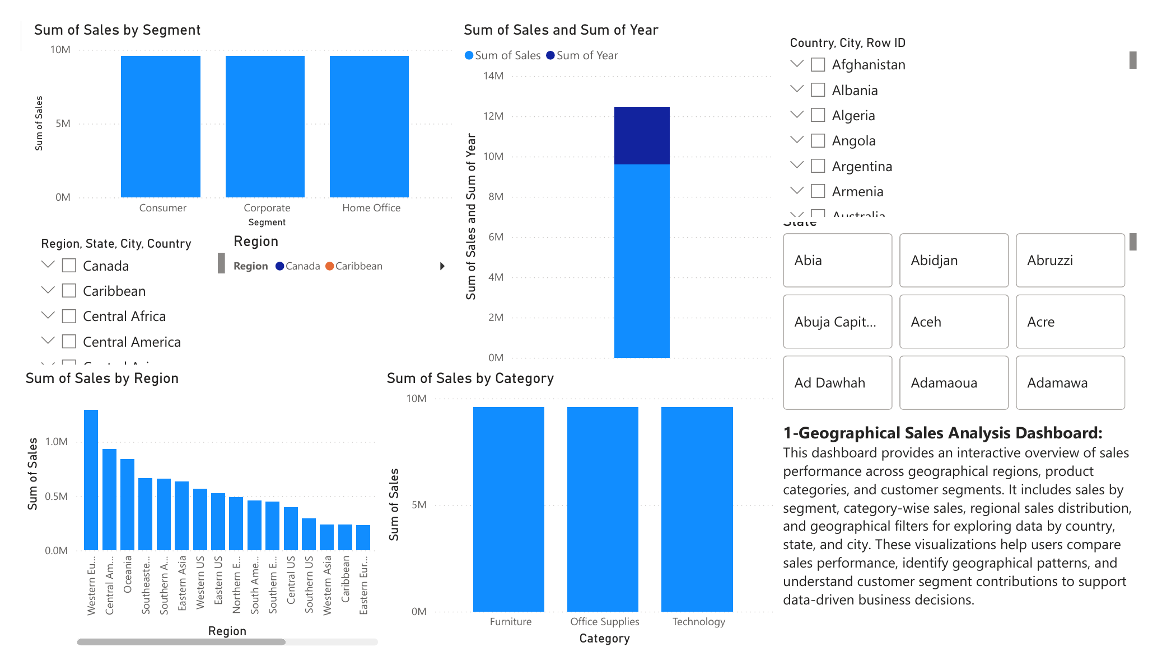
Figure 2: Geographical Sales Analysis Dashboard showing Sum of Sales by Region.
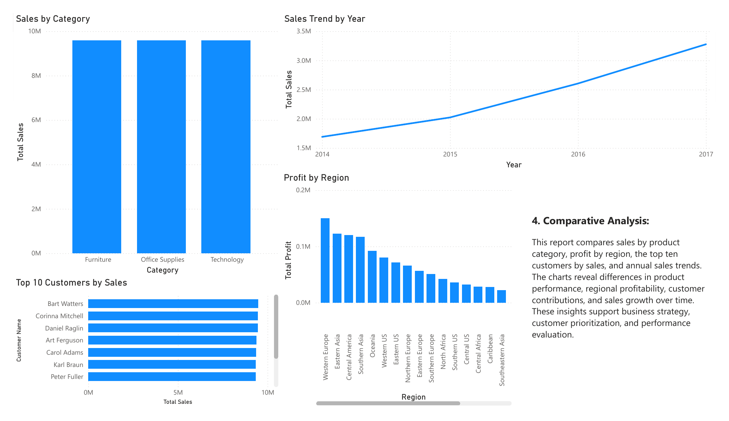
Figure 3: Comparative Analysis page showing Profit by Region and Sales Trend by Year.
The exact regional figures read from the Matrix Report are:
Region | Sales | Profit | Margin | Sales share | Profit share
Western Europe | 1,294,590.88 | 150,495.79 | 11.6% | 13.5% | 13.7%
Central America | 934,250.46 | 120,447.84 | 12.9% | 9.7% | 10.9%
Oceania | 841,748.06 | 92,160.77 | 10.9% | 8.8% | 8.4%
Southeastern Asia | 665,269.66 | 22,400.65 | 3.4% | 6.9% | 2.0%
Southern Asia | 659,911.20 | 116,814.43 | 17.7% | 6.9% | 10.6%
South America | 459,210.18 | 17,962.50 | 3.9% | 4.8% | 1.6%
Southern Europe | 451,117.70 | 51,121.97 | 11.3% | 4.7% | 4.6%
Western Asia | 238,084.48 | -39,604.61 | -16.6% | 2.5% | -3.6%
Caribbean | 237,740.13 | 27,696.57 | 11.6% | 2.5% | 2.5%
Eastern Europe | 233,265.06 | 56,523.63 | 24.2% | 2.4% | 5.1%
North Africa | 170,983.92 | 42,366.81 | 24.8% | 1.8% | 3.8%
Western Africa | 135,797.11 | -37,294.52 | -27.5% | 1.4% | -3.4%
Central Africa | 111,970.26 | 28,520.73 | 25.5% | 1.2% | 2.6%
Eastern Africa | 100,631.33 | 18,191.54 | 18.1% | 1.0% | 1.7%
Southern Africa | 79,666.26 | 17,456.04 | 21.9% | 0.8% | 1.6%
Note: Margin and share percentages were calculated from the Matrix Report values against the overall totals (Sales 9,596,822.81; Profit 1,101,816.89). Regions not expanded in the Matrix screenshot (US regions, Canada, Eastern Asia, Northern Europe, Central Asia) were read from the Profit by Region chart and dashboard filters.
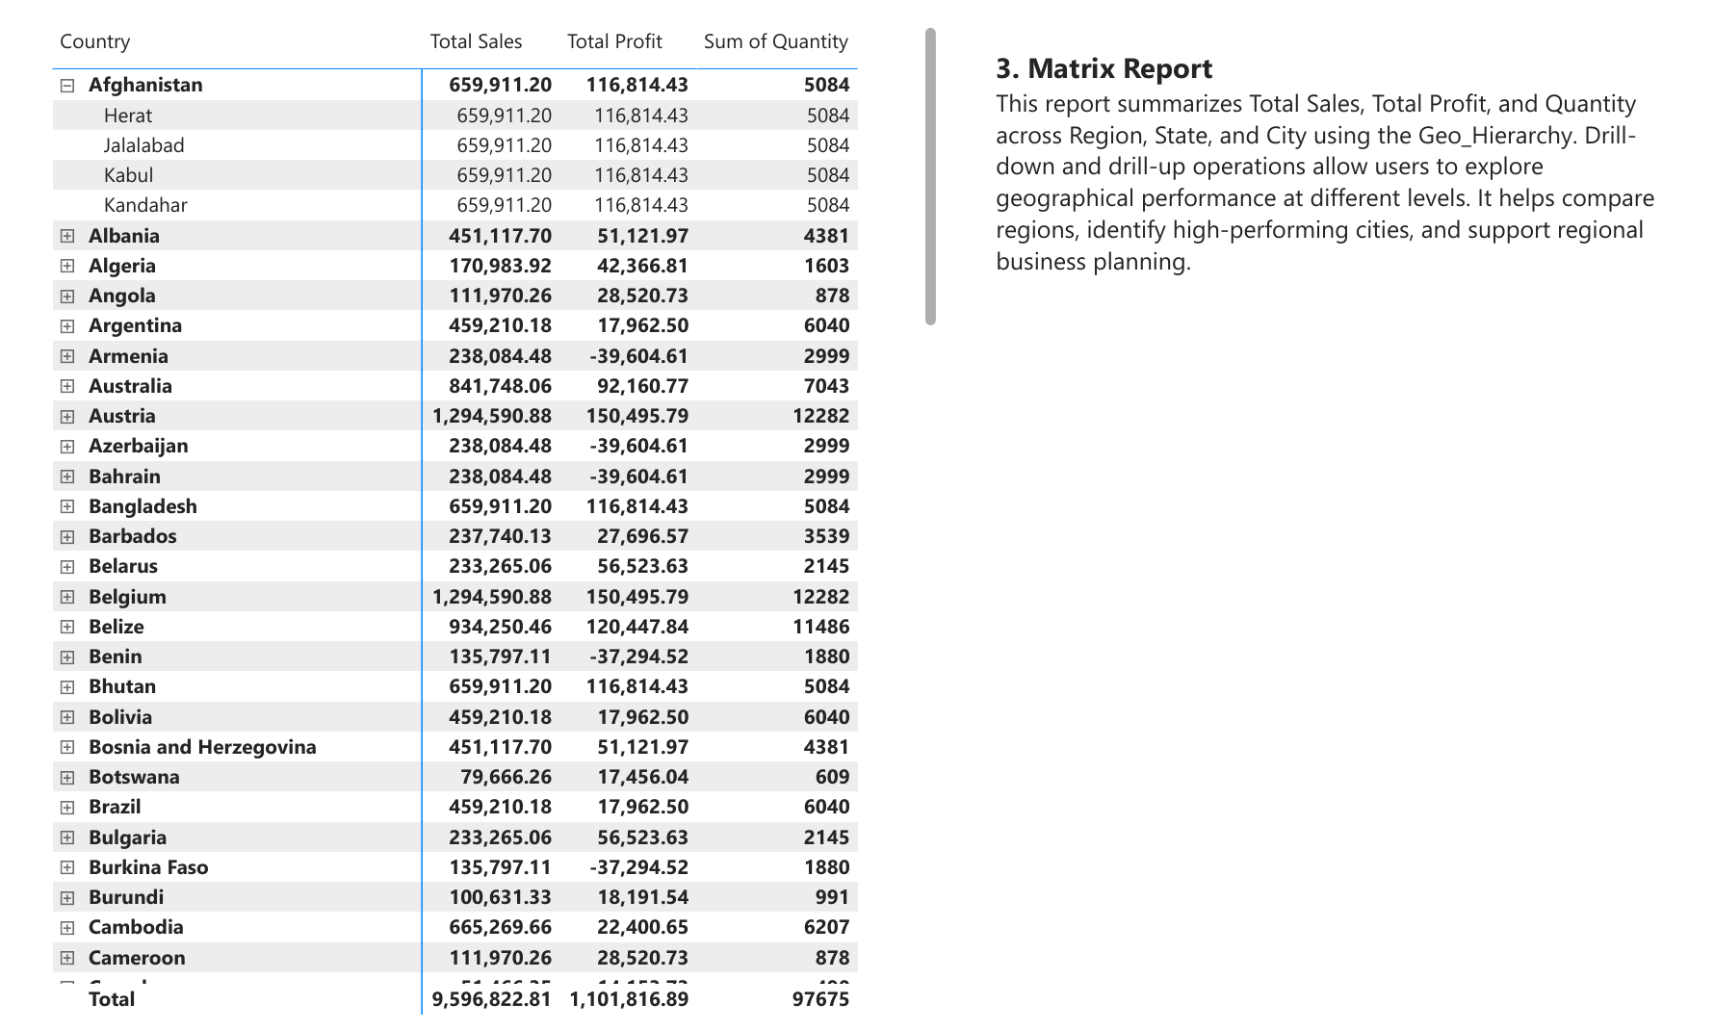
Figure 4: Matrix Report showing Total Sales, Total Profit and Quantity by country (country rows carry their region totals).
Observations:
- Highest sales: Western Europe (1.29M), which is also the most profitable region (150.5K). Here the highest-sales region is also the highest-profit region.
- Second tier: Central America (934K sales, 120K profit) and Oceania (842K sales, 92K profit) follow, both with healthy margins near the company average.
- High sales, weak profit: Southeastern Asia ranks 4th in sales (665K) but earns only 22.4K profit (3.4% margin). South America sells 459K but earns only 18.0K (3.9%).
- Loss-making: Western Asia (-39.6K) and Western Africa (-37.3K) together lose about 76.9K, which wipes out about 7% of total company profit.
- Small but very profitable: Central Africa (25.5%), North Africa (24.8%), Eastern Europe (24.2%) and Southern Africa (21.9%) earn margins about double the company average on low sales volumes.
Applying the Region slicer on the Executive Dashboard confirmed these patterns at the filtered level:
Region filter (Year 2015 to 2017 unless stated) | Sales | Profit | Orders | Margin
All regions (2015 to 2017) | 7.91M | 917.24K | 21K | 0.12
Caribbean (2014 to 2017) | 237.74K | 27.70K | 856 | 0.12
Central US | 315.94K | 32.34K | 942 | 0.10
Canada | 45.22K | 12.85K | 169 | 0.28

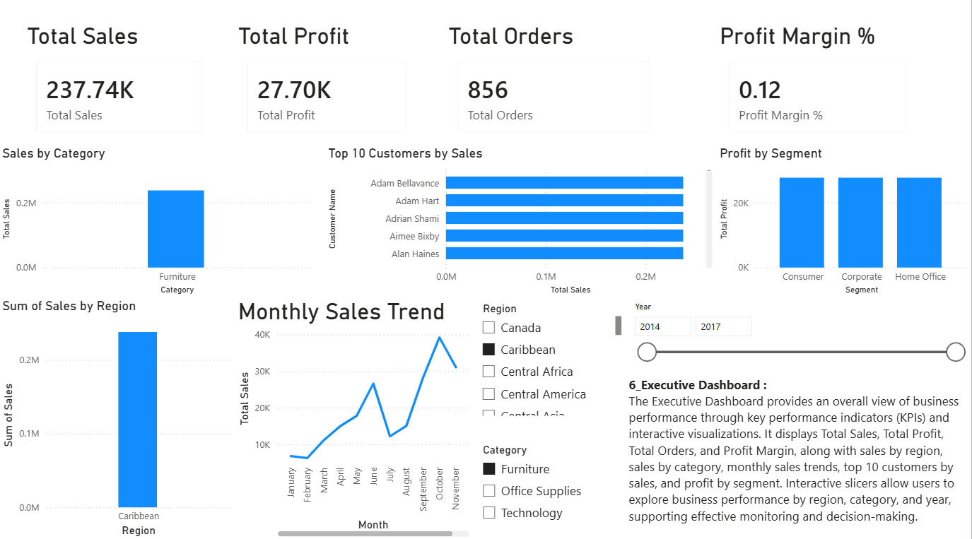
Figure 5: Executive Dashboard filtered to the Caribbean region.
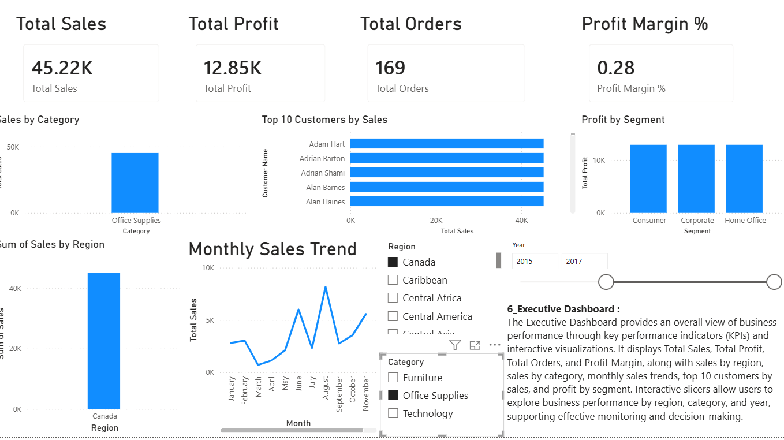
Figure 6: Executive Dashboard filtered to Canada, showing the highest margin (0.28) on low sales volume.
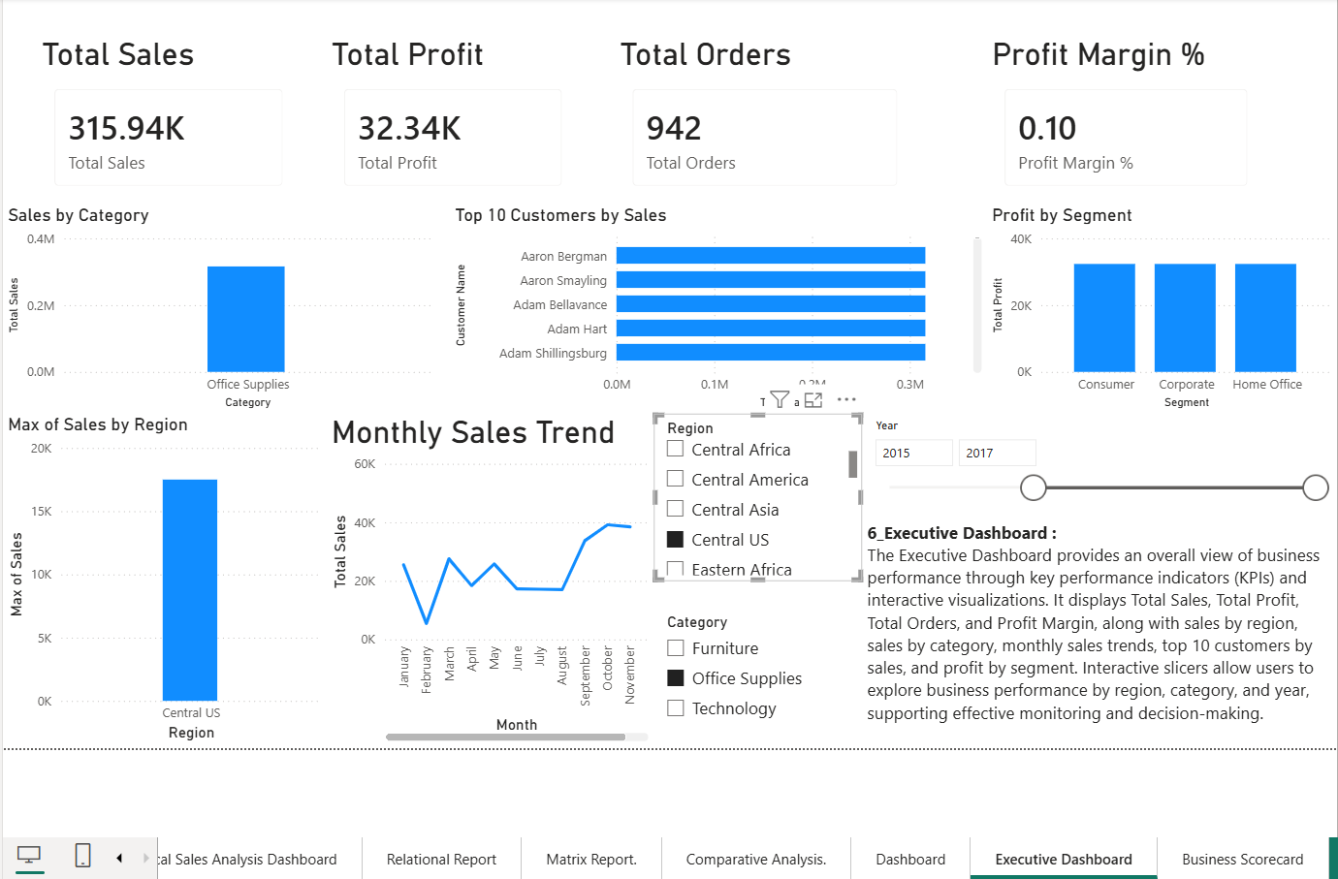
Figure 7: Executive Dashboard filtered to Central US, showing a below-average margin of 0.10.
Step 3: Analyzed Profitability by Product Category using Sales by Category and Profit by Category charts (Category on X-axis, Profit on Y-axis).
Observation (data model validation): In every report page the three categories, Furniture, Office Supplies and Technology, show the same value, and each bar equals the grand total (about 9.6M in Sales by Category; about 32K in Profit by Category when filtered to Central US). The same pattern appears in Sum of Sales by Segment, Profit by Segment, and Top 10 Customers by Sales, where every customer bar shows almost the same total. Selecting a Category in the slicer also leaves the KPI cards unchanged (Office Supplies with 2015 to 2017 still shows 7.91M, the total for all categories).
This shows that Category, Segment and Customer fields are not filtering the Sales and Profit measures through the current relationships, while the Region and Year fields filter correctly. In the Matrix Report, every country inside a region also repeats its region total (for example Afghanistan, Bangladesh and Bhutan each show 659,911.20, the Southern Asia total), and the Relational Report profit total (2,388,101.35) does not match the true total profit (1,101,816.89). The current model therefore relates the sales fact table to the other tables at Region level only.
Category-level and segment-level profitability conclusions are therefore not drawn from the current visuals, because doing so would report numbers that the data does not support. Correcting these relationships is recorded as a weakness and as a priority recommendation.
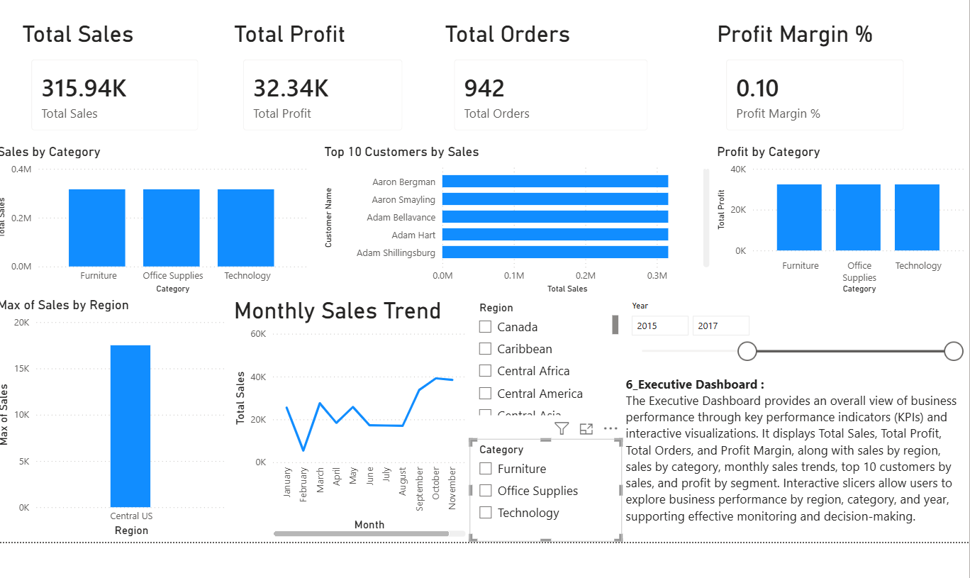
Figure 8: Sales by Category and Profit by Category show identical bars for all three categories, revealing a relationship issue in the data model.
Step 4: Analyzed Customer Segment Performance using Profit by Segment and Sum of Sales by Segment. Consumer, Corporate and Home Office show identical values (each bar equals the filtered total, for example about 917K profit for 2015 to 2017). For the reason explained in Step 3, segment comparison cannot be made reliably until the model relationships are corrected.
Step 5: Analyzed Monthly and Yearly Sales Trends using the Sales Trend by Year line chart and the Monthly Sales Trend chart.
Year | Total Sales (approx.) | YoY growth | Evidence
2014 | 1.69M | - | Total 9.60M minus 2015 to 2017 total of 7.91M
2015 | 2.03M | +20% | Sales Trend by Year chart
2016 | 2.60M | +28% | Sales Trend by Year chart
2017 | 3.27M | +26% | Sales Trend by Year chart

- Sales are increasing every year, rising from about 1.69M in 2014 to about 3.27M in 2017, an increase of roughly 94% over the period.
- Profit is not growing faster than sales. Profit for 2014 was about 184.6K (1,101.8K total minus 917.2K for 2015 to 2017), a margin of about 10.9%. For 2015 to 2017 the margin was 11.6%. The margin is almost flat at 11 to 12%, which confirms management's concern: the business is growing revenue, but it is not converting that growth into higher profitability.
- Monthly seasonality (2015 to 2017): February is the weakest month (about 0.35M) and sales build through the second half of the year, with peaks in June (about 0.82M), September (about 0.86M) and November (about 0.95M, the highest). July shows a clear dip (about 0.48M).
Note: monthly and yearly values are read from the line charts and are approximate.
Step 6: Documented significant observations and captured screenshots (Win + Shift + S) of the Executive Dashboard, regional analysis, category and segment visuals, sales trends, and Business Scorecard. These are included as Figures 1 to 9 in this report and saved in the Experiment_7_Screenshots folder.
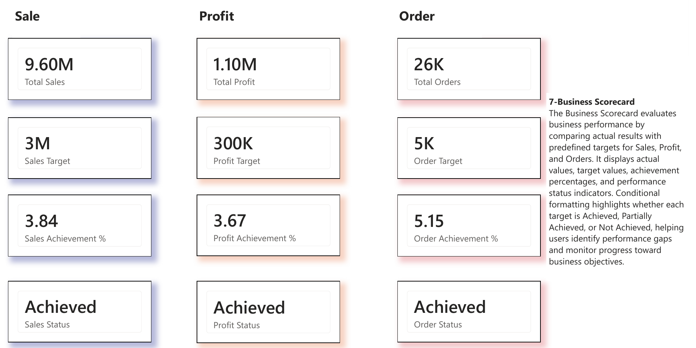
Figure 9: Business Scorecard: Sales 9.60M vs 2.5M target (3.84), Profit 1.10M vs 300K target (3.67), Orders 26K vs 5K target (5.15).
Scorecard observation: All three targets show "Achieved" with achievement of 384% (Sales), 367% (Profit) and 515% (Orders). The Sales Target card shows "3M" because of display rounding; the actual target is 2.5M (9.60M / 2.5M = 3.84). The targets are illustrative and far below actual performance, so the scorecard currently cannot separate strong and weak performance. Achievement values are also displayed as decimals (3.84) instead of percentages (384%).
Part B: Business Problem Identification
Step 7: Identified Business Strengths.
Strength | Evidence from Power BI | Business significance
S1. Consistent sales growth | Sales Trend by Year rises every year: about 1.69M (2014) to 3.27M (2017), YoY growth of 20%, 28% and 26%. | Demand is strong and growing; the business has a solid revenue base to build on.
S2. Western Europe is the leading region on both sales and profit | Sales 1,294,590.88 (13.5% of total) and Profit 150,495.79 (13.7% of total), margin 11.6%. | The largest market is also the largest profit source, so growth here directly adds profit.
S3. Strong contribution from Central America and Southern Asia | Central America: 934K sales, 120K profit (12.9%). Southern Asia: 660K sales, 117K profit (17.7%). | Together these two regions supply over 21% of company profit at above-average margins.
S4. Overall profitability is positive and stable | Profit 1.10M on 9.60M sales; margin 11.5%; Profit Achievement 367% of target. | The business is fundamentally profitable, so the problem is margin improvement, not survival.

Step 8: Identified Business Weaknesses.
Weakness | Evidence from Power BI | Possible implication
W1. Loss-making regions | Western Asia profit -39,604.61 (-16.6% margin); Western Africa -37,294.52 (-27.5%). Combined loss about 76.9K. | These regions remove about 7% of total profit. Pricing, discounting, shipping cost or product mix in these markets needs investigation.
W2. High sales but very low margin | Southeastern Asia: 665K sales (6.9% share) but only 22.4K profit (2.0% share, 3.4% margin). South America: 459K sales, 18.0K profit (3.9%). | Revenue in these regions is not converting into profit, which is a direct cause of profit lagging behind sales.
W3. Flat profit margin despite rising sales | Sales nearly doubled from 2014 to 2017, but margin stayed at about 10.9% (2014) and 11.6% (2015 to 2017). | Growth is volume-driven, not margin-driven. This is the core problem in the business scenario.
W4. Analytical gaps in the BI model and scorecard | Category, Segment and Customer visuals show identical values; scorecard targets are achieved by 367% to 515%. | Management cannot yet see which products or customer types lose money, and the scorecard does not flag real performance gaps.

Step 9: Identified Business Opportunities.
Opportunity | Supporting evidence | Proposed action | KPI to monitor
O1. Lift margin in Southeastern Asia and South America | Combined sales 1.12M at 3.4% to 3.9% margin vs 11.5% company average. | Review discounts, pricing and shipping costs. At the company-average margin these regions would earn about 88.7K more profit (54.0K + 34.8K). | Profit Margin %, Region Profit
O2. Turn around or restructure loss-making regions | Western Asia and Western Africa lose about 76.9K combined. | Investigate loss-making orders and products; cap discounts; stop or reprice unprofitable lines. Reaching break-even alone adds about 76.9K profit. | Region Profit
O3. Grow high-margin regions | Central Africa 25.5%, North Africa 24.8%, Eastern Europe 24.2%, Canada 28% margin, but each has under 2.5% of sales. | Targeted marketing and wider product range in these markets to grow volume at high margin. | Region Sales, Sales Share %
O4. Plan around seasonality | Peaks in June, September and November; lowest month February; dip in July. | Align inventory, staffing and promotions with peak months; run full-price campaigns in slow months instead of deep discounts. | Monthly Sales, Monthly Profit

Step 10: Supported findings with analytical evidence. The evidence used for each analysis is summarized below.
Analysis | Power BI visual used | Key evidence recorded
Regional performance | Sum of Sales by Region, Profit by Region, Matrix Report | Western Europe leads (1.29M / 150.5K); two loss-making regions
Category profitability | Sales by Category, Profit by Category | Identical bars: relationship issue identified
Customer performance | Profit by Segment, Top 10 Customers by Sales | Identical bars: relationship issue identified
Sales trends | Sales Trend by Year, Monthly Sales Trend | 1.69M to 3.27M growth; flat 11 to 12% margin; Q4 peak
Overall performance | KPI cards on Executive Dashboard | 9.60M sales, 1.10M profit, about 25.7K orders, 11.5% margin
Scorecard | Business Scorecard page | 384% / 367% / 515% achievement; all Achieved

Temporary slicer filters were cleared before capturing the overall-performance screenshots.

Part C: Business Insight Report
Step 11: Prepared the Business Insight Report with the sections below.
C.1 Objective of Analysis
To analyze Global Superstore business performance using the existing Power BI reports and dashboards, explain why profitability is not growing at the same rate as sales, identify areas of strong and weak performance, and recommend data-driven improvements.
C.2 Reports and Dashboards Used
- Geographical Sales Analysis Dashboard (Experiment 5): sales by region, segment and category with geographic filters.
- Matrix Report (Experiment 5): Total Sales, Total Profit and Quantity by country and region.
- Comparative Analysis (Experiment 5): Profit by Region, Sales Trend by Year, Sales by Category, Top 10 Customers.
- Executive Dashboard (Experiment 6): KPI cards, five charts, Region/Category/Year slicers.
- Business Scorecard (Experiment 6): actual vs target, achievement % and status for Sales, Profit and Orders.
C.3 Key Findings
- Sales are growing strongly but margin is flat. Sales rose from about 1.69M (2014) to 3.27M (2017), while profit margin stayed at about 11 to 12%. Profit grows only because volume grows. (Sales Trend by Year, KPI cards)
- Western Europe is the strongest region. It leads both sales (1.29M) and profit (150.5K). (Matrix Report, Profit by Region)
- Two regions lose money. Western Asia (-39.6K) and Western Africa (-37.3K) remove about 7% of total profit. (Matrix Report)
- Two large regions earn very little. Southeastern Asia and South America generate 1.12M sales (11.7% of total) but only 40.4K profit (3.7% of total). (Matrix Report)
- Small markets are highly profitable. Central Africa, North Africa, Eastern Europe and Canada earn 24% to 28% margins on small volumes. (Matrix Report, Canada filter)
- Sales are seasonal. Second-half months, especially November, are strongest; February is weakest. (Monthly Sales Trend)
- The BI model needs correction. Category, Segment and Customer visuals cannot currently separate performance, and scorecard targets are too low to flag gaps. (Profit by Category, Business Scorecard)
C.4 Business Strengths
Consistent year-on-year sales growth (20% to 28%), Western Europe as a leading high-sales and high-profit region, strong profit contribution from Central America and Southern Asia, and a stable positive overall margin of 11.5% (see Step 7).
C.5 Business Weaknesses
Loss-making operations in Western Asia and Western Africa, very low margins in Southeastern Asia and South America, a flat profit margin despite rapid sales growth, and gaps in the BI model and scorecard that hide product and customer-level problems (see Step 8).
C.6 Opportunities for Improvement
Improve margins in high-volume low-margin regions, restore loss-making regions to break-even, expand in high-margin small markets, and use seasonal patterns for planning and promotions (see Step 9). Bringing Southeastern Asia and South America to the company-average margin and loss-making regions to break-even would add an estimated 165.6K of profit, about 15% more than today's 1.10M, without any increase in sales.
C.7 Recommendations
Identified issue | Recommendation | Expected benefit | KPI to monitor
Loss-making Western Asia and Western Africa | Drill down to country, product and order level to find loss-making lines; set discount limits and reprice or remove unprofitable products. | Up to about 76.9K profit recovered at break-even | Region Profit, Profit Margin %
Low margin in Southeastern Asia and South America | Review discount policy, shipping costs and product mix; move sales toward higher-margin products. | About 88.7K extra profit at company-average margin | Region Profit Margin %
Flat margin despite sales growth | Set margin-based targets, not only sales targets; reward profitable growth rather than volume. | Profit grows faster than sales | Profit Margin % by Year
Untapped high-margin markets | Targeted marketing and product range expansion in Central Africa, North Africa, Eastern Europe and Canada. | Higher-margin sales growth | Region Sales, Sales Share %
Seasonal demand | Plan inventory and staffing for June, September and November peaks; use non-discount campaigns in February and July. | Smoother revenue and fewer margin-reducing discounts | Monthly Sales and Profit
Model and scorecard gaps | Fix relationships between the sales fact table and the Product/Customer tables using Product ID, Customer ID and Order ID keys; reset targets using prior-year actuals plus a growth rate; format achievement as %. | Reliable category, segment and customer analysis; meaningful scorecard status | Data validation checks, Achievement %

C.8 Conclusion
Global Superstore is a growing and profitable business, with sales nearly doubling between 2014 and 2017 and Western Europe leading both sales and profit. However, the profit margin has stayed at about 11 to 12%, which explains why profit is not growing as fast as management expects. The main causes visible in Power BI are two loss-making regions and two high-volume regions with margins below 4%. Fixing these, growing high-margin markets, and correcting the data model so that category and customer profitability can be analyzed are the priority actions. Power BI made it possible to locate these issues quickly and attach measurable KPIs to each recommendation.
Step 12: Inserted the Power BI screenshots (Figures 1 to 9) with descriptive captions to support each finding.
Part D: Executive Presentation
Step 13: Prepared a 6-slide Executive Presentation (BI_Experiment_7_Executive_Presentation.pptx) with the following structure.
Slide | Title | Content
1 | Introduction | Experiment title, business scenario (sales up, profit not keeping pace), objective, Global Superstore dataset.
2 | Dashboard Overview | Executive Dashboard screenshot (Figure 1); KPIs: 9.60M sales, 1.10M profit, about 25.7K orders, 11.5% margin.
3 | Key Findings | Sales 1.69M to 3.27M with flat margin; Western Europe leads; Profit by Region chart (Figure 3).
4 | Business Issues Identified | Strengths, weaknesses and opportunities summary; loss-making and low-margin regions with figures.
5 | Recommendations | Top 3 actions with issue, action and KPI; estimated profit gain of about 165.6K.
6 | Conclusion | Overall assessment, most important issue (flat margin), priorities, and the role of Power BI.

Step 14: Presented the findings before the instructor and class using the Executive Dashboard and Business Scorecard as live evidence.
Step 15: Justified each recommendation with data-driven evidence: every recommendation is linked to an exact figure from the Matrix Report, a trend from the line charts, or a KPI card, and to a KPI that will be used to measure the result.
Recommendation Summary Sheet
No. | Business finding | Supporting evidence | Recommendation | KPI to monitor
1 | Loss-making regions | Western Asia -39.6K; Western Africa -37.3K | Drill down, cap discounts, reprice or remove loss lines | Region Profit
2 | High sales, low margin | SE Asia 3.4%; South America 3.9% margin | Review pricing, discounts, shipping and mix | Profit Margin %
3 | Flat margin with rising sales | Margin about 10.9% (2014) vs 11.6% (2015 to 2017) | Add margin targets to the scorecard | Profit Margin % by Year
4 | High-margin small markets | Central Africa 25.5%; Canada 28% | Targeted growth campaigns | Region Sales
5 | Seasonal demand | Peak November; low February and July | Seasonal inventory and promotion plan | Monthly Sales
6 | BI model and scorecard gaps | Identical Category/Segment bars; 367% to 515% achievement | Fix relationships; recalibrate targets | Achievement %

Part E: Summary and Interpretation
Deliverable | Content | Purpose
Business Insight Report | Objective, reports used, findings, strengths, weaknesses, opportunities, recommendations, conclusion, screenshots | Explains business performance and the reasons behind it.
Executive Presentation | 6 slides from introduction to conclusion | Communicates the findings to management concisely.
Recommendation Summary Sheet | Finding, evidence, recommendation, KPI | Gives management a one-page action list.
BI_Experiment_7.pbix | Existing reports, Executive Dashboard, Business Scorecard | Provides the supporting analytical evidence.
7. RESULT
Advanced analytics techniques were successfully integrated with the Business Intelligence reports and dashboards developed in Experiments 5 and 6 using Microsoft Power BI. KPI, trend, comparative, ranking and segmentation analysis showed that Global Superstore sales grew from about 1.69M in 2014 to about 3.27M in 2017, while the profit margin stayed flat at about 11 to 12%. Western Europe was identified as the strongest region, Western Asia and Western Africa as loss-making regions, and Southeastern Asia and South America as high-sales, low-margin regions.
Business strengths, weaknesses, opportunities and recommendations were identified, supported by Power BI evidence, and communicated through a professional Business Insight Report, a Recommendation Summary Sheet, and a 6-slide Executive Presentation. The analysis also validated the data model and identified relationship and target-setting improvements needed for deeper category and customer analysis.
8. LEARNING OUTCOMES
- Apply advanced analytical techniques to business reports and dashboards. (CO3-BT3)
- Analyze organizational performance using BI tools and KPIs. (CO3-BT4)
- Generate business insights from analytical findings. (CO5-BT6)
- Develop strategic recommendations based on data-driven evidence. (CO5-BT6)
- Communicate analytical findings through professional reports and presentations. (CO5-BT6)
- Validate a BI data model by checking whether visuals respond correctly to filters and relationships.
9. REFERENCES
- Sharda, Delen & Turban, Business Intelligence and Analytics.
- Cindi Howson, Successful Business Intelligence.
- Ralph Kimball & Margy Ross, The Data Warehouse Toolkit.
- Microsoft Power BI Official Documentation.

