- KEY INSIGHT FROM THE SQL ANALYSIS
IN TASK 1 : SALES AND ORDER ANALYSIS.
I find total number of delivered ,pending or shipped order. Total delivered order shows us the completion of payment and after receiving the delivery it is also show us customer is stafied.
delivered | 5057
pending | 5069
shipped | 4874
Then I find revenue over time I only consider thouse order which is successfully deliverd
TASK 2:
I find top 5 hig value customer
7950 | 2060.7799999999997
6567 | 2000.6699999999998
6050 | 1972.3000000000002
8795 | 1874.5100000000002
6006 | 1680.5299999999997
And which state of customer are order for using shipping address
TASK 3:
I find which payment system is best for payment it..which lead to the conclusion net banking is best option currently.
TASK 4:
In this task I find ..in 15000 order only 33.71% order are accurately deliverd
15000 | 5057 | 33.71%
- Also total succesfull order by month
2.OBSERVATION FROM CUSTOMER RETENTION ANALYSIS
In customer retention analysis I make use measure like order frequency..location from analysis
my key observation from customer retension analysis are
DURING THE COURSE OF 4 YEARS, WE HAVE A TOTAL OF 15K ORDERS.
- THE ORDER FREQUENCY PER DAY SHOWS US THAT REPEATED ORDERS ARE AT 2.9K.
- IN QUARTER 2 OF 2020, JUNE RECORDED THE HIGHEST NUMBER OF ORDERS, WHICH IS 12. ALSO, ORDER ID 1001 HAS 4 SUCCESSFUL ORDERS.
- WE CAN ALSO TRACK WHERE OUR CUSTOMER ORDERS CAME FROM.
- CUSTOMERS BELONGING TO AP, AR, AS, AZ, AND AK HAVE A LOWER NUMBER OF ORDERS COMPARED TO OTHERS..
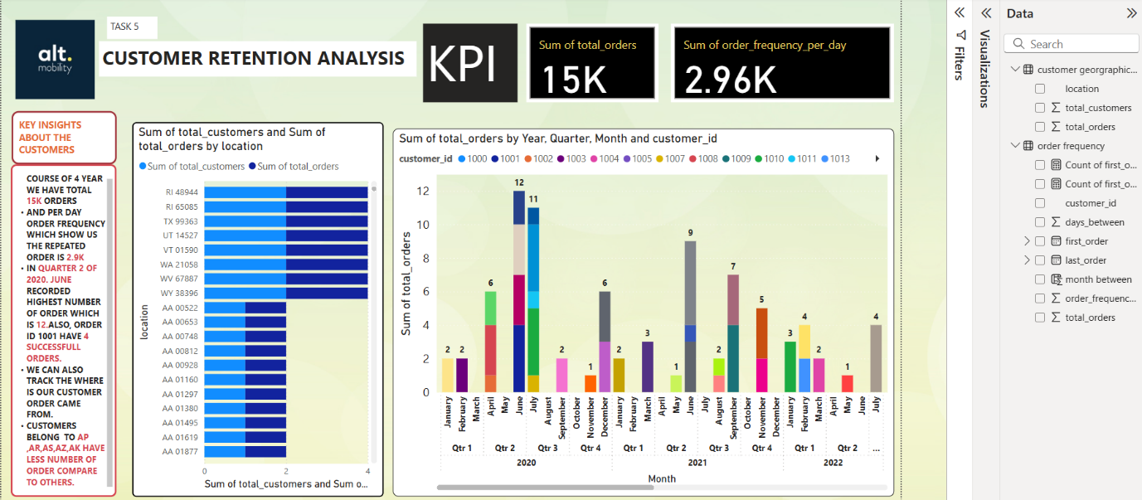
3. RECOMMENDATION FOR ALT MOBILITY
1.payment system need to be more net banking centric
2.focus on AP,AR,AS, AZ and AK may be marketing and branding will work.

