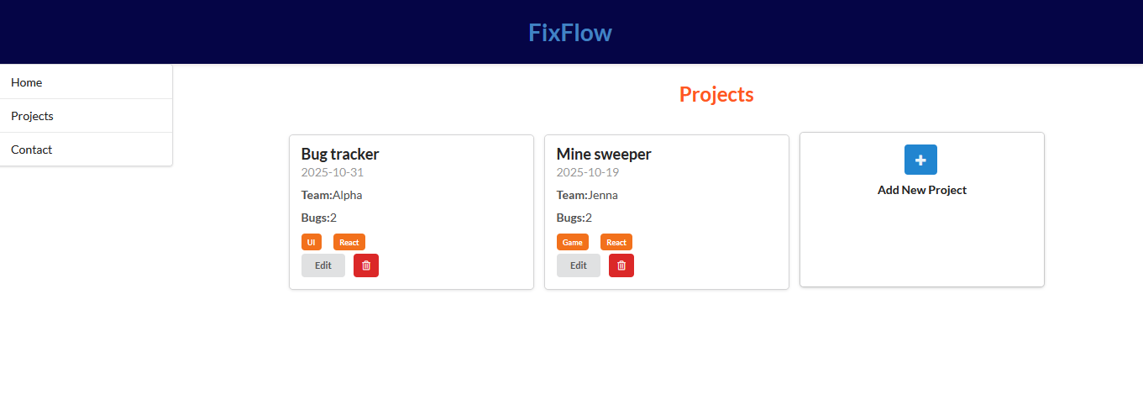
Form for adding new Project
Delete button
Projects, clickable to open in full of bugs’ detail
Button to open form
Navigation bar

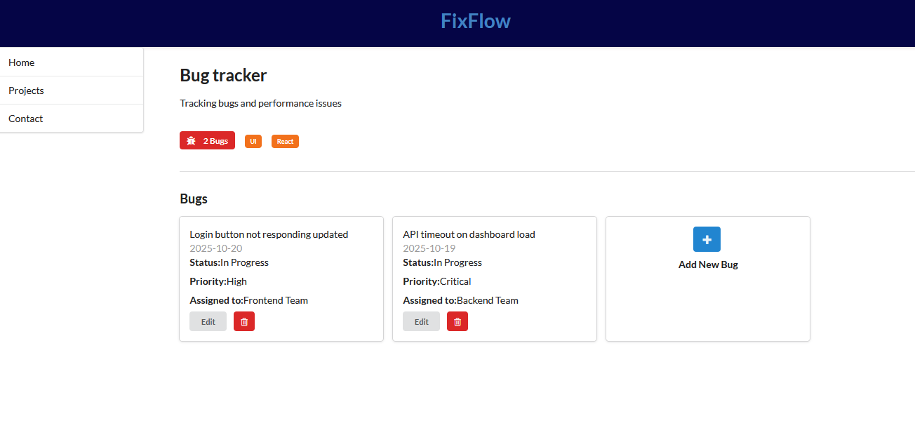
Form for adding new bug
Bugs list in a card style with details
Project’s details along with total number of bugs
Navigation bar

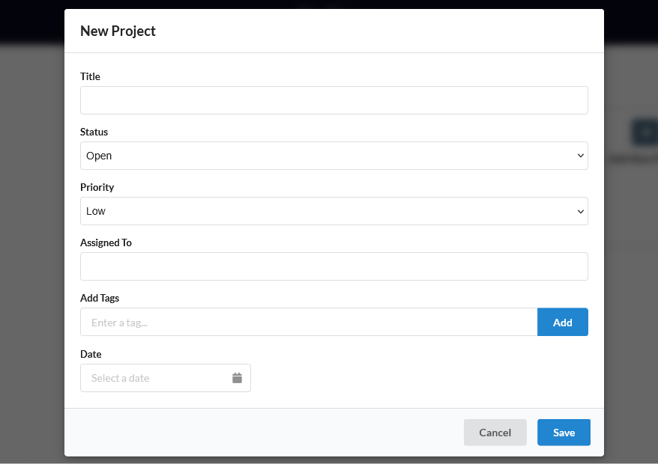
This creates a list and displays underneath
Form for adding new Project
Shows a calendar to select date
Drop down list for fields

