NAME:PASTAPURE SAMRUDDHI NAGNATH
AIM:WRITE A ‘C’ PROGRAM TO SEARCH A PARTICULAR DATA FROM THE GIVEN ARRAY OF STRING USING LINEAR SEARCH METHOD
_____________________________________________________________________________
#include<stdio.h>
#include<conio.h>
#include<string.h>
int linear_search(char arr[][10],int n,char*key)
{
int i;
for(i=0;i<n;i++)
{
if(strcmp(arr[i],key)==0)
{
return i;
}
}
return -1;
}
void main()
{
char string[10][10];
int n,i,index;
char key[10];
clrscr();
printf("enter number of string:");
scanf("%d",&n);
printf("enter %d string:\n",n);
for(i=0;i<n;i++)
{
printf("string %d:",i+1);
scanf("%s",string[i]);
}
printf("\n enter a string to search:");
scanf("%s",key);
index=linear_search(string,n,key);
if(index!=-1)
{
printf("string %s found at position %d\n",key,index+1);
}
else
{
printf("string '%s',not found \n",key);
}
getch();
}
POSITIVE OUTPUT:
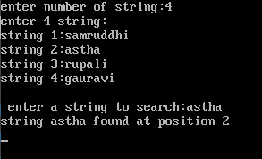
NEGATIVE OUTPUT:
