Product Reviews Data Analysis Report
Dataset: dataset_61.csv
Prepared by: Sama Kenawy
Client: Radwa Khaled
Date: 3-May 2026

1. Introduction
This report presents a comprehensive data analysis of the product reviews dataset (dataset_61.csv). The analysis covers the full data science pipeline: data cleaning, exploratory data analysis (EDA), and visualization. The goal is to extract meaningful patterns from customer review behavior between October 2022 and October 2025.

2. Data Cleaning

2.1 Initial Dataset Overview
The raw dataset contained the following structure before cleaning:

Column | Type | Description
Review_ID | Object | Unique review identifier
Product_ID | Object | Product identifier
User_ID | Object | User identifier
Review_Date | Object | Date of review
Rating | Float64 | Product rating (1.0 – 5.0)
Review_Text | Object | Text content of review
Verified_Purchase | Object | Whether the purchase was verified (Yes/No)
Extra_1 | Object | Unknown column with random words
Review_Length | Int64 | Number of words in review (engineered)

Shape: 2,969 rows × 8 columns (before cleaning)

2.2 Handling Duplicate Rows
Duplicates were identified and removed before any transformation. Investigation revealed that the Extra_1 column was the only difference between duplicate rows, confirming it as a noise column. After dropping Extra_1, 32 true duplicate rows were removed.

2.3 Dropping Unnecessary Columns
The following columns were dropped with justification:

Column | Reason for Dropping
Extra_1 | Random meaningless words — no analytical value
Review_ID | Unique per row — acts only as an index
User_ID | Not required for product/rating analysis
Review_Text | Synthetic gibberish — no sentiment value
Verified_Purchase | Virtually identical ratings (2.97 vs 3.02) — no impact

2.4 Feature Engineering — Review Length
Before dropping Review_Text, a Review_Length column was engineered to capture the number of words per review. Pre-imputation analysis confirmed that reviews with missing ratings had similar lengths to those with ratings (mean: 11.4 vs 11.6 words), indicating data was Missing Completely At Random (MCAR), which validated the median imputation approach.

2.5 Rating Column — Missing Value Imputation
617 missing rating values were identified (approximately 20.8% of the dataset). The following imputation strategy was applied:
- Step 1: Product-level median imputation — each missing rating was filled with its product's median rating to preserve individual product rating profiles.
- Step 2: Fallback — for products with all-NaN ratings, the overall dataset median (3.0) was used.
- Step 3: Half-star ratings (1.5, 2.5, 3.5, 4.5) resulting from even-count product medians were removed (8 rows) as the original data contained only whole-number ratings.

Pre-imputation validation confirmed that mean = median = mode = 3.0, making any standard method equivalent. A slight inflation of rating 3.0 post-imputation is acknowledged as an unavoidable limitation.

2.6 Review Date — Type Conversion & Feature Extraction
The Review_Date column was stored as object type and converted to datetime64[ns] using pd.to_datetime(). Two time-based features were extracted to support temporal analysis:
- Year — integer year extracted for annual trend analysis
- Month — month name extracted for seasonal pattern analysis

Date range confirmed: October 2022 – October 2025 (approximately 3 years).

2.7 Final Clean Dataset
After all cleaning steps, the final dataset contains:

Column | Type | Role
Product_ID | Object | Group reviews by product
Review_Date | Datetime64 | Time-based analysis
Rating | Float64 | Core metric
Year | Int32 | Annual trend analysis
Month | Object | Seasonal pattern analysis

Final shape: 2,937 rows × 5 columns

3. Exploratory Data Analysis

3.1 Date Range Overview
Metric | Value
Earliest Review | October 23, 2022
Latest Review | October 22, 2025
Total Years Covered | 4 years (2022–2025)
Total Reviews | 2,937

3.2 Rating Distribution
Ratings are distributed across whole-number values (1–5). Rating 3.0 shows a notable spike due to imputation, as documented in the data cleaning section.

Rating | Count | Percentage
1.0 ⭐ | 490 | 16.7%
2.0 ⭐⭐ | 479 | 16.3%
3.0 ⭐⭐⭐ | 993 | 33.8%
4.0 ⭐⭐⭐⭐ | 504 | 17.2%
5.0 ⭐⭐⭐⭐⭐ | 471 | 16.0%

3.3 Review Volume per Year
Year | Number of Reviews | Note
2022 | 180 | Partial year (Oct–Dec only)
2023 | 936 | Full year
2024 | 1,006 | Most active year
2025 | 823 | Partial year (Jan–Oct only)

3.4 Average Rating per Year
Year | Average Rating
2022 | 2.95
2023 | 3.00
2024 | 2.99
2025 | 3.00

3.5 Product Review Distribution
Reviews per Product | Number of Products | Percentage
1 Review | 2,125 | 84.6%
2 Reviews | 351 | 14.0%
3 Reviews | 30 | 1.2%
4+ Reviews | 5 | 0.2%

4. Visualizations

4.1 Average Rating by Month for Each Year (Line Chart)
This chart shows the monthly average rating trend across all four years. Each subplot represents one year, allowing direct comparison of rating consistency over time.
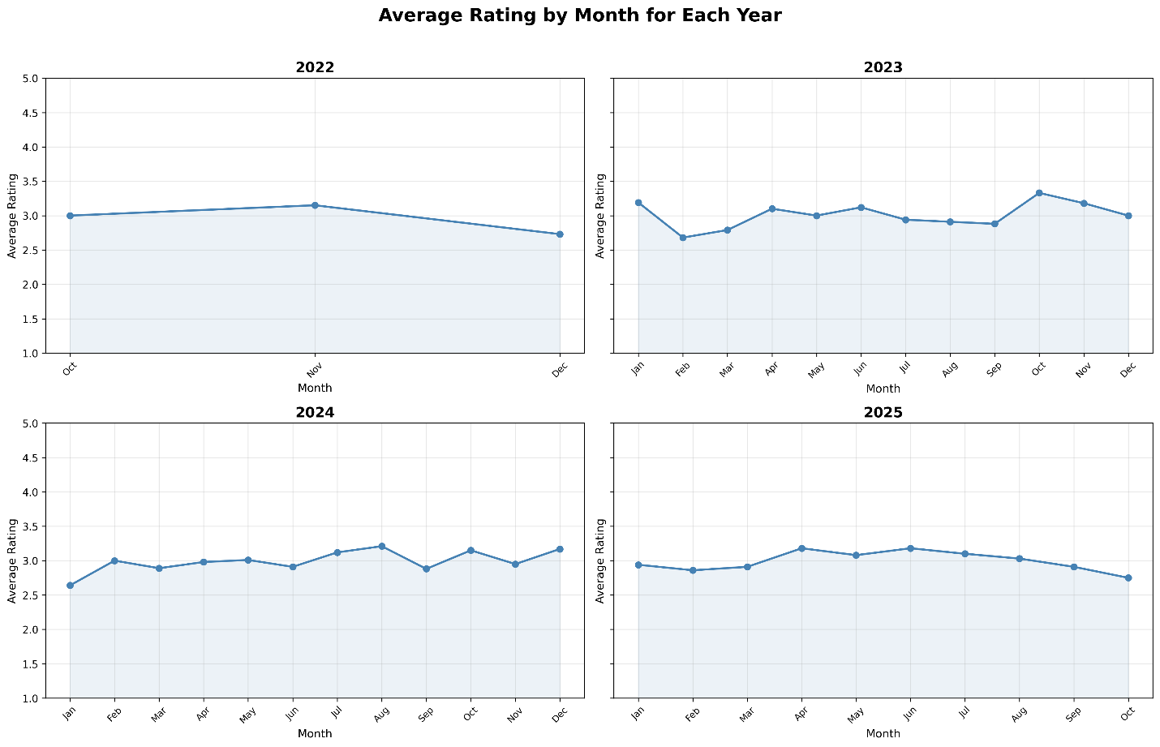

Key observation: Ratings remain flat between 2.7 and 3.3 across all months and years, indicating no seasonal patterns or year-over-year improvement.

4.2 Monthly Review Activity by Year (Bar Chart)
This grouped bar chart displays the number of reviews submitted each month, broken down by year. Pastel colors differentiate each year for easy comparison.
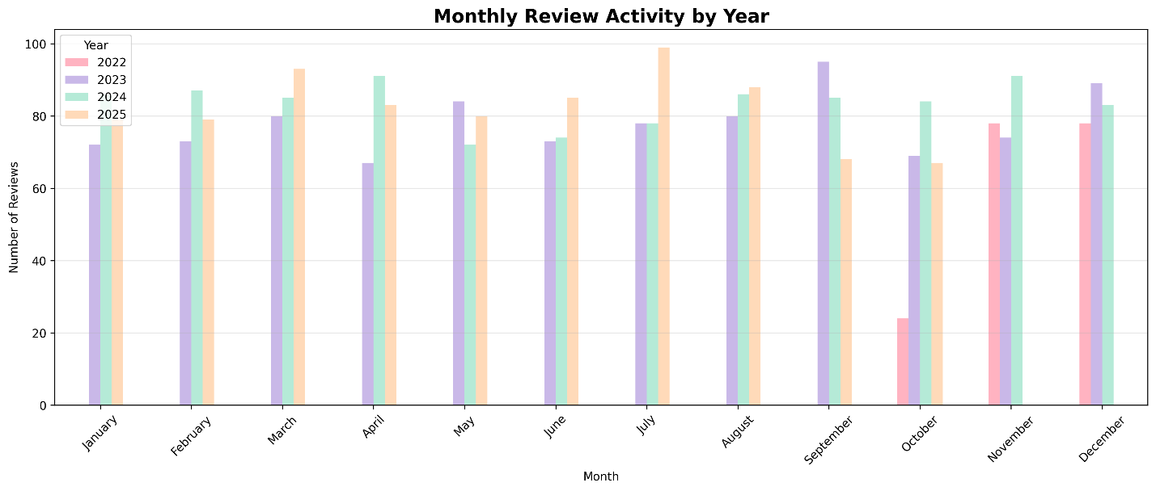
Key observation: July 2025 recorded the highest single-month activity with 99 reviews, suggesting a mid-year engagement peak.

4.3 Distribution of Reviews Across Products (Bar Chart)
This chart illustrates how reviews are distributed across products, revealing the concentration of single-review products.
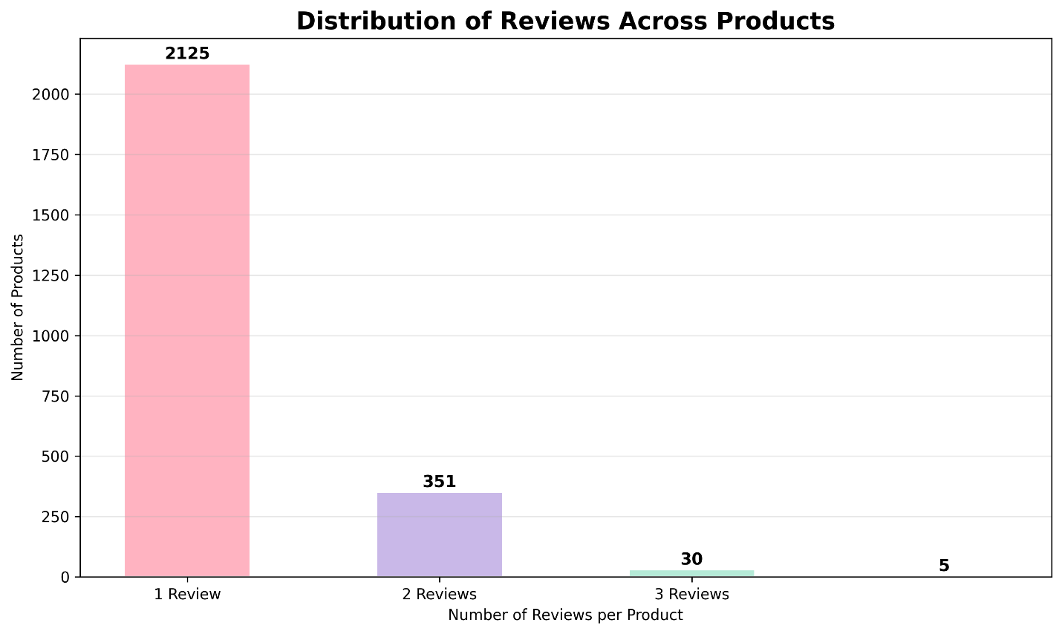

Key observation: 84.6% of products have only one review, making individual product ratings statistically unreliable for decision-making.

5. Key Insights & Conclusions

Insight 1 — Ratings Are Consistently Neutral Across All Years
Average ratings remained between 2.95 and 3.00 across all four years with no meaningful upward or downward trend. This suggests customer satisfaction has been stagnant and unchanged over the three-year period.

Insight 2 — 2024 Was the Most Active Review Year
2024 recorded 1,006 reviews — the highest annual volume in the dataset. Combined with July 2025 peaking at 99 reviews in a single month, this points to growing user engagement that may be worth investigating and capitalizing on.

Insight 3 — Most Products Are Under-Reviewed
84.6% of products (2,125 out of 2,511 unique products) have only a single review. This severely limits the reliability of product-level ratings and makes it difficult to draw meaningful conclusions about individual product performance. Encouraging more reviews per product should be a priority.

6. Limitations
- Review_Text was synthetically generated and contained no real sentiment, preventing text-based analysis.
- 617 missing ratings (20.8%) required imputation, introducing a slight bias toward rating 3.0.
- 2022 and 2025 are partial years, making year-over-year volume comparisons imprecise.
- 84.6% of products have only one review, making product-level averages statistically unreliable.

7. Recommendations
- Encourage customers to leave reviews — especially for products with only one review — to improve statistical reliability.
- Investigate why ratings have remained flat at ~3.0 for three years and identify opportunities to improve product quality or customer satisfaction.
- Leverage the mid-year engagement peak (July) for targeted marketing campaigns.
- Consider implementing a verified review incentive program to increase review volume and quality.

8. Cleaned Dataset
Cleaned_DataSet.csv

End of Report — Prepared by Sama Qanawi for Radwa Khaled

