Address and reduce pollution fouling our air, water, and soil
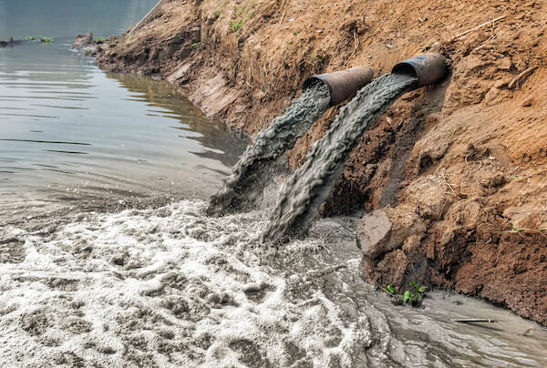
Wastewater, whether from industrial, agricultural, or domestic sources, is a major environmental concern that affects water, soil, and air quality. It contains pollutants such as heavy metals, chemicals, pathogens, and organic waste, which, if not properly treated, can harm ecosystems and public health. Effective wastewater treatment ensures that contaminants are removed before the water is released back into the environment, preventing pollution and supporting sustainable water use.
Fig(2): Industrial waste water
https://www.google.com/url?sa=i&url=https%3A%2F%2Fwww.aquaread.com%2Fblog%2Fimpacts-of-industrial-waste%2F&psig=AOvVaw2r36UuptuW-KGmHcmwQDGF&ust=1739742224394000&source=images&cd=vfe&opi=89978449&ved=0CBYQjRxqFwoTCNCsn_7SxosDFQAAAAAdAAAAABAE

Importance:
Proper wastewater treatment is essential for maintaining clean and safe water resources. Untreated wastewater can spread diseases, degrade soil fertility, and disrupt aquatic ecosystems by causing oxygen depletion and harmful algal blooms. Clean water is a fundamental necessity for drinking, agriculture, and industry, making wastewater management crucial for human well-being and economic growth. By treating wastewater, we can also recover valuable resources such as clean water, energy, and nutrients that can be reused in various sectors.

Amplitude:
Globally, billions of liters of wastewater are generated every day, with a significant portion being discharged into the environment without adequate treatment. In developing regions, poor sanitation infrastructure and lack of wastewater treatment facilities exacerbate the issue, leading to widespread waterborne diseases and environmental degradation. Industrial wastewater adds to the problem by introducing toxic substances like lead, mercury, and oil into water bodies, while agricultural runoff contributes excessive fertilizers and pesticides, contaminating groundwater and rivers. The pollution of freshwater sources not only threatens biodiversity but also increases water scarcity, making clean water less accessible to millions of people worldwide.
Solutions
To reduce problems of wastewater pollution, Innovative approaches include:
- Advanced Treatment: Removing contaminants using filtration, chemical neutralization, and biological treatment.
- Strict Regulations: Enforcing laws requiring industries to treat wastewater before discharge.
- Recycling & Reuse: Promoting greywater reuse for irrigation and industrial processes.
- Eco-Friendly Agriculture: Reducing chemical fertilizers and using natural filtration methods.
- Improved Infrastructure: Expanding sewage treatment plants and upgrading drainage systems.
- Public Awareness: Educating communities on water conservation and prospering waste disposal.
- Nature-Based Solutions: Using wetlands and green infrastructure to filter wastewater naturally.

Manage and increase the sources of clean water
Egypt faces a growing water crisis due to population growth, climate change, and limited freshwater resources. The Nile River, the country’s primary water source, is under pressure from pollution and overuse. To ensure a sustainable water supply, Egypt must adopt innovative strategies to manage and expand its clean water sources. One of the most effective ways to achieve this is through wastewater treatment and reuse, which can significantly increase the availability of clean water for agriculture, industry, and domestic use.

Importance
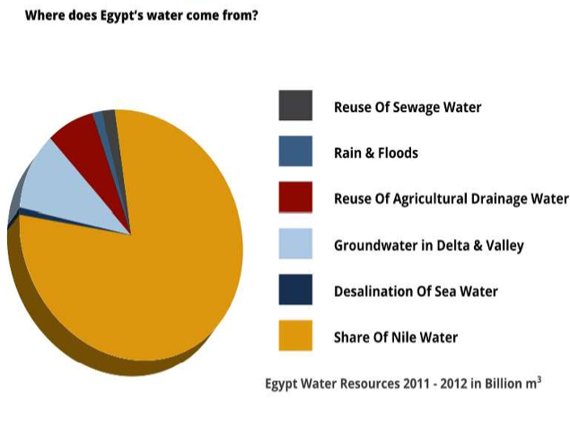
Access to clean water is essential for public health, food security, and economic development. Water scarcity in Egypt threatens agricultural production, increases desertification, and puts stress on urban water supplies. Without effective management, the country risks facing severe water shortages that could impact millions of people. Treating and reusing wastewater provides a reliable alternative source of water, reducing dependence on the Nile and conserving freshwater for drinking and essential needs.
Fig(3): Water quality and health in Egypt
https://www.google.com/url?sa=i&url=https%3A%2F%2Fcairoclimatetalks.net%2Fwp-content%2Fuploads%2F2021%2F07%2FWater-quality-and-health-in-Egypt-Dr.-Amal.pdf&psig=AOvVaw0mT-vvK2IE58R4PyVkYw-z&ust=1739744619807000&source=images&cd=vfe&opi=89978449&ved=0CBYQjRxqFwoTCJCm6PzbxosDFQAAAAAdAAAAABAS

Amplitude
Egypt receives limited annual rainfall, making it highly dependent on the Nile, which is affected by pollution, upstream water usage, and climate change. Rapid urbanization and industrial expansion have further increased water demand, leading to over-extraction of groundwater and depletion of existing sources. Additionally, inefficient irrigation practices waste large amounts of water in agriculture, which consumes over 80% of Egypt’s freshwater supply. With rising population growth, the gap between water demand and supply is widening, making urgent action necessary.

Solutions
- Wastewater Treatment & Reuse: Expand treatment plants and use purified wastewater for irrigation.
- Seawater Desalination: Build cost-effective desalination plants, especially solar-powered ones.
- Efficient Irrigation: Promote drip irrigation to reduce water waste in farming.
- Pollution Control: Enforce laws to prevent industrial and agricultural pollution.
- Smart Water Management: Use AI to monitor and optimize water distribution.
These measures can help Egypt secure more clean water for the future.

