Daily Portfolio Digest
Automated Market Briefing Pipeline — n8n · JavaScript · Finnhub API · Discord
A self-hosted automation that delivers a formatted daily brief on my holdings and watchlist to Discord — with zero manual steps and zero subscription costs.
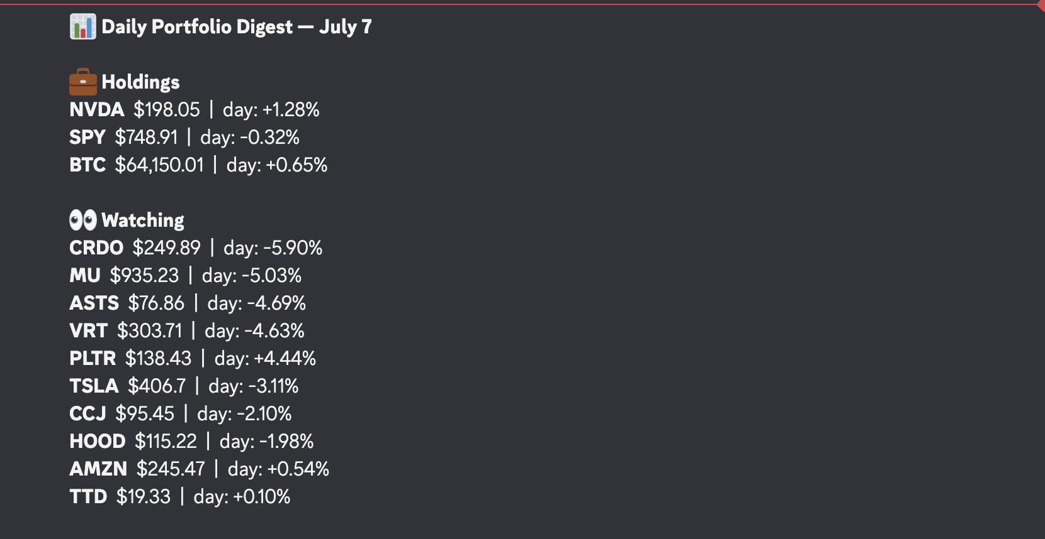
The finished digest, delivered to Discord every day at 5pm.

The Problem
I was checking Robinhood constantly across scattered positions with no consolidated view. I wanted one automated daily message that showed how my holdings (NVDA, SPY, BTC) and a broader watchlist moved — sorted so the biggest story always comes first — delivered to my phone at market close.
Off-the-shelf portfolio trackers either cost money, require linking brokerage credentials, or bury the signal in an app I'd have to open anyway. So I built the pipeline myself.

What It Does
Every day at 5:00 PM, the workflow:
- Reads a configurable list of 13 tickers (stocks + crypto)
- Pulls live quotes from the Finnhub REST API
- Computes day-over-day and week-over-week changes against its own accumulated price history
- Formats a digest — holdings separated from watchlist, watchlist sorted by magnitude of move
- Delivers it to a private Discord channel via webhook
- Saves today's prices as a dated snapshot for future comparisons
The result: biggest mover on top, my actual money clearly separated from names I'm just tracking, readable in ten seconds.

Architecture
Schedule Trigger (daily 5pm)
│
Ticker List ──── 13 items, one per symbol
│
Finnhub API ──── GET /quote, once per ticker
│
Label Quotes ─── re-attach symbols to raw price data
│
Compare ──────── read dated snapshots from disk,
│ compute Δday / Δweek, write today's snapshot
│
Format Digest ── holdings/watchlist split, magnitude sort,
│ collapse 13 items → 1 message
│
Discord Webhook ─ POST formatted message
In one sentence: a small ETL pipeline — extract from a market API, transform against persisted state, load to a messaging channel.
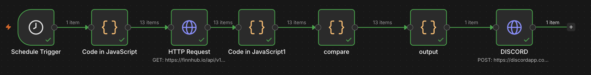
The live n8n canvas — item counts on each connection show the fan-out (13 tickers) and fan-in (1 message) pattern in action.

Design Decisions Worth Explaining
Self-maintained price history. Historical price data is where market APIs start charging. Instead of paying, the pipeline persists a dated JSON snapshot (snapshot-2026-07-07.json) to local disk on every run and computes changes against its own memory. Lookback tolerance — checking 1–3 days back for “yesterday” and 6–10 days back for “last week” — makes the system self-healing across weekends and missed runs. The workflow has state, which is what separates a pipeline from a script.
One pipeline for stocks and crypto. Finnhub serves equities by plain symbol (NVDA) and crypto by exchange-prefixed symbol (BINANCE:BTCUSDT). A display-name mapping in the format layer means BTC rides the exact same rails as everything else — no special-case branch.
Editorial logic in the format layer. The digest splits holdings from watchlist and sorts the watchlist by absolute daily move, so the biggest story surfaces first regardless of direction. On day one this immediately exposed a pattern: three AI-infrastructure names (CRDO, MU, VRT) down ~5% together — a sector-level move visible only because magnitude sorting put them side by side.
Fan-out / fan-in item handling. n8n executes downstream nodes once per item. The ticker node fans out to 13 items so the API call scales automatically; the format node collapses back to a single item so Discord receives one message instead of thirteen.

What Broke and How I Fixed It
Real builds break. These were mine:
- Safari secure-cookie block — n8n's local editor refused to load in Safari. Fixed with the N8N_SECURE_COOKIE=false environment flag for localhost use.
- File-access restriction — n8n blocks workflows from writing to arbitrary disk locations by default. Fixed by creating a dedicated directory and whitelisting it via N8N_RESTRICT_FILE_ACCESS_TO.
- Sandboxed modules — Code nodes can't touch Node built-ins like fs by default. Enabled with NODE_FUNCTION_ALLOW_BUILTIN=fs.
- Node-reference fragility — a Code node referencing another node by name broke when auto-generated names didn't match. Fixed the reference and renamed nodes descriptively so it can't recur.
- The snapshot corruption bug (best one). The memory file was silently being overwritten with the formatted Discord message instead of price data — because the file-write node sat downstream of the format step. Every comparison came back n/a. Diagnosed by reading item counts on the canvas: the branch showed “1 item” where price data should have been “3 items.” Fixed by branching the file-write directly off the compare node, then later eliminating the extra nodes entirely by moving persistence into the compare logic. The lesson: in a data pipeline, where you tap the stream matters as much as what you do with it.
All environment flags are baked into a single shell alias (n8n-start) so the whole system launches with one command.

Stack
Piece | Choice | Why
Orchestration | n8n (self-hosted, local) | Free, visual debugging, per-item execution model
Market data | Finnhub free tier | 60 calls/min, stocks + crypto, key-in-URL simplicity
Persistence | Dated JSON files on disk | Free historical data via self-maintained state
Delivery | Discord webhook | No auth, no OAuth, instant mobile push
Logic | JavaScript (Code nodes) | Comparison math, formatting, file I/O
Total cost: $0/month. Total build time: roughly four hours including all debugging.

Running It
- Import workflow.json into n8n
- Get a free API key at finnhub.io and add it to the HTTP Request node
- Create a Discord webhook (Server Settings → Integrations → Webhooks) and paste the URL into the Discord node
- Create a snapshot directory and launch n8n with the environment flags below
- Edit the ticker array in the first Code node to your own watchlist
- Set the workflow to Active
N8N_SECURE_COOKIE=false \
N8N_RESTRICT_FILE_ACCESS_TO=/path/to/snapshot/dir \
NODE_FUNCTION_ALLOW_BUILTIN=fs \
npx n8n

Roadmap
- News synthesis layer — the digest shows that CRDO fell 5.9%, not why. Next version pulls the day's headlines per ticker from Finnhub's news endpoint and uses an LLM call to write a one-line explanation for each significant mover.
- Concentration alerts — flag when a single position drifts past a set share of tracked value.
- Earnings calendar warnings — surface upcoming report dates so nothing blindsides me.
- Always-on hosting — currently runs while my Mac is awake; migration to a small cloud instance or Raspberry Pi would remove that dependency.
Built July 2026. Not investment advice — this tool reports what happened; the thinking is still my job.

