Project Documentation: Road Signs Detection System

1. Summary
This project presents a Road Signs Detection System that integrates YOLOv8 for detecting road signs in street images and a custom CNN (based on ResNet) for classifying them into specific categories such as 'Stop', 'Left Turn', and 'Right Turn'. The system enhances directional sign recognition by addressing YOLO's limitations in distinguishing similar signs. The solution uses Python and PyTorch, incorporates preprocessing with data augmentation for YOLO and auto-cropping for RESNET, and applies evaluation metrics such as accuracy, precision, recall, F1-score, and mAP. The dataset includes 1,200 labeled images and achieves high accuracy using the integrated pipeline.

2. Introduction
The Road Signs Detection System aims to enhance autonomous driving and smart city infrastructure by accurately identifying road signs from images. The motivation stems from the need for real-time, reliable detection of traffic signs to ensure road safety and assist driver decision-making. Traditional object detection methods often struggle with visually similar signs, particularly directional ones.
This project builds on advancements in deep learning, particularly YOLO (You Only Look Once) for object detection and Convolutional Neural Networks (CNNs) for image classification. By combining these two models, we enhance both the localization and identification stages in the detection pipeline. The hybrid method significantly improves classification accuracy over using YOLO or CNN alone.

3. Dataset
The dataset used for training and validation comprises approximately 1,200 labeled images across three categories: Stop, Left Turn, and Right Turn signs. Images were sourced from public datasets and manual collection efforts.
During preprocessing, the following steps were applied:
- Grayscale conversion

Image resizing to 64×64 pixels

Normalization

Data Augmentation using the RoboFlow, applying techniques such as flipping, brightness adjustment, and rotation to increase data variability.

Additionally, YOLOv8 incorporates its own real-time augmentation during training, including mosaic augmentation, color jittering, and scaling, enhancing detection robustness.

Data split:

Training set: 80%

Validation set: 20%

Testing set: Independent and entirely new dataset (not derived from the 1,200 images)

The testing phase was performed on a completely separate dataset that was not used during training or validation. This independent test set allowed us to accurately evaluate the generalization ability of the models on previously unseen real-world images.

This setup ensured realistic performance evaluation and avoided overfitting to the original dataset.

4. Methodology

Initial Approach: YOLOv8 Detection: We initially start with YOLOv8 for end-to-end detection and classification of road signs with data augmentation manually and from yolo model. While YOLOv8 performed well in identifying ‘Stop’ signs, it consistently failed to differentiate between ‘Left Turn’ and ‘Right Turn’.

Problem Resolution Strategy: To solve this problem, we tried 2 attempts:

We first attempted to improve YOLO’s classification through traditional data augmentation using built-in YOLO augmentation settings. However, this did not lead to meaningful improvements in distinguishing left vs. right signs.

CNN-Based Classification on YOLO Crops (Effective):
We used YOLOv8 solely for detection, extracting bounding boxes for all detected signs. Since YOLO classified ‘Stop’ signs correctly, we preserved that output. However, for directional signs, we cropped the predicted bounding box images and passed them to a Convolutional Neural Network (ResNet based) for classification into ‘Left’ or ‘Right’.
The CNN was trained using these cropped images and significantly improved classification accuracy for directional signs.

Final Integrated System: In the final solution, YOLOv8 handles object localization, while CNN handles directional classification. So, we made two stages solution for this main problem. first stage will be YOLO predictions and second stage CNN classification, so these two models were integrated into a single pipeline that performs:
- Detection: YOLOv8 detects all road signs and provides bounding boxes.
- Cropping: Directional signs are cropped based on YOLO’s bounding boxes.
- Classification: Cropped signs are classified using the ResNet18-based CNN model.
- Inference: Combined predictions (YOLO for ‘Stop’, CNN for ‘Left/Right’) form the final output

CNN Architecture (ResNet18-based):
- Input: 224×224 RGB images
- Base Model: Pretrained ResNet18 from torchvision.models
- Architecture: Includes residual blocks, batch normalization, and ReLU activations
- Final Layer: Modified fully connected layer for 2-class output (Left/Right)
- Activation Functions: ReLU (intermediate), Softmax (implied at output)
- Optimizer: Adam (learning rate = 1e-4)
- Loss Function: CrossEntropyLoss
- Training: 50 epochs with early stopping and learning rate scheduling

Evaluation Criteria
- Accuracy
- Confusion Matrix
- Precision & Recall
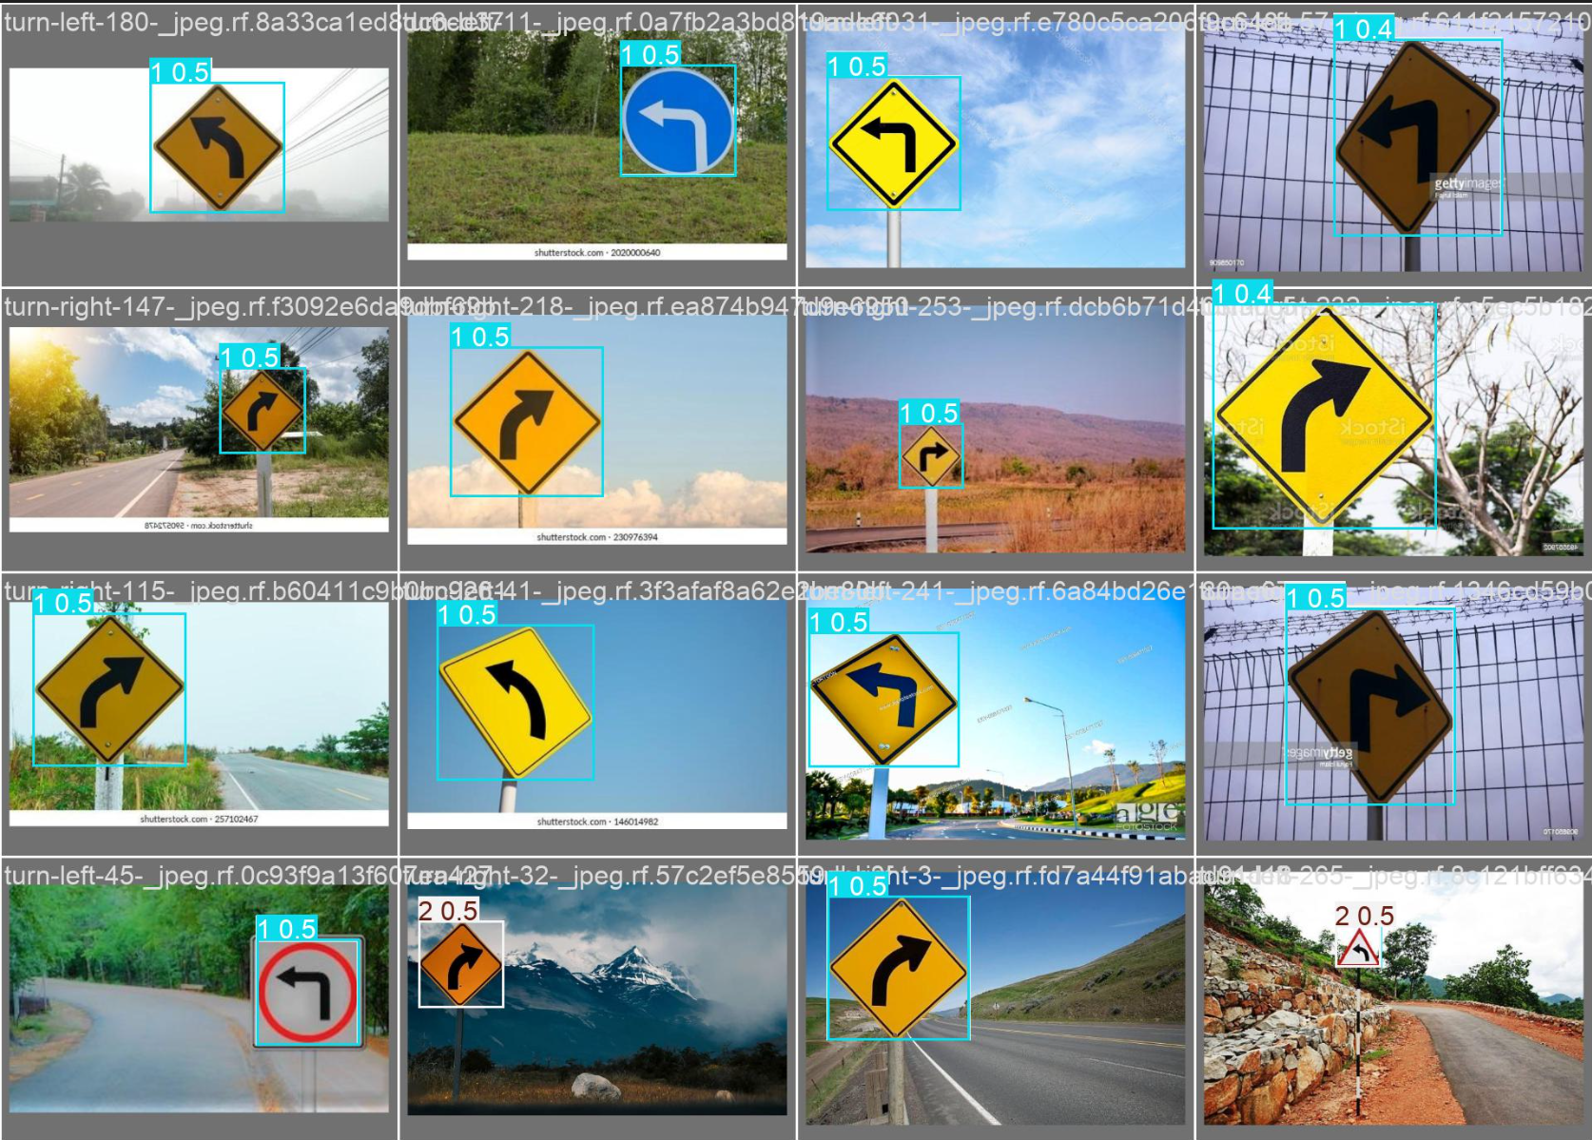
- mAP@50 and mAP@75 (for YOLO detection quality)
Detection before using CNN and only use YOLO:

5. Results
5.1 YOLOv8 Performance (Object Detection Only)
The YOLOv8 model achieved strong detection results, particularly for 'Stop' signs. The mean average precision (mAP) was approximately 98% at IoU threshold 0.5 and around 96% at 0.75. While YOLO was reliable in locating road signs within raw images, it struggled to accurately classify between 'Left Turn' and 'Right Turn' signs due to their visual similarity. These limitations highlighted the need for a secondary classification model
5.2 CNN Classifier Performance (On Cropped Signs)
The CNN classifier, trained on cropped train images of road signs predicted from YOLO, performed with approximately 96% accuracy. Precision and recall were both high, particularly for the left and right turn categories as they achieved approximately 96%. The model showed minor confusion between those two classes, but overall classification performance was strong.
5.3 Integrated YOLO + CNN Pipeline
When combining YOLO for object detection with CNN for classification, the overall system achieved around 99% accuracy, with precision and recall values near 99% and 99%, respectively. This evaluation was performed using a completely new and unseen test dataset, ensuring fair and unbiased assessment of generalization. This integration effectively addressed YOLO’s directional limitations by delegating the task of fine-grained classification to the CNN. As a result, the confusion between 'Left Turn' and 'Right Turn' signs was significantly reduced, and the robustness of the overall system improved. The hybrid pipeline proved to be more reliable and accurate than using either model individually, especially in scenarios requiring both precise localization and accurate classification of visually similar signs.
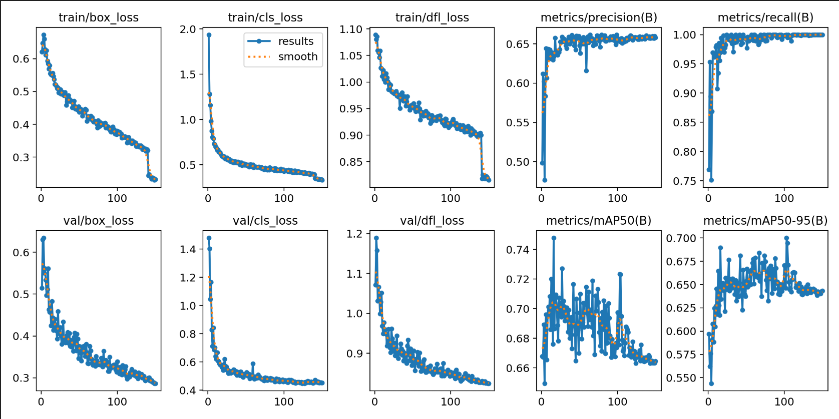
results for yolo model :

YOLO confusion matrix
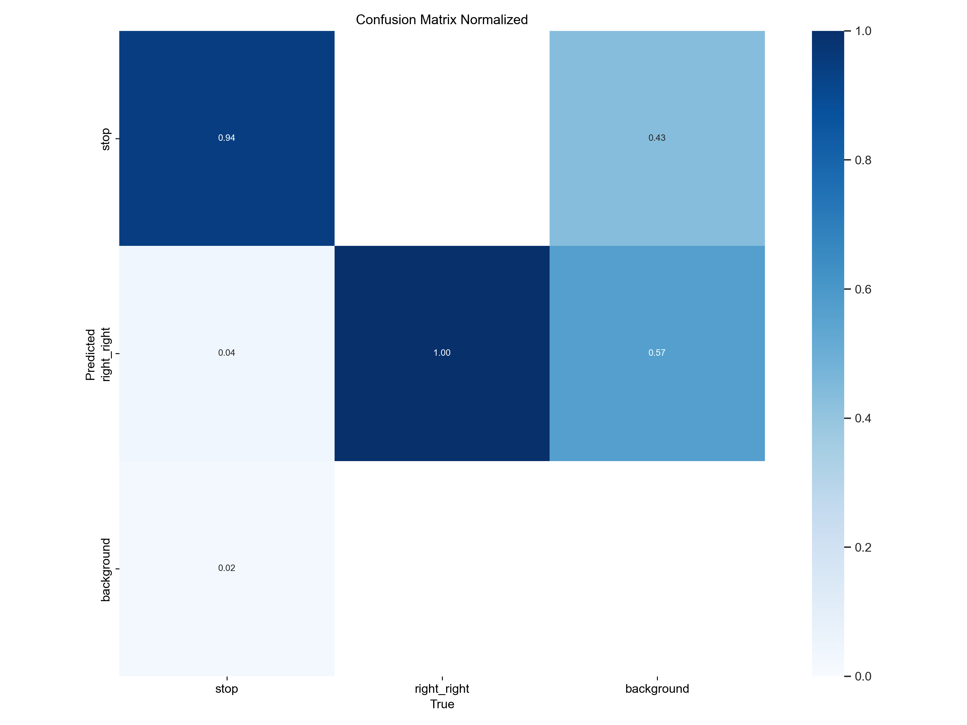

CNN confusion matrix Integrated confusion matrix
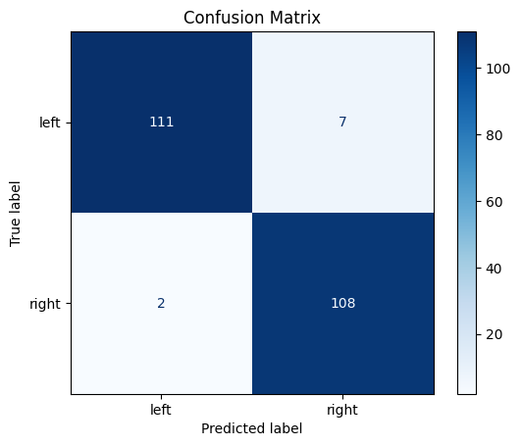 | 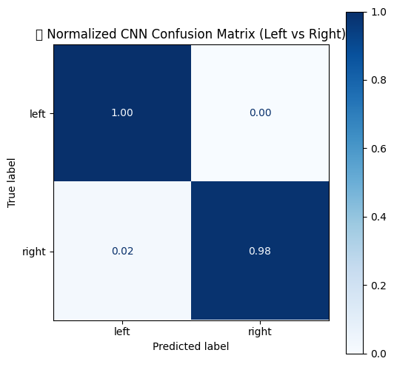

The confusion matrix analysis revealed that most misclassifications occurred between Left and Right Turn signs, highlighting their visual similarity. YOLO was highly effective in detecting 'Stop' signs. Combining YOLO’s localization and CNN’s classification improved overall robustness.

6. Conclusion
This project demonstrates a robust two-stage approach for road sign detection and classification. YOLOv8 efficiently detects road sign locations, while a custom CNN classifier accurately categorizes them, especially improving the detection of similar directional signs. This hybrid method addresses limitations in using YOLO alone for classification.

7. Developed
- By Sama Shalabi and Tala Dowiekat

8. References
- Roboflow : https://app.roboflow.com/

