Task 3

- I evaluated fairness by comparing the number of members and checkouts across different neighborhoods
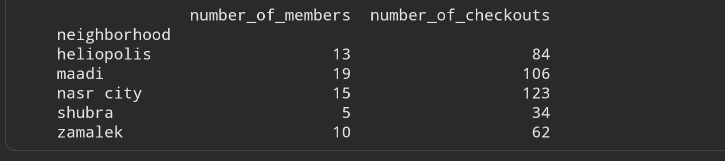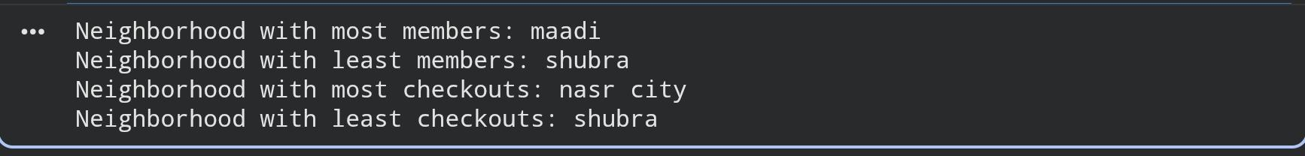
As we can see here shubra has the least members and the least checkouts, so this neighborhood is less represented neighborhood
I suggest making more activities in shubra more than any neighborhoods.

