CYBER SECURITY
PROJECT 3
Phishing Awareness Analysis & Triage Toolkit
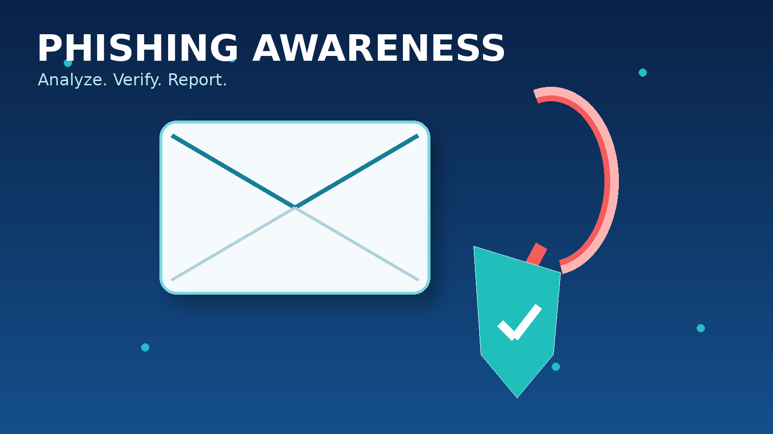
Student Name | Samaa Ahmad
Organization | DecodeLabs
Task | Task 3 - Phishing Awareness Analysis

Contents
1. Introduction and Project Objectives | 3
2. Phishing Review Framework and Red-Flag Checklist | 4
3. Email 1 - Microsoft Account Warning | 5
4. Email 2 - CEO Payment Request | 6
5. Email 3 - Parcel Delivery Payment | 7
6. Email 4 - HR Policy Attachment | 8
7. Email 5 - Zoom Meeting Invitation | 9
8. Email 6 - HBL Account Alert | 10
9. Email 7 - Q3 Project Update | 11
10. Phishing Triage Decision Tree | 12
11. Conclusion | 13
Training Note
The seven email screenshots in this report are simulated examples prepared for phishing-awareness analysis. No real malicious links are intended to be used or opened.

1. Introduction and Project Objectives
Phishing is a social-engineering technique in which an attacker pretends to be a trusted person, brand, department, or service in order to influence a user into clicking a link, opening an attachment, sharing information, or making a payment. This project focuses on threat identification rather than coding.
The purpose of this report is to analyze sample emails, identify suspicious links or keywords, list the red flags, explain why a message is safe or unsafe, and classify the final outcome as Safe, Suspicious, or Malicious.

Project requirements addressed
- Identify suspicious links, domains, wording, and keywords.
- List the red flags found in each email or message.
- Explain why each message is safe, suspicious, or unsafe.
- Apply header and URL checks, including sender-domain review.
- Build a simple triage process with clear actions: Close, Warn/Verify, or Block & Escalate.

Key terms used in this report
SDM - Sender-Domain Mismatch | The visible sender/brand does not match the actual sending domain. Example: a Microsoft-branded email sent from an unrelated domain.
BIB - Browser-in-the-Browser | A fake login popup that imitates a real browser authentication window. A normal button or link alone is not a BIB attack.
Urgency / Fear Trigger | Wording that pressures the user to act quickly, such as “within 24 hours,” “immediately,” or “your account will be suspended.”
Dangerous Attachment | An unexpected or executable file, such as an .exe attachment, that may contain malicious code.
Lookalike Domain | A domain designed to look similar to a trusted brand or service in order to deceive the user.

2. Phishing Review Framework and Red-Flag Checklist
Each email was reviewed using a consistent triage checklist. The objective is not to assume that every unusual message is phishing, but to identify evidence and then make a clear decision.
Check | What to inspect | Typical red flag
Sender & domain | Display name, full email address, domain | Brand/department name does not match the actual sending domain.
Subject & wording | Urgency, fear, secrecy, authority | “Act now,” “within 24 hours,” “do not discuss,” “account suspended.”
Links & buttons | Displayed URL and destination/domain | Lookalike domain, unfamiliar login/payment URL, shortened or misleading link.
Sensitive action | Payment, password, OTP, MFA, personal data | Unexpected request for money or credentials.
Attachments | File type, name, whether expected | Executable or unusual attachment such as .exe.
Context | Was the message expected? Does the request make sense? | Unexpected meeting, payment, account warning, or policy request.
Psychological trigger | Authority, urgency, curiosity, fear/greed | Message pressures the user to bypass normal verification.
Final action | Safe / Suspicious / Malicious | Close / Warn & Verify / Block & Escalate.
Golden rule: Pause - Verify - Report
PAUSE: Stop before clicking, replying, paying, scanning a QR code, or opening an unexpected attachment.
VERIFY: Confirm the request through a trusted second channel or known contact details.
REPORT: Report suspicious messages so the threat can be investigated and blocked.

Email 1 Analysis - Microsoft Account Warning
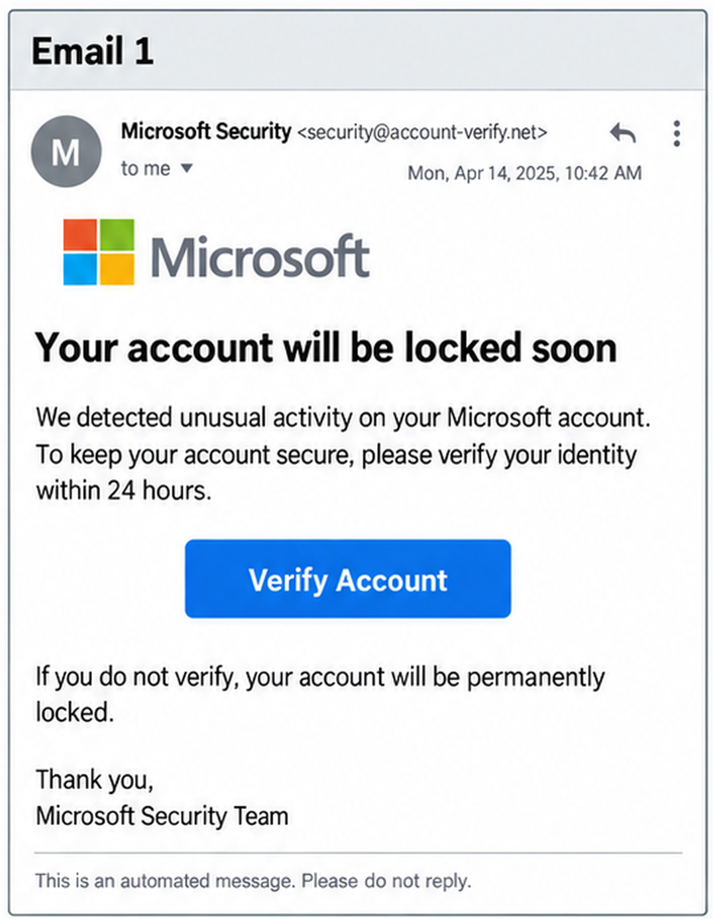
Sender / domain | Microsoft Security <security@account-verify.net>
Red flags identified | SDM; urgent/fear-based wording; suspicious “Verify Account” call-to-action.
Suspicious wording | “Your account will be locked soon”; “verify your identity within 24 hours”; “your account will be permanently locked.”
Additional red flags | The claimed Microsoft identity does not match the account-verify.net domain. The message pressures the user to act through a button instead of independently visiting the service.
Why unsafe | The combination of brand impersonation, mismatched domain, urgency, and account-lock threat is consistent with credential-phishing behavior.
Correction / note | The key issue is not just unusual wording; it is the combination of SDM + urgency + a verification button.

MALICIOUS | Recommended action: Do not click. Report the message, block/escalate the sender/domain, and verify the account through the official service separately.

Email 2 Analysis - CEO Payment Request
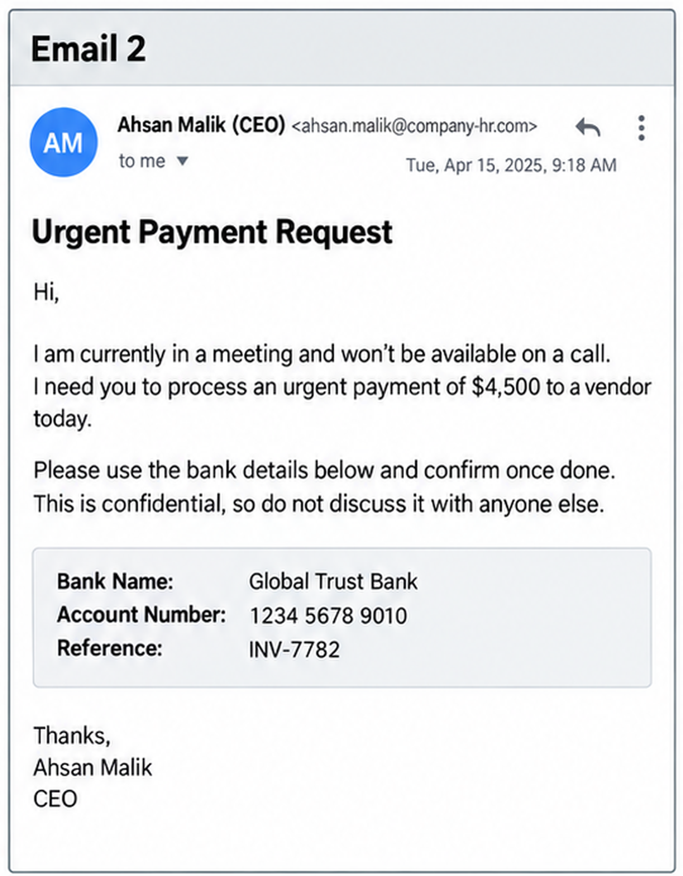
Sender / domain | Ahsan Malik (CEO) <ahsan.malik@company-hr.com>
Red flags identified | SDM/impersonation concern; authority trigger; urgency; secrecy; unusual payment request.
Suspicious wording | “I need you to process an urgent payment of $4,500”; “I won’t be available on a call”; “This is confidential, so do not discuss it with anyone else.”
Additional red flags | The sender attempts to prevent independent verification by saying he is unavailable. Bank-transfer instructions are provided directly in the email, and the request tries to bypass normal approval procedures.
Why unsafe | A high-value payment request combined with CEO authority, urgency, secrecy, and blocked verification is a classic business-email-compromise pattern.
Correction / note | “Do not discuss it with anyone else” is a strong red flag because it discourages the user from verifying the request with colleagues or finance staff.

MALICIOUS | Recommended action: Do not transfer funds. Verify with the executive using a known phone number or internal channel, then report and escalate the email.

Email 3 Analysis - Parcel Delivery Payment
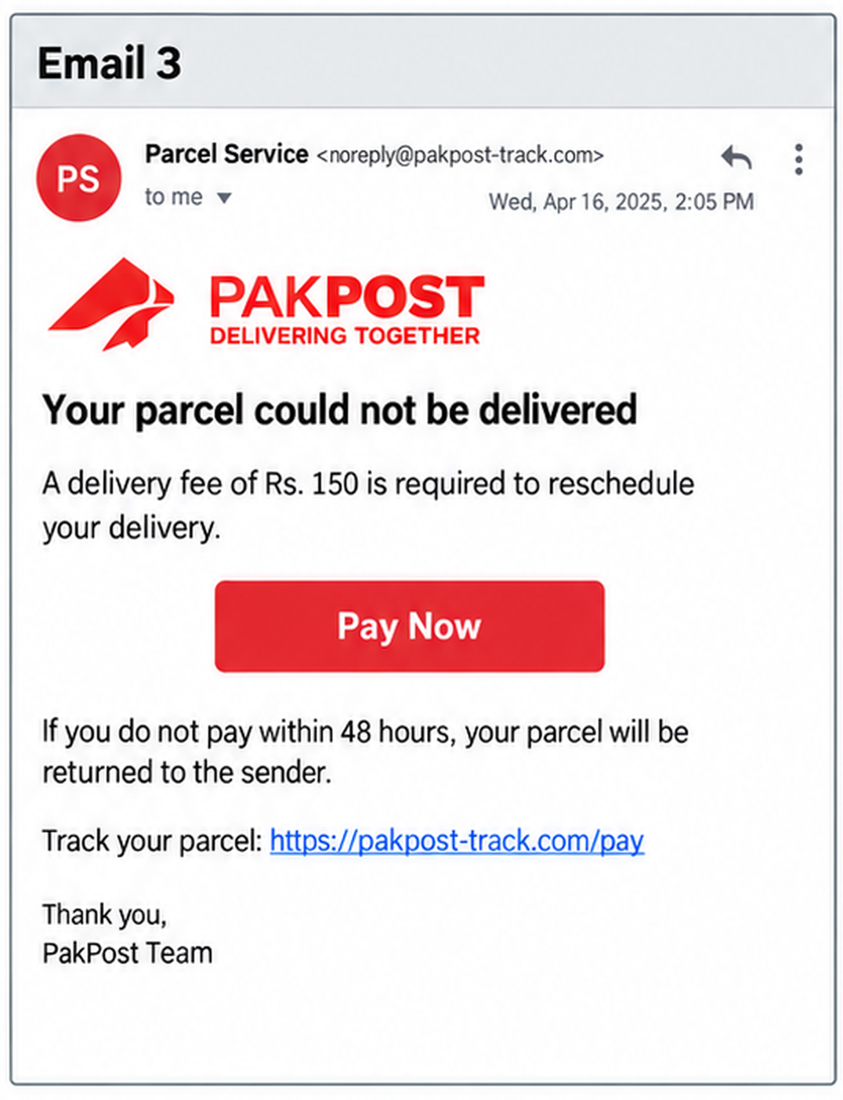
Sender / domain | Parcel Service <noreply@pakpost-track.com>
Red flags identified | SDM/lookalike-domain concern; unexpected payment; urgency/fear; suspicious payment link.
Suspicious wording | “Your parcel could not be delivered”; “A delivery fee of Rs. 150 is required”; “If you do not pay within 48 hours, your parcel will be returned.”
Link concern | https://pakpost-track.com/pay - the domain is presented as a brand-tracking site and should not be trusted without independent verification.
Why unsafe | The message uses a small payment and delivery threat to push the user toward a payment link. The sender/domain does not clearly establish that the message is from the real postal service.
Correction / note | BIB is NOT visible here. A Browser-in-the-Browser attack would require a fake browser/login popup. This sample shows a suspicious payment link, not BIB.

MALICIOUS | Recommended action: Do not use the payment link. Verify any delivery through the courier’s independently accessed official website or app, then report the email.

Email 4 Analysis - HR Policy Attachment
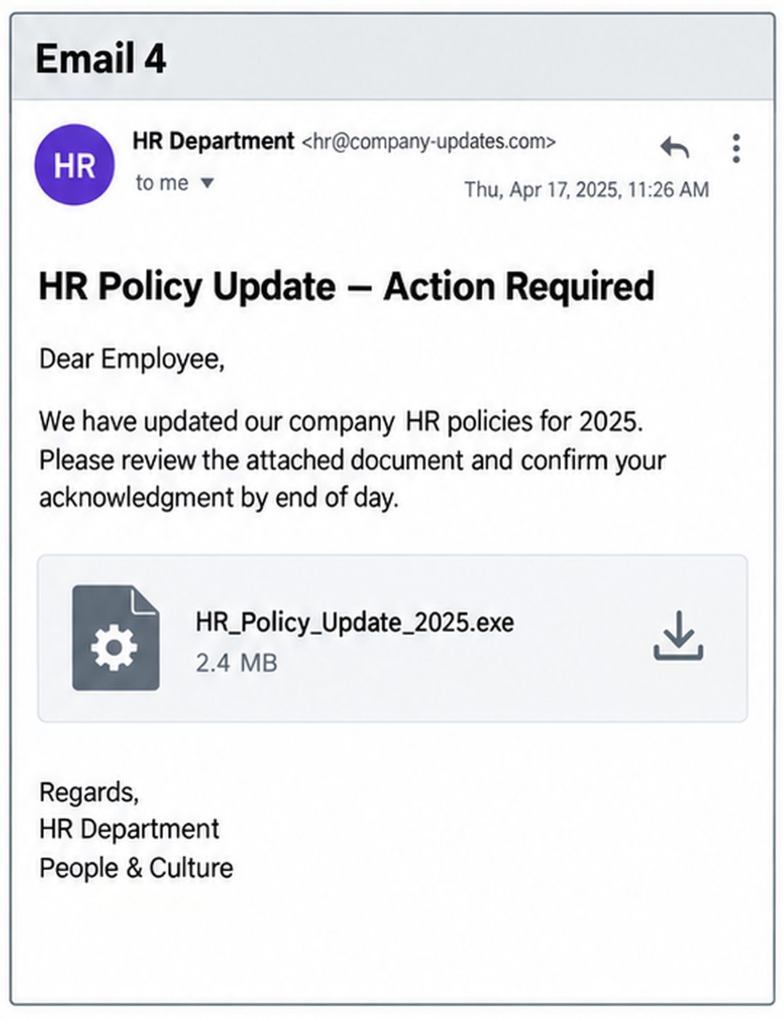
Sender / domain | HR Department <hr@company-updates.com>
Red flags identified | SDM/internal impersonation concern; dangerous attachment; deadline pressure; generic greeting.
Suspicious wording | “HR Policy Update - Action Required”; “confirm your acknowledgment by end of day.”
Attachment | HR_Policy_Update_2025.exe - an executable file presented as an HR policy document.
Additional red flags | A legitimate policy update would normally be expected as a document or portal notice, not an unexpected executable. “Dear Employee” is generic and the sender domain looks external to an internal HR context.
Why unsafe | The .exe attachment creates direct malware risk, while the urgency and HR impersonation encourage the user to open it quickly.

MALICIOUS | Recommended action: Do not download or run the attachment. Report the message, quarantine/block it, and confirm any HR update through the normal internal HR channel.

Email 5 Analysis - Zoom Meeting Invitation
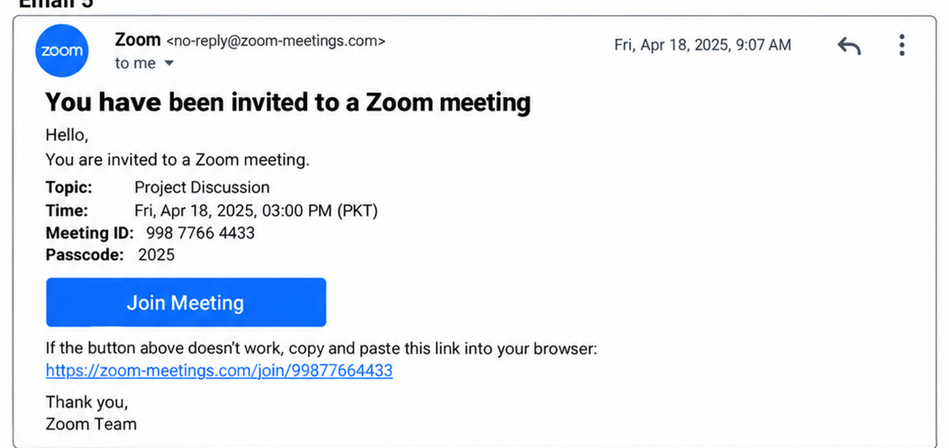
Sender / domain | Zoom <no-reply@zoom-meetings.com>
Red flags identified | Lookalike-domain concern; unexpected meeting invitation; suspicious join link.
Suspicious link | https://zoom-meetings.com/join/99877664433 - the email and link both use a domain designed to look related to Zoom.
Context concern | The message gives a meeting ID and passcode, but there is no independent confirmation of who scheduled the meeting or why the user was invited.
Why suspicious | The branding looks familiar, but the sender/link domain should be verified before clicking. A meeting invitation can be used to lead users to a fake login page.
Correction / note | BIB is NOT proven by the screenshot. A normal “Join Meeting” button is not BIB. BIB would only be confirmed if clicking opened a fake browser-authentication popup.

SUSPICIOUS | Recommended action: Do not click the link until the organizer and meeting are verified through a trusted channel. If verification fails, report and block the message.

Email 6 Analysis - HBL Account Alert
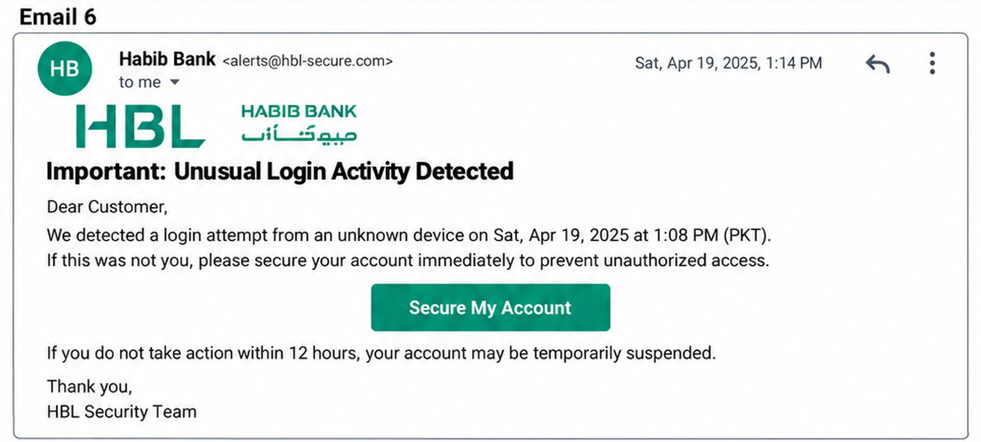
Sender / domain | Habib Bank <alerts@hbl-secure.com>
Red flags identified | SDM/lookalike-domain concern; fear and urgency; account-security lure; action button.
Suspicious wording | “Important: Unusual Login Activity Detected”; “secure your account immediately”; “If you do not take action within 12 hours, your account may be temporarily suspended.”
Additional red flags | Generic “Dear Customer” greeting and a “Secure My Account” button attempt to move the user into an urgent security action without independent verification.
Why unsafe | The message combines bank impersonation, a security scare, a deadline, and a clickable action. These elements are intended to make the user react before checking the sender and domain.
Verification principle | Banking alerts should be verified by independently opening the bank’s official app/site or using a known number, not by using the email button.

MALICIOUS | Recommended action: Do not click the button. Independently check the account through the official banking app/site and report the phishing message.

Email 7 Analysis - Q3 Project Update
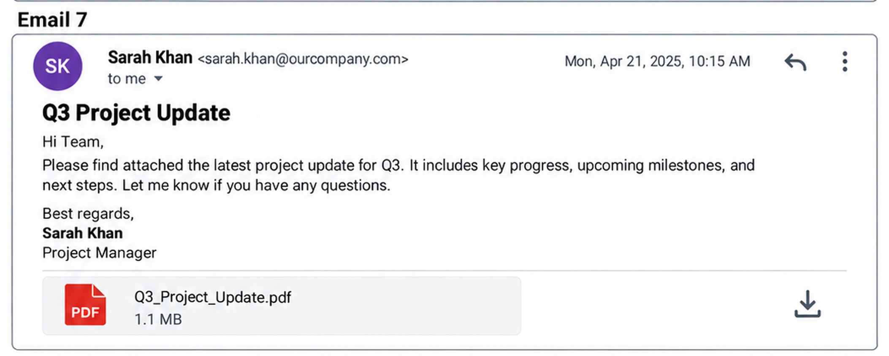
Sender / domain | Sarah Khan <sarah.khan@ourcompany.com>
Initial concern reviewed | Attachment and sender/domain were checked, but no clear mismatch or malicious behavior is visible in the sample context.
Wording | “Please find attached the latest project update for Q3... Let me know if you have any questions.” The language is routine and contains no urgency, fear, secrecy, or financial request.
Attachment | Q3_Project_Update.pdf - the file type and filename match the stated purpose of the email.
Why safe | The sender uses the expected organizational-style domain, the request is normal, there is no suspicious link, no demand for credentials/payment, and the attachment is consistent with the message.
Correction / note | An attachment by itself is NOT automatically a red flag. SDM is also not present if ourcompany.com is the expected company domain. The context and file type must be evaluated together.

SAFE / LEGITIMATE | Recommended action: If the sender and project context are expected, the email can be handled normally. If uncertain, verify the sender before opening any attachment.

10. Phishing Triage Decision Tree
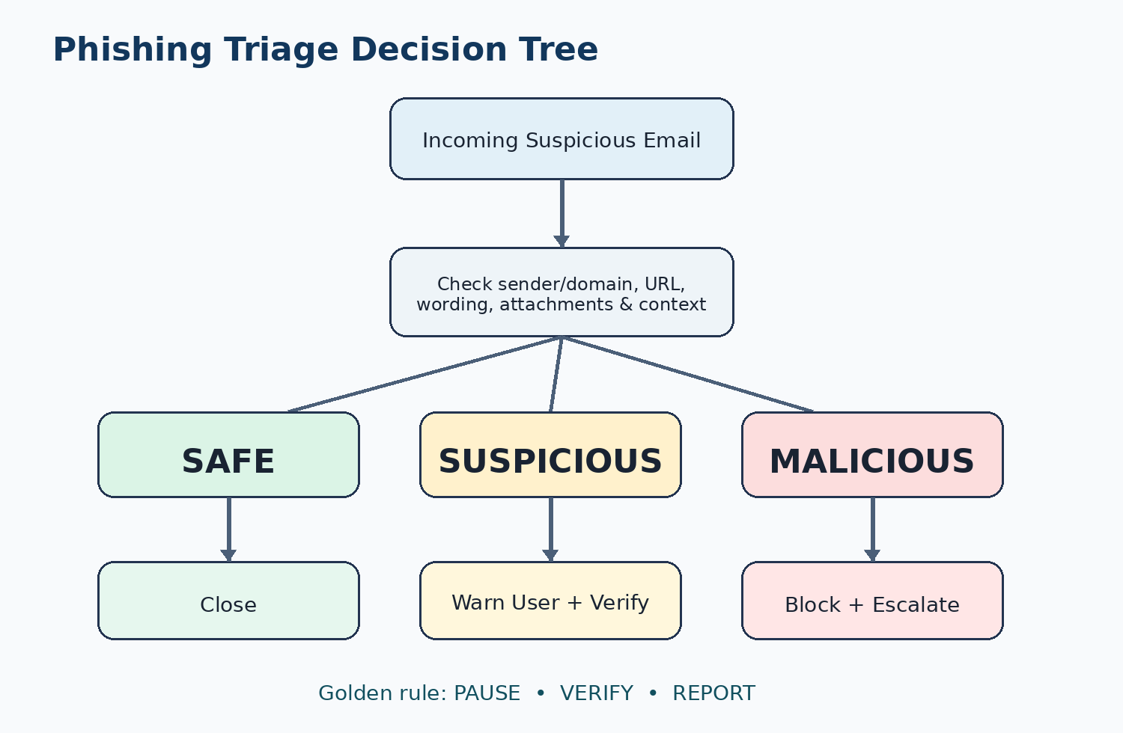

How to use the triage outcome
Outcome | Meaning | Action
Safe | No meaningful red flags after context and sender checks. | Close / proceed normally.
Suspicious | Some red flags exist, but malicious intent is not yet confirmed. | Warn the user and verify independently.
Malicious | Multiple strong indicators show phishing, impersonation, credential theft, malware, or payment fraud. | Block the sender/domain and escalate/report.
Final user response model
1. Pause before interacting with the message.
2. Verify the request through a separate trusted channel.
3. Report suspicious or malicious messages instead of simply deleting them.

11. Conclusion
This project demonstrates that phishing analysis is a combination of technical observation and security awareness. The strongest indicators in the reviewed samples were sender-domain mismatch, lookalike domains, urgency, fear, secrecy, authority impersonation, suspicious links, unexpected payment requests, and dangerous attachments.
The review also showed why context matters. Not every button is a Browser-in-the-Browser attack, and not every attachment is malicious. Email 7 was deliberately treated as legitimate because its sender, wording, context, and PDF attachment were consistent with a normal project update. Correct triage requires evidence rather than assumptions.
The most useful response is to Pause, Verify, and Report. If a message is safe, it can be closed or handled normally. If it is suspicious, the user should be warned and the request verified independently. If it is malicious, the sender/domain should be blocked and the incident escalated to the appropriate security team.

Final classification summary
Email | Classification | Primary reasons
1 - Microsoft | Malicious | SDM, urgency/fear, verification button
2 - CEO Payment | Malicious | Authority, urgency, secrecy, payment request
3 - Parcel Delivery | Malicious | Lookalike domain, payment lure, deadline
4 - HR Policy | Malicious | Dangerous .exe attachment, impersonation, pressure
5 - Zoom Invite | Suspicious | Lookalike domain, unverified meeting link
6 - HBL Alert | Malicious | Bank impersonation, fear/urgency, action button
7 - Q3 Update | Safe / Legitimate | Normal context, expected-style sender, matching PDF attachment

