Movie Discovery
1. Project Planning & Management
1.1 Project Proposal
Project Name: Movie Discovery Application
Overview: A feature-rich mobile app that enables users to discover, search, and track movies effortlessly. Users can create and manage watchlists and favorites, explore detailed movie information, and enjoy a personalized experience with dark mode, customizable fonts, and multi-language support (English and Arabic).
Objectives:
- Provide a user-friendly interface for browsing and searching movies.
- Allow users to manage personal movie collections (favorites, watchlist, watched).
- Integrate Firebase for authentication and user data storage.
- Implement dynamic themes, fonts, and language settings.
Scope:
- Mobile application using Kotlin and Jetpack Compose.
- Backend integration with Firebase Authentication and Firestore.
- Integration with external Movie API for fetching movie data.
- User account management (signup, login, logout, delete account).
- Movie details with fallback translations for missing data.
1.2 Project Plan
Week | Task
1 | Project Analysis
2 | Project setup, GitHub repo creation, static UI
3 | API integration with Retrofit
4
  Navigation & unit testing
5 | security improvements, UI polish, documentation

1.3 Milestones & Deliverables:
- Completed UI design and implemented app theme.
- Fully functional authentication module: login, signup, and email verification.
- Home screen displaying movie categories: popular, trending, upcoming, and top-rated.
- Profile screen with dark mode, logout, account deletion, and personal movie lists (watched, watchlist, favorites).
- Movie detail screen showing movie description, rating, and release date.
- Settings module with language selection and font management.
- Search functionality allowing users to find specific movies and browse by categories.
- Testing conducted, bugs identified and fixed.
- Final deployment on emulator and real devices.
1.4 Resource Allocation:
- Full-Stack Development: All team members are responsible for both frontend (UI implementation, Jetpack Compose screens, theming) and backend/integration (API calls, Retrofit, ViewModel state handling).
- Testing & QA: Shared responsibility among all members , writing and executing unit tests, validating features, and reporting/fixing bugs.
- Project Management: Team leader , responsible for coordinating tasks, monitoring progress, managing meetings, and ensuring deliverables.
1.5 Task Assignment & Roles
- Team Leader: Oversee project timeline, assign tasks, coordinate meetings, and ensure timely completion of deliverables.
- Full-Stack Developers: Implement all app screens (Home, Profile, Movie Details, Search, Categories), integrate APIs and backend logic, handle ViewModel states, and maintain UI/UX consistency.
- Shared Testing Responsibility: All team members contribute to testing, bug fixing, and feature validation.
1.6 Risk Assessment & Mitigation Plan
- Risk: API rate limits or downtime.
Mitigation: Use cached/fake data for testing; handle errors gracefully.

- Risk: Firebase authentication issues.
Mitigation: Thorough testing of sign-up, login, and email verification flows.

- Risk: Team delays in development.
Mitigation: Weekly meetings, milestone tracking, and clear task distribution.

- Risk: Multi-language support issues.
Mitigation: Test app in English and Arabic; fallback to English if translation missing.

1.7 KPIs (Key Performance Indicators)
- Screen Load Time Measurement
- To measure the screen load performance of the application, we recorded the time taken for each screen to fully load using log outputs from the ScreenLoad debug statements. Multiple measurements were taken for each screen to calculate an average load time.

- Most screens load within 1 second, meeting the expected performance targets. typical performance is under 500 ms.
- App Launch Time Measurement
- To measure the app launch performance, we recorded the time from the application start until the MainActivity was fully created using log outputs from the AppLaunch debug statements. Multiple launches were measured to calculate an average launch time.

- The average app launch time was approximately 1.9 seconds.
2.Suggested Improvements
- UI/UX Enhancements: Improve animations, transitions, and accessibility features for better user experience.
- Performance Optimization: Implement caching strategies for API data to reduce load time and network usage.
- Feature Expansion:
  - Add notifications for upcoming releases or favorite movies.
  - Integrate more detailed movie metadata (cast, trailers, ratings from multiple sources).
  - Implement offline mode for better usability without network connection.
- Security Enhancements: Strengthen authentication by adding multi-factor authentication (MFA).
- Testing Improvements: Increase test coverage, including edge cases for API errors and user settings changes.
3. Requirements Gathering
3.1 Stakeholder Analysis
- Primary Stakeholders:
  - Movie Enthusiasts: Users who want to discover, track, and manage movies.
- Stakeholder Needs:
  - Users need a smooth, intuitive interface to browse and search movies.
  - Users require personalized settings, including language, font, and dark mode.
  - System must ensure secure authentication and data privacy.
  - Stakeholders expect reliable and fast access to movie data with minimal downtime.

3.2 User Stories
User Story 1: As a user, I want to sign up and verify my email so that I can securely access my account.
  - User Story 2: As a user, I want to browse popular, trending, upcoming, and top-rated movies so that I can discover new content.
  - User Story 3: As a user, I want to search movies by title or genre so that I can find specific movies quickly.
  - User Story 4: As a user, I want to view a detailed movie page (including release date, description, and rating) so that I can decide if I want to watch it.
  - User Story 5: As a user, I want to add movies to my favorites, watchlist, or mark as watched so that I can organize my movie tracking.
  - User Story 6: As a user, I want to browse collections of movies based on specific, curated categories so that I can easily find specialized content.
  - User Story 7: As a user, I want to access and modify my app preferences (e.g., dark mode, font size, default language) so that I can tailor the application experience to my personal needs.
3.3 Use Cases

ID | Name
UC 1.1 | Successful New Account Registration
UC 1.2 | Existing User Login
UC 2.1 | Viewing Home Page Categories
UC 3.1 | Search by Movie Title
UC 4.1 | Accessing and Viewing Core Details
UC 5.1 | Adding Movie to Watchlist
UC 5.2 | Adding Movie to Favorites
UC 5.3 | Marking a Movie as Watched
UC 6.1 | Browse Curated Collections
UC 7.1 | Switching to Dark Mode
UC 7.2 | Changing App Language

3.4 Functional Requirements
1. User & Authentication
- FR 1.1: The system must implement user sign-up, login, and email verification using Firebase Authentication.
- FR 1.2: The system must manage user accounts, allowing login via verified email and password.
- FR 1.3: The system must provide a mechanism for secure password reset.

2. Movie Data & Browsing
- FR 2.1: The system must integrate with TMDB API for real-time movie information (titles, descriptions, ratings, etc.).
- FR 2.2: The main browsing screens must display dynamic movie lists for Popular, Trending, Upcoming, and Top-rated categories.
- FR 2.3: The application must provide a dedicated screen for Curated Collections (e.g., "Action" "Mystery") separate from standard browsing.
- FR 2.4: Movie lists (categories, search results) must implement pagination or infinite scrolling (lazy loading) to handle large datasets efficiently.
3. Search & Details
- FR 3.1: The system must provide search functionality by movie title.
- FR 3.2: The movie detail screen must display comprehensive data: description, release date, runtime, cast list, crew (director/writer), and official ratings.
4. Tracking & Personalization
- FR 4.1: The system must allow logged-in users to add movies to their Watchlist, mark them as Favorites, or mark them as Watched.
- FR 4.2: User tracking lists (Favorites, Watchlist, Watched) must be persisted and synchronized using Firebase Firestore.
- FR 4.3: The system must provide a settings screen to modify personalization settings including dark/light theme, default language, and font size/type.
- FR 4.4: The system must persist and recall all personalization settings across application sessions and device logins.
3.5 Non-functional Requirements
1.Performance
- NFR 1.1: Movie list screens must load with initial data within3 seconds on a standard 3G/4G mobile network.
- NFR 1.2: Search queries must return results within 1 second after the user stops typing (implementing debounce functionality).
2.Security & Reliability
- NFR 2.1: All user credentials and personal data must be handled securely.
3.Usability & Maintainability
- NFR 3.1: The application code must be structured using the Model-View-ViewModel (MVVM) architectural pattern to ensure separation of concerns and maintainability.
- NFR 3.2: The system must have unit test coverage for ViewModels/business logic classes to ensure reliability during development and future changes.

4. System Analysis & Design
4.1 Problem Statement & Objectives
The Movie Discovery application solves the core problem of fragmented movie discovery and inefficient personal tracking. Users lack a secure, unified platform to research, organize, and manage their film consumption. Our objective is to deliver a centralized, personalized, and multilingual solution by leveraging TMDB API integration for real-time data, utilizing Firebase for secure authentication and persistent user tracking (Favorites, Watchlist), and providing robust search and curated category browsing to ensure quick, relevant content discovery.No diagram here; purely descriptive text.
4.1.1 Use Case Diagram & Descriptions
Actors:
- Registered User: The primary actor who interacts with the core features of the application (browsing, searching, tracking).
- External API (TMDB): An external system providing the source movie data.
- Firebase Authentication/Firestore: An external system managing user access and persistent data storage.
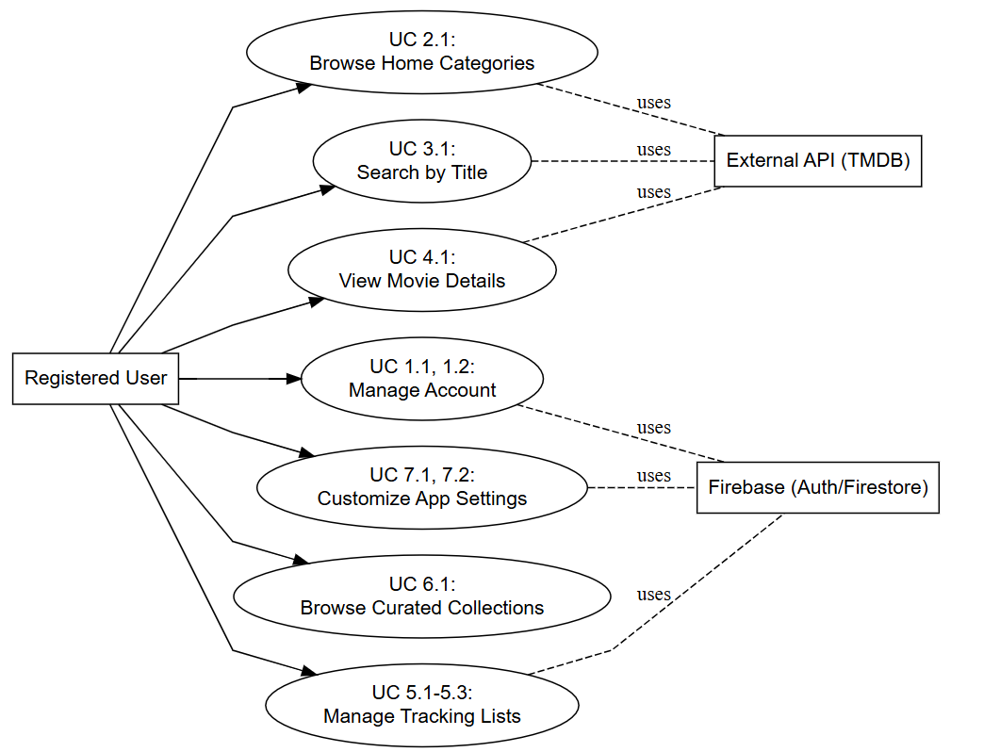

1. UC: Manage Account (UC 1.1 & 1.2)
Attribute | Description
Goal | Allow the Registered User to securely register, verify their email, and log in to the application.
Primary Actor | Registered User
Secondary Actor | Firebase (Auth)
Flow of Events | User enters credentials (sign-up or login). System validates credentials, performs email verification (for new accounts), and grants secure access to the application via Firebase Auth.
Success Condition | User is authenticated and securely logged into their profile.

2. UC: Browse Home Categories (UC 2.1)
Attribute | Description
Goal | Allow the Registered User to discover new content via standard, dynamic categories.
Primary Actor | Registered User
Secondary Actor | External API (TMDB)
Flow of Events | User lands on the Home screen. System requests and displays distinct sections for Popular, Trending, Upcoming, and Top-Rated movies from the TMDB API. User scrolls and interacts with these sections.
Success Condition | The main browsing screen is fully populated with categorized movie content.

3. UC: Search by Title (UC 3.1)
Attribute | Description
Goal | Allow the Registered User to quickly locate specific movies using their title.
Primary Actor | Registered User
Secondary Actor | External API (TMDB)
Flow of Events | User taps the search icon and begins typing a title. System sends the query to the TMDB API and displays real-time suggested results. User selects a movie to view its details.
Success Condition | Relevant movie suggestions are displayed, and the user can select a result.

4. UC: View Movie Details (UC 4.1)
Attribute | Description
Goal | Provide the Registered User with comprehensive data to make a decision about watching a movie.
Primary Actor | Registered User
Secondary Actor | External API (TMDB)
Flow of Events | User taps a movie poster. System loads the dedicated detail page, fetching the description, release date, and rating from the TMDB API. User reviews this information.
Success Condition | The movie's detail page is fully rendered with core information.

5. UC: Manage Tracking Lists (UC 5.1, 5.2, 5.3)
Attribute | Description
Goal | Allow the Registered User to organize their personal movie tracking status (Watchlist, Favorites, Watched).
Primary Actor | Registered User
Secondary Actor | Firebase (Firestore)
Flow of Events | User views a movie and taps the icon for Watchlist, Favorites, or Watched. System records the movie ID and the corresponding status change in Firebase Firestore to maintain persistent tracking.
Success Condition | The movie's status is updated and synchronized to the user's profile lists.

6. UC: Browse Curated Collections (UC 6.1)
Attribute | Description
Goal | Allow the Registered User to easily find movies grouped by specific, specialized themes or genres.
Primary Actor | Registered User
Secondary Actor | External API (TMDB)
Flow of Events | User navigates to the collections screen. System displays curated categories (e.g., "Action," "Comedy"). User taps a category, and the system displays a list of all movies belonging to that specific collection via the TMDB API.
Success Condition | A dedicated list of specialized movies for the selected category is displayed.

7. UC: Customize App Settings (UC 7.1 & 7.2)
Attribute | Description
Goal | Allow the Registered User to personalize the application's appearance and display settings.
Primary Actor | Registered User
Secondary Actor | Firebase (Firestore)
Flow of Events | User accesses the Settings screen and modifies a preference (e.g., toggles Dark Mode or selects a new Default Language). System saves the new preference to Firebase Firestore and immediately applies the change to the UI.
Success Condition | The application's interface is updated according to the user's saved preferences.

4.1.2 Software Architecture
The Movie Discovery app uses a Layered Architecture based on the Model-View-ViewModel (MVVM) design pattern for high testability and separation of concerns.
The system operates in two parts:
- Mobile Client (MVVM): The application handles the UI (View), manages all business logic and state (ViewModel), and directly interacts with the external services.
- External Data Providers: These services supply all necessary resources:
  - TMDB API: Provides real-time movie data.
  - Firebase Authentication: Provides user security and access.
  - Firebase Firestore: Provides persistent storage for user tracking and settings.

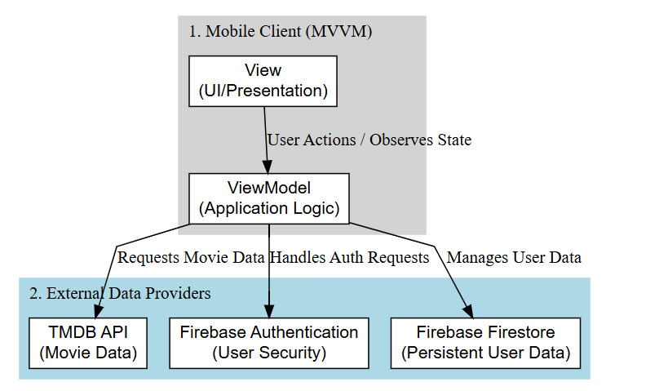
4.1.3 Database Design & Data Modeling
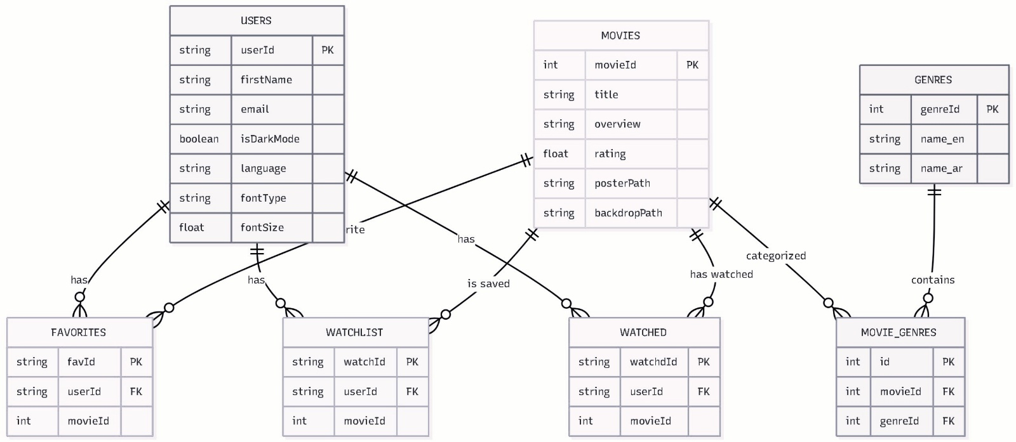
Collection Path | Document ID | Fields | Data Type
/users | {userId} | firstName, lastName, email,password , isDarkMode, language, fontType, fontSize | String, String, String, String, Boolean, String, String, Float
/users/{userId}/watched | Auto-ID | movieId (FK), title | Int, String
/users/{userId}/favorites | Auto-ID | movieId (FK), title | Int, String
/users/{userId}/watchlist | Auto-ID | movieId (FK), title | Int, String

4.1.4 Data Flow & System Behavior
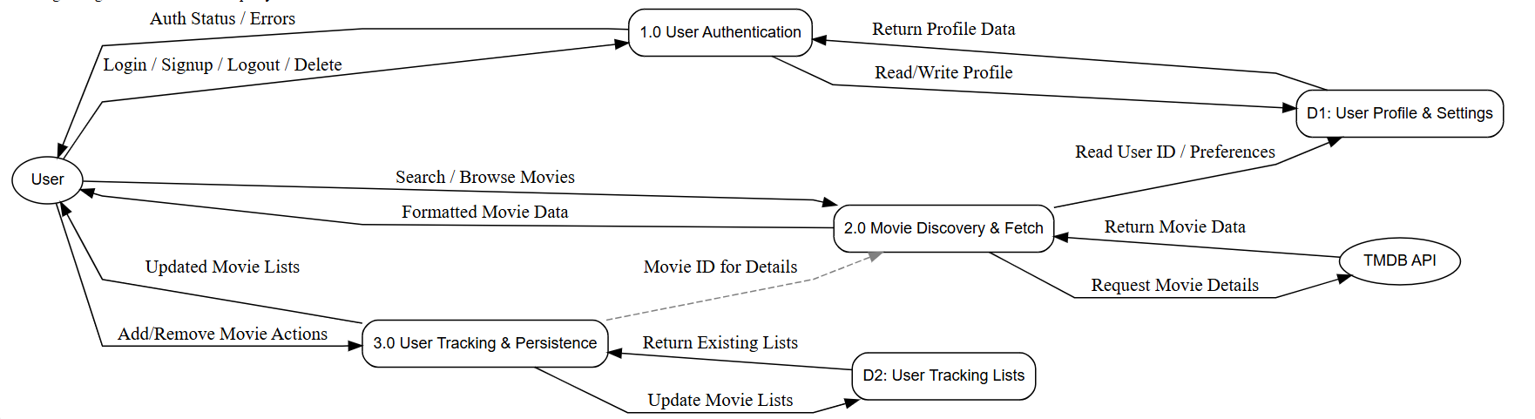
The system is centered around the User and consists of three main processes (labeled 1.0, 2.0, and 3.0) and two data stores (D1 and D2):
- User Authentication (1.0): Handles user actions like Login, Signup, Logout, and Account Deletion. It interacts with the D1: User Profile & Settings data store to read/write profile data and returns authentication status/errors to the User.
- Movie Discovery & Fetch (2.0): Handles Search and Browsing for movies. It fetches comprehensive movie data by interacting with an external service, the TMDB API, and returns formatted movie data to the User. It also needs to read the User's ID/Preferences from D1 to potentially personalize results.
- User Tracking & Persistence (3.0): Manages the User's personalized movie lists (like Watchlist, Watched, etc.). It processes Add/Remove Movie Actions from the User, updates the D2: User Tracking Lists data store, and returns the updated lists to the User.
4.1.5 Sequence Diagrams
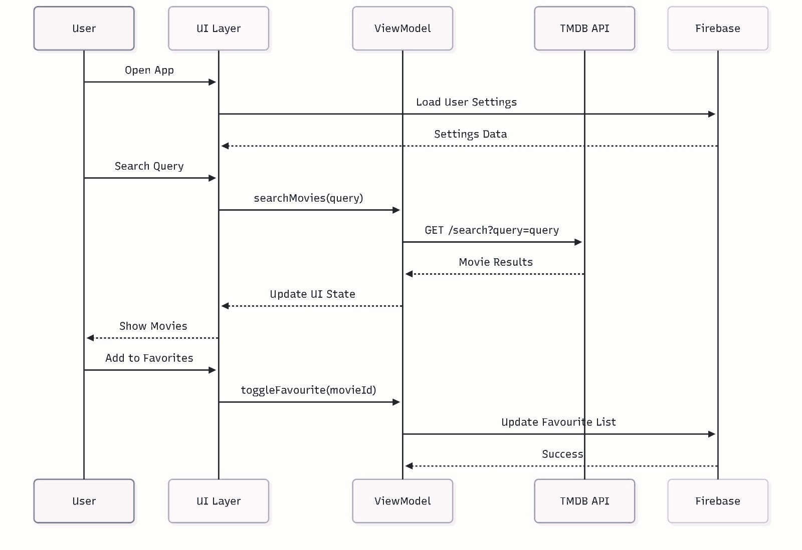
This UML Sequence Diagram depicts the real-time interaction flow between the application's components and external services.
It outlines three main sequences:
- System Initialization: The UI Layer requests and the ViewModel fetches User Settings from the Firebase backend upon opening the app.
- Movie Discovery: User searches trigger the ViewModel to make a remote GET request to the TMDB API. The results are then processed and displayed by the UI Layer.
- Data Persistence: The ViewModel handles user actions like Add/Remove from Favorites by directly updating the Favourite List stored in Firebase.

4.1.6 Activity Diagram
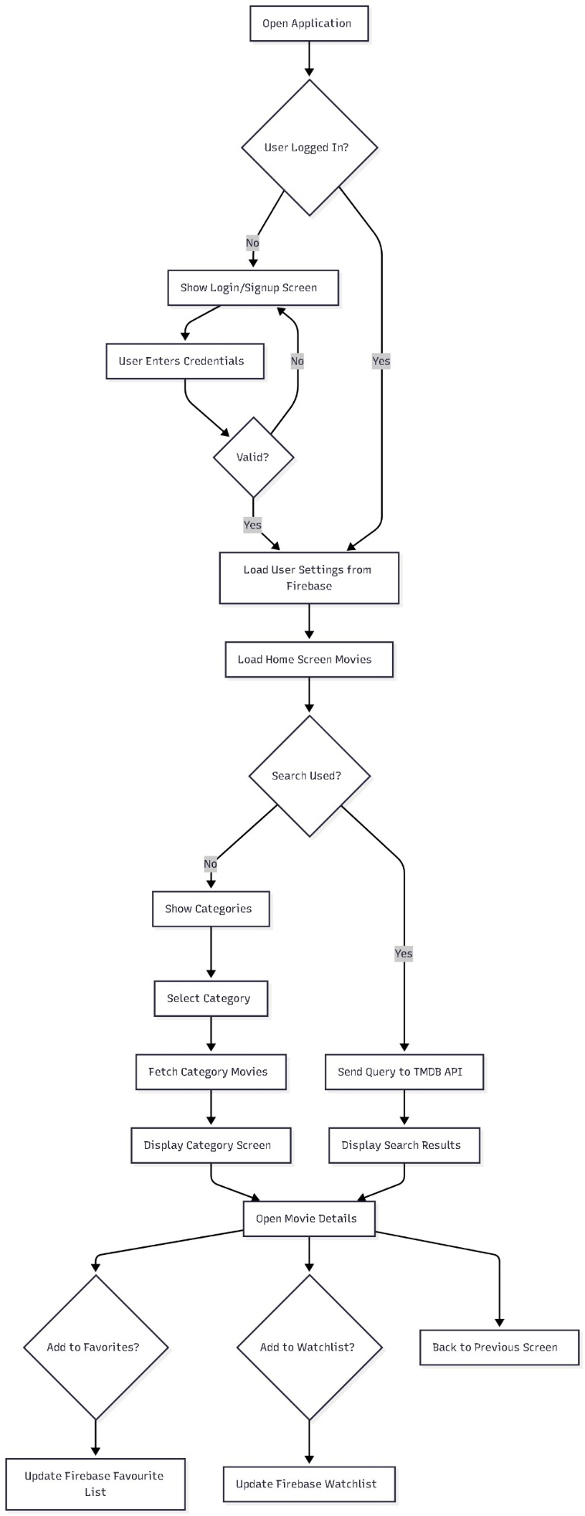
This Flowchart details the complete user journey and application logic for initialization and core functionalities:
- Authentication Path: Upon starting, the system checks if the User is Logged In. If not, it forces a flow through the Login/Signup Screen until valid credentials are provided.

- Initialization: Once authenticated, the application proceeds to Load User Settings from Firebase and Load Home Screen Movies.

- Content Discovery Logic: The flow branches based on user intent:
  - Search Path: If Search Used, the query is sent directly to the TMDB API, and results are displayed.
  - Browsing Path: If search is not used, the system allows the user to Show Categories, Select Category, and Fetch Category Movies before displaying the results.

- Action Persistence: From any results screen, the user can Open Movie Details. From there, the user can choose to Add to Favorites or Add to Watchlist, which triggers an update to the respective lists in Firebase.

4.1.7 State Diagram
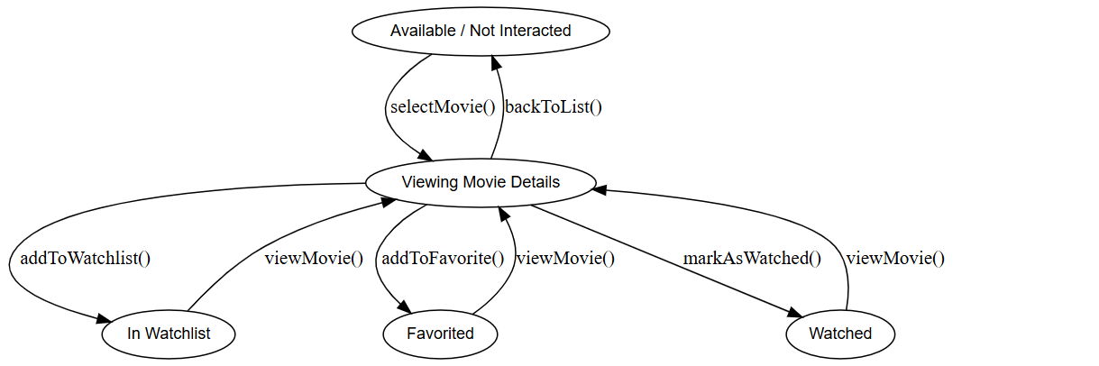
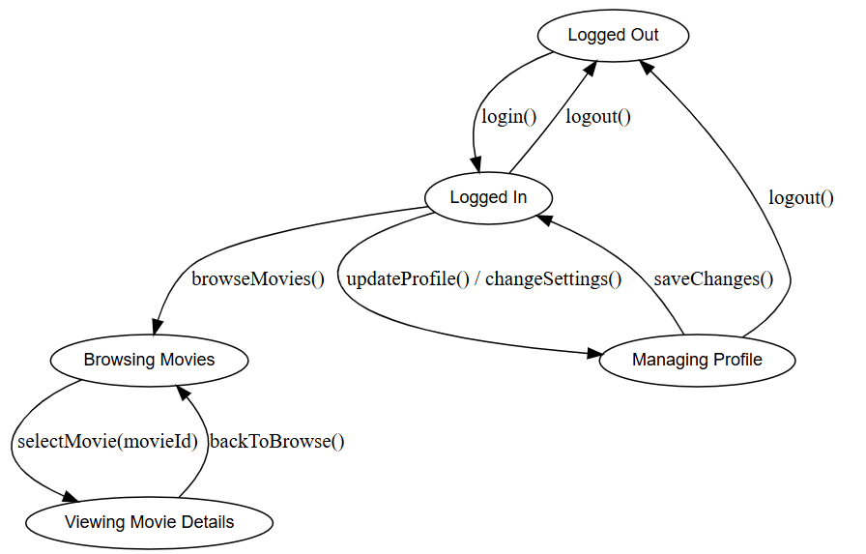
These two State Diagrams collectively describe the dynamic behavior and state transitions within the application across user management and content interaction:
1. Movie Interaction State
This diagram focuses on the state of a single Movie object relative to the user's lists:
- Viewing Details: The central state, Viewing Movie Details, can be reached from the Available / Not Interacted state .
- List Management: From the details view, the movie can transition into the In Watchlist, Favorited, or Watched states using specific methods (addToWatchlist(), addToFavorite(), markAsWatched()).
- Reversion: A movie in any list state can typically return to the Viewing Movie Details state for further action (potentially deletion/removal actions which are implied but not fully detailed).
2. User/Application State
This diagram focuses on the user's authentication and navigation state:
  - Authentication Cycle: The user transitions between the Logged Out and Logged In states via login() and logout() operations.
  - Profile Management: From the Logged In state, the user can move to the Managing Profile state (via updateProfile() or changeSettings()) and return upon saveChanges().
  - Content Discovery: The Logged In state is the gateway to Browsing Movies, which allows navigation to Viewing Movie Details and back.
4.1.8 Class Diagram
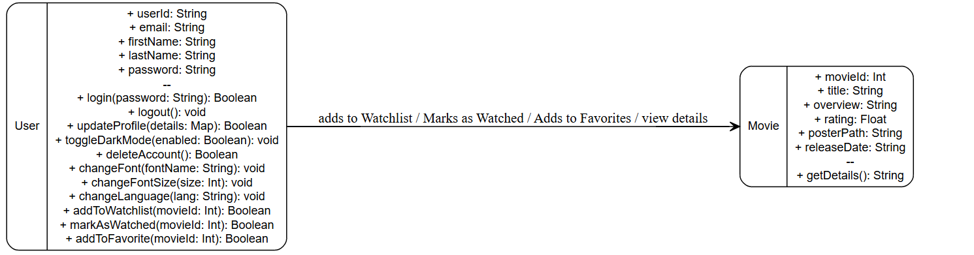This is a UML Class Diagram showing two core classes:
- User: Defines attributes (like email, password) and methods for user actions, including login/logout, updating preferences, and managing movie lists (addToWatchlist, addToFavorite).
- Movie: Defines attributes (like movieId, title, rating) and a method (getDetails).
The diagram shows that the User class performs actions on the Movie class to manage personal lists and view details.

4.2 UI/UX Design & Prototyping
This section documents the visual design system, color palette, typography, and core screen layouts, ensuring the application provides a modern, intuitive, and accessible user experience.
4.2.1 Design Goals and Principles
The design is built upon the following principles:
- Cinematic Aesthetics: Utilizing a dark, high-contrast theme to place visual emphasis on movie poster artwork, mimicking a theater environment.
- Clarity and Hierarchy: Using strong accent colors (Red and Gold) to guide the user's focus toward primary actions and critical information (ratings, status).
- Personalization: Ensuring key user settings (dark mode toggle, language, font size) are immediately accessible and impactful. The design supports dynamic theming and Right-to-Left (RTL) layouts.
- Mobile-First Approach: All screens are designed for optimal legibility and ease of interaction on mobile devices, featuring large, rounded cards and generous padding.

4.2.2 Visual Style Guide
A. Color Palette
The application supports both Dark and Light color schemes to minimize eye strain and offer personalization.
Name | Dark Mode Hex Value | Light Mode Hex Value | Role in Application | Examples from Screenshots
Background Color | #1E1E2F (DarkNavy) | #FFFFFF (White) | Primary Theme Background. | Dark mode background is deep purple/navy; Light mode background is pure white .
Surface Color | #2C2C3E (CardBackground) | #F5F5F5 (Light Gray) | Elevated Elements and Cards. | Movie card background, search bar background.
AccentRed | #E50914 | #E50914 | Primary Action Color (Consistent across themes). | Buttons, active tab indicators, and titles like "Movie Discovery".
Gold | #FFFFD700 | N/A | Secondary Accent Color. | Movie ratings (stars).
TextPrimary | #FFFFFF (White) | #000000 (Black) | High-contrast Text (Titles, main content). | Major headings, Movie titles.
TextSecondary | #B0B0C3 (Light Gray) | #000000 (Black) | Support Text (Sub-text). | Placeholder text, Subheadings.
B. Typography
The application uses a single, highly readable font family, Roboto, ensuring consistency across all text elements, while offering alternatives for personalization and internationalization.
- Font Family: Roboto (as defined by R.font.roboto_regular).
- Body Text: 16.sp for standard movie descriptions and lists.
- Title Large: 22.sp and Bold for main section headers and titles.
- Accessibility: The application supports user control over Font Size to enhance accessibility, configurable via the Settings screen. The application also supports specific font types like Cairo (often used for Arabic scripts) and Momo (used as a default fallback) to accommodate different languages and user preferences.
C. UI Elements
  - Action Buttons: Primary buttons use the high-visibility AccentRed color, featuring large, rounded rectangles for easy tapping (e.g., "Sign In," "Watch Now," "Reset to Default").
  - Interactive Cards: Movie listings use elevated Surface Color backgrounds with large, clear poster art and rating information (Gold star).
  - State Indicators: icons (heart , star , play ) are used to clearly indicate a movie's status (Favorite, Watchlist, Watched).

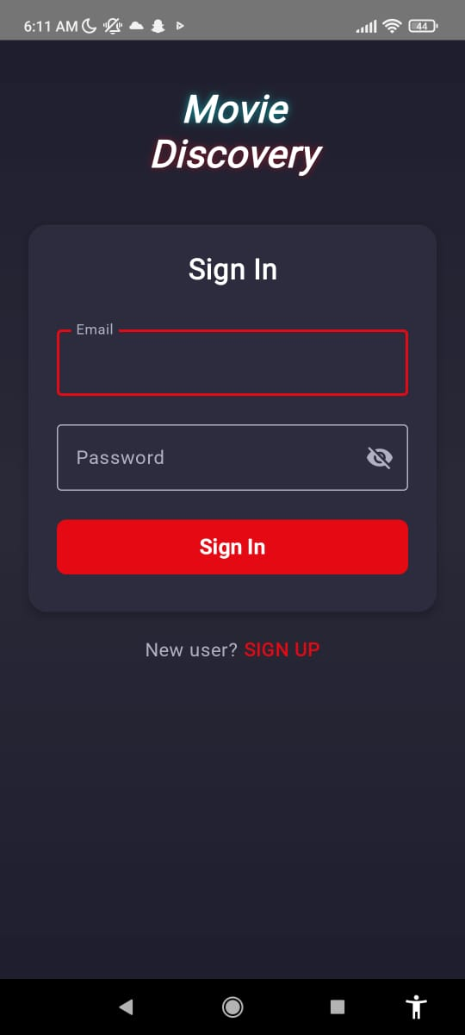
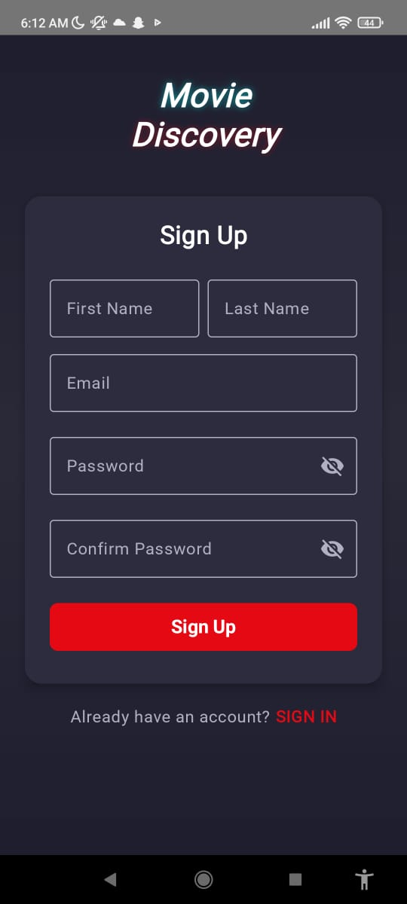
4.2.3 Key Screen Prototypes
The following prototypes represent the core user flows of the application.
A. Authentication Screens
The Login and Sign Up screens maintain a minimal, secure focus, using a dark/light card structure for input fields over the main background.
- Login/Signup: Clear primary buttons (AccentRed) drive the conversion, while the "New User?" or "Already have an account?" links are prominently placed at the bottom.
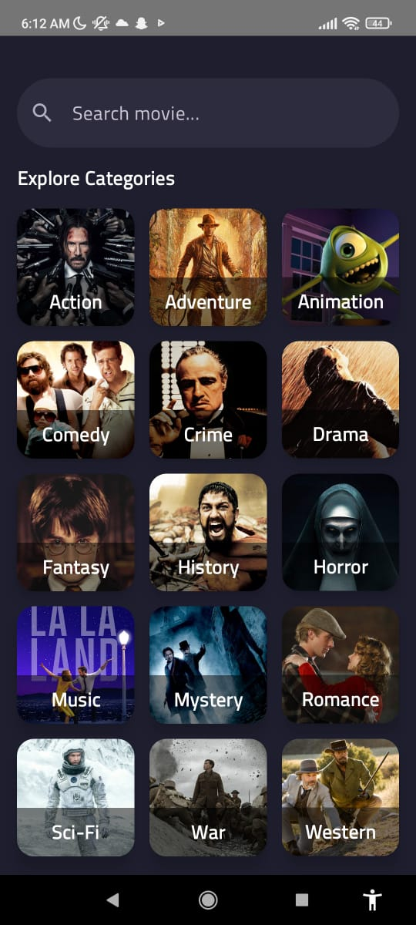
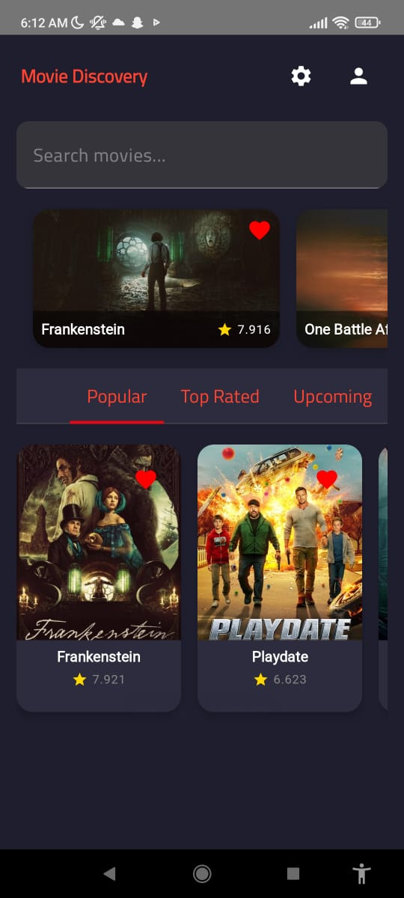

B. Home and Discovery Screens
The main screens prioritize content browsing and intuitive navigation.
- Home Screen: Features a prominent search bar and a tabbed navigation system ("Popular," "Top Rated," "Upcoming") to categorize initial movie listings.
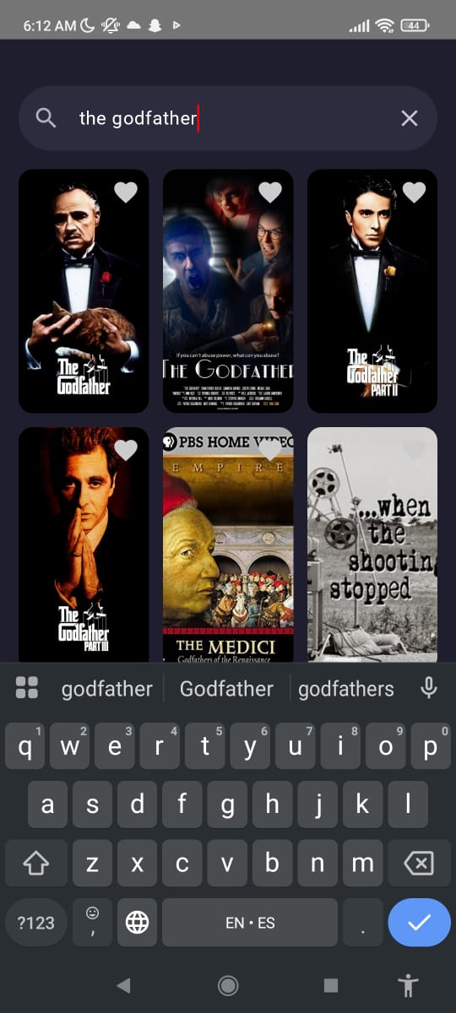
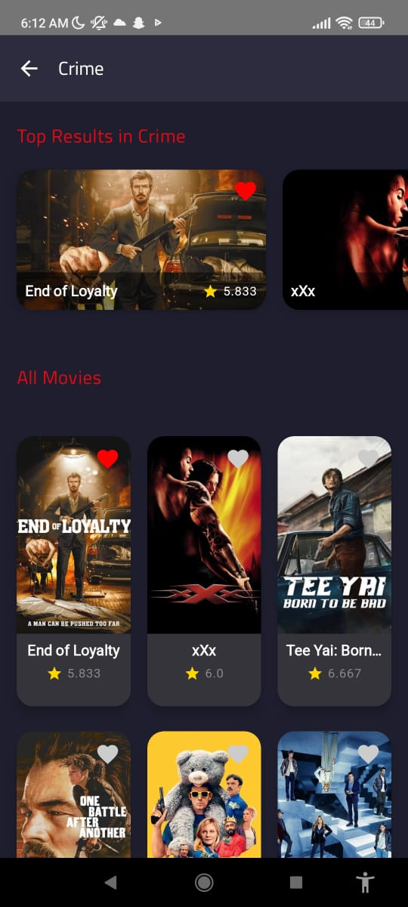
- Category Screen: Offers a grid of visually distinct, tappable category cards (e.g., Action, Adventure, Crime), each identified by a relevant movie poster thumbnail, facilitating quick discovery.
- Search Results: Presents results in a clear grid format, with the search query persisting at the top.

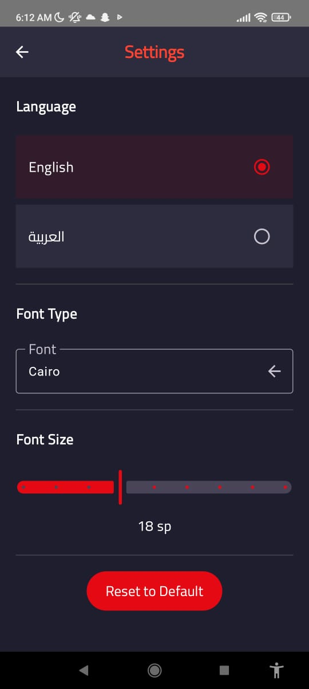
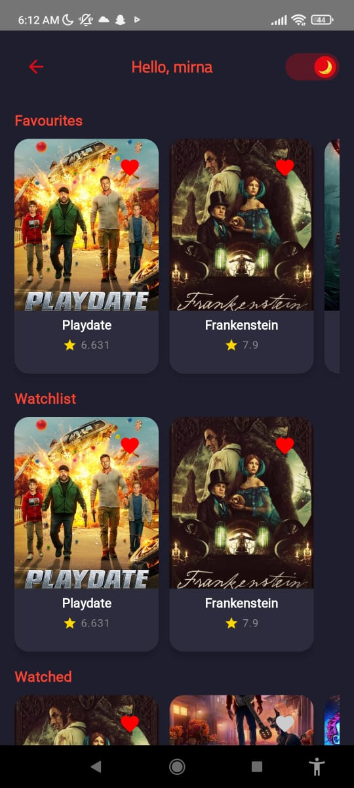
C. User Profile and Settings
The user-focused screens offer quick access to personal data and customization.
- Profile/Lists Screen: Clearly separates personalized content into vertical sections: Favourites, Watchlist, and Watched. A prominent moon/sun toggle allows for quick switching between Dark and Light modes

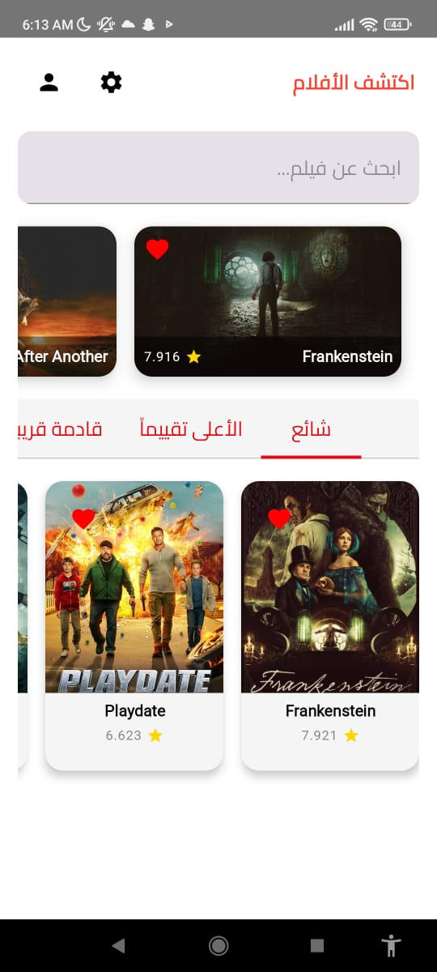
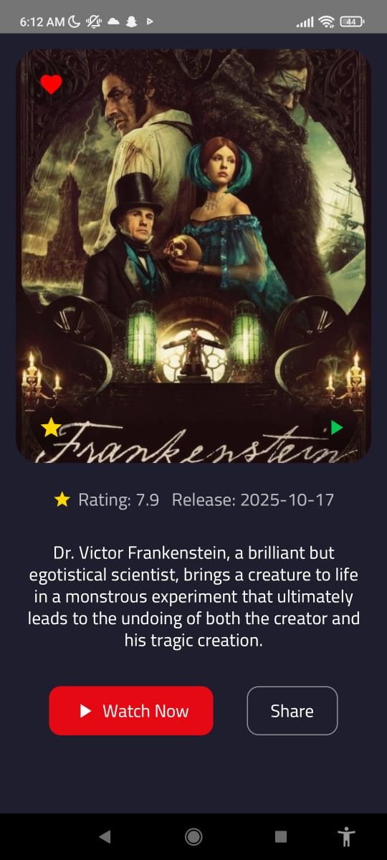
- Settings Screen: Allows granular control over key accessibility and language features, including language selection (English/العربية), font type, and font size adjustment via a highly visual slider.
- Movie Details Screen: Displays the movie's main poster prominently, along with rating and overview. Key actions like "Watch Now" and "Share" are presented as distinct buttons at the bottom.

4.3 System Deployment & Integration
Technology Stack:
- Backend:
  - Firebase Authentication (Auth) – for user login/signup and secure authentication
  - Firestore – for storing user data, profiles, and movie interactions
- Frontend:
  - Kotlin (Android) – primary language for app development
  - Jetpack Compose – for building declarative, modern Android UIs
- APIs:
  - TMDB API – to fetch movie data, details, and images
Deployment Diagram:
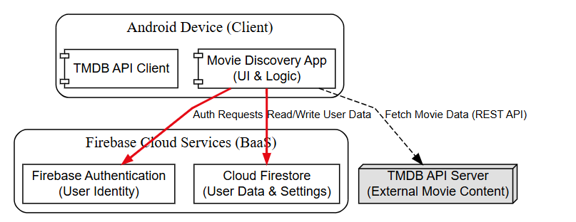
This diagram illustrates the three-tier architecture for the Movie Discovery App running on an Android client. The app leverages a Backend-as-a-Service (BaaS) and an external REST API to manage user identity, personal data, and movie content.

1. Android Device (Client)
The Movie Discovery App (UI & Logic) is the core client application.
  - It utilizes a TMDB API Client to fetch external movie data.
  - It communicates directly with Firebase for all user-related functions.
2. Firebase Cloud Services (BaaS)
Firebase provides the cloud backend for user management (Red Arrows):
- Firebase Authentication: Handles Auth Requests for user identity (login/signup).
- Cloud Firestore: Manages Read/Write User Data & Settings.
3.TMDB API Server (External API)
This external service provides all the film-related content (Dashed Black Arrow):
  - It supplies External Movie Content to the client via a REST API call initiated by the Movie Discovery App to Fetch Movie Data.

Component Diagram: 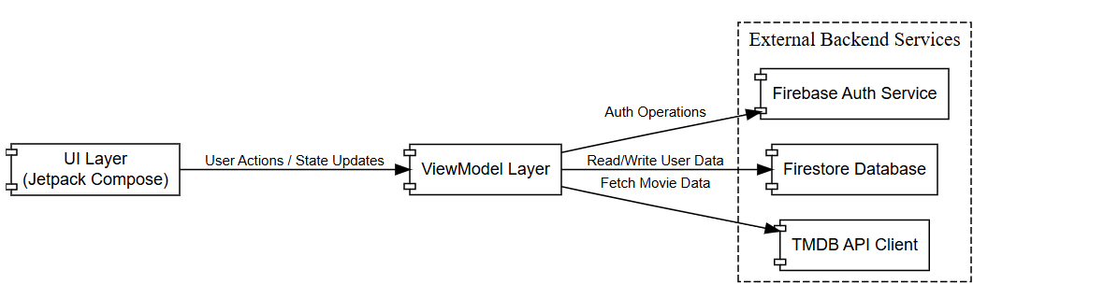
1. Components
The system is composed of three main architectural domains:
- Android Device (Client): Contains the core Movie Discovery App logic and the TMDB API Client.
- Firebase Cloud Services (BaaS): Provides Firebase Authentication and Cloud Firestore for user management and data storage.
- TMDB API Server: An external component that delivers External Movie Content via REST API.
2. Interactions
The arrows represent the usage and dependency relationships:
- User Management (Solid Red): The Movie Discovery App uses Firebase for Auth Requests and Read/Write User Data.
- Content Fetching (Dashed Black): The Movie Discovery App uses the TMDB API Server to Fetch Movie Data.

  - Additional Deliverables
API Documentation TMDB API (Used by Movie Discovery App)
1. Overview
The Movie Discovery App integrates with TMDB (The Movie Database) to fetch all movie-related data including trending movies, popular lists, details, searches, genres, and cast information.
Response Format:
JSON
Base URL:
https://api.themoviedb.org/3/
Authentication:
TMDB API Key
2. Endpoints Used

Trending Movies
Method: GET
Endpoint: /trending/movie/week
Purpose: Used to display trending movies on the home screen.
Parameters:
  - page (optional): Pagination number
Popular Movies
Method: GET
Endpoint: /movie/popular
Purpose: Used to display a list of popular movies.
Parameters:
  - page (optional)
Search Movies
Method: GET
Endpoint: /search/movie
Purpose: Used for searching movies by keyword.
Parameters:
  - query (required): Search keyword
  - page (optional)
Movie Details
Method: GET
Endpoint: /movie/{movie_id}
Purpose: Fetches detailed information about a specific movie.
Movie Credits
Method: GET
Endpoint: /movie/{movie_id}/credits
Purpose: Retrieves cast information for a movie.
Genre List
Method: GET
Endpoint: /genre/movie/list
Purpose: Used to fetch all movie genres for filtering.
Image Retrieval
Endpoint for Posters:
https://image.tmdb.org/t/p/w500/{poster_path}
Used to display movie posters and images.

Testing & Validation
The system was validated using multiple testing techniques to ensure correctness, reliability, and usability. The main testing categories included unit testing, integration testing, and user acceptance testing (UAT).
1. Unit Testing
Unit tests were written using JUnit, Kotlin Coroutines Test, and Mock to verify the correctness of ViewModel logic and independent functions.
Key unit-tested components
- HomeViewModel
Validates updates of popular, trending, upcoming, and top-rated movie lists.
Tests empty responses and null property handling.
Confirms list order and independence of categories.
- MovieDetailViewModel
Tests successful movie detail fetching from the API.
Validates error handling when API calls fail.
- UserViewModel
Tests favourite list operations.
Tests watchlist and watched list updates.
Confirms correct user data state management.
2. Integration Testing
Integration tests were applied to verify how different modules interact together.
- API + ViewModel Integration
MovieDetailViewModelTest integrates a mocked TMDB API service with the ViewModel to ensure correct state updates.
- StateFlow Interaction
Ensures ViewModels properly update UI-related state.
- User Data Manipulation
Confirms consistent updates across favourites, watchlist, and watched collections.
These tests ensure the internal components of the app communicate and operate correctly as a unified system.

3. User Acceptance Testing (UAT)
UAT was performed to validate real user workflows and ensure the app meets functional requirements.
UAT Scenarios
    - Login and signup using Firebase Authentication.
    - Browsing popular, trending, upcoming, and top-rated movies.
    - Viewing movie details and checking loading behavior.
    - Adding/removing movies from favourites, watchlist, and watched lists.
    - Ensuring smooth navigation between screens.
    - Verifying screen loading speed requirements.
    - General usability and error-free interactions.
These tests confirm the system behaves correctly from the user's perspective and satisfies project requirements.

Deployment Strategy
The deployment strategy defines how the system will be delivered, hosted, and scaled to ensure availability, reliability, and performance.
1. Hosting Environment
- Mobile Client: Android application distributed via Google Play Store.
Users download and install the app on their devices.
The app communicates with backend services via secure HTTPS connections.
- Backend Services:
Firebase Authentication: Handles user sign-up, login, and identity verification.
Firestore: Stores user data such as watchlists, favorites, watched movies, and settings.
TMDB API: Provides external movie data and content.
- Serverless Architecture: Firebase handles backend logic and scaling automatically, eliminating the need for traditional servers.
2. Scaling Considerations
- Backend Scaling:
Firestore supports high read/write throughput and global replication.
- Mobile App Scaling:
App is lightweight and optimized for performance.
Lazy loading of movie content ensures minimal bandwidth usage.

- API Rate Limits:
TMDB API has request limits; caching frequent queries reduces API calls.
Pagination is implemented to fetch movie lists efficiently.
5. Testing & Quality Assurance
1. Testing Overview
- Purpose: Verify correctness, reliability, and performance of the Movie Discovery app.
- Scope: Includes unit tests, integration tests, and user acceptance tests for Android frontend, Firebase backend, and TMDB API interactions.
- Testing Types:
  - Unit Testing: Validate individual ViewModels and data-handling classes (e.g., HomeViewModel, MovieDetailViewModel, UserViewModel).
  - Integration Testing: Ensure components interact correctly.
  - User Acceptance Testing (UAT): Confirm app meets user requirements and provides expected behavior.
2. Test Plan
Test Area | Scenario | Test Steps | Expected Outcome
Authentication | User sign-up | Enter valid email/password → Submit | Account is created; verification email sent
 | Invalid email/password | Enter invalid credentials → Submit | Error message displayed
 | Login | Enter valid verified credentials → Login | User redirected to home screen
 | Login unverified email | Enter valid unverified credentials → Login | Error message asking to verify email
Home Screen (Movies) | Load popular movies | App launches → Load home screen | Popular movies list is displayed correctly
 | Load trending movies | App launches → Load home screen | Trending movies list is displayed correctly
 | Load upcoming movies | App launches → Load home screen | Upcoming movies list is displayed correctly
 | Load top-rated movies | App launches → Load home screen | Top-rated movies list is displayed correctly
Movie Details | Fetch movie details | Select a movie → View details | Movie details fetched from TMDB and displayed
 | API failure | Simulate API failure → View details | Error message displayed; no crash
User Data | Add to favorites | Select movie → Add to favorites | Movie appears in favorites list
 | Remove from favorites | Remove movie from favorites | Movie removed from favorites list
 | Add to watchlist | Select movie → Add to watchlist | Movie appears in watchlist
 | Mark as watched | Select movie → Mark as watched | Movie appears in watched list
Settings | Change language | Update language → Save | App language updates accordingly
 | Change font type/size | Update font settings → Save | App reflects new font settings
Logout | Log out | Tap logout button | User redirected to login screen

3. Expected Outcomes
    - Application functions as intended with no crashes.
    - Firebase stores and retrieves user data reliably.
    - TMDB API content is displayed accurately.
    - User interactions (favorites, watchlist, settings) persist across sessions.
    - UI updates correctly for different settings (language, font, etc.).
    - Error conditions are handled gracefully (network failures, empty responses).

  - Automated Testing
The Movie Discovery app uses automated testing to ensure correctness, reliability, and maintainability of the code. Automated tests are implemented primarily in Kotlin using JUnit and Kotlin Coroutines Test for asynchronous flows.
1. Unit Tests
Unit tests validate the functionality of individual classes and components:
- HomeViewModelTest
Verifies loading of popular, trending, upcoming, and top-rated movies.
Checks handling of empty responses and movies with null properties.
Confirms multiple calls to loadMovies() work correctly.
- MovieDetailViewModelTest
Ensures correct fetching of movie details from TMDB API.
Validates error handling when API throws exceptions.
- UserViewModelTest (FakeUserViewModel)
Tests favorites, watchlist, and watched lists functionality.
Confirms adding/removing items updates the state correctly.
Verifies dummy movie data retrieval for testing purposes.
Example Automated Test Script
@Test
fun loadMovies should update popular movies() = runTest {
viewModel.loadMovies()
val movies = viewModel.popularMovies.first()
assertEquals(2, movies.size)
assertEquals("Popular Movie 1", movies[0].title)
assertEquals("Popular Movie 2", movies[1].title)
}
Description: Validates that the HomeViewModel correctly loads the popular movies list.
Automation Benefit: Ensures changes to data sources or logic do not break existing behavior.
Bug Reports & Resolutions
Description | Severity | Detection Method | Resolution / Status
Login failure for users with unverified email | High | Unit testing (AuthViewModelTest) | Added email verification check; users must verify email before logging in.
Favorites/Watchlist updates not reflected immediately in UI | Medium | Manual testing & UserViewModelTest | Updated StateFlow to emit changes immediately on add/remove actions.
Settings (language, font type, font size) not persisting | Medium | Manual testing | Updated updateUserSetting() to persist to Firestore and reflect changes in UI instantly.
Dark mode toggle not applied immediately | Low | Manual testing | Bound isDarkMode StateFlow to UI; changes now reflect instantly.

