# **DATASCI W209: Data Visualization and Communication**

## **Name: Simon Macarthur**

### **Email:** [**samacart@berkeley.edu**](mailto:samacart@berkeley.edu)

### **Class Name: MIDS-W261-1**

### **Assignment 4: Critique**

### Assignment 4: Critique

Pick two visualizations from two different types of media (e.g., newspaper, magazine, website, blog). One must be an example that you consider successful and one must be an example you consider unsuccessful. Do not use examples that have been critiqued before, such as those from visualization textbooks or visualization blogs. Use of the evaluative questions from the asynchronous material about critique (e.g, does it convey useful information or insight?) should guide your analysis.

**Assignment due date:** 12 noon PST, day of week 7 live session

**Analysis Questions**

***Successful Visualization***

**I) Provide a brief overview of the visualization example you consider to be successful (What is it about? What are relevant variables shown?):**

Ebola, Malaria, Smallpox, the SARS pandemic. These are all diseases we have heard of, and have been sensationalised in the media, adding fuel to the fire of concern around virulence. However, can the signal be seen amongst all of this noise? Is it possible to easily and quickly see the data that identifies which of these diseases are most deadly, and most contagious.

The Guardian addressed this very issue in a publication on October 15, 2014. During the height of the Ebola crisis in Africa, general panic was increasing throughout the world about the possibility of catching this deadly disease. I consider this to be a very successful visualization which portrays the infectiousness of various pathogens. Firstly, the layout of this visualization is very easy to read, without having too much information clutering the screen. Being related to disease it would be very easy to move into far too much technical jargon, but the author has maintained a readable version of this through the simplicity of showing the information comparing two main variables:

- Deadliness – the case fatality rate; and

- Contagiousness – a basic average reproduction number, signifiying how many people one person is likely to infect.

- Primary Transmission Method (identified by color)

This visualization can be found at <http://www.theguardian.com/news/datablog/ng-interactive/2014/oct/15/visualised-how-ebola-compares-to-other-infectious-diseases>

**ii) The maker’s possible goals:**

Published during the height of the Ebola crisis, the author was most likely intending this visualization to provide an anchor for the readers to understand that, whilst Ebola is a deadly disease, there are also other diseases which are more deadly and contagious. Taking advantage of the timeliness of providing insight into Ebola, the author was also likely to seize the opportunity to educate readers about the general virulence of pathogens, and generate some conversation about what can be done to combat these.

**Iii) The likely intended audience:**

Given the focus on Ebola when this was published, the intended audience was likely to be the general population. The expected demographic would most likely be fairly-well educated, as they need to be able to grasp simple ideas pertaining to contagiousness and fatality rates. However, given the simplicity in design of this visualization, it could also be designed to provide basic understanding of pathogens, with the reader able to search for more technical information if desired.

**iv) Screen capture or photo of the visualization:**

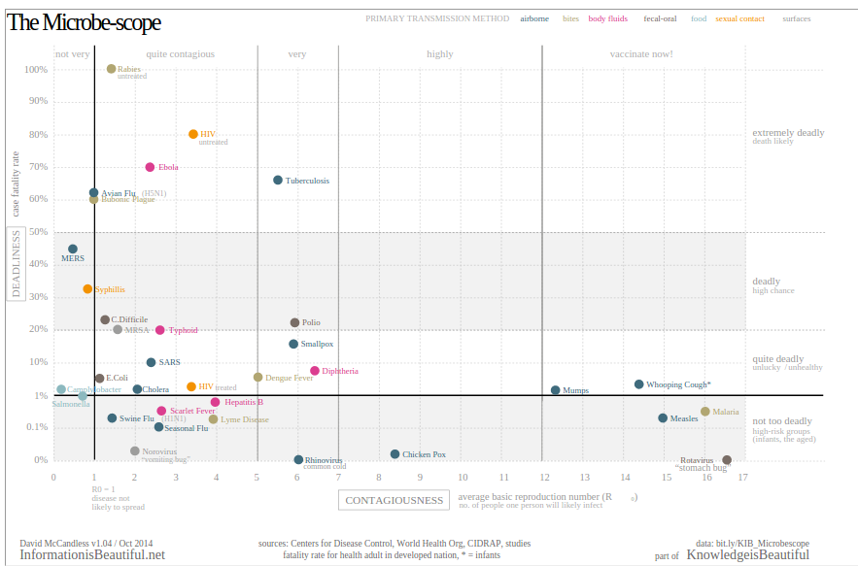

**v) A prioritized list of strengths of the visualization, addressing the evaluative questions discussed in the asynchronous material (this list may be in bullet-points):**

*\* Simple Design.*

The design of this visualization is simple, yet powerful. It provides a quick, easy snapshot and comparison without putting strain on the reader to understand complexities of viruses.

*\* Ability to communicate complex ideas using simpler terminology*

The development of a key variable contagiousness, and the sectioning of this within the visualization ensure the reader can easily digest the information being presented.

*\* Easy ability to compare and contrast a variety of variables (such as contagiousness, deadliness and tranmission methods)*

Being able to compare and contrase diseases in two-dimensions (contagiousness and deadliness) allowed the reader to understand the virulence of a particular pathogen. However, by adding the third dimension of color, signifying tranmission method, it allows the reader to obtain a level of understanding regarding not just how deadly a pathogen is, but also how easily this is transmitted.

*\* Sections provide additional details, again portrayed in laymans terms (contagious levels for example)*

**vi) Were there any weaknesses?**

Whilst this visualization is very strong, well presented and articulate, there is some confusion over the scale of the y-axis. This axis starts at 0%, moves to 0.1% and then is equally spaced as it then jumps to 1%, 10%, 20%, up to 100%. This adds confusion, as the scale of the axis leads the reader to believe they are all equally separated in terms of deadliness. However, in reality, there is much less difference in deadliness for those at the lower end of the spectrum, than once you move past 10%.

***Unsuccessful Visualization***

***I)* Provide a brief overview of the visualization example you consider to be unsuccessful (What is it about? What are relevant variables shown?):**

Gun laws in the USA has been another hot topic of late. The visualization I have chosen to critique as being unsuccessful is the epitomy of this topic. It attempts to provide insight into how gun laws are dramatically different from state to state within the USA. This is a complex issue in itself, and whilst the author has gone an admirable job of collating information, the way it is presented leaves the reader confused and perplexed.

The visualization is looking at various complex variables, such as:

- What laws are on file, broken into categories

- 2012 election results, voting for Obama or Romney

- An overall gun control score, based on the Brady Campaign Score

- Murder Rate, based on the number of firearm murders per 100,000 people

**ii) Source reference/ link:**

The visualization was published on Monday, December 17 2012 by *The Globe and Mail*. The original source can be found at <http://www.theglobeandmail.com/news/world/gun-control-in-america-a-state-by-state-breakdown/article6465107/>

**iii) The maker’s possible goals:**

The author of this visualization was attempting to draw correlation between gun laws, regional areas and voting preferences in the 2012 election. There is an attempt to draw the reader's attention to the fact that the stronger gun laws tend to be in regions associated with voting for Obama. By switching to the 'region' view, there is also the possibility that the author is attempting to also correlate gun laws and voting preferences to regions with the USA. For example, the northeast and parts of the northwest have much more stringent gun laws that other regions.

**iv) The likely intended audience:**

The likely intended audience for this visualization would be members of the public who are interested in both politics, but also gun control laws and the proliferation of gun violence within the USA. The visualization attempts to draw out more clearly the link between lack of gun control laws and associated violence, which is likely to draw the ire of the gun lobbyist and pro-gun community.

**v) Screen capture or photo of the visualization:**

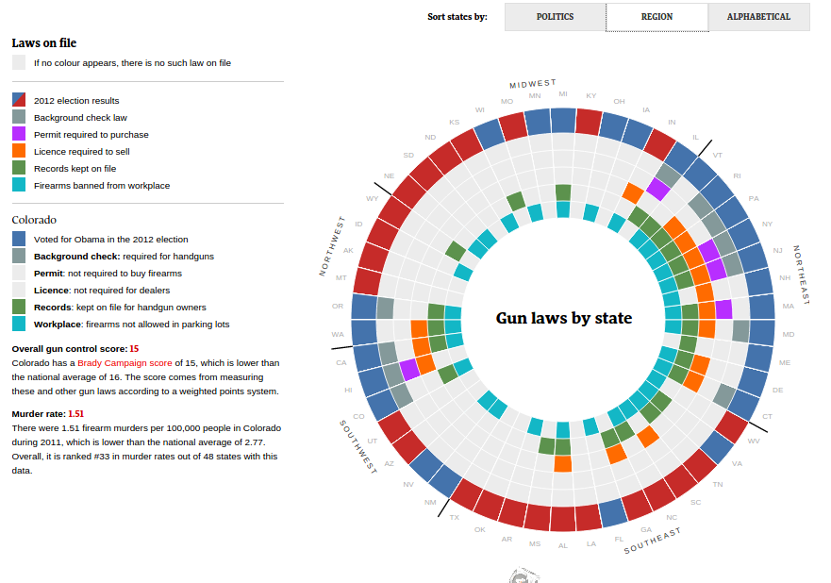

**vi) A prioritized list of weaknesses of the visualization, addressing the evaluative questions discussed in the asynchronous material (this list may be in bullet-points):**

Credit should be given to the author in attempting to bring together a very complex topic into one single visualization. However, there are some shortcomings which mean the message is not portrayed as optimally as it could be:

* Whilst the author has made a strong attempt to provide a flashy, interactive view of gun control laws and political preferences, unfortunately the overall message is lost in the complexity of the chart.

* The circular nature of the chart makes it challenging to read. There is no correlation between the location of the items in each of the circles, but human nature will automatically attempt to provide this correlation. It is also very challenging to maintain focus on individual areas, with there being a need to constantly revert back to the legend to refresh the reader's memory of what each box refers to.

* There are multiple insights which are missed from the initial chart until scrolling over individual areas. These include 'Overall Gun Control Score', 'Murder Rate', and associated rankings nationally. These would make powerful insights, and comparison of these variables between regions is challenging, requiring the user to scroll between regions and attempt to remember or record these variables.

* The Murder rate data is only available for 48 of the 52 states, meaning valuable information is being lost. This information is not easily identified, until reading the fine print for the individual region.

* Given the depth of information attempted to be portrayed, it may have been a better design decision to also provide this information in tabular format. This would allow the user to also delve into the detail, and could allo the author to remove some clutter form the chart.

* No time series is provided. This is simply a snapshot at a point in time of gun control laws and political preferences. It would have been useful to be able to see how these laws have changed, and what events were key to these changing, so that other states can learn from these experiences.

* There is an assumption by the reader that the gun control laws provided are linked to the political preference provided for the 2012 election. However, it does not provide information as to whether these laws were written during a different political party in history, and thus are not related to current voting trends.

**vii) What were any strengths?**

An admirable attempt was made to bring together a large amount of information. There is not strong or incorrect use of color within the chart, and there is consistency in both color and typeface usage. The ability to drill down into more information on each state is very useful, and definitely adds to the positivity of the chart. However, even with these strengths, the overall impression of the chart is poor.